Online System

Use Case Specification Document

UC-5
Bookkeeping
Version No. 1.0

Project Document Revision History
VersionNumber | Date | Revision Author | Description of Revision
1.0 | 05/23/2018 | Derek Dai | Initial Creation

Table of Contents
1. Introduction 4
2. Use Case Information 4
2.1 Actors 4
2.2 Use Case Interaction 4
3. Trigger 4
4. Pre-condition(s) 5
5. Post-condition(s) 5
5.1 Show brief info of all stations 5
The following Swimlane diagram covers the showing records functionality 5
5.2 Insert/Update/View detailed info about certain station 6
5.3 Other use cases 6
6. Use Case Specification Review and Signoff 6

Introduction
The purpose of this use case is to let the user view/download/upload documents and manuals. The functionalities are categorized into either functional or non-functional requirement. The functional ones listed are as follows:
- Show all the documents and manuals
- Upload documents
- Download documents
- Search for certain content

As for the non-functional requirement:
- Progress bar should be shown when loading the data
- The system can provide infinite scrolling down like Facebook post
- Just like previous system, the bookkeeping should also fetch brief info about documents and provide detailed info as well as download service if user is interested
The Online System is a web-based project. The user interface is to be function properly on all platforms, including desktop computers, notebooks, and mobile devices.

Use Case Information

Actors
The Online System will allow all registered users to view or update information of every station in the lab. All actors in the following table will be able to make full use of all functionalities in this use case:
Actor Name | Role | Description
Registered User | Main | Any user with an active account

Use Case Interaction
This use case is independent from other use cases without any predecessor or successor.

Trigger
Functionality | Trigger
Search suggestions | User type in the search filed
Upload document | Upload button pressed
Download document | Download button pressed
Search for certain document | Search button is pressed

Pre-condition(s)
Main page

Post-condition(s)
The system will enter 3 different post-conditions based on user’s action
- If user logout, then the system will enter the login page
- If user use navigation bar, he or she will be navigate to another page (among Main page, Document & Manuals page, test status page, and bookkeeping page)
- It is more common that the user will continuously working on the current pageUse Case Swimlane (Activity) Diagram

Show brief info of all stations

The following Swimlane diagram covers the showing records functionality
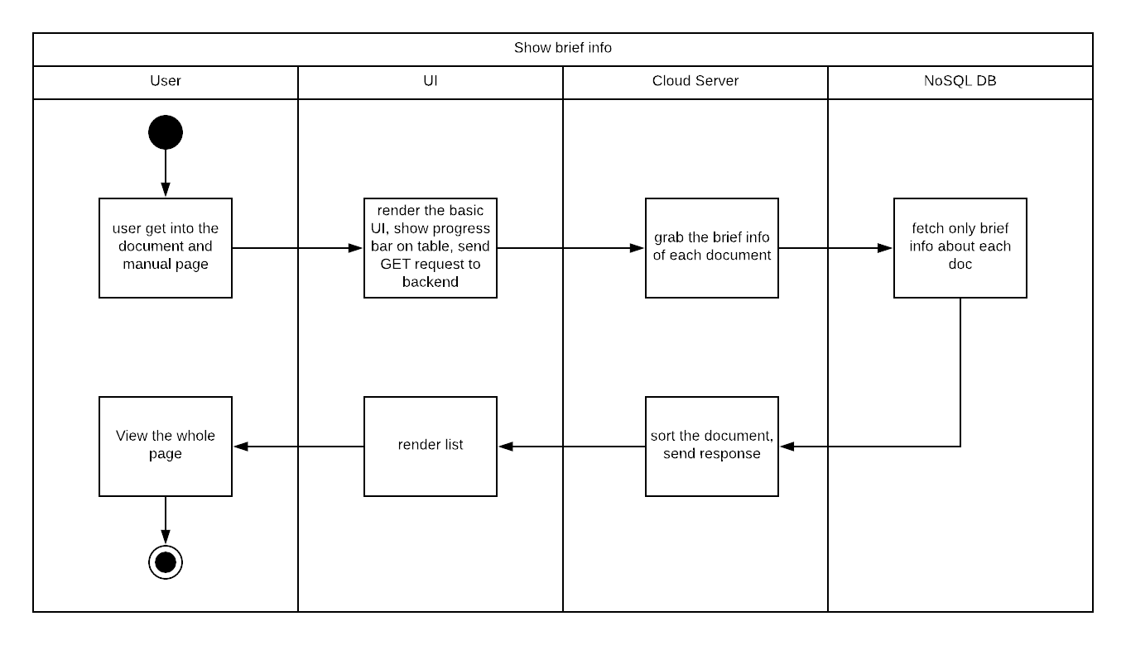
Diagram 6.1 Version 1.0 05/16/2018

Insert/Update/View detailed info about certain station
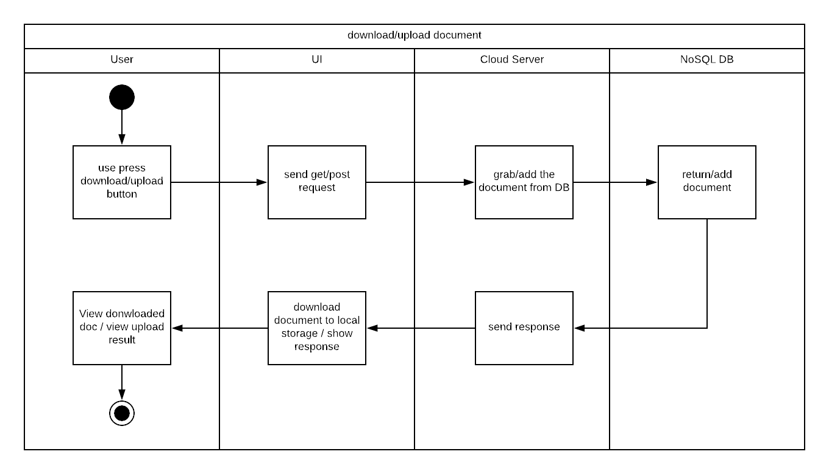
Diagram 6.2 Version 1.0 05/16/2018

Other use cases
Since other use cases only regarding User and UI, we do not draw those simple swim lane diagrams

Use Case Specification Review and Signoff
Review and Signoff of the Use Case Specification
Name | Project Team Role | Signature | Date
Yue Dai | Developer | YD | 05/18/2018

