Online System

Use Case Specification Document

UC-1
User login
Version No. 1.0

Project Document Revision History
VersionNumber | Date | Revision Author | Description of Revision
1.0 | 05/16/2018 | Derek Dai | Initial Creation
1.1 | 05/17/2018 | Derek Dai | Modify the post condition from station info page to the main page

Table of Contents
1. Introduction 4
2. Use Case Information 4
2.1 Actors 4
2.2 Use Case Interaction 4
3. Trigger 5
4. Pre-condition(s) 5
5. Post-condition(s) 5
6. Use Case Swimlane (Activity) Diagram 6
6.1 User Login Online System 6
The following Swimlane diagram covers the login functionality 6
6.2 Forget Password 7
6.3 Go to Registration 8
7. Main/Basic Flow(s) of Events (Happy Path) 8
7.1 User login: 8
7.2 Forget password 9
7.3 Got to Registration 9
8. Alternate/Exception Flow of Events 9
8.1 Invalid Data Entry 9
9. Assumptions/Business Rules including Non-Functional Requirements 10
10. Use Case Specification Review and Signoff 10

Introduction
The purpose of this use case is to let the user use their email address and password to log into the system. The functionalities are categorized into either functional or non-functional requirement. The functional ones listed are as follows:
- Check the password and username(Email)
- Shows error message if the username is not existing
- Shows error message if the password is not correct based on the given username
- Allows user to retrieve his or her password by adding the forgot password functionality
- Allows user to go to the register page
As for the non-functional requirement:
- The checking must be 100% accurate, it should be sensitive to capital alphabet in the password. It should tolerate Upper-case or Lower-case username.
- The checking speed which is actually the ajax connection should be stable and fast, user should get the result back in at most 5 seconds
- Furthermore, since the username is email address, we can first check if the username is in the correct format (whether it is a valid Litepoint Email address). Also we should show error message if the password filed is still empty
- While checking the input, the system should show a progress bar in order to let the user know the system is processing his or her request
- If the user forgets his or her password, the password can be sent to user’s Email address, the result should be displayed not matter the Email is sent successfully or not

The Online System is a web-based project. The user interface is to be function properly on all platforms, including desktop computers, notebooks, and mobile devices.

Use Case Information

Actors
The Online System will allow all registered users to view or update information of every station in the lab. All actors in the following table will be able to make full use of all functionalities in this use case:
Actor Name | Role | Description
Registered User | Main | Any user with an active account

Use Case Interaction
This use case is independent from other use cases without any predecessor or successor.

Trigger
Functionality | Trigger
User login checking | Login button pressed by the user
Forget password | Forget password button pressed by the user
Show login result | Result sent back from the back-end system
Navigate to the registration page | Register button pressed by the user

Pre-condition(s)
None

Post-condition(s)
The system will enter 3 different post-conditions based on user’s action
- If the user successfully login, then he or she will be navigated to the main page
- If the user presses the forget password button, then he or she will stay on the login page, the password will be sent to the user’s Email address
- If the user presses the register button, he or she will be navigated to the registration page

Use Case Swimlane (Activity) Diagram

User Login Online System

The following Swimlane diagram covers the login functionality
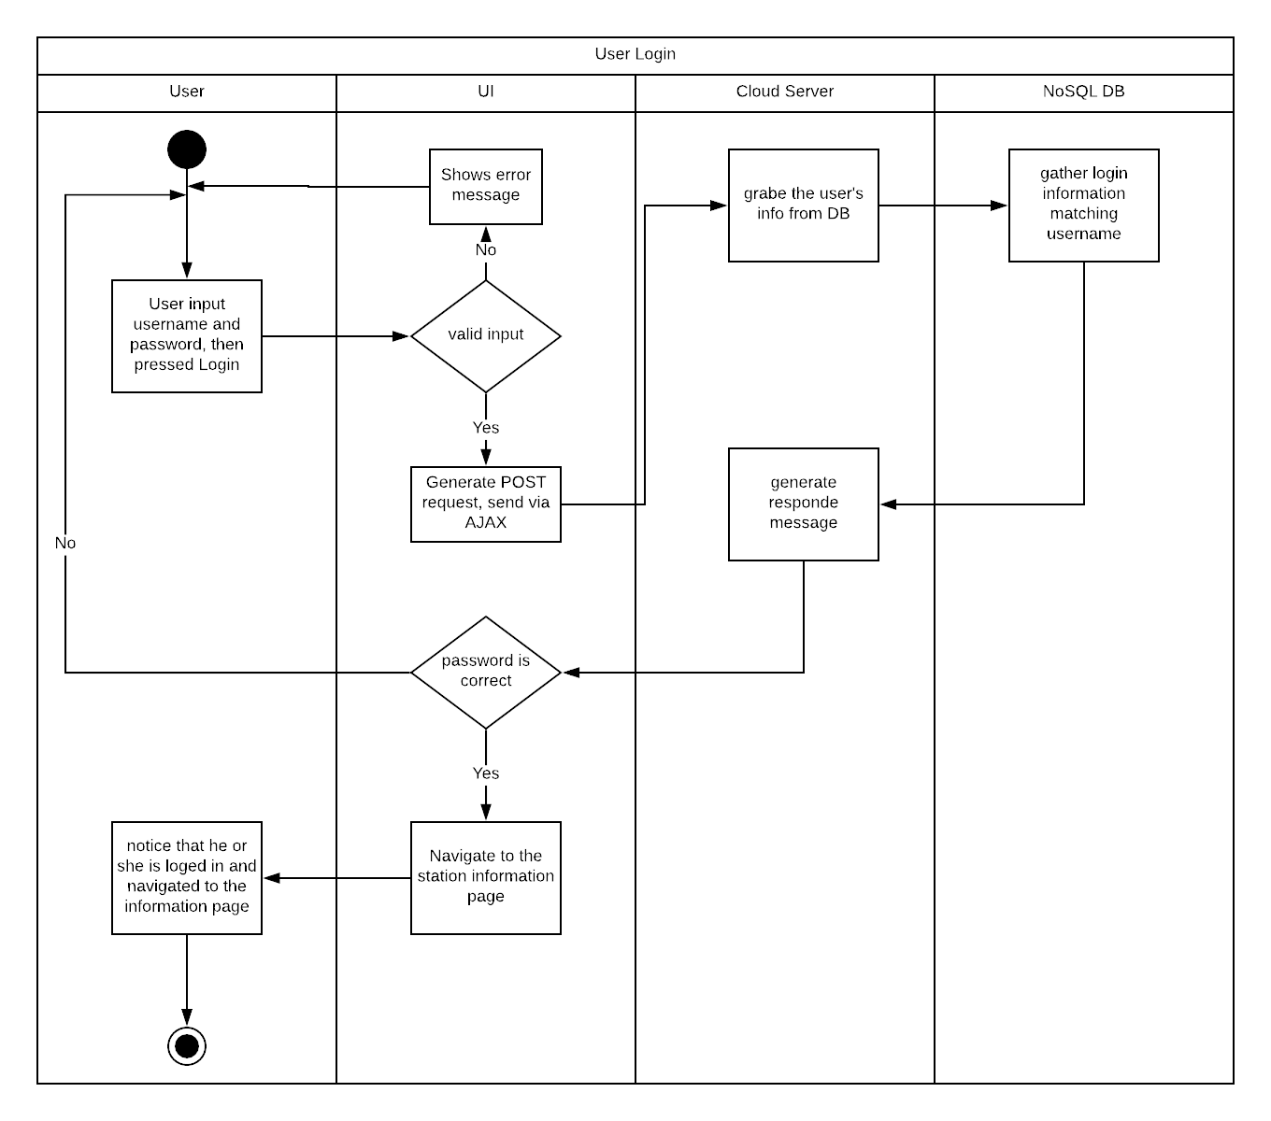
Diagram 6.1 Version 1.0 05/16/2018

Forget Password
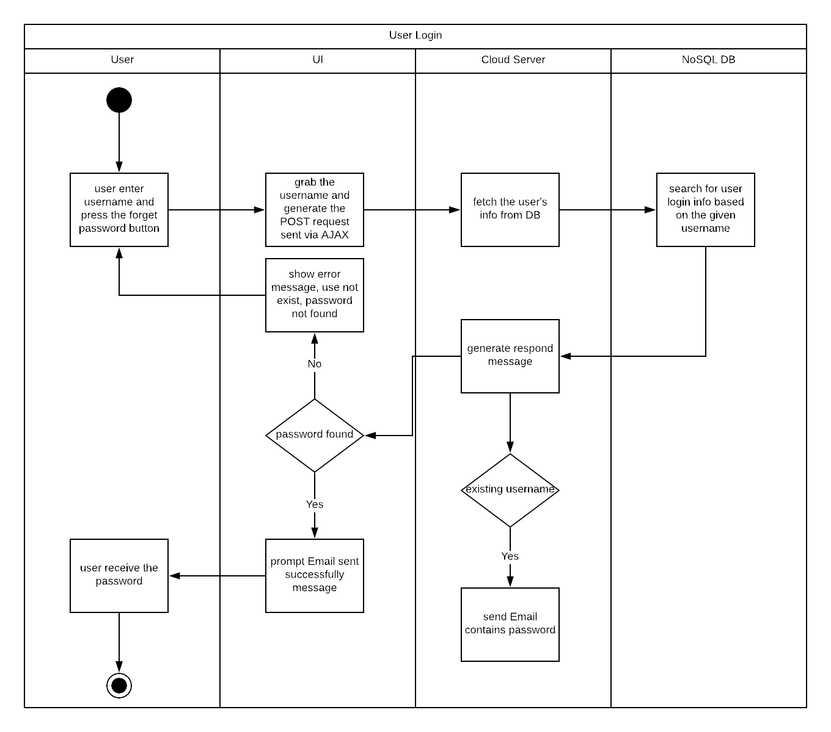
Diagram 6.2 Version 1.0 05/16/2018

Go to Registration
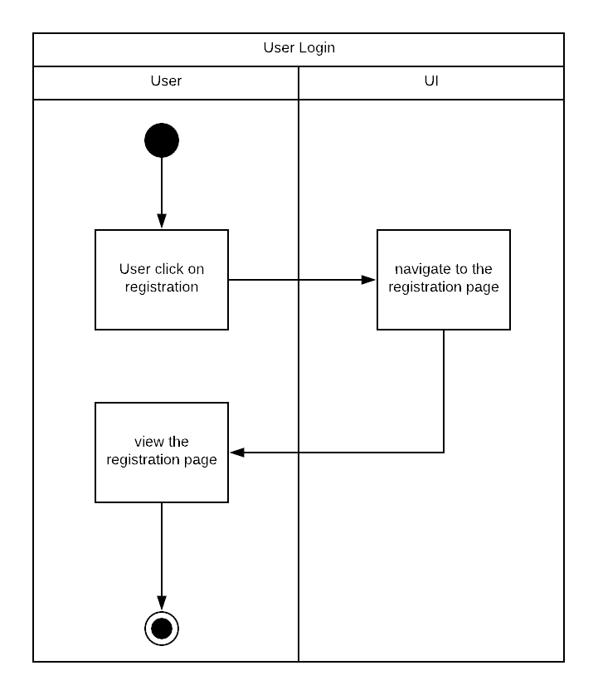
Diagram 6.3 Version 1.0 11/21/2015

Main/Basic Flow(s) of Events (Happy Path)
The “User” throughout this section refers to Registered Users.

User login:
See Swimlane Diagram 6.1 for a visual representation of this flow.
      - The user will input email address and password in order to login click submit button.
      - The interface will check for valid email address and password.
      - The interface will generate request and sent to back-end system.
      - The system will grab the user login information from DB.
      - The system will generate a respond and send it back to front-end.
      - The interface will check the result, and navigate user into the main page if the authentication is correct.
      - The user will view the main page.

Forget password
See Swimlane Diagram 6.2 for a visual representation of this flow.
      - The user will input username and click forget password button.
      - The interface will send post request to the back-end.
      - The back-end will grab the user’s information based on username.
      - The system will generate respond and send an Email that contains the password toward the user
      - The interface will display the “Email is sent” info to user.
      - The user will get his or her password for the online system.

Got to Registration
See Swimlane Diagram 6.3 for a visual representation of this flow.
      - The user will press the register button.
      - The interface will navigate users to the registration page
      - User can then start the registration

Alternate/Exception Flow of Events

Invalid Data Entry
      - The users will input his or her username and password
      - The username and password is invalid, error message will be shown
      - The username is not existing, error message will be shown
      - The password is not correct based on the given username, error message will be shown

Assumptions/Business Rules including Non-Functional Requirements
We assume that the Online System is only used by our co-workers, all email address have to be the Litepoint Email address.

Use Case Specification Review and Signoff
Review and Signoff of the Use Case Specification
Name | Project Team Role | Signature | Date
Yue Dai | Developer | YD | 05/18/2018

