Presentation (15 marks)• Describe the target audience (2 mark)

-- 1.This is an app designed for restaurants to book seats. Restaurant customers can book and cancel their reservations online, making it convenient for customers to book and reserved their tables in advance, and then complete their meals at the restaurant.

-- 2.Customer, table, order management are designed in a management system by PHP via IOS API

• Explain what problem is being solved (2 mark)

--1. Convenient for customers to book register and make dining tables reservation online, also can cancel reservation;

--2. Reduce the number of restaurant staff answering calls from customers to book dining tables, and improve work efficiency.

--3. Restaurant manager can manager order, customer and table reservation. If customer finish, manager can confirm the order finish to release table.

• Explain/demonstrate how your app compares to other possible solutions (2 mark)

-- The traditional and commonly used solution is to book a dining table by making a phone call. If the phone is busy, it may cause customers to be unable to call, which may result in customers booking other places and losing customers. By allowing customers to book dining tables online independently, such incidents can be effectively avoided.

• Demonstrate thoroughly how the app is used (2 marks)

--presentation.mp4

• Explain what frameworks/services you used to solve the problem (2 mark)

--Swift/Swift UI/IOS simulation/API/PHP/MySQL

• Demonstrate the greatest difficulty you encountered and how you solved it, in coding or design. (2 marks)

-- 1. I was not very good at switching the status of reservation orders in the reservation list interface. Then, by reviewing and learning the SwiftUI development documentation, I used the @ State attribute to track order status, and used the Picker view to allow users to switch order status.

--2. Customer,order,table management is big challenge, I used API to link backend management system. Not familiar with the use of MAMP software

• Demonstrate how you achieve minimum viable product by following an iterative  
product design cycle (1 mark)

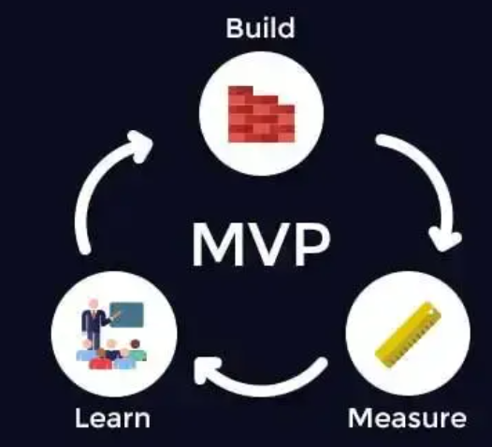

Step 1: Clarify product objectives: The primary goal is to achieve online reservation and cancellation of table reservations, and to meet the registration and storage of customer login information.

Step 2: Define the user behavior path of the product. The steps for user login and reservation cancellation. The backend can manage users and query who has booked which dining table at what time. When used up, it should be released in a timely manner to reserve for the next customer.

Step 3: List product features based on user paths. Functionally, it should be possible to choose a time reservation or cancel the reservation. The backend can release the completed dining table.

Step 4: Prioritize the functions listed in the previous step. First, create reservation and cancellation functions, then add user management, and finally create backend management functions.

Step 5: Build the final set of features. After clarifying the final set of features, you can draw a product prototype diagram, engage in in-depth communication with some target users, determine the final prototype draft, and enter the development phase.

• Presentation skills (2 marks)