GRAPHS

Contents:
- DFS
- Applications of DFS
- Topological Sorting
- SCCs (Kosaraju’s algorithm)

Some discussion about expected time complexity
Generally, time limit is 1 sec
10^7-10^8 operations in 1 sec

If, N <= 10^5
O(N^2) code will get TLE
O(N log N) code will get accepted

If N<=20
O(2^N) code will get accepted

There are t <=10^5 testcases
Summation of N <=10^5 for all the testcases
(It is same as 1 testcase with N <= 10^5)
In graph questions, when no. of nodes , n <=10^5, use adjacency list (to avoid MLE)

DFS (Depth first search)

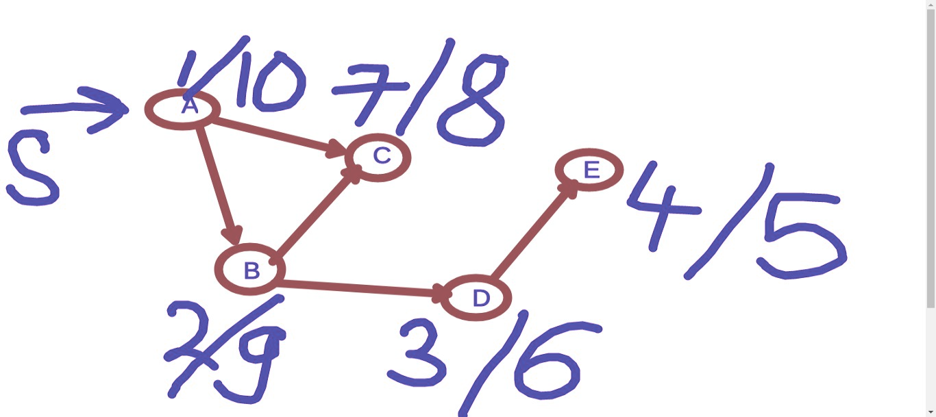

Visiting Time
Finishing Time

Colour codes in DFS
White: Unvisited node
Gray: Visited but not finished node
(Visited but all its neighbours are not visited)
Black: Finished node
(Visited and all its neighbours are also visited)
Try running DFS on below graph and calculating visiting and finishing time of each node:
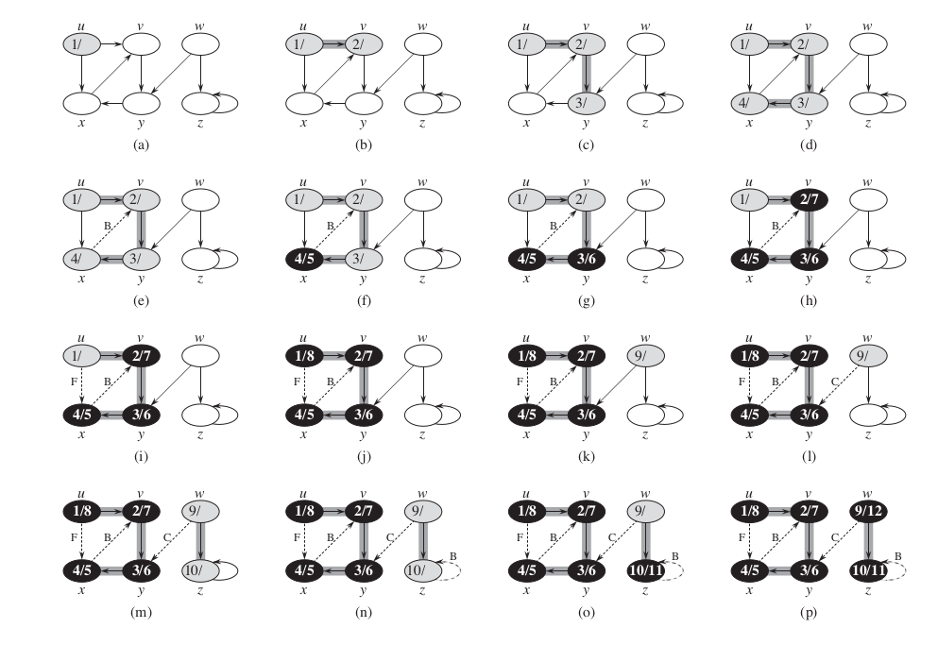

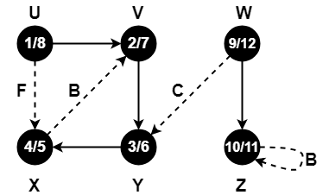

Taking graph input as adjacency list
int n; // no. of nodes
vector<vector<int> > adj; // adjacency list
int main()
{
cin>>n;
int e; // no. of edges;
cin>>e;
adj.resize(n);
while (e--)
{
int u,v;
cin>>u>>v;
adj[u].push_back(v);
adj[v].push_back(u); // for undirected graph
}
}

Code for normal DFS

int n; // no. of nodes
vector<vector<int> > adj; // adjacency list
vector<bool> vis; // initialise all values with false
void dfs(int node)
{
vis[node]=true;
for(auto child: adj[node])
{
if ( ! vis[child] )
{
dfs(child);
}
}
}

Code for DFS when you need to calculate colour of each node at every instant

vector<int> colour;
// 0 - white (Use constants or #define for colours)
// 1 - gray
// 2 - black
void dfs(int node)
{
colour[node]=gray;
for(auto child: adj[node])
{
if ( colour[child] ==0 )
{
dfs(child);
}
}
colour[node]=black;
}

Code for DFS when you need to calculate visiting time and finishing time of nodes

int timerCode=1;
vector<int> visTime;
vector<int> finishTime;
void dfs(int node)
{
vis[node]=true;
visTime[node]=timerCode;
timerCode++;
for(auto child: adj[node])
{
if ( ! vis[child] )
{
dfs(child);
}
}
finishTime[node]=timerCode
timerCode++;
}

Calling DFS in main()

for(int i=0; i<n; i++)
{
if (!vis[i])
{
dfs(i);
}
}

Tree

Tree is an undirected connected graph without any cycle
Properties:
- If there are n nodes in a tree, then it will have n-1 edges

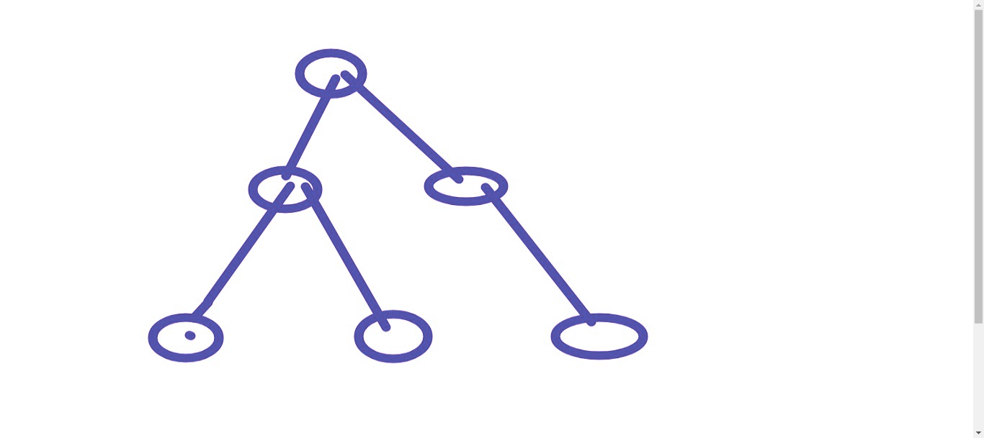
- If you are given a connected graph with n nodes and n-1 edges, then the given graph is a tree
- If you are given a connected graph with n nodes and n edges, then the given graph will contain exactly 1 cycle
- Each node has a single parent in tree
You have been given a tree of n nodes with root at 0. Find level of each node using DFS
vector<int> level;
// level[0] =0;
void dfs(int node)
{
vis[node]=true;
for(auto child: adj[node])
{
if ( ! vis[child] )
{
level[child]=level[node]+1;
dfs(child);
}
}
}
// in main, call dfs(0); // Because 0 is root of tree

DFS on trees can also be implemented as:
// call dfs(0, -1) in main()
void dfs(int node, int par)
{
for(auto child: adj[node])
{
if (child != par)
{
level[child]=level[node]+1;
dfs(child);
}
}
}
Q. Checking whether given graph is bipartite graph

Link: https://cses.fi/problemset/task/1668

It can be done using DFS
vector<int> teamNum;
bool dfs(int node, int currTeam)
{
vis[node]=true;
teamNum[node]=currTeam;
for(auto child: adj[node])
{
if ( teamNum[child] == teamNum[node])
return false;
if ( ! vis[child] )
{
bool temp=dfs(child, 3 - currTeam);
if(temp==false)
return false;
}
}
return true;
}
int main()
{
for(int i=0; i<n; i++)
{
if(!vis[i])
{
bool temp=dfs(i,1);
if(!temp)
{
cout<<"IMPOSSIBLE";
return 0;
}
}
}
// Print the team values if division is possible
}

Detecting cycle in a graph

no of nodes=n

int colour[n];

Return true if cycle present else false.
bool dfs(int node, int parent)
{
colour[node]=1;
for(auto child: adj[node])
{
if ( child!=parent && colour[child] == 1 )
{
// You can remove the condition for child!=parent, when you want to detect even the 2 node cycles in directed graph like 1->2, 2->1
return true;
}
else if( child!=parent && colour[child] == 0 )
{
bool temp = dfs(child, node);
if( temp == true) return true;
}
}
colour[node]=2;
return false;
}

int main()
{
// Take graph input
// .....
for(int i=0;i<n;i++)
colour[i]=0;
// Mark colour of all nodes as WHITE (unvisited)
for(int i=0; i<n; i++)
{
if(colour[i] == 0)
{
bool cycle = dfs(i,-1);
if(cycle)
{
cout<<"Cycle Present";
return 0;
}
}
}
cout<<"No cycle found";
return 0;
}
You can try running this code over below example:
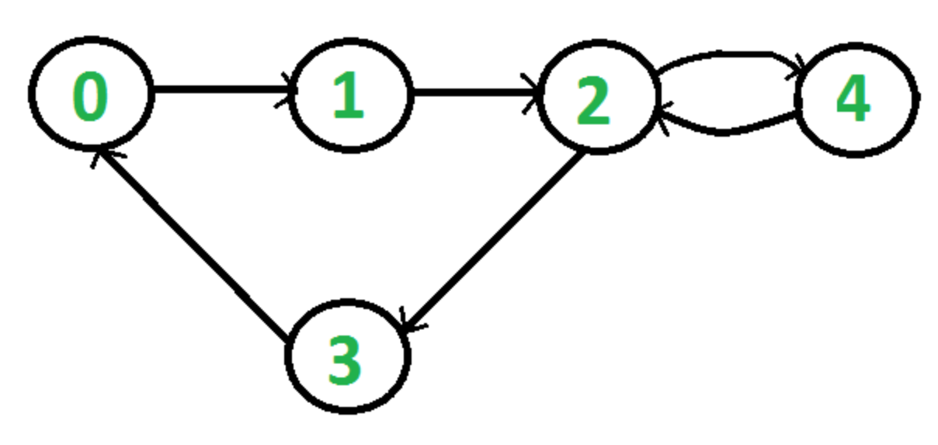
*dfs(0)
col[0]=1
0->child==1
**dfs(1,0(parent))
col[1]=1
***dfs(2)
col[2]=1
****dfs(3)
col[3]==0
col[3]=1
3->
child=0
color of child==1-->cycle
col[0]==1
return true;

****dfs(4)

col[3]=2
col[2]=2
col[1]=2
col[0]=2


dfs(A)
col[A]=1
A->child:B,C
*dfs(B)
child:C,D
**dfs(C)
col[C]=1;
child C-NULL
col[C]=2
false ret

**dfs(D)
col[D]=1
D->CHILD:E
***dfs(E)
col[E]=1
col [E]=2
ret false;
col[D]=2
ret false

*dfs(C)
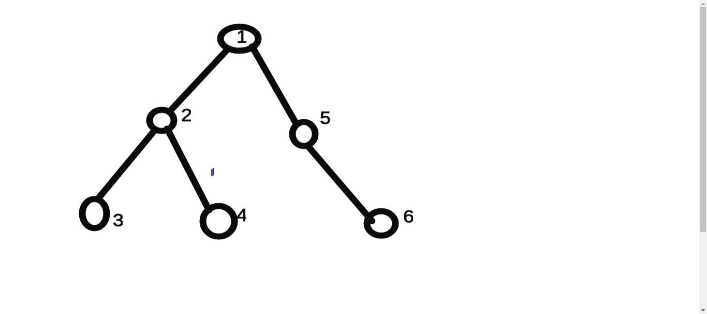
Given a tree, you need to find the gcd of all the values of nodes in subtree of every node. 0 is root node
Example, in above graph, ans[5] = gcd(5,6)
ans[2]= gcd(2,3,4)

No. of nodes, n <= 10^5

Try to solve this problem using DFS

vector<int> ans(n);

// call dfs(0, -1) in main()
void dfs(int node, int par)
{
ans[node]=val[node];
for(auto child: adj[node])
{
if (child != par)
{
dfs(child);
ans[node] = __gcd(ans[node], ans[child]);
}
}
}

Topological sort:

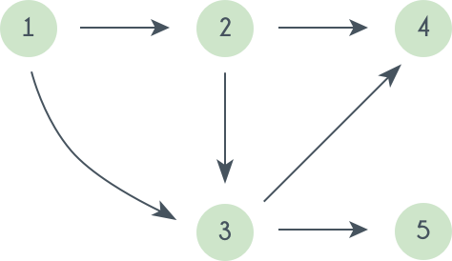
DAG -> Directed Acyclic graph

(U,v) u->v - u comes before v
1 before 3
1 before 2
2 before 4
2 before 3
3 before 4
3 before 5

(v1,v2,v3….,vn,v1)
V1 before v2
V2 before v3
Vi before v(i+1) 1<=i<n
Vn before v1
In_deg = {0,1,2,2,1}
T : {1}
In_deg = {-1,0,1,2,1}
T: {1,2}
In_deg={-1,-1,0,1,1}
T: {1,2,3}
In_deg = {-1,-1,-1,0,0}
T: {1,2,3,4,5} , {1,2,3,5,4}

Algo:
int n,m;
vector<int> adj[n];
int in_deg[n]={0};
for(int i=0;i<m;i++){
int x,y;
cin>>x>>y;
adj[x].push_back(y);
in_deg[y]++;
}
queue<int> q;
for(int i=0;i<n;i++){
if(in_deg[i]==0){
q.push(i);
}
}
vector<int> topo_sort;
while(!q.empty()){
int x = q.front();
q.pop();
topo_sort.push_back(x);
for(int i=0;i<adj[x].size();i++){
int y = adj[x][i];
in_deg[y]--;
if(in_deg[y]==0){
q.push(y);
}
}
}

Method 2 of topological sort

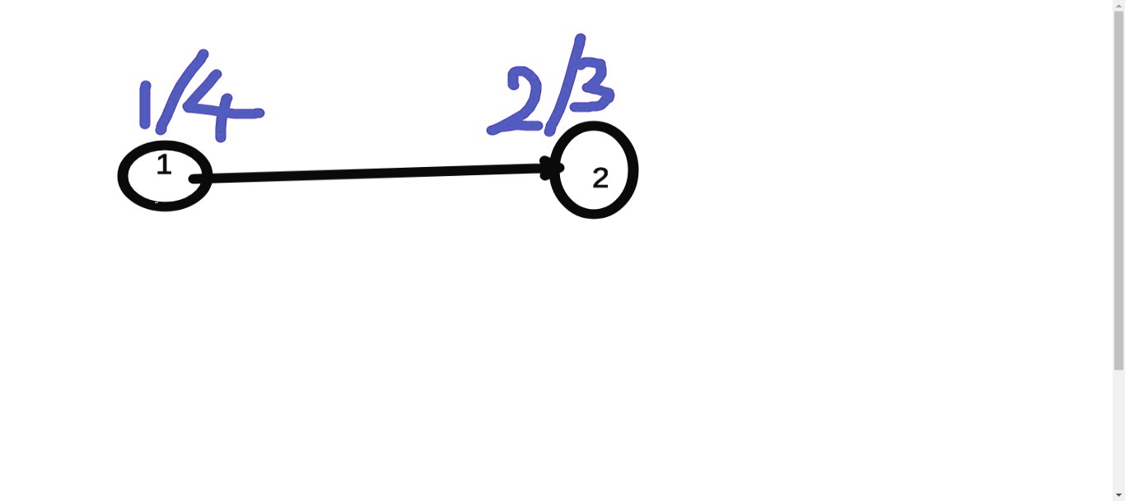
Topological sort is order of nodes in decreasing order of finishing times

int n; // no. of nodes
vector<vector<int> > adj; // adjacency list
vector<bool> vis;
// initialise all values with false
stack<int> st;
void dfs(int node)
{
vis[node]=true;
for(auto child: adj[node])
{
if ( ! vis[child] )
{
dfs(child);
}
}
st.push(node);
// push to stack when finished
}
int main()
{
while(!st.empty())
{
cout<<st.top()<<'\n';
st.pop();
}
}

Topological sort is also used for DP on graph problems.
Try these 2 problems:
- https://www.hackerearth.com/practice/algorithms/graphs/topological-sort/practice-problems/algorithm/lonelyisland-49054110/

- https://cses.fi/problemset/task/1679/

Some more practice problems

- https://www.codechef.com/problems/CHFNFRN
- https://cses.fi/problemset/task/1666
- https://codingcompetitions.withgoogle.com/kickstart/round/000000000019ff43/00000000003379bb
- https://cses.fi/problemset/task/1669
- https://cses.fi/problemset/task/1678/

