GRAPHS
Day 3
(Shortest Path Algorithms)

Contents:
- BFS Algorithm for shortest path
- Shortest Path in a DAG
- Dijkstra Algorithm
- Bellman Ford Algorithm
- Floyd Warshall Algorithm
- Graph Modelling Problems

BFS Algorithm for shortest path
(For unweighted graph)
Weight of edge will be 0 or 1
Given an undirected graph, a source vertex s, and a destination vertex f . Find the shortest distance from s to f and also the shortest path.
Link : https://cses.fi/problemset/task/1667
Example s=0, f=3 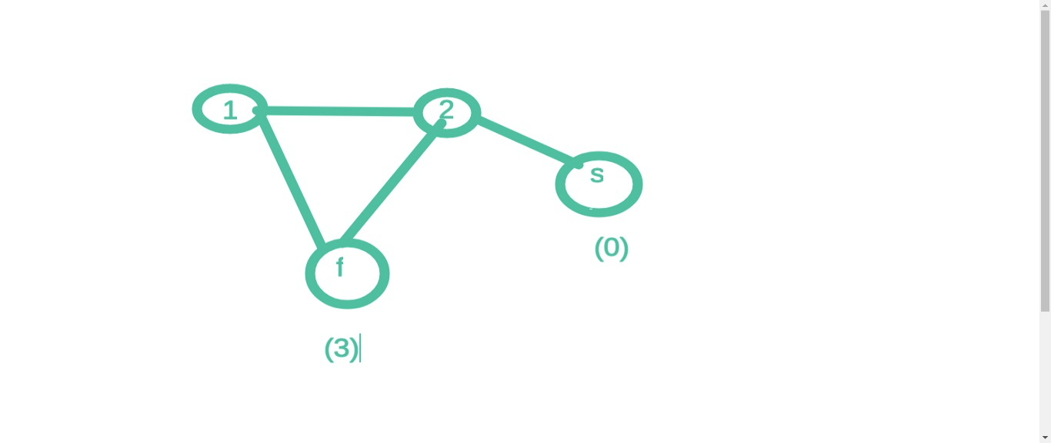
In above example, shortest distance = 2 and shortest path is 0, 2, 3

Solution
We can apply BFS to find shortest distance
For finding shortest path, store the parent of each vertex (some node from which a node was reached).

int parent[ ];
// parent[i] = -1 for all nodes
bool vis[ ];
queue<int> q;
int dist[]; // initialise with INFINITY (1e18)
q.push(s);
vis[s]=true;
dist[0];
while(!q.empty())
{
int t=q.front();
q.pop();
for(auto it: adj[t])
{
if(!vis[it] )
{
vis[it] = true;
parent[it]=t;
q.push(it);
dist[it]=dist[t]+1;
}
}
}
cout<<dist[ f ];
vector<int> path;
path.push_back(f);
trace(f);
reverse(path.begin(), path.end());
// now, print the path vector
void trace(int node) {
if( parent[node] == -1)
return;
path.push(parent[node]);
trace(parent[node]);
}

Shortest Path in DAG

(Weighted Graph)

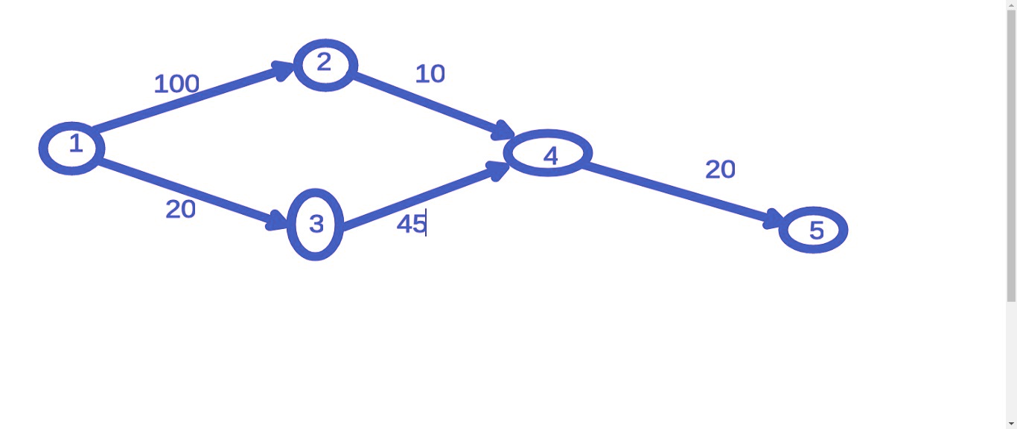

Relaxation Operation
Node u, has a neighbour v with a edge(u,v) with weight w.
if (d[u] + w < d[v] )
{ d[v] = d[u] + w;
}

Algorithm
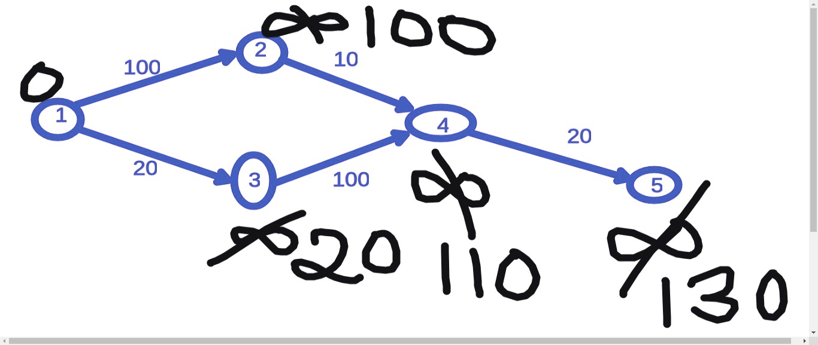

- Mark dist[i] = INFINITY (10¹⁸) for all nodes and dist[s]=0;
- Get topological sorted ordering of the graph in a vector topo.
- Relax all neighbours of these nodes in this order.
for( int i=0; i<n; i++)
{
int u=topo[i];
for(auto it: adj[u])
{ // Relaxing all neighbours of u
int v=it;
int w=weight(u,v);
if(dist[u] + w < dist[v])
{
dist[v] = dist[u] + w ;
parent[v]=u; // for path
}
}
}
// Call trace() as we did in previous question to trace the shortest path

Try this problem: https://cses.fi/problemset/task/1680

Dijsktra’s Algorithm

Given any weighted graph with non-negative edges, find shortest distance as well as shortest path from a source node s to destination node f.

- Distance Minimisation Problem
- Greedy algorithm
- Pick node with shortest distance till now and relax all its neighbours
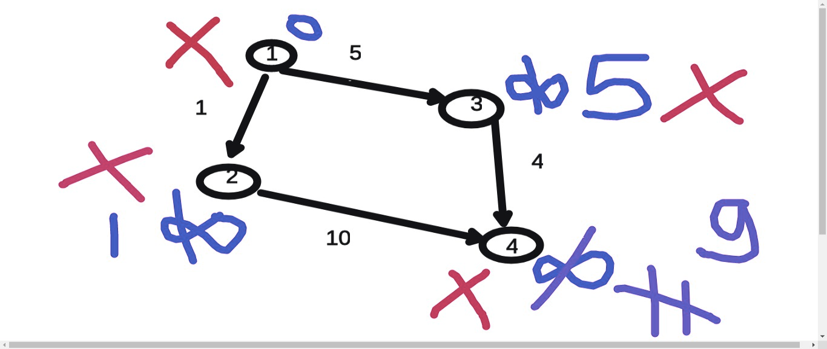

STL Priority Queue

- Contains the largest element at top, by default.
#include<bits/stdc++.h>
using namespace std;
int main()
{
priority_queue<int> pq;
pq.push(2);
pq.push(5);
pq.push(1);
pq.push(4);
cout<< pq.top(); // 5
return 0;
}
3 functions in priority_queue:
- pq.push() ; O(log N)
- pq.pop(); O( log N )
- pq.top(); O(1)
You can also pass a comparator like this, so that it contains the smallest element at top:
int main()
{
priority_queue<pair<int,int>, vector<pair<int,int>> , greater<pair<int,int>> > pq;
pq.push({3,1});
pq.push({8,2});
pq.push({6,0});
pq.push({8,1});
cout<< pq.top().first<<' ' << pq.top().second; // 3 1
return 0;
}

Priority Queue of structure (Optional)
#include<bits/stdc++.h>
using namespace std;
struct student
{
int marks;
int rollno;
bool operator < (const student & s2) const
{
return (marks < s2.marks) || (marks==s2.marks && rollno > s2.rollno);
}
// Top element would have highest marks and if marks are equal then lowest roll number
};
int main()
{
priority_queue<student> pq;
pq.push({3,1});
pq.push({6,0});
pq.push({8,2});
pq.push({8,1});
cout<< pq.top().marks<<" "<<pq.top().rollno; // 8 1
return 0;
}

Code for Dijkstra Algorithm
#define pii pair<int,int>
// n: number of nodes
int dist[n];
void dijkstra(int s)
{
priority_queue<pii, vector<pii> , greater<int,int> > pq;
for(int i=0; i<n; i++)
{
dist[i]=INFINITY;
}
vector<bool> vis(n,false);
dist[s]=0;
pq.push({dist[s], s});
while (!pq.empty())
{
int u=pq.top().second;
pq.pop();
if (vis[u]) continue;
vis[u]=true;
for(auto p: adj[u])
{
int v=p.first;
int w=p.second;
if(!vis[v] && dist[u] + w < dist[v])
{
dist[v] =dist[u] + w;
parent[v] = u;
pq.push({dis[v], v});
}
}
}
}

Time complexity: O( V log(V) + E log(V) )

Limitation:
Dijkstra algorithm fails when edges have negative weights. See example below

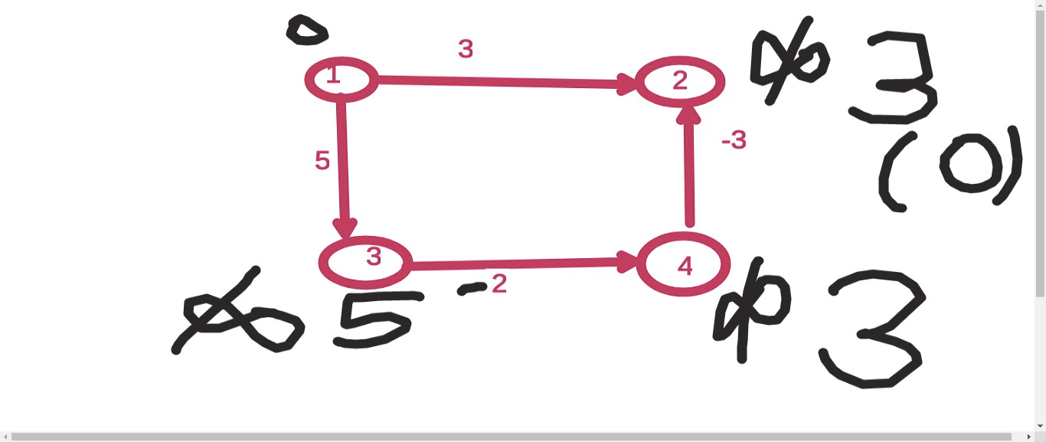

Bellman Ford Algorithm

- Will also work for negative edges
n = number of nodes
e = edges

dp[i] = shortest distance to node i
dp[i] = INFINITY for all
dp[s]=0;
for(int i=1; i<=n-1; i++)
{
for(auto e: edges)
{
int u=e.first;
int v=e.second.first;
int w=e.second.second;
if(dp[u]+w <dp[v])
{ // relaxation
dp[v]=dp[u]+w;
}
}
}

Time complexity: O(V. E)

Floyd Warshall Algorithm

(All Pair Shortest Path Algorithm)
- Based on DP
dist[i][j] = shortest distance from node i to node j
// initially all dist[i][j]= INFINITY if there is no edge of i to j
// dist[i][j] = weight(i,j) if there is edge from it
to j
// dist[i][i]=0;

for(int k=0; k<n; k++)
{
for(int i=0; i<n; i++)
{
for(int j=0; j<n; j++)
{
dp[i][j] = min(dp[i][j], dp[i][k] + dp[k][j]);
}
}
}

Time complexity: O (V³)

Try:
- https://cses.fi/problemset/task/1671
- https://cses.fi/problemset/task/1672
- https://www.spoj.com/problems/ARBITRAG/

Detecting negative cycle in a graph using Bellman Ford

- Run normal bellman ford algorithm
- Run an extra iteration and check if any vertex can be relaxed, we can say there is a “Negative cycle”.
(In negative cycle, there is no finite shortest path possible)

Graph Modelling

Try to solve this problem:
(Similar problem was asked in Goldman Sachs and Sprinklr coding rounds this year)
You want to travel from city A to city B
There are N cities and M bidirectional roads connecting these cities
Your car can store only upto C litres of fuel and the tank is initially full.
Each road(i,j) has a value Wij = amount of fuel needed to go from i to j
And in every city, you can buy fuel at a rate C[i] dollar / litre
Find the minimum amount of dollars to travel from A to B.

Solution Approach :
Imagining a new graph:
struct node {
int city;
int remainingFuel;
};
dist[node] = min. dollars spent to reach this state (node)
Total states (nodes) = N * (C+1)

Suppose u are at a node (u, f) // city u and fuel remaining is f
Suppose there is edge from u to v
You can move to :
(i) node (v, f - W(u,v) ) by paying 0 dollar
(ii) node (u, f +1) by paying C[u] dollars
(These will cover all the cases)

Now, It becomes a simple shortest path problem
So, you can apply Dijkstra Algorithm here.
Such problems are also called State Dijkstra.
You can also refer this blog for graph modelling :
https://codeforces.com/blog/entry/45897

Now, think if NxC <= 10^10, array of C[i] was of 120 size only, what change will you make ?

For distance array instead of using dist[N][C+1], take an unordered map and when updating distance, check whether node is present in unordered map or not.

Try this problem: (Exactly similar problem was asked in Sprinklr internship coding round this year)

https://www.hackerearth.com/practice/algorithms/graphs/shortest-path-algorithms/practice-problems/algorithm/shortest-path-revisited-9e1091ea/

If you get stuck, have a look at my submission:
https://csacademy.com/code/6lzpE1DT/

Also try this problem:
(CSES Flight Discount)
https://cses.fi/problemset/task/1195

Also try this problem ( asked in GS intern test ‘20):
https://www.hackerrank.com/challenges/synchronous-shopping/problem

[Hint: Use bitmasks for a state/node]
In case you need it, link to my submission:
https://csacademy.com/code/abQnzrEa/

