GRAPHS
Day 4
(DSU and MST)
Youtube link :
https://youtu.be/QHCGQ371eXs

Contents:
- DSU and related operations
- Applications of DSU
- Kruskal’s Algorithm for MST

DSU (Disjoint Set Union)

- A data structure used for performing the union of disjoint sets very efficiently
- Disjoint sets: Any 2 sets are disjoint when their intersection is an empty set.
Eg. A = { 1, 2, 6}
B = {4, 5 }
A intersection B = ϕ ( empty set )
So, A and B are disjoint sets

3 operations:
- make_set() ; // To create DSU initially
- find_set(); // Find the set to which an element belongs ( To find representative of a set )
- union_set(); // Take Union of 2 sets or merge 2 sets
Representative of a set is the topmost element :
(Parent of representative is that element itself)
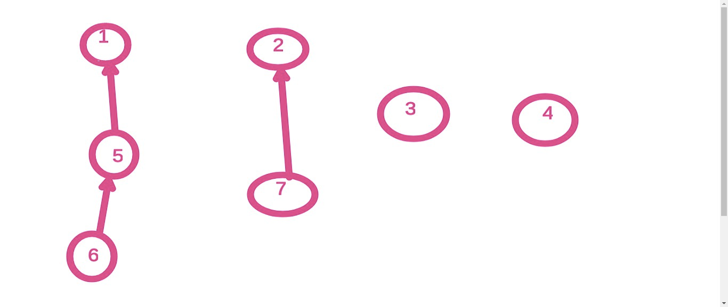

Naive implementation
const int MAX=100005;
int par[MAX];
void make_set(int n)
{
for(int i=0; i<n; i++)
{
par[i]=i;
}
}

int find_set(int x)
{
if( par[x] == x)
{
return x;
}
return find_set(par[x]);
}

// You can also write this in a while loop like:
(Both will work the same way, use anyone which you like)

int find_set(int x)
{
while( par[x] != x)
{
x=par[x];
}
return x;
}

void union_set(int a, int b)
{
int p1 = find_set(a);
// representative of set of a
int p2 = find_set(b);
// representative of set of b
if ( p1 ! = p2)
{
par[p1]=p2;
}
}

Time complexity: O(d)
Where d = depth ( distance from the representative )

Faster Implementation

- Path compression in find_set():
(Store the representative in parent directly)
int find_set(int x)
{
if( par[x] == x)
{
return x;
}
par[x]=find_set(par[x]);
return par[x];
}

It reduces time complexity to O (log N) approximately

- Union by Rank in union_set() :
- Create another array for size of set. ( rnk[ ] )
- Make smaller set as a child of larger set.

int rnk[ 100005];
void make_set(int n)
{
for(int i=0; i<n; i++)
{
par[i] = i;
rnk[i] = 1;
}
}
void union_set(int a, int b)
{
int p1 = find_set(a);
int p2 = find_set(b);
if ( p1 == p2)
return;
if (rnk[p1] > rnk[p2])
{
par[p2]=p1;
rnk[p1] = rnk[p1] + rnk[p2];
}
else
{
par[p1] = p2;
rnk[p2] = rnk[p1] + rnk[p2];
}
}

Time Complexity of find_set() and union_set(), when you use both path compression and union by rank: O( α(N) )
where α(N) = Inverse Ackermann Function (Approximately , it is equal to O(1) )

Try this problem:
https://www.hackerrank.com/challenges/merging-communities/problem

Solution:
const int MAX=100005;
int par[MAX];
int rnk[MAX];
void make_set(int n)
{
for(int i=1; i<=n; i++)
{
par[i] = i;
rnk[i] = 1;
}
}
int find_set(int x)
{
if( par[x] == x)
{
return x;
}
par[x]=find_set(par[x]);
return par[x];
}
void union_set(int a, int b)
{
int p1 = find_set(a);
int p2 = find_set(b);
if ( p1 == p2)
return;
if (rnk[p1] > rnk[p2])
{
par[p2]=p1;
rnk[p1] = rnk[p1] + rnk[p2];
} else
{
par[p1] = p2;
rnk[p2] = rnk[p1] + rnk[p2];
}
}
int main()
{
int n,q;
cin>> n >> q;
make_set(n);
while(q--)
{
char ch;
cin>>ch;
if(ch=='M')
{
int a,b;
cin>>a>>b;
union_set(a,b);
}
else {
int a;
cin>>a;
int representative = find_set(a);
cout<<rnk[representative]<<'\n';
}
}
return 0;
}

Applications of DSU

- Finding the number of components in a graph

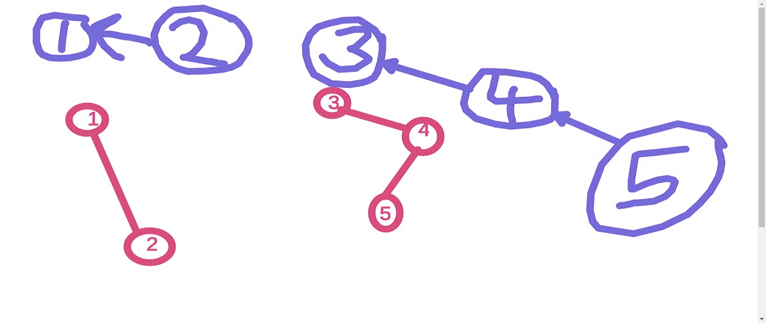
Try:
https://cses.fi/problemset/task/1676

Solution:
int mx=1;
void union_set(int a, int b)
{
int p1 = find_set(a);
int p2 = find_set(b);
if ( p1 == p2)
return;
if (rnk[p1] > rnk[p2])
{
par[p2]=p1;
rnk[p1] = rnk[p1] + rnk[p2];
mx=max(mx,rnk[p1]);
} else
{
par[p1] = p2;
rnk[p2] = rnk[p1] + rnk[p2];
mx=max(mx,rnk[p2]);
}
}
int components = n;
cin>> n >> m;
make_set(n);
int u,v;
while(m--)
{
cin>>u>>v;
u--;
v--;
if( find_set(u) == find_set(v) )
{
cout<<components<< " "<<mx<<'\n';
continue;
}
union_set(u,v);
components--;
cout<<components<< " "<<mx<<'\n';
}

- Finding a cycle in undirected graph
Code:
make_set(n);
for( auto e: edges)
{
int u=e.first;
int v=e.second;
if ( find_set(u) == find_set(v) )
{
cout<<"Cycle found";
break;
}
union_set(u,v);
}

MST (Minimum Spanning Tree)

Spanning Tree of a graph :
A spanning tree is a tree containing all nodes of the given graph and is a subgraph of the given graph.

Example of not a spanning tree:
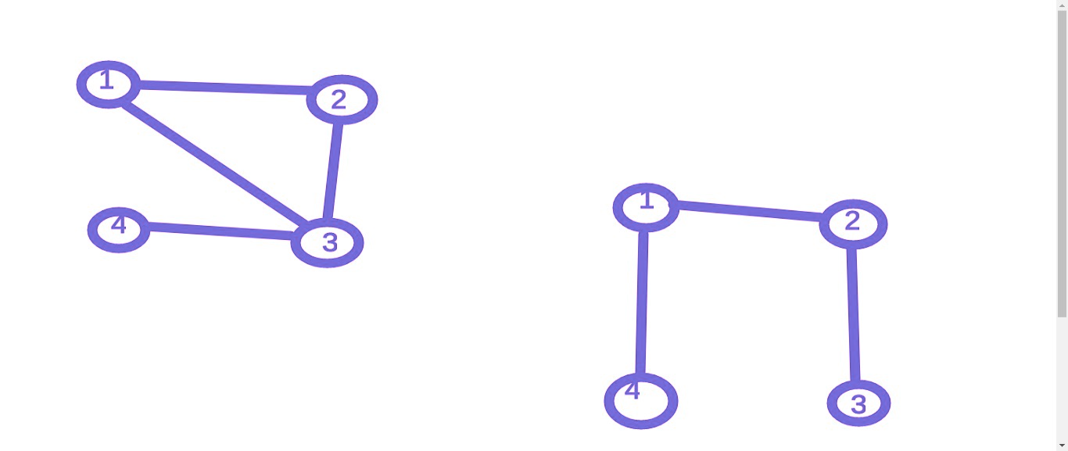
(Since edge (1,4) is not present in the original graph)

Example of a Spanning Tree:
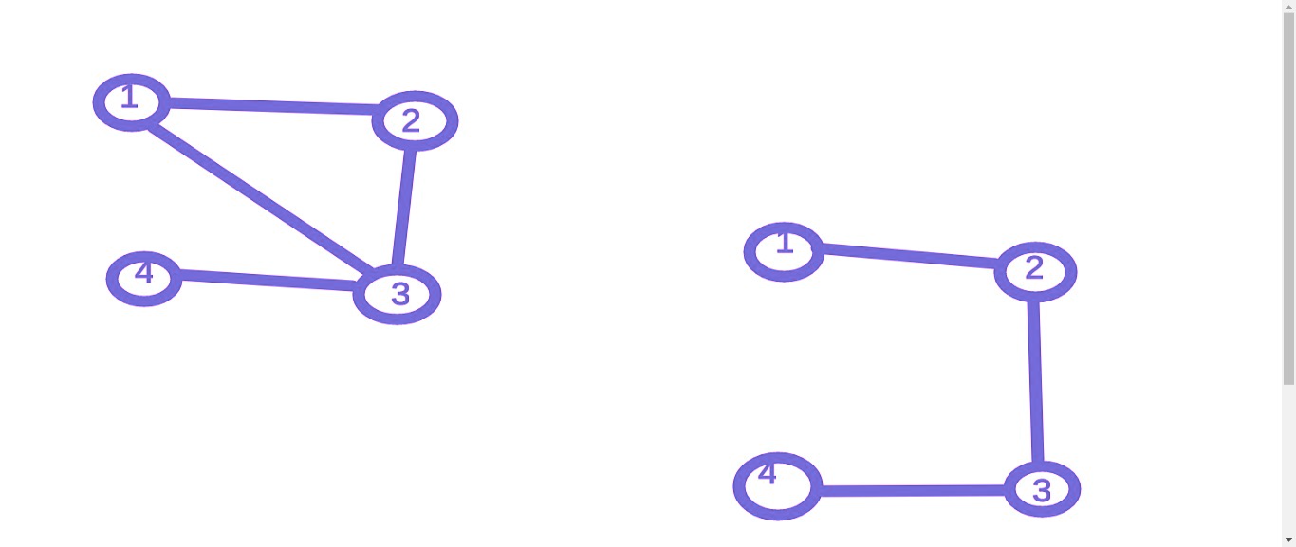

Minimum Spanning Tree:
We need to find a spanning tree whose sum of edges is minimum.

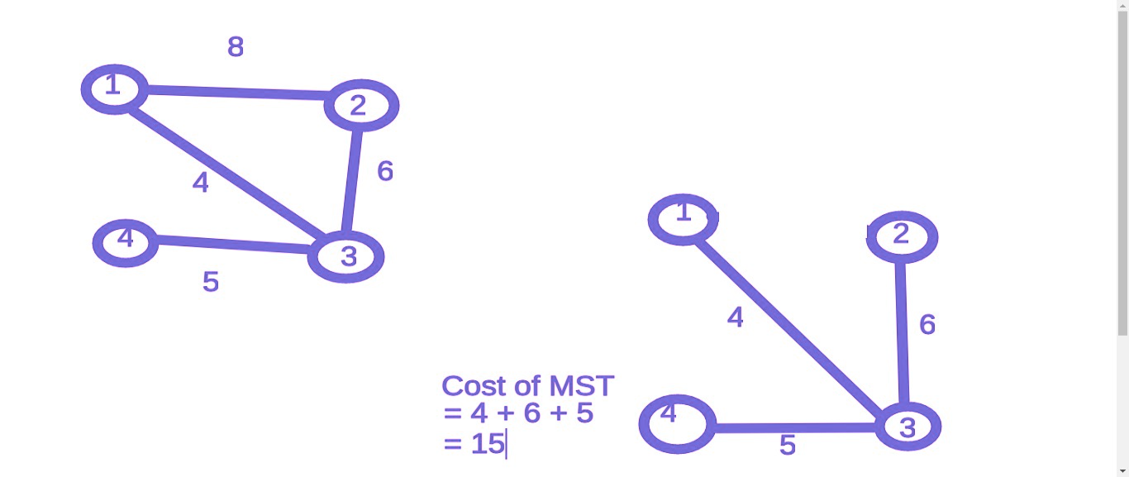

Kruskal’s Algorithm
(A Greedy Algorithm)
- Sort edges in increasing order of weights

make_set(n);
int sum=0;
int cnt=0;
for (auto e: edges)
{
int u=e.first;
int v=e.second.first;
int w=e.second.second;
if ( find_set(u) == find_set(v) )
{
continue;
}
union_set(u,v);
sum = sum + w;
cnt++;
}
if( cnt == n-1)
cout<<sum<<'\n';
else
{
cout<<"NO MST Possible";
}

Try to solve:

https://cses.fi/problemset/task/1675

Q. Find a spanning tree of a given graph with minimum products of weights?

Solution:

- Find MST with Kruskal’s algorithm and print the products of its weights.

Q. Given n cities and m pipe connections between those cities . For digging a well in a city i, it costs C[i]. Find minimum cost to provide water supply to all.
Example:
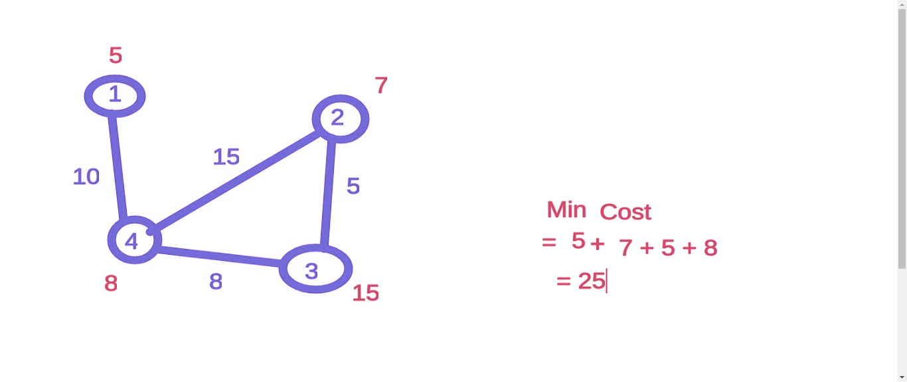
Solution Approach:

Consider a imaginary node 0 and connect it to all remaining nodes with a edge cost of C[i].

Now, find the MST of this new graph.

