GRAPHS
Day 5
(SCC, Diameter of a tree, Binary Lifting)
Youtube link :
https://youtu.be/aH_olfWOFLk

Contents:
- SCC (Strongly Connected Components)
- Diameter of Tree
- Binary Lifting

SCC (Strongly Connected Components)

Connected Graph (For undirected graph): An undirected graph such that ∃ a path between every pair of vertices. Eg. Graph A given below.
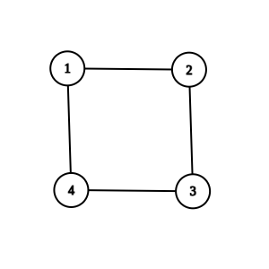
Graph A

SCC (Strongly Connected Component): A subset of vertices in a directed graph, such that ∃ a path between every pair of vertices. Eg. Graph B

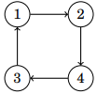
Graph B
Q. Is Graph C given below an SCC ?
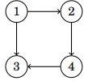
Graph C
There is no path from 4 to 1, so Graph C is not a SCC

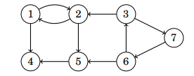
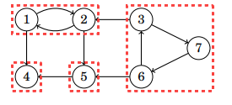
If we replace each of the SCCs of any directed graph by a single node, we get a SCC-condensed graph like the graph below:
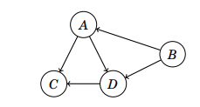
This SCC-condensed graph will always be a DAG (Directed Acyclic Graph).
Some properties of SCCs:
- For any directed graph, after reversing all the edges, the SCCs remain the same.
- Source node of original graph becomes sink node in the reversed graph and vice-verca.
- If we start DFS from the source of original graph (or sink of the new reversed graph), every node of the sink SCC would be traversed.

Kosaraju’s Algorithm for finding SCCs
- Run dfs on given graph G and find the nodes in decreasing order of finish time (Topological Sorting).
- Create a new graph G^{T}, which has all the edges reversed from the original graph.
- Start DFS in this new graph G^{T}, in the topological order of G. Each node visited by dfs() call of a node, belong to the same SCC component.
Example:
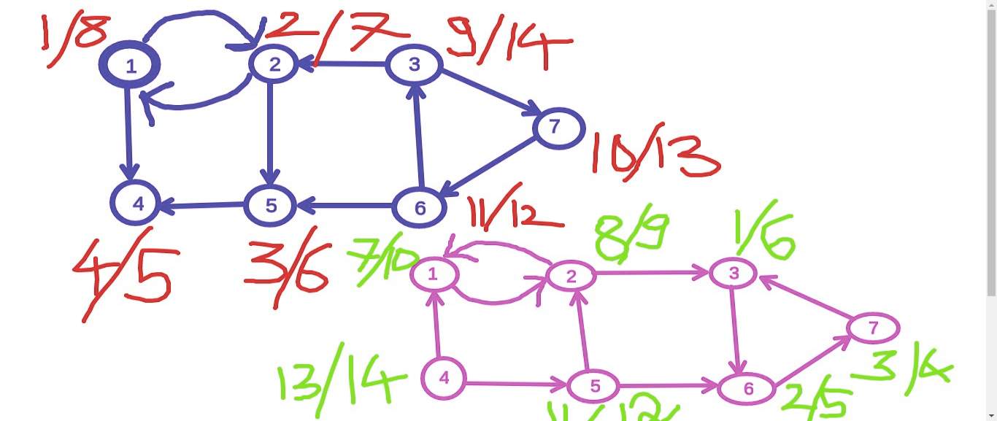
SCCs are:
{ 3, 6, 7} - D
{ 1, 2} - A
{4} - B
{5} - C
Now, the SCC condensed graph (also a DAG) is: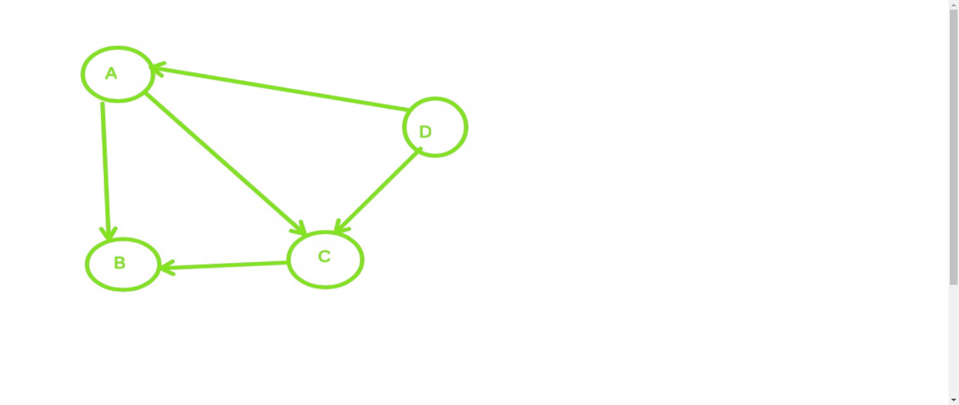
Note: Using this SCC-technique, we are able to convert any directed graph into a DAG.

Code for finding all SCCs of a directed graph:

vector<bool> vis;
vector<vector<int> > g, gr;
stack<int> st;
vector<int> component;
vector<vector<int> > sccs;
void dfs1(int i)
{
vis[i]=true;
for(auto it: g[i])
{
if(!vis[it])
{
dfs1(it);
}
}
st.push(i);
}
void dfs2(int i)
{
vis[i]=true;
for(auto it: gr[i])
{
if(!vis[it])
{
dfs2(it);
}
}
component.push_back(i);
}
int main()
{
int n, m;
cin>>n >> m;
g.resize(n);
gr.resize(n);
for(int i=0; i<m; i++)
{
int u,v;
cin>>u>>v;
u--; // to make u and v on 0-based indexing
v--;
g[u].push_back(v);
gr[v].push_back(u);
}
vis.assign(n,false);
for(int i=0; i<n; i++)
{
if(!vis[i])
{
dfs1(i);
}
}
vis.assign(n,false);
while(!st.empty())
{
int t=st.top();
st.pop();
if(vis[t])
continue;
component.clear();
dfs2(t); // Run DFS in reverse graph
// in topological order of original graph
sccs.push_back(component);
}
// You can also further convert graph
// to SCC-condensed graph (DAG)
// See practice problem 2 for my sample code
return 0;
}
Practice Problems:
- https://cses.fi/problemset/task/1683

2. https://www.codechef.com/problems/MCO16405
Solution:
Consider this problem for a DAG:

dp[i] = Maximum number of people you can visit if you start from node i

dp[A] = max(dp[B], dp[C]) + people in city A

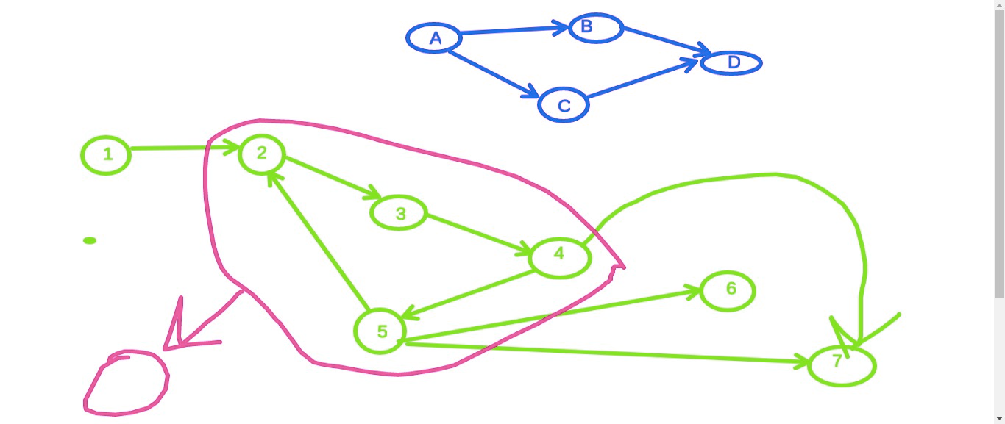

// First find all the SCCs
// Create a new SCC-condensed graph in which C[i] value of a node is sum of C[i] of all nodes in that SCC, which will always be a DAG
// Now, Apply DP on this DAG
long long dp[MAX] ;
for(int i=0; i<n; i++)
{
dp[i]=0;
}
for(auto u: rev(topo))
{
for(auto v: new_adj[u])
{
dp[u] = max(dp[u], dp[v]);
}
dp[u] = dp[u] + C[u];
}

// Try to implement the code for this problem yourself and if you don’t get it, you can look at my submission: https://www.codechef.com/viewsolution/40482695

3. https://www.spoj.com/problems/CAPCITY/
[ Hint: Think of what would be your answer if given graph was a DAG? ]
Solution:
- First find SCCs, and print the SCC of the sink node (the node which was last in the topological order)

A general tip
Whenever you find a problem that involves a directed graph and you can’t solve it by simple BFS/DFS or shortest path algorithms, rethink that problem assuming given graph as a DAG and if you can find a solution to it in that way. Then, you can use SCCs to convert the given directed graph to DAG and then apply your solution to it.

Tree Diameter

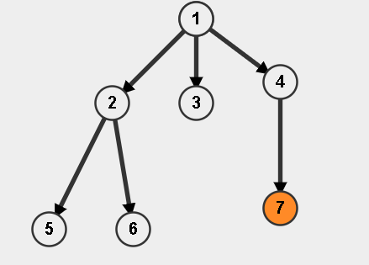

Diameter: Max no of edges present b/w two nodes, in a tree.
More than one Diameter can exist in a tree.
Diameters are not unique always.

In the case of trees, diameter is always formed by leaf nodes.

Diameter Calculation

Method-1: Depth calculation using DFS

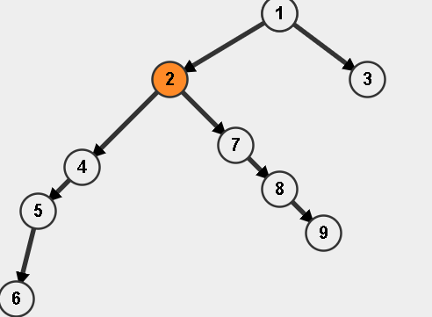

v->adj list..
n-->no of nodes..
int depth[n],ans[n];
void dfs(int s,int par)
{
int m1=-1,m2=-1;
// store top 2 max depths among x childs..
for(int i=0;i<v[s].size();i++)
{
int ch=v[s][i];
if(ch!=par)
{
dfs(ch,s);

if(depth[ch]>=m1)
{
m2=m1;
m1=depth[ch];
}
else if(depth[ch]>m2)
m2=depth[ch];
}
}
//m1,m2-->max values store..
//m1>=m2
depth[s]=m1+1;
//m2=-1
ans[s]=m1+m2+2;
//m1+1
}
// res = max(ans[s])
cout << res; // Diameter

Method 2: Run DFS 2 times
- Assume any node a as root
- Start dfs from a and find that node b, having max dist from a
[ Using depth[child]=depth[node]+1 ]
(This node b will be an endpoint of a diameter)
- Now, Start dfs from node b and find the node c, which is at max distance (d) from b.
This value of d is the diameter of the tree.

Time complexity of both methods: O(n), where
n = no . of nodes
(No of edges in tree=n-1)
Practice Problem for finding diameter:
https://cses.fi/problemset/task/1131

The diameter found using the above methods, is only valid in case of a tree.

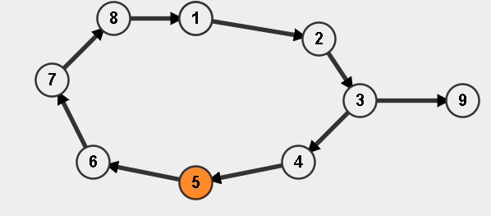
Diameter using the above method == 4 → wrong
Actual==5(7-->9)

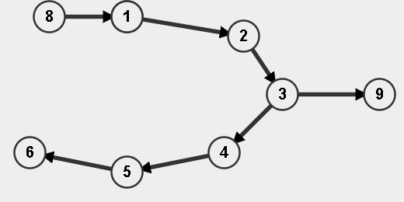

Binary Lifting

Finding k^{th} parent
Q. Given a tree and a node x, find k^{th} parent.
Assume root as 1.
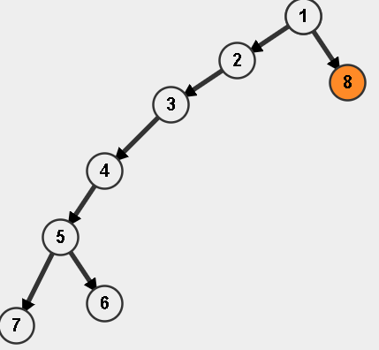
par[7][2]==2 ?
2^j-->2^j-1→2^(j-1)
par[7][2]=par[par[7][1]][1](par[4][1])
(2^2)th parent of 7th node==(2^1)th parent of 4th node
(2^j)-->jumps req..half (2^j)/2 ju
mp
k==5..101
2->powers..parent store..
7-->2^(0)==5
7-->2^(1)==4
7-->2^(2)==2
k==5th parent of 7
int ans=7
5--0>101..ans=5
5-->2^2-->1

x=9
2nd parent..
int p=9
if(k>n)
return root node..
for(int i=0;i<k;i++)
p=par[p];
p=3..ans…

n->nodes..
Time complexity of above method?
O(n)/query

a^(n) ??
int res=1;
n times loop
res=res*a;
O(n-->exponent)
n-->binary representation
n=5 (101 in binary)
So, n = 5 = 2^2 + 2^0

- Every distance can be divided into powers of 2 - [with at max log2(n) terms]
Eg. 11 = 2^3 + 2^1 + 2^0
(from binary representation of 11)
10 = 2^3 + 2^1
(from binary representation of 10)

- Using this, we can answer every query in log(n) time, if we precompute the answer of all the powers of 2
Note: Log(n) values is always <= 30 in general problems, when n<=10⁹

O(logn)
x..log(x) order-->bits..
8-->1000
log(x)+1

int x=log(n)+1; //max possible jump req to reach
// a parent (You can also take x=30)

vector<vector<int> > v; // adjacency list of tree
int par[n][x];
// par[i][j] = 2^(j)^{th} parent of i^{th} node
store 2^1,2^2 parents of node s
void dfs(int s,int p)
{
// s-->source node
// p-->parent of s..
par[s][0]=p;
for(int j=1;j<=x;j++)
par[s][j]=par[par[s][j-1]][j-1];
for(int i=0;i<v[s].size();i++)
{
int ch=v[s][i];
if(ch!=p)
dfs(ch,s)
}
}
k-->jump-->binary representation

int find_kth(int s,int k)
{
for(int j=x;j>=0;j--)
{
if((1<<j)&k)//jth bit set or not in k..
{
s=par[s][j];//jump of 2^j
k-=(1<<j);
}
return s;
}
Time complexity: O(log n) per query
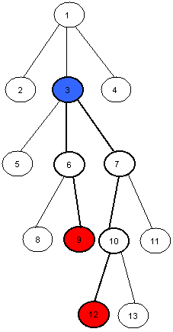
Practice Problem on binary lifting:
https://cses.fi/problemset/task/1687

Try the problem by yourself and if you get stuck, you can check our submission:
https://cses.fi/paste/488fefbbe9ece7ce179075/

Some more practice problems:
1. https://cses.fi/problemset/task/1686
2. https://www.spoj.com/problems/BREAK/

Link to my submission for SPOJ BREAK: (in case, you are stuck)

https://csacademy.com/code/ehtKr5CJ/

