V.EXPERIMENT
This section reports the results of our evaluation.First,we describe the data we are using for the experiments,and then we present the results,along with our interpretation.
- Data
We conducted our experiments with data from our crowd-sourced android testing platform,i.e,Kikbug.Specifically,testing data of three applications are used to evaluate the performance of S-CAT,which are SE-1800,UBOOK and iShopping.SE-1800 is an electrical monitoring application, and Ubook is an online shopping guide application.All the three crowd-sourced testing tasks were performed between the time period October,2015 and January,2016.In the implementation ,all the information mentioned in Section II were collected through the android client and reported by the crowd-sourced workers,i.e.,the logcat file and event sequence.
On the one hand ,as for the crowed-sourced workers’ different behavior while testing,some test data would be duplicate .For example,more than one logcat file was produced while crowed-sourced workers were testing one application ,which cause the redundancy.On the other hand,there are three applications’ information mixed up in the original logcat data set and the event sequence data set.So the original data set is chaotic.Meanwhile,we standardize the original data from the textual data to the list data .Figure 1 shows an example of the logcat. Every record is in the (time,processID,threadID,priority/tag,message)format, where the priority is one of the following character values, ordered from lowest to highest: V - Verbose (lowest priority), D - Debug, I - Info, W - Warning, E - Error, F -Fatal, S - Silent (highest priority).Figue 2 shows an example of standardized logcat. Figure 3 shows an example of the event sequence,and figure 4 shows the standardized.
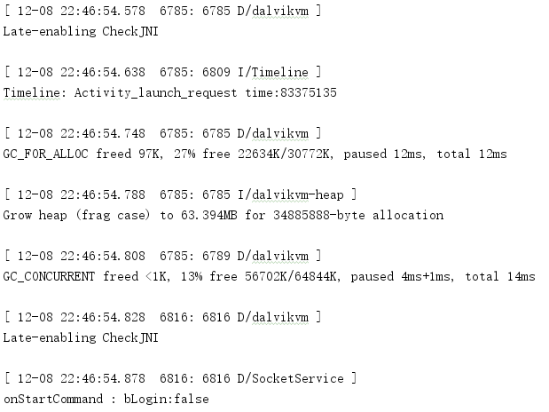
Figure 1
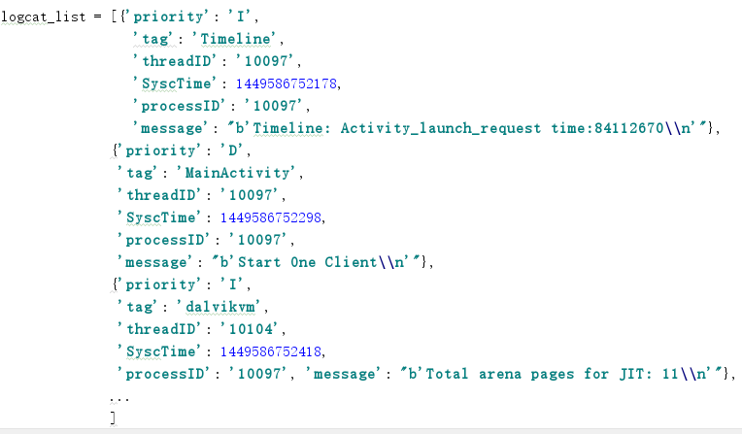
Figure 2
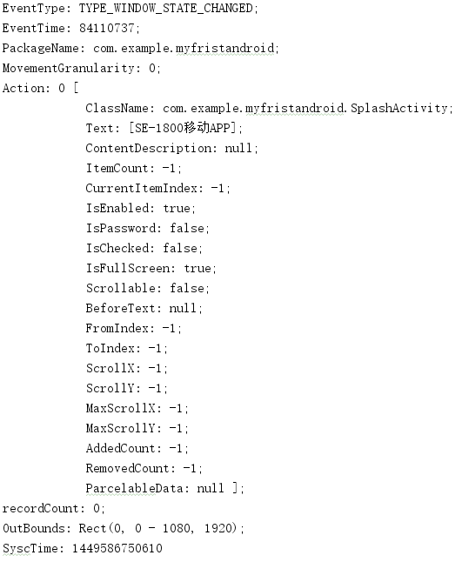
Figure 3
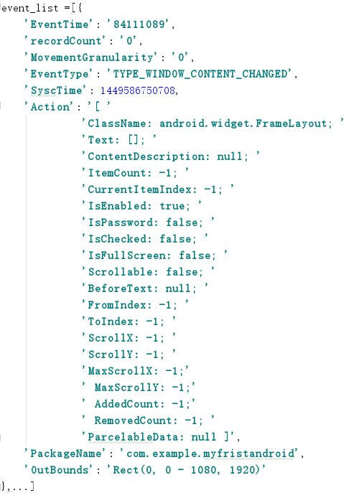
Figure 4

Besides these,we should choose the useful data and remove the meaningless data.The unilateral data which only contains one kind of data and lack the other kind,is defined as the meaningless data.For example,the data set 1 is the unilateral data because over a continuous period of time there are only logcat data without event sequence data.Accordingly,the data set 2 is not the unilateral data.So we keep the data 2 and abandon the data 1.

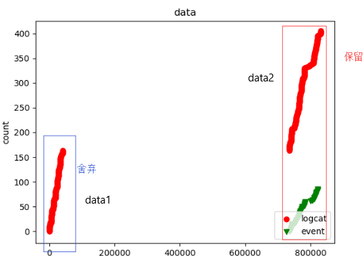

- Remove Duplicates
For every crowed-sourced worker’s testing data folder,we collect every piece of log information in every file and remove duplicate information.We take event sequence data set as an example,so does the logcat data set.
SYMBOL | DEFINITION
u | Crowd-sourced worker
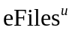 | Event sequence files related to u
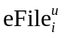 | Event sequence file i related to u
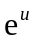 | A piece of event sequence e in related to u
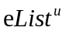 | Processed event sequence list related to u

Algorithm 1:Remove Duplicates and standardized
Input:Event Sequence Files
Output:Event Sequence File
- List =[]
- for in :
- for in :
- if 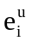 in :
- continue;
- else:
- .append( )
- Classify Data
SYMBOL | DEFINITION
u | Crowd-sourced worker
 | Android application
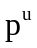 | Android application related to u
 | Processed event sequence list related to u
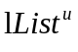 | Processed logcat sequence list related to u
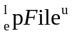 | Processed file include logcat file and event file related to u
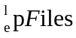 | Processed files include logcat file and event file
- Algorithm 2:Classify Data
Input:Event Sequence list ,Logcat list ,
Output:
- List 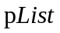=[]
- for l in :
- if is not None:
- Find from and
- Store in
- Store in
- Store in

- Deeper preprocess
SYMBOL | DEFINITION
u | Crowd-sourced worker
 | Processed event sequence list related to u
 | Processed logcat sequence list related to u
 | Processed file include logcat file and event file related to u
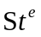 | Event
- Algorithm 3:Time selection
Input:Event Sequence list ,Logcat list ,
Output:
- List =[]
- for l in :
- if is not None:
- Find from and
- Store in
- Store in
- Store in

