**Q.1**

**Test Result**

**一張含有 文字, 軟體, 網頁, 電腦圖示 的圖片

AI 產生的內容可能不正確。 Git Log**

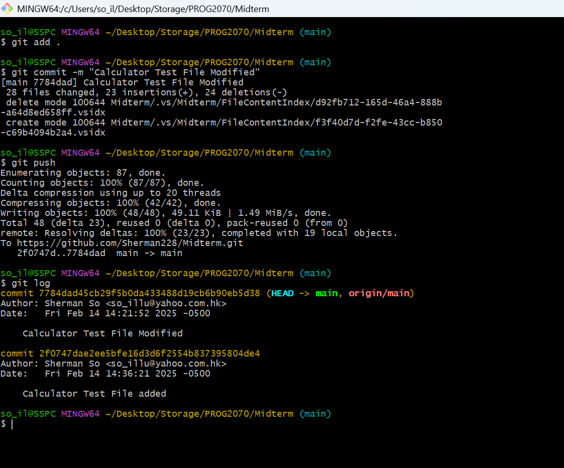

**Test Code**

using NUnit.Framework;

using Midterm;

namespace NUnitCalculatorTest

{

public class UnitTest1

{

private Calculator _calculator { get; set; } = null;

[TestCase(-10, "The number is negative.")]

[TestCase(0, "The number is zero.")]

[TestCase(10, "The number is between 1 and 10.")]

[TestCase(20, "The number is between 11 and 20.")]

[TestCase(30, "The number is between 21 and 30.")]

public void CategorizeNumber_Test(int number, string sentence)

{

// Act

string result = Calculator.CategorizeNumber(number);

// Assert

Assert.AreEqual(result, sentence);

}

}

}