* Add_A_Product  
  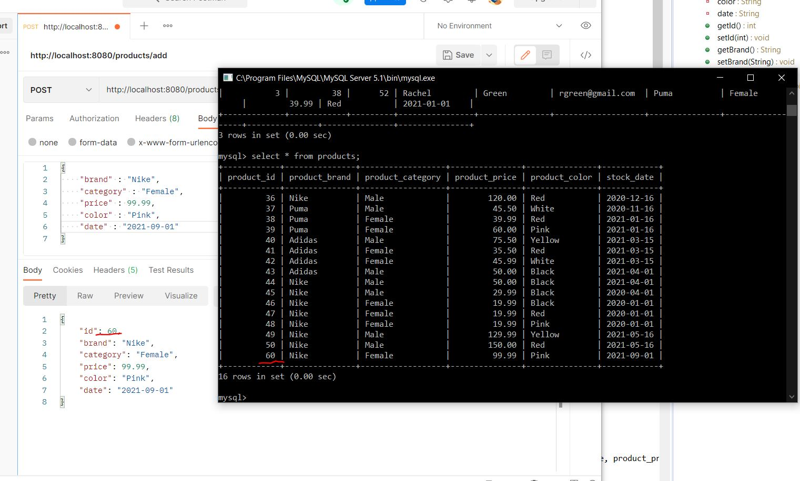
* ADD_A_User  
  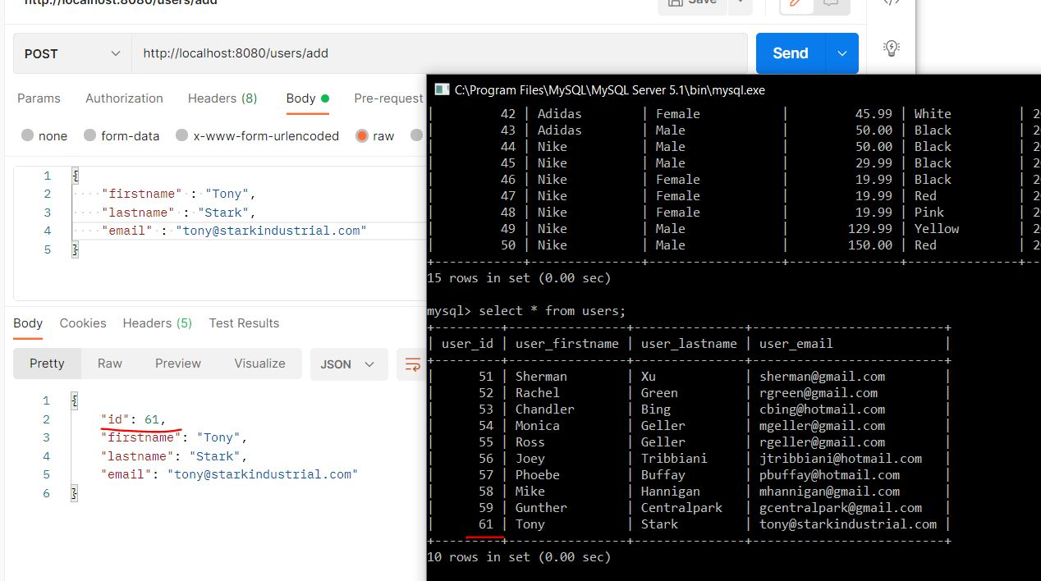
* Admin_User_Change_Password  
  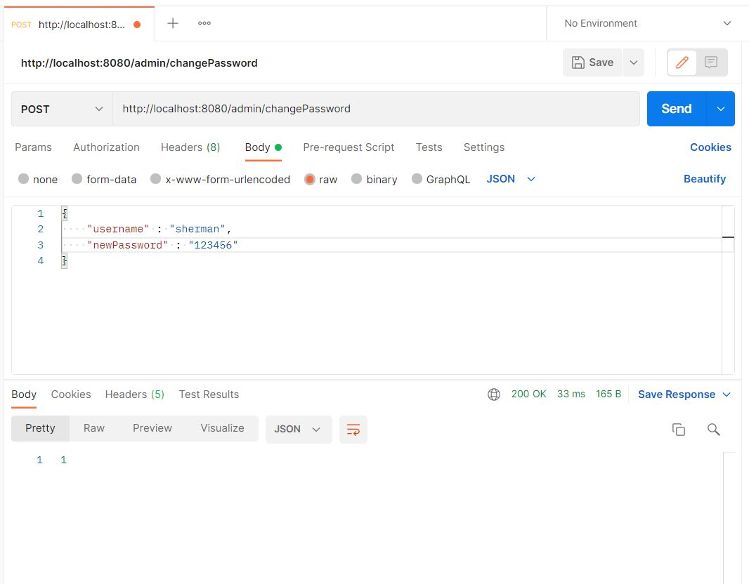
* Admin_User_Change_Password_Exception  
  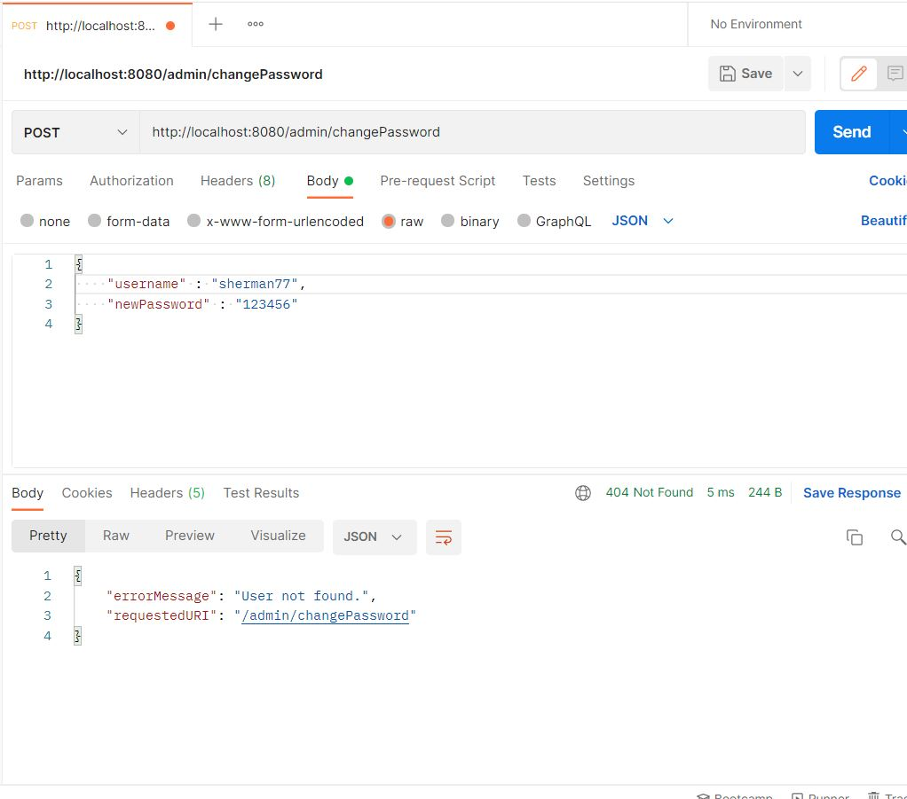
* Admin_User_Login  
  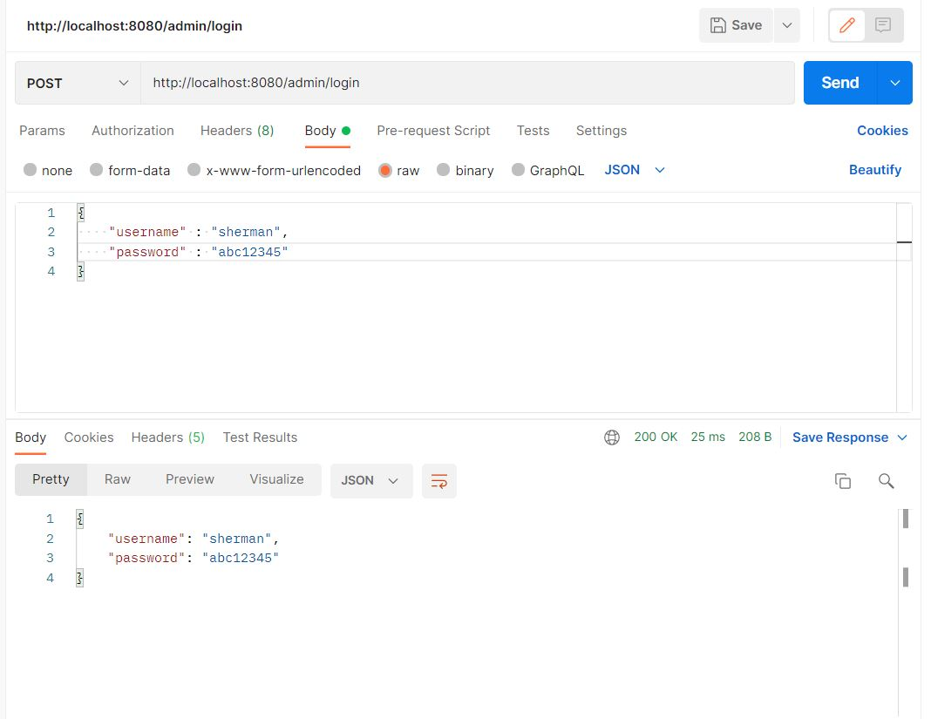
* Admin_User_Login_Exception1  
  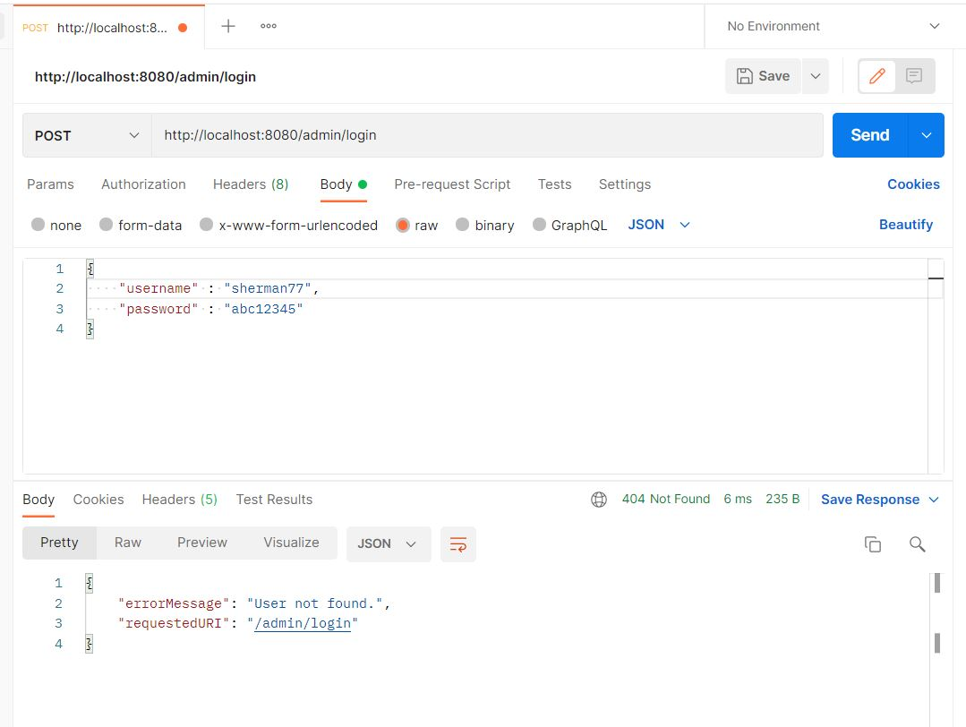
* Admin_User_Login_Exception2  
  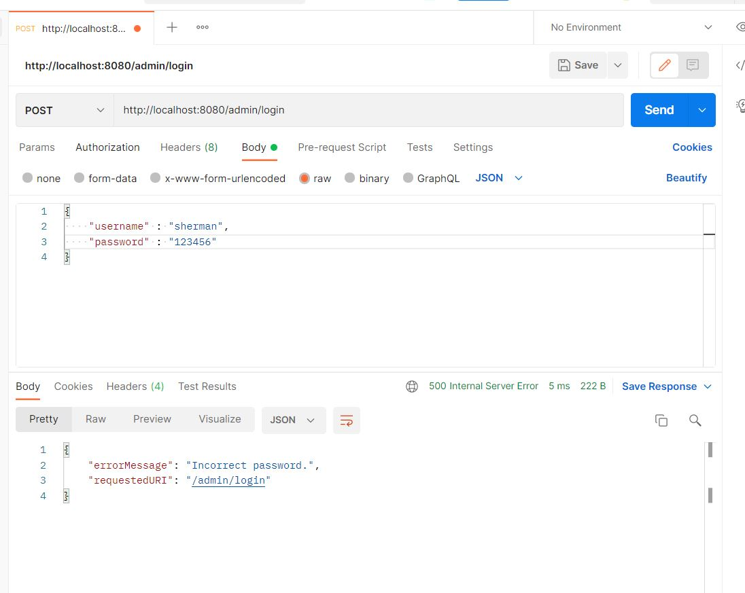
* Delete_A_Product  
  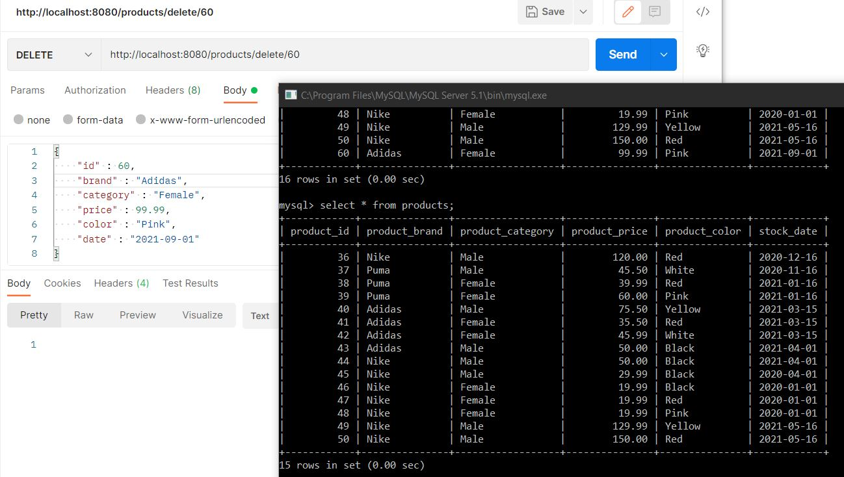
* Delete_A_User  
  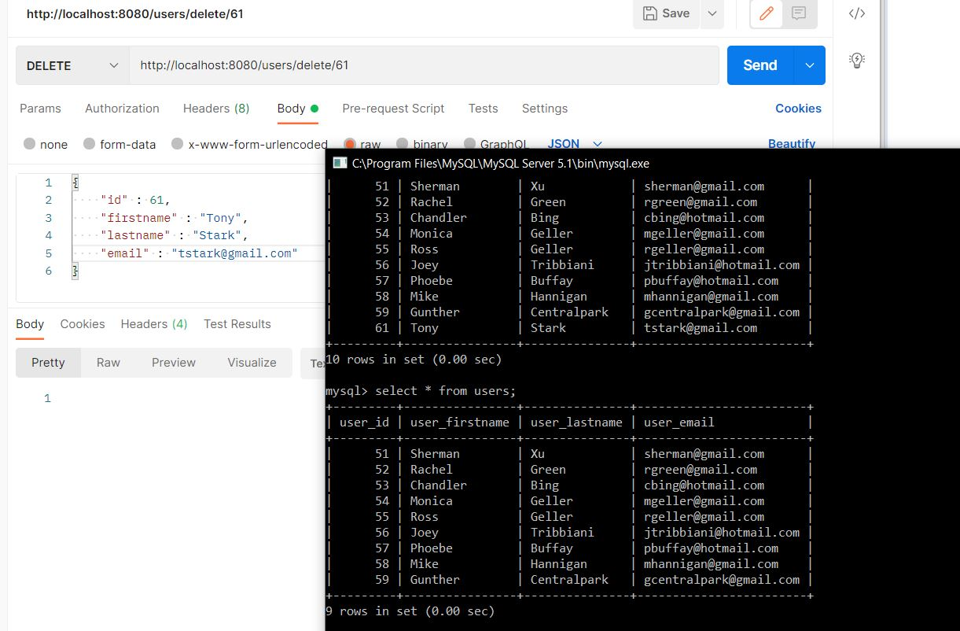
* Get_All_Products  
  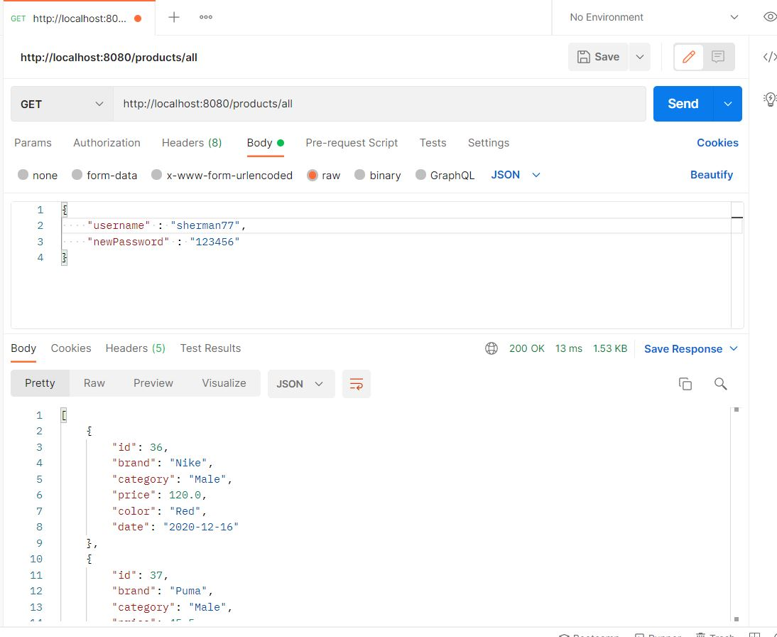
* Get_All_Purchase_Records  
  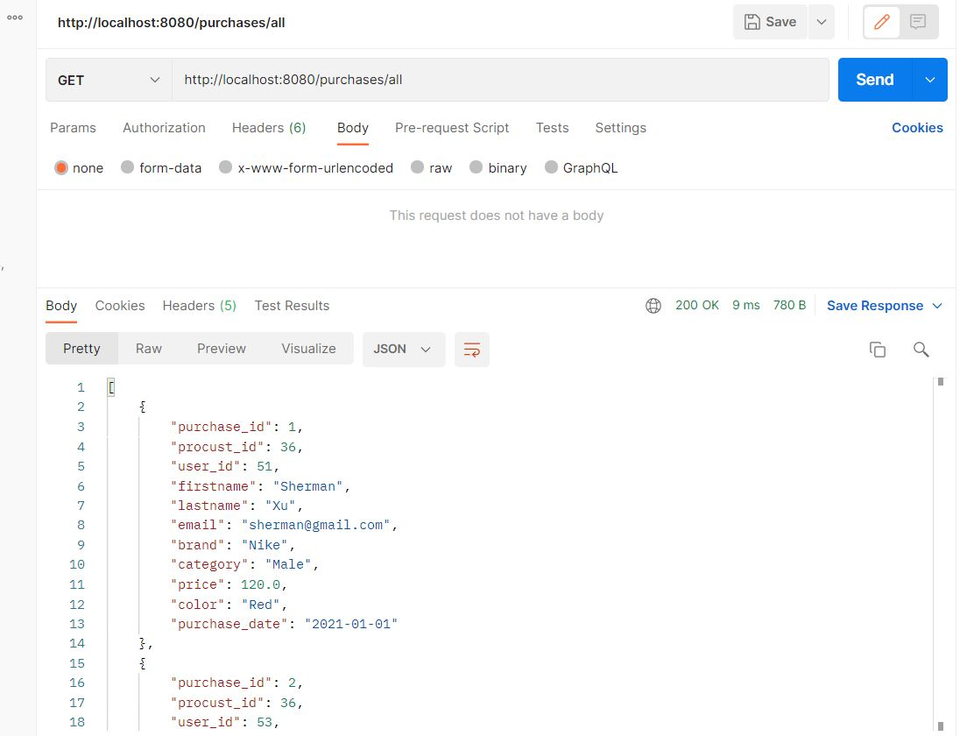
* Get_All_Users  
  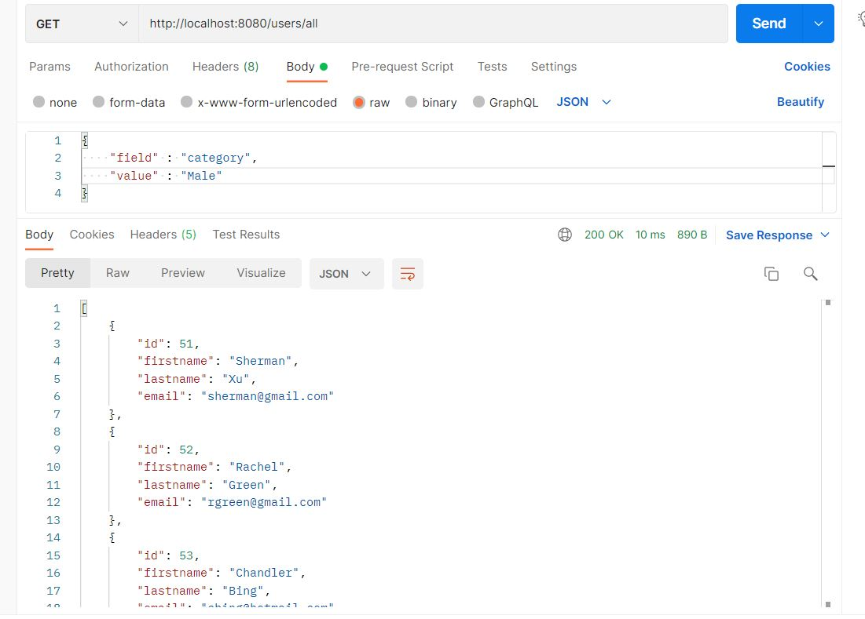
* Search_Product_By_Field  
  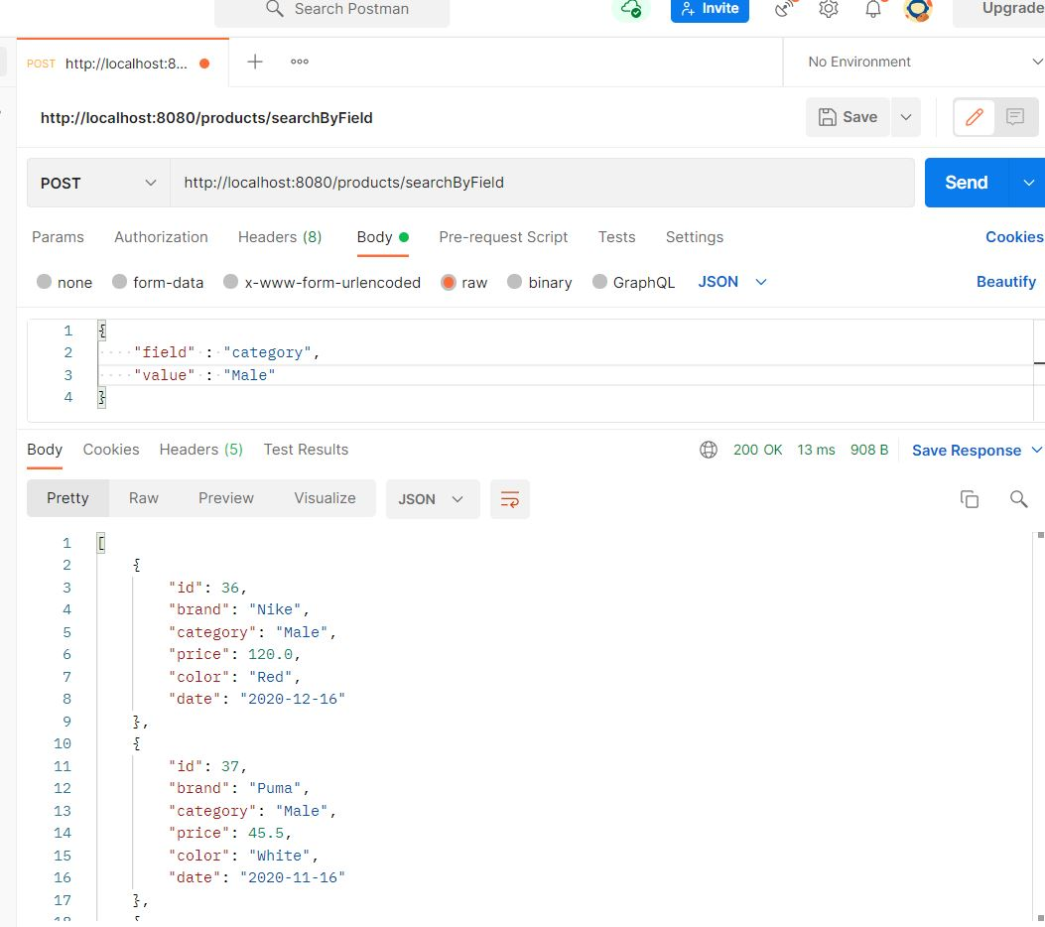
* Search_Product_By_Id  
  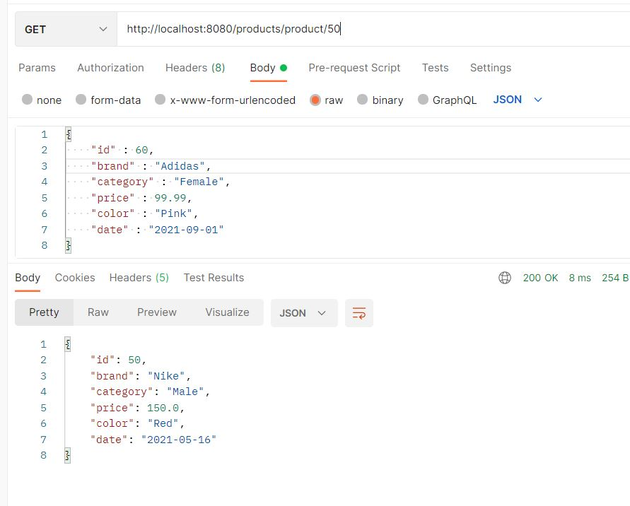
* Search_Purchase_Records_By_Category  
  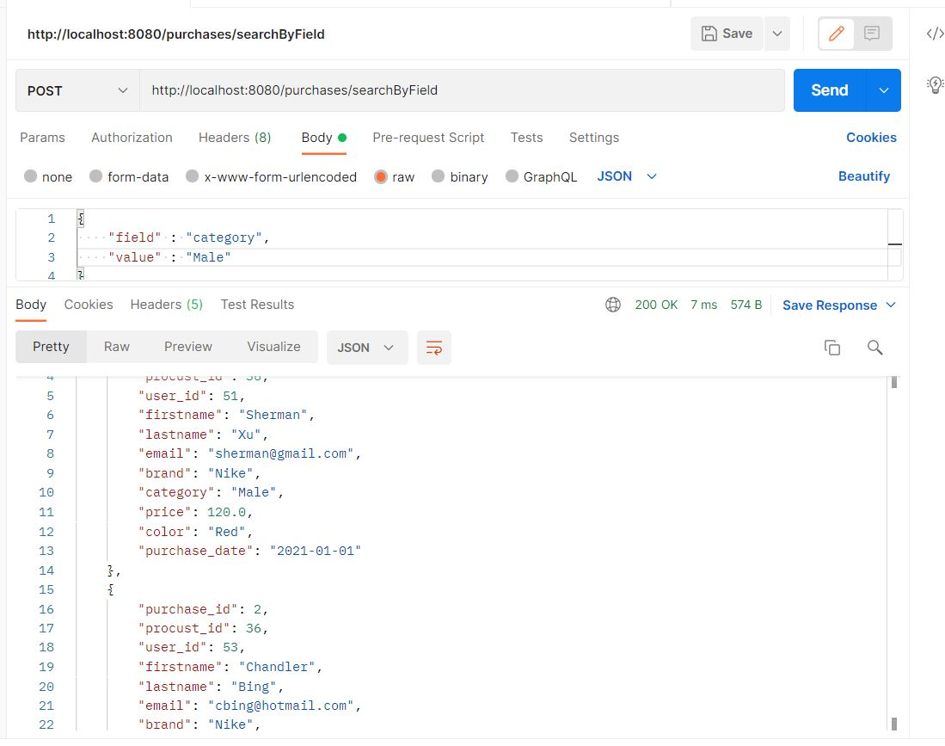
* Search_Purchase_Records_By_Date  
  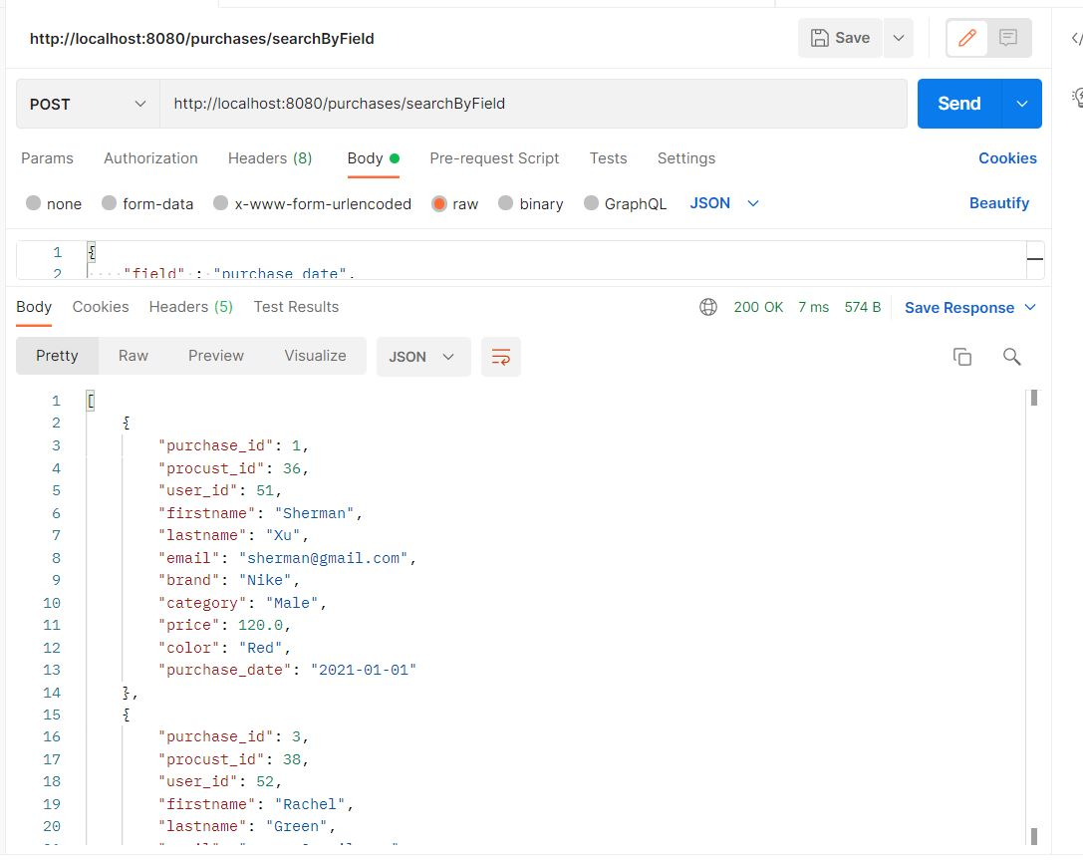
* Search_User_By_Field  
  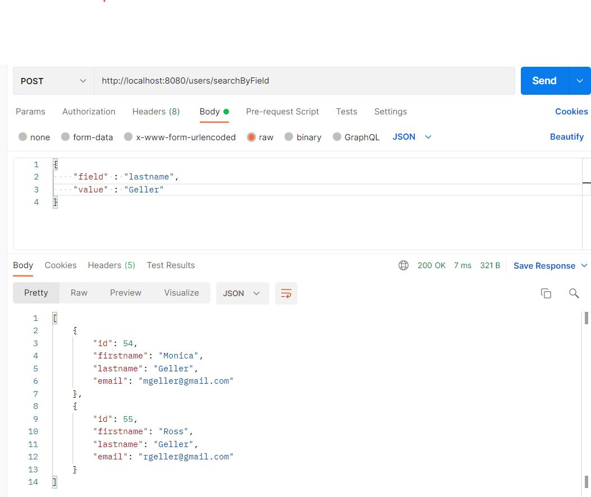
* Search_User_By_Id  
  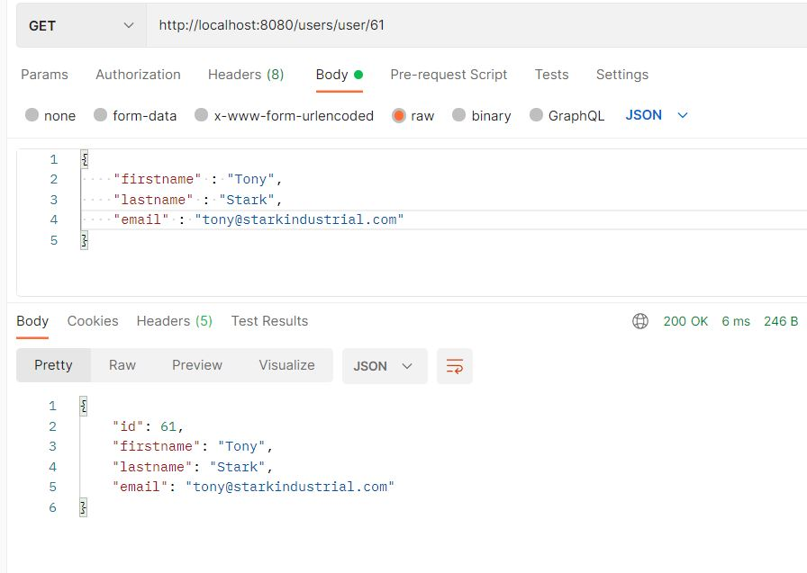
* Update_A_Product  
  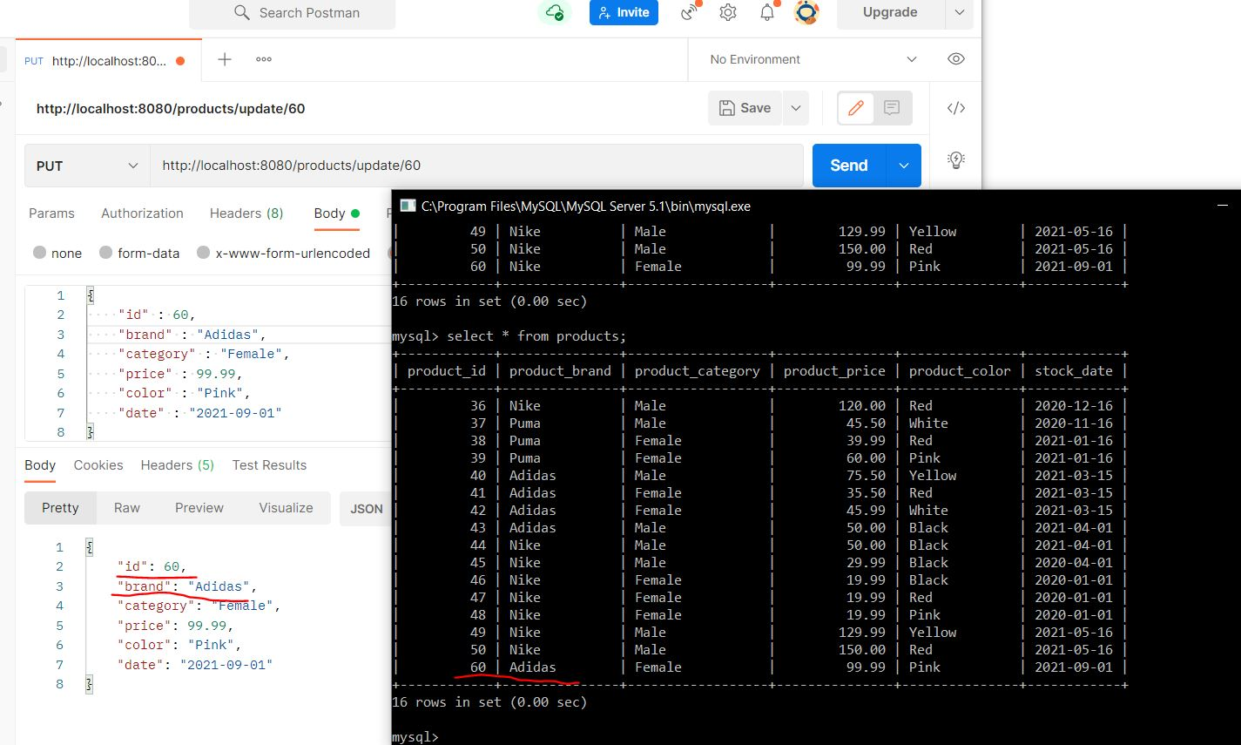
* Update_A_User  
  