PG FSD Implement OOPS using JAVA with Data Structures and Beyond

Phase-5 Project Specification Document

* Introduction

This is an online test application, backend services are developed with Spring-boot and frontend application was developed with Angular.

* Database schema
  + Users - to store user information  
    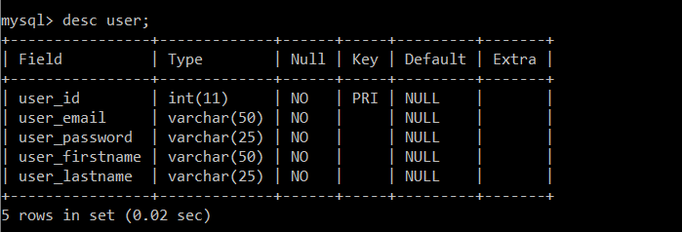
  + Questions- to store quiz questions  
    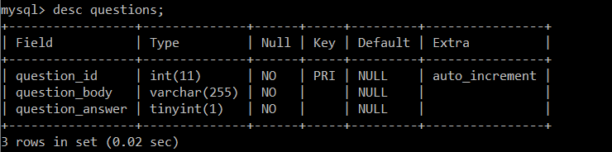
* APIs
  + users
    - *Login with username and password*
      * POST <http://localhost:8080/users/login>
    - *Register*
      * POST <http://localhost:8080/users/add>
  + questions
    - *Get all questions*
      * GET <http://localhost:8080/questions/all>
* Usage of application
  + Fire up backend service
    - Run as Maven Clean
    - Run as Maven install
    - Run as Spring Application
    - For detailed payload information about APIs please refer to the screenshots.
  + Fire up frontend application
    - Open terminal
    - Use ‘ng serve –port:4300 –open'