* Welcome Page  
  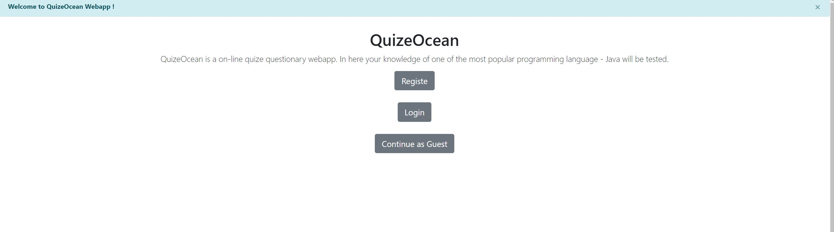
* Login Page  
  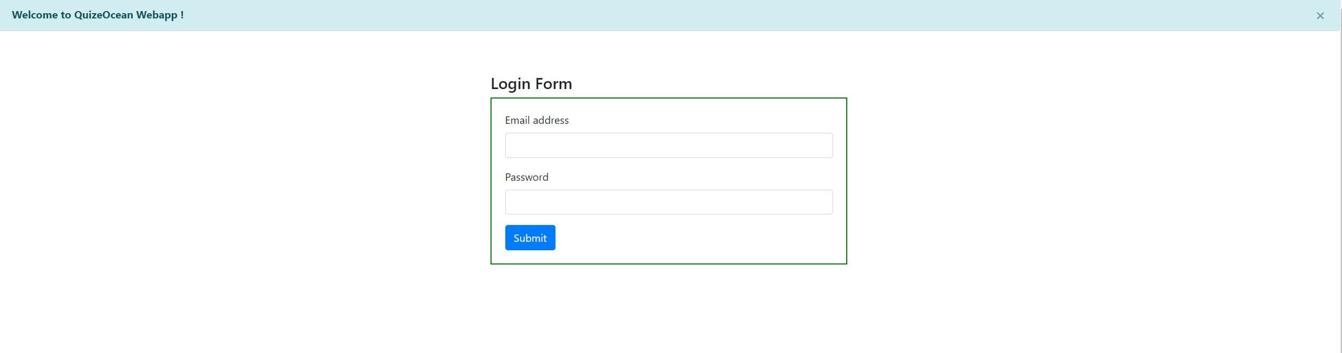
* Login Verification  
  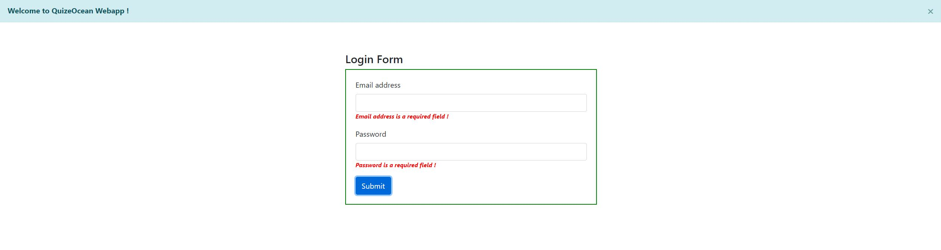
* Login Succussed  
  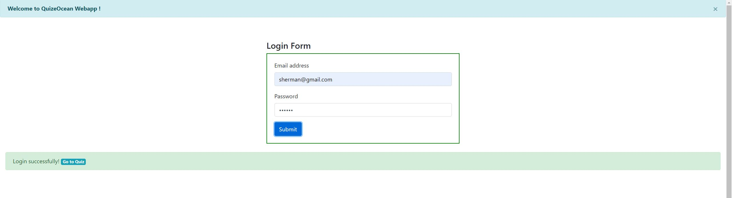
* Login Failed  
  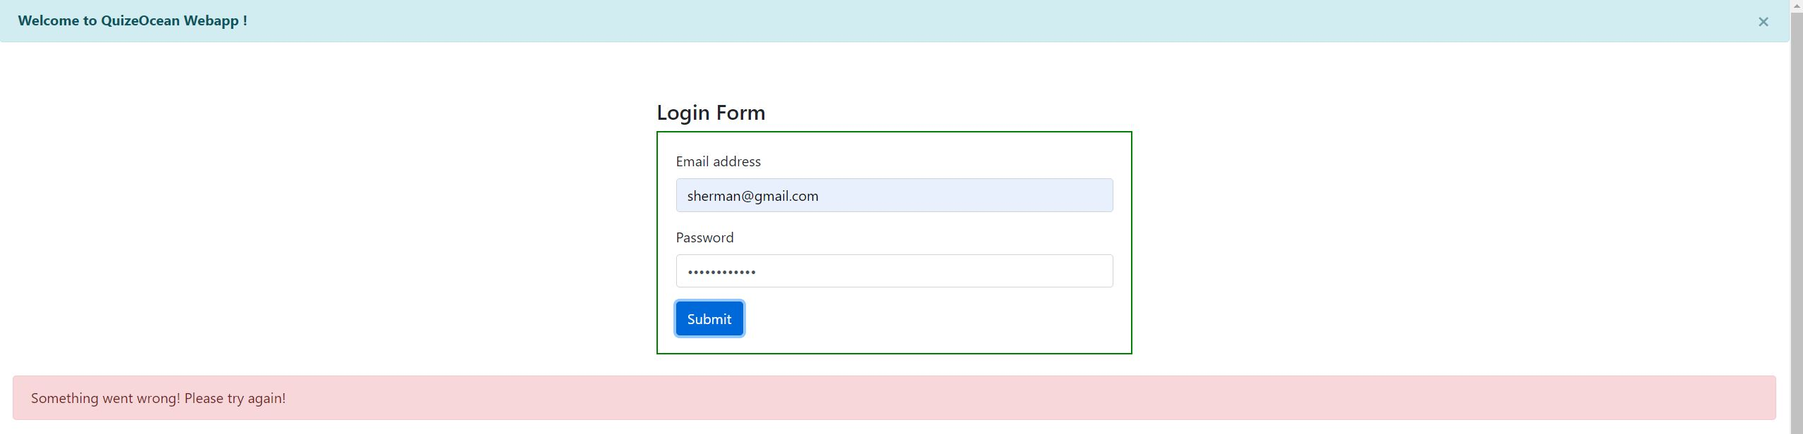
* Register Page  
  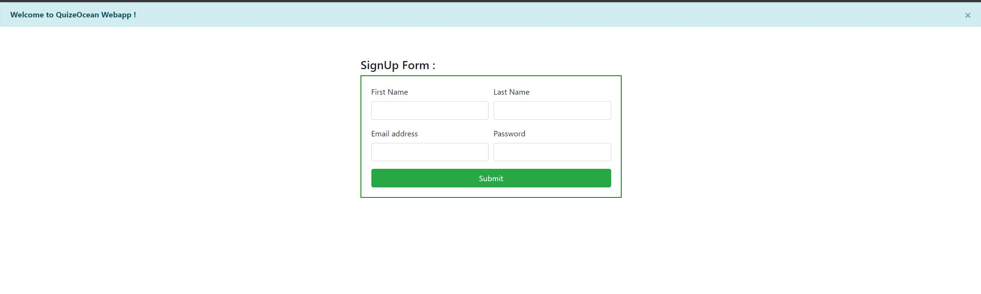
* Register Verification  
  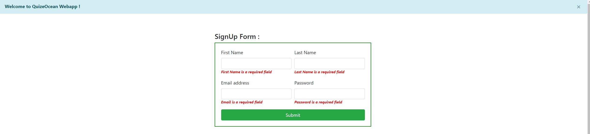
* Register Succussed  
  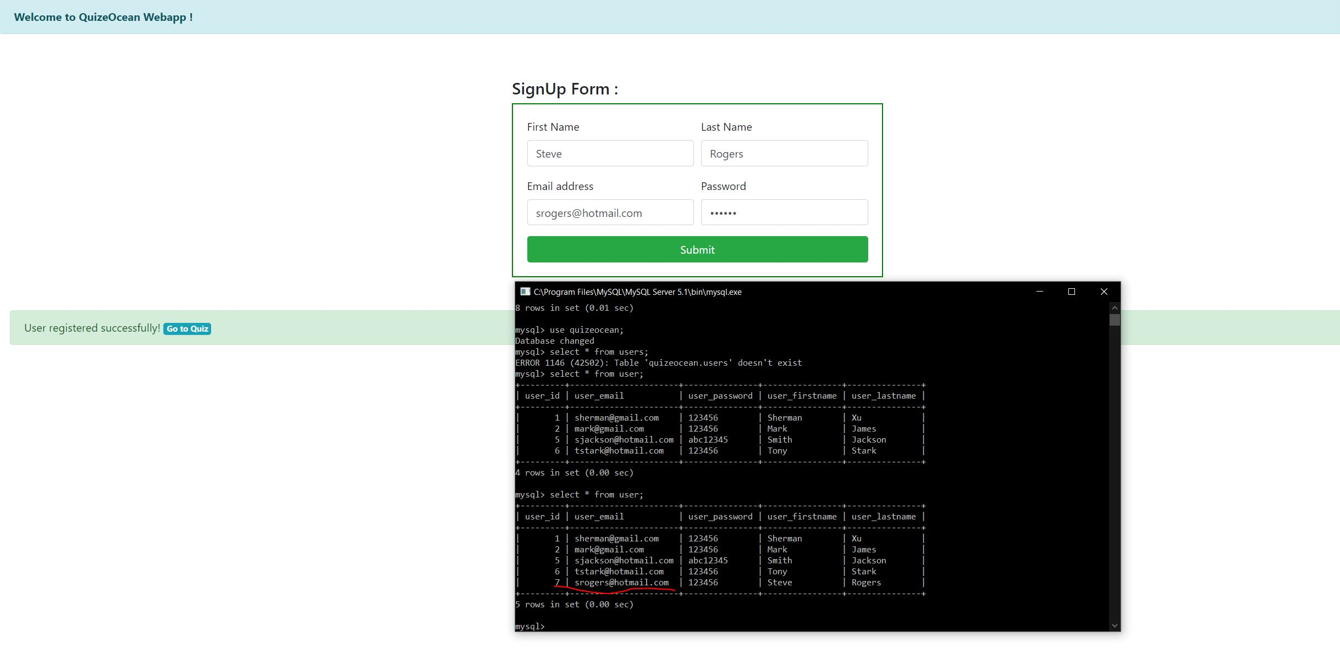
* Questions Page  
  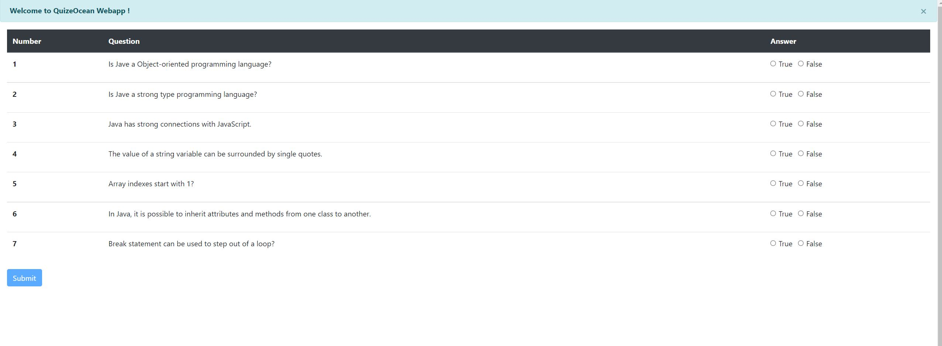
* Questions Review  
  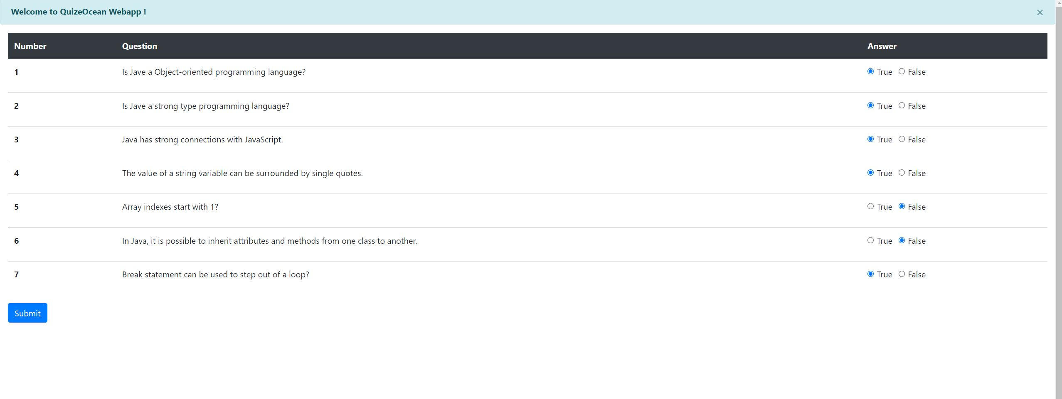
* Results Review  
  