Concentrate or Spread? Shaping Topological Resampling Priors
for Differentiable Triangle-Soup Reconstruction
Viritphon Chongpermwattanapol Pizzanu Kanongchaiyos
Department of Computer Engineering, Faculty of Engineering,
Chulalongkorn University, Bangkok, Thailand
2026-07-03
Abstract
Differentiable rasterization reconstructs a 3D triangle soup from images by following photometric gradients while periodically resampling triangles to redistribute geometric detail. We first show this pipeline is topologically blind: Chamfer and Hausdorff distances cannot separate reconstructions that differ in genus, connectivity, or enclosed-void structure, and any topological bias supplied at initialization is erased by the first resampling step. Correct topology therefore requires guidance applied in the loop, together with a persistence-based metric able to detect it. We introduce topology-aware adaptive resampling: a precomputed importance field that localizes the target’s persistent features and biases where new triangles respawn and which triangles are protected from pruning. It is budget-neutral and reduces exactly to the baseline when disabled. A single mass-preserving scale on the field interpolates between a concentrated prior (importance piled on each feature’s localized death-simplex) and a spread prior (the same mass distributed over the feature’s support), letting us ask not whether topological guidance helps but what spatial form it should take. Our central finding is that a spread prior is at least as good as concentrating at every feature dimension, and strictly better for voids and loops; the natural hypothesis of a dimensional crossover—concentrate for high-dimensional features, spread for low-dimensional ones—does not hold. For enclosed voids (H2) a spread prior cuts bottleneck distance to the target by 33–53% below the baseline across spheres, cubes, and capped cylinders, at comparable or better geometry; but a width-matched non-topological control recovers most of this, so the void gain is chiefly a width (spread) effect rather than topological placement—at matched width, placing the prior at the topological locus adds only a small, shape-dependent residual (significant for cylinder and sphere, absent for the cube). For loops (H1) concentrating backfires, over-tessellating the loop into phantom handles and underperforming the baseline, while a wide prior recovers the correct topology—driven by width, not topological placement, since a width-matched non-topological prior does at least as well. For components (H0) neither prior beats generic densification (a null). One principle accounts for all three: a feature’s death-simplex is a localized witness, not its full support, so spreading importance over that support is the right bias (for a void the support fills the surface, so width alone realizes it); the harm from being narrow is what depends on dimension—catastrophic for one-dimensional loops, mild for two-dimensional voids, and immaterial for zero-dimensional components. These results replace the question “does topological guidance help reconstruction?” with a prescription for how to shape it—spread, do not concentrate—and a caveat: the benefit is carried by width, not topological targeting per se, since a width-matched non-topological prior does as well or better.

Introduction
Differentiable rasterization optimizes an explicit 3D representation directly against multi-view images by backpropagating a photometric loss through the rasterizer (Loper and Black 2014; Kato et al. 2018; Liu et al. 2019; Laine et al. 2020). A triangle soup—an unstructured collection of triangles with no shared connectivity—is an attractive such representation: it is cheap to render, places no manifold constraint on the geometry, and supports adaptive resampling, a periodic in-loop step that prunes poorly-contributing triangles and respawns new ones to redistribute resolution where the image residual demands it, in the spirit of the adaptive densify-and-prune loops of explicit-primitive and mesh-evolution pipelines (Kerbl et al. 2023; Held et al. 2025; Nicolet et al. 2021; Palfinger 2022).
Such pipelines are tuned to minimize geometric error, and geometric error is exactly what they reduce. But geometry and topology are different: a reconstruction can be everywhere close to the target surface yet wrong in genus, in the number of connected components, or in whether an enclosed void survives. Our first contribution is to show that the standard pipeline is topologically blind in a precise, measurable sense. We construct matched pairs of candidate reconstructions whose Chamfer distance to the ground truth is equal by construction but whose topology differs, and show that Chamfer—and even Hausdorff—cannot separate them, whereas the bottleneck distance between persistence diagrams can (Section 5.1). We further observe that a topological bias injected only at initialization is erased: the first resampling step washes it out, so the final topology is independent of the initial bias.
Two consequences follow, and they frame the paper. First, correcting topology requires guidance applied in the loop, not at initialization. Second, detecting whether topology is correct requires a metric that sees it—a persistence-based measure rather than a point-to-point distance.
We introduce topology-aware adaptive resampling (Section 3): a precomputed importance field that localizes the target’s persistent features and biases (i) where new triangles respawn and (ii) which triangles are protected from pruning. The method is budget-neutral (the triangle count is held fixed) and reduces exactly to the baseline when its single strength knob is set to zero. Within this one mechanism we vary a concentrate$↔$spread scale on the importance field, which lets us ask not merely whether topological guidance helps, but what spatial form the guidance should take.
Our central finding concerns the spatial form of that guidance. A topological prior helps voids (H2), but chiefly through width: a spread prior lowers bottleneck-to-target by 33–53% across spheres, cubes, and capped cylinders, yet a width-matched non-topological control recovers most of it—so the void gain is mainly a spread effect, with only a small, shape-dependent topological residual (Section 5.2). But the natural hypothesis—that high-dimensional features want a concentrating prior and low-dimensional ones a spreading one, a dimensional crossover—turns out to be false. Comparing the two priors directly (Section 5.3), a spread prior is at least as good as concentrating at every dimension and strictly better for voids and loops; concentrating on a one-dimensional loop actively backfires, over-tessellating it into phantom handles. Across dimensions the benefit tracks width, not topological placement—a width-matched non-topological prior does at least as well (better, on the loop)—so the operative takeaway is to spread resampling resolution, not to target topology per se. The unifying reason (Section 6) is that a feature’s death-simplex is only a localized witness of its support, so spreading importance over that support is the right bias—while the harm from concentrating is what depends on dimension. This turns “does topology help?” into a prescription for how to shape the prior.

Related work

Topology in 3D reconstruction.
Topological correctness in reconstruction has mainly been pursued along three lines. Interactive, constraint-driven reconstruction resolves topological ambiguity during fitting, deferring to a user where the data cannot decide genus or connectivity (Sharf et al. 2007). Mesh repair removes topological defects—holes, spurious handles, disconnected shells—from an already-built mesh (Ju 2004; Attene 2010). Closest to our setting, persistence-based priors have been imposed while fitting an implicit representation to a point cloud, promoting a prescribed persistence diagram during optimization (Brüel-Gabrielsson et al. 2020). All of these presuppose either explicit connectivity (something to repair or constrain) or a global surface fit that can absorb a topological penalty. A triangle soup under differentiable rasterization offers neither: there is no connectivity to repair, and we show (Section 5.1) that a topological bias present only at initialization is erased by the first resampling step—so guidance has to act inside the resampling loop itself.

Persistent-homology-based losses and priors.
Persistent homology can serve as an optimizable objective: differentiable persistence layers (Brüel Gabrielsson et al. 2020), topological loss terms for image segmentation (Hu et al. 2019; Clough et al. 2022), persistence-driven shape matching (Poulenard et al. 2018), and a general convergence analysis for persistence-based objectives (Carrière et al. 2021). In all of these the topological signal reaches the parameters as a gradient, at the price of a persistence computation in every step. Our importance field is deliberately weaker: the target’s diagram is computed once, offline, and only steers where the resampler spends its fixed triangle budget; nothing is differentiated through persistent homology. This makes the prior essentially free at training time and isolates the question studied here—where topological guidance should place resolution—from how a differentiable topological signal would be constructed (the natural next phase; Section 7).

Differentiable rendering / rasterization.
Differentiable rasterizers obtain image-space gradients for explicit geometry, from approximate derivatives (Loper and Black 2014; Kato et al. 2018) to smoothed coverage (Liu et al. 2019) and high-performance modular primitives (Laine et al. 2020). On top of them, explicit-primitive pipelines evolve their primitive set in the loop: 3D Gaussian splatting densifies and prunes by view-space gradient magnitude (Kerbl et al. 2023), triangle splatting carries the same adaptive-density recipe to triangle primitives (Held et al. 2025), and mesh-evolution methods remesh inside the inverse-rendering loop (Nicolet et al. 2021; Palfinger 2022). In every case the densification heuristic is photometric or geometric—screen-space error, gradient magnitude, edge length—and none targets topology. The triangle-soup pipeline we build on inherits exactly this heuristic, which is what makes it topologically blind (Section 5.1).

Remeshing and adaptive sampling.
Allocating resolution adaptively is classical: progressive meshes and quadric-error simplification concentrate triangles where a geometric error metric demands (Hoppe 1996; Garland and Heckbert 1997), and remeshing methods adapt triangle density to curvature or approximation error, interactively or in real time (Alliez et al. 2003; Botsch and Kobbelt 2004; Dunyach et al. 2013). Our resampling policy keeps this machinery and swaps the signal: importance derives from the target’s persistent features rather than from curvature or error. The non-topological controls B3/B5 (Section 4) are precisely the generic-densification analogue of such heuristics at matched kernel width—which is what lets the experiments separate “more resolution, well spread” from “resolution placed by topology.”

Topology-aware adaptive resampling
The method has two offline-then-online parts: a precomputed importance field distilled once from the target, and a resampling policy that consumes the field inside the training loop. Neither touches the renderer, and both are budget-neutral.

The importance field
Let $P$ be a seeded surface sample of the target. We compute its persistence diagram (Edelsbrunner et al. 2002) with a GUDHI (Maria et al. 2014) alpha complex (Edelsbrunner and Mücke 1994) and keep the significant features—intervals whose lifetime exceeds a self-calibrating multiple of the median nearest-neighbour spacing. Each significant feature $f$ of homological dimension $d_{f}$ is localized in space using the persistence pairs together with the alpha-complex point coordinates: an H1 loop is located by the edge/triangle that births/fills it, an H2 void by the tetrahedron that fills it (which sits on the bounding shell), and an H0 component by the edge that merges it. This yields, per feature, a set of 3D kernel centers $\{c\}_{f}$ on the target surface.
Each feature contributes an isotropic Gaussian splat, and the field is evaluated on a dense surface sample $Q$ (an “option-B surface splat”) so that importance is tied to the manifold the soup must reproduce:
r(q) = f​ wfc∈{c}f​exp​−q−c22 σf2, q∈Q,
with per-feature weight $w_{f}$ equal to the (normalized) persistence and radius $σ_{f}$ set to the feature’s own death scale—its alpha circumradius $\sqrt{{\text{death}}_{f}}$, clamped to a spacing floor and a bounding-box-fraction ceiling. The per-dimension fields are normalized to $[0,1]$ and a query point takes the value of its nearest sample in $Q$.

Concentrate$↔$spread scale.
We add a single scale $s​≥​1$ that widens every kernel while preserving the injected surface mass: $σ_{f}→s σ_{f}$ and $w_{f}→w_{f}/s^{2}$. Because a 2D Gaussian’s surface integral scales as $wσ^{2}$, the total importance mass f​wfσf2 is invariant in $s$; $s$ changes only the spatial spread of the prior, not how much of it there is. By construction $s​=​1$ is the concentrated field and is numerically identical to the field used without the knob.

The resampling policy
The baseline resampler periodically (i) prunes the least screen-visible triangles and (ii) respawns triangles by subdividing large screen-space edges. Our policy biases both with the field via one strength knob $λ_{\text{topo}}$, and keeps the triangle count $N$ fixed:
- Prune protection (keep-map). Faces are ranked by $\text{visibility}+λ_{\text{topo}} κ imp$, where $imp$ is the field value at the face centroid and $κ$ a visibility-scale factor; the same number of faces is removed as in the baseline, so important faces are protected without changing the budget.
- Budget-neutral densification. After the unchanged baseline split, we add up to $cap=λ_{\text{topo}}​⋅​c​⋅​N$ extra subdivisions of the highest-importance visible faces, then remove exactly $cap$ faces with the protective keep-map. Net face count is unchanged; the effect is a pure trade of low-importance triangles for high-importance ones.
When $λ_{\text{topo}}=0$ both levers are bypassed and the policy reduces exactly to the baseline resampler (bit-identical resampling decisions); this is condition B0 below. The policy is field-agnostic: swapping which field it reads (concentrated topological, spread topological, or a non-topological control) gives the different experimental conditions of Section 4 without any other change.

Experimental setup

Conditions.
All conditions are identical in seed, target scene, triangle budget $N$, optimizer, step count, and schedule; they differ only in the resampling importance (Section 3.2).
- B0 — baseline resampler ($λ_{\text{topo}}=0$); the control.
- B1 — topological field applied once at initialization only; tests whether init-time bias survives (it does not).
- B2 — topological field applied in-loop, concentrated ($s​=​1$); the proposed method.
- B3 — a non-topological importance field (random blobs at the default narrow width) applied in-loop; with B2 it tests whether narrow topological placement beats narrow non-topological densification.
- B4 — topological field applied in-loop but spread ($s​>​1$); identical to B2 except for the concentrate$↔$spread scale. Results in Sections 5.2 and 5.3.
- B5 — a non-topological field width-matched to B4 (random blobs widened to B4’s kernel $σ$, mass-preserved); with B3 and B4 it separates topological placement from kernel width (H2 shapes; Section 5.2).

Synthetic targets with known topology.
Targets are analytic shapes rendered into multi-view scenes so the ground-truth surface (and hence its Betti numbers) is exact. Each shape’s Betti numbers are recovered by the alpha-complex pipeline before any reconstruction experiment.
Synthetic targets and their (verified) Betti numbers.
target | $(b_{0},b_{1},b_{2})$ | decisive dim | role
sphere | $(1,0,1)$ | H2 | enclosed void
cube | $(1,0,1)$ | H2 | void, flat faces / sharp edges
cylinder | $(1,0,1)$ | H2 | void, capped
torus | $(1,2,1)$ | H1 | loops / handle
two_spheres | $(2,0,2)$ | H0 | two components
three_spheres | $(3,0,3)$ | H0 | three components
double_torus | $(1,4,1)$ | H1 | genus-2, multi-loop

Metric.
The primary metric is the bottleneck distance (Cohen-Steiner et al. 2007; Edelsbrunner and Harer 2010) between the reconstruction’s persistence diagram and the target’s, in the shape’s decisive homology dimension, reported as the tail mean over the last 30% of training steps (lower is better). Geometry is reported in parallel as Chamfer / Hausdorff-95 (% of bbox diagonal) so that any topological gain can be checked to occur at comparable geometry rather than from a geometric change.

Determinism and seeds.
Resampling decisions (the face structure $F$) are deterministic given the seed, but the CUDA rasterizer’s gradient atomics make vertex positions $V$ not bit-reproducible run-to-run: two same-seed baseline runs can drift by a small number of triangles. We therefore (i) use paired seeds across conditions and (ii) average each comparison over multiple seeds—5 for the H2 study and the torus, 3 for the remaining crossover shapes; the topology metric samples the soup $α​×$area-weighted and is robust to a few drifting triangles.

Budget.
All comparisons are budget-neutral: the triangle count $N$ is held fixed across conditions and across the run (the densify step trades faces 1-for-1). Training runs 2500 steps, at $N=1200$ for the H2 study and at each shape’s headroom budget for the crossover (Table 2).

Results

Geometric metrics are topologically blind
We build three controlled pairs (A = topologically correct, B = topologically wrong). In each pair A’s geometry is bisection-matched so its Chamfer distance to the ground truth equals B’s; topology is the only thing that differs. Diagrams are computed on 40,000 seeded surface samples per shape.
In all three cases Chamfer ranks the wrong candidate equal-or-better while the bottleneck distance separates them cleanly (Figure 1). The blindness holds even at the level of geometry’s most outlier-sensitive metric: Hausdorff-95 is lower (better) for the wrong candidate in cases i and ii.
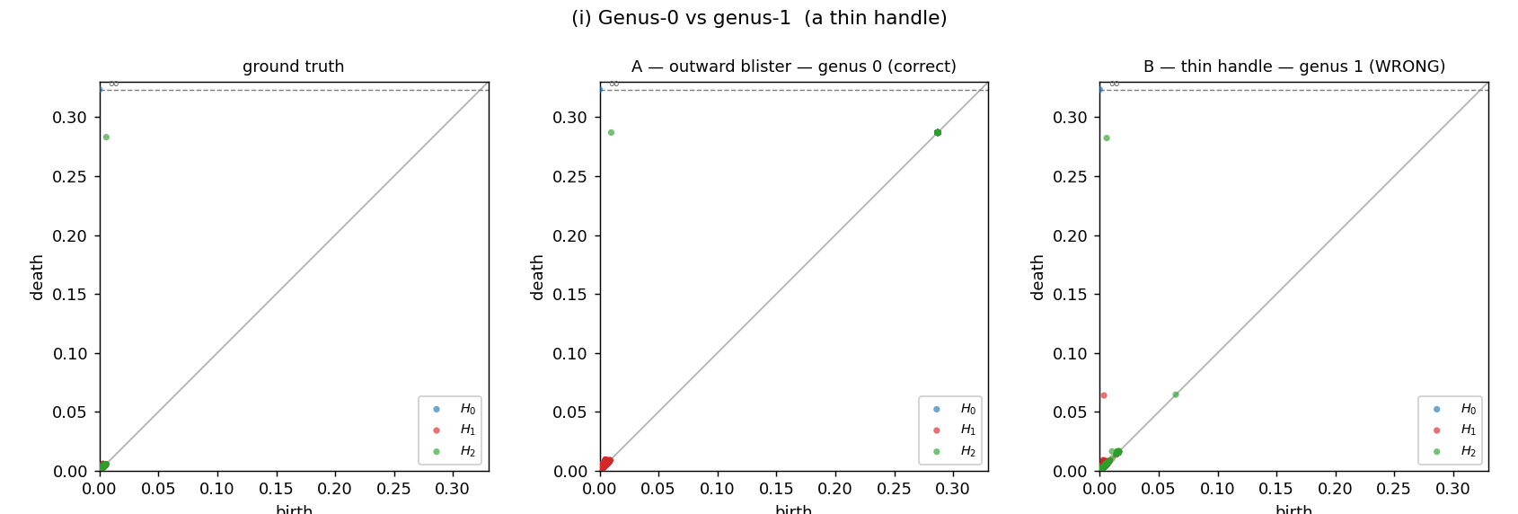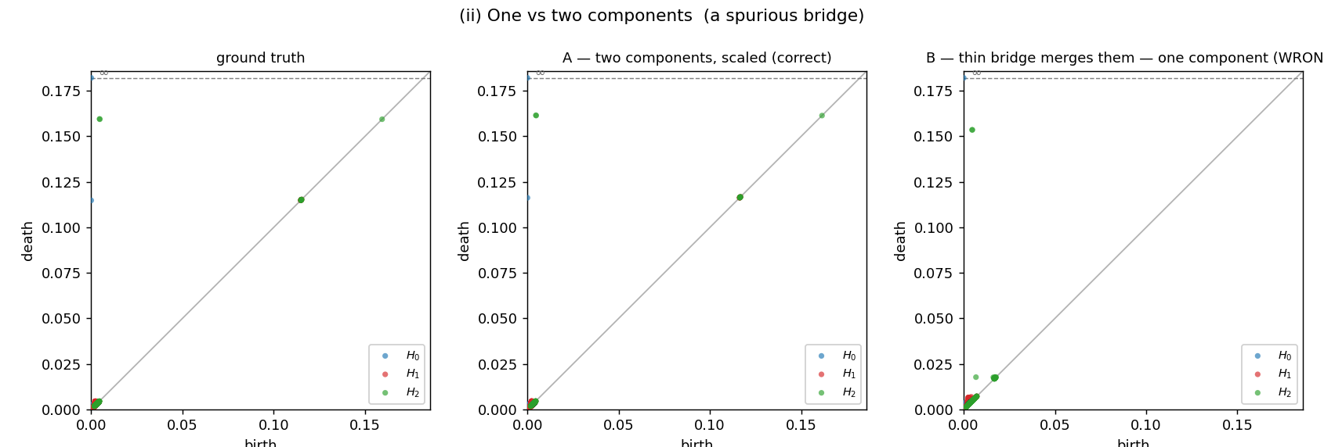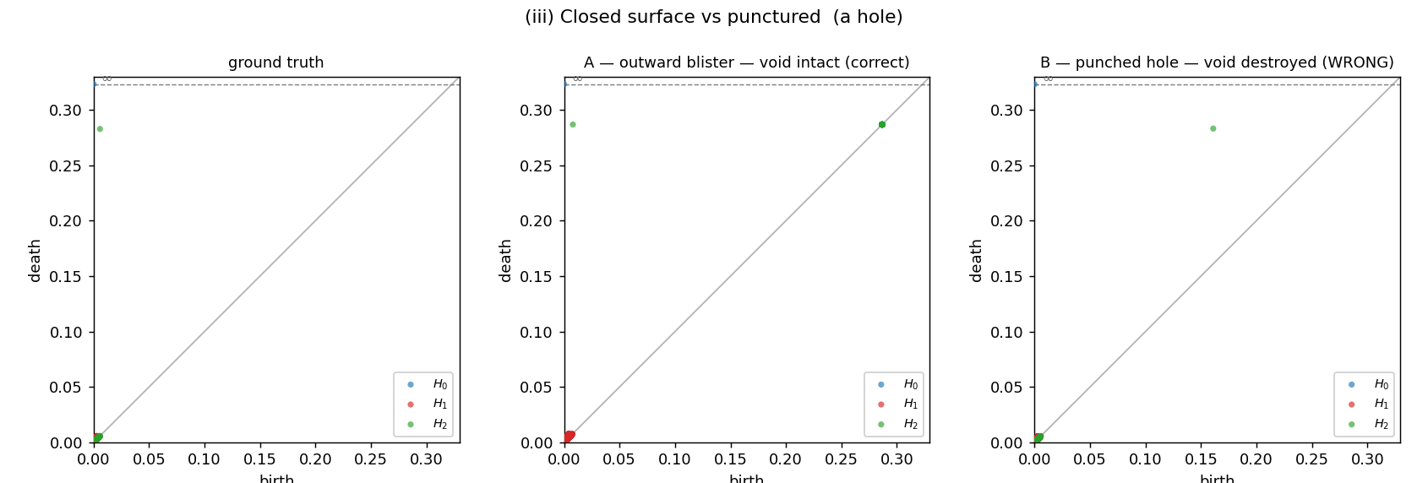
Persistence diagrams (GT / A / B) for the three blindness cases: (i) genus, (ii) components, (iii) void.
A topological bias supplied only at initialization does not survive training: the first resampling step removes it, so the final topology is independent of the initial bias. The persistence-based stability series makes the gap visible—Chamfer drifts smoothly while the bottleneck jumps when a spurious feature becomes significant (Figure 2).
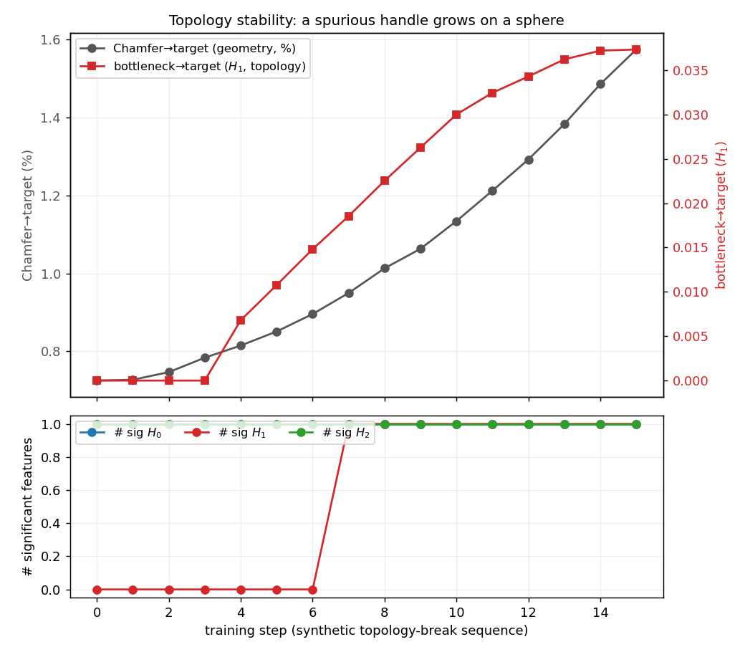
Topology stability series: Chamfer (smooth) vs bottleneck-H1 (jumps when a spurious handle becomes significant).

Voids (H2): mostly width, with a shape-dependent topological residual
For voids, spreading the resampling prior helps substantially—a controlled 2$×$2 over kernel width (narrow $s=1$ vs. wide $s=3$) and placement (topological vs. non-topological; Table [tab:h2]) shows the gain is chiefly a width effect with a smaller, shape-dependent topological component. Width: at matched placement, widening cuts error by 15–33% (topological B4-vs-B2 by 18–33%, non-topological B5-vs-B3 by 15–33%), so both wide priors land far below both narrow ones. (Not every wide-vs-narrow cross-pair clears 15%—e.g. B5-vs-B2 is $≈$9% for the cylinder—so the range is stated for matched-placement widening.) Placement: the topological-placement benefit is real but shape-dependent, clearest for the cylinder, where topology helps at both widths (narrow B2-vs-B3 by 7.8%; wide B4-vs-B5 by $≈$4.6$σ$); for the sphere it is weak (narrow: a tie; wide: $≈$2.2$σ$), and for the cube absent (a tie at both widths). B4 is the best single condition at better-or-equal geometry, but a width-matched non-topological control recovers most of its advantage, so the void gain is chiefly width with a real but shape-dependent topological residual. Init-time bias washes out (B1$≈$B0).
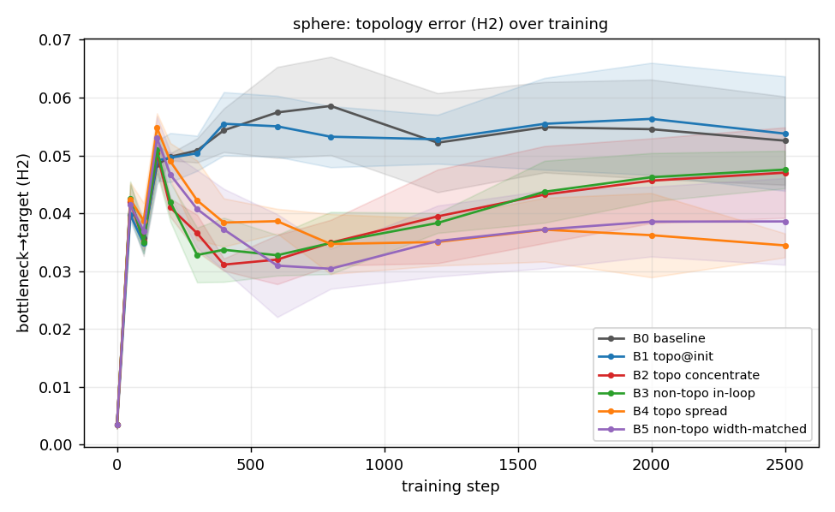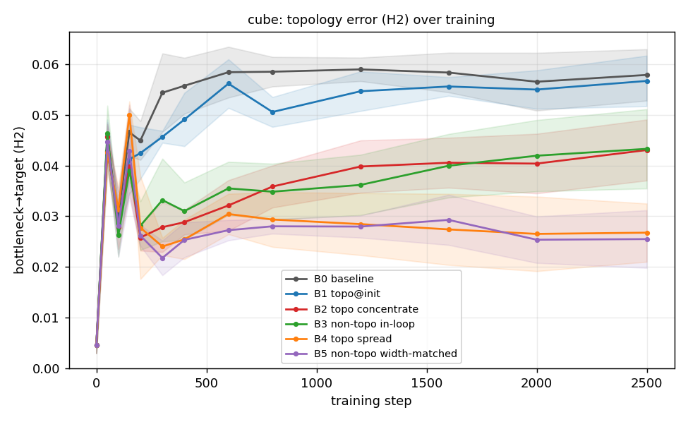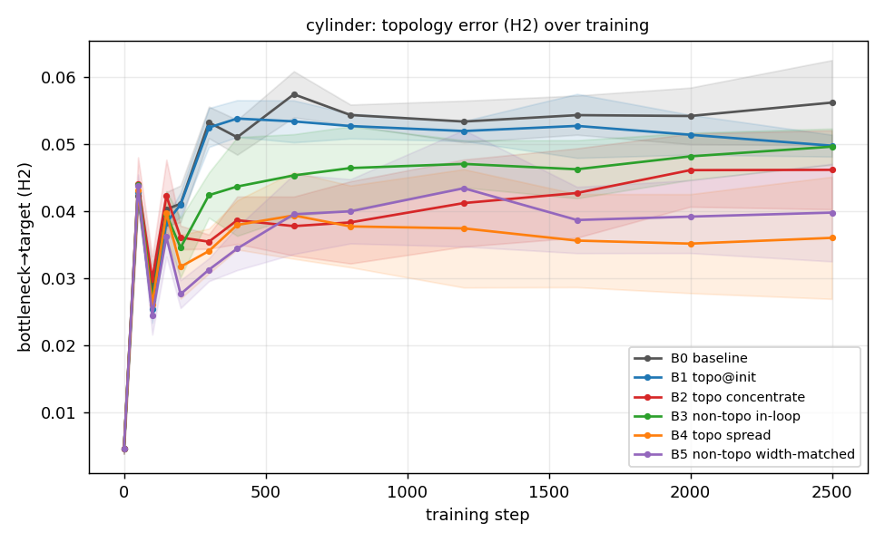
Bottleneck-to-target over training for the three voids (conditions B0–B5): the two wide priors (B4 topological, B5 non-topological) track well below the two narrow priors (B2, B3), and B4/B5 nearly coincide—width, not topology, is the driver. Geometry parity: Figure 4.
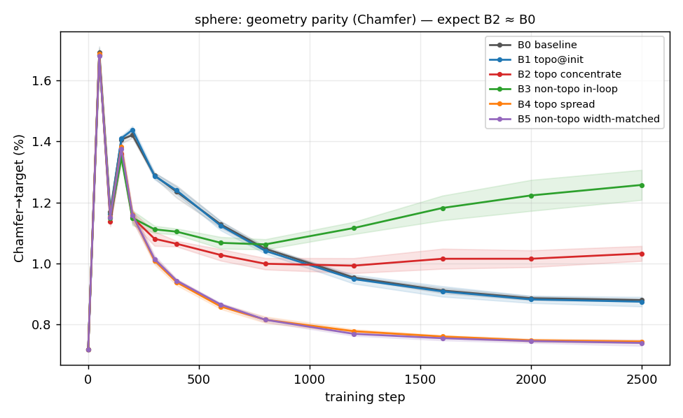
Sphere geometry (Chamfer): B4 (spread) sits at or below baseline, so the topological gain is not bought with geometry.
Whether this “spread beats concentrate” ordering is special to voids or holds across feature dimensions is the subject of Section 5.3.

Does the optimal prior flip with dimension?
Section 5.2 shows spread beats concentrate for voids. Does a low-dimensional feature instead prefer concentration—a dimensional crossover? We compare the concentrated (B2) and spread (B4) priors—identical but for the width scale—in each shape’s decisive dimension, at a per-class headroom budget, and track the signed difference $Δ=\text{bottleneck}(\text{B4})−\text{bottleneck}(\text{B2})$ (Table 2); a crossover would show $Δ$ change sign with dimension. We add a genus-2 double_torus ($b_{1}=4$) and three_spheres ($b_{0}=3$).
Concentrate vs. spread across feature dimensions: $Δ≤0$ everywhere, so there is no sign flip and no crossover—spread is at least as good as concentrating at every dimension, and strictly better for voids and the torus. The H2 rows are the paired-seed run of Table [tab:h2] (h2_unified, 5 seeds); the low-dimensional rows are the crossover run (torus 5 seeds, others 3). Each row is internally consistent (one run per shape).
target | dim | $N$ | B2 concentrate | B4 spread | $Δ=$B4$−$B2
sphere | H2 | 1200 | 0.0438 | 0.0357 | $−0.0081$
cube | H2 | 1200 | 0.0409 | 0.0273 | $−0.0136$
cylinder | H2 | 1200 | 0.0440 | 0.0360 | $−0.0080$
torus | H1 | 700 | 0.0425 | 0.0316 | $−0.0109$
two_spheres | H0 | 700 | 0.0059 | 0.0057 | $−0.0002$
three_spheres | H0 | 700 | 0.0062 | 0.0053 | $−0.0009$
double_torus | H1 | 2000 | inconclusive (bottleneck pinned; see text)

No crossover; spread wins or ties everywhere.
$Δ=$B4$−$B2 (spread minus concentrate, both topological) is clearly negative for voids and the torus (spread better) and only marginally negative for the two H0 shapes—within noise of the non-topological control, i.e. a null. Nowhere does concentrating win, so the optimal spatial prior does not flip with dimension. Because this $Δ$ holds placement fixed (both priors topological), it isolates the effect of width; whether the loop spread-win is topological needs the non-topological arm, which we add for the torus next (Table 3).

On the loop, width drives the gain; topological placement does not.
A width$×$placement 2$×$2 on the torus (Table 3), mirroring the void analysis, decomposes the spread-win. Width helps massively at either placement: widening drops the bottleneck $26\%$ for the topological pair (B2$→$B4) and $33\%$ for the non-topological pair (B3$→$B5), putting both wide cells far below both narrow ones. Placement, by contrast, gives no benefit on the loop—at both widths the non-topological prior is better: narrow B3 $0.0397<$ B2 $0.0425$ ($7.6σ$) and wide B5 $0.0267<$ B4 $0.0316$ ($3.25σ$), so the best torus condition is a wide non-topological prior. The only distinctly topological effect is a harmful one: at this budget only the narrow-topological prior (B2) inflates significant-H1 into phantom handles ($4.4$ vs. a true $2$; B3, B4, and B5 all hold $2.0$), the concentrate backfire of Section 6. So on the torus, as on the voids, width drives the gain—but here topological placement is a small cost, not a small residual.
Torus width$×$placement 2$×$2 (5 paired seeds, $N=700$), mirroring Table [tab:h2] for a loop. Width helps at either placement (both wide cells far below both narrow); at matched placement the non-topological prior is better at both widths (narrow $7.6σ$, wide $3.25σ$), so the loop spread-win is a width effect. Topological placement’s only distinct effect is harmful: the narrow-topological B2 alone inflates significant-H1 into phantom handles.
 | narrow ($s=1$) |  | wide ($s=3$)
2-3(lr)4-5 torus (H1), $N=700$ | B2 topo | B3 non-topo | B4 topo | B5 non-topo | B0
bottleneck (tail mean) | 0.0425 | 0.0397 | 0.0316 | 0.0267 | 0.0409
significant-H1 (true $2$) | 4.4 | 2.0 | 2.0 | 2.0 | 2.0

Components are a null.
For two_spheres and three_spheres neither topological prior beats the non-topological control: component correctness is governed by the absence of geometry in the inter-component gap, which a placement prior does not control (Section 6).

Multi-loop genus-2: inconclusive.
On double_torus the decisive-dimension bottleneck is identical across all conditions (pinned at $0.0264$) and the soup recovers only 2 of the 4 loops at every budget tried, so this stress test does not discriminate; we report it as inconclusive rather than support, and flag a higher-resolution re-run as future work.
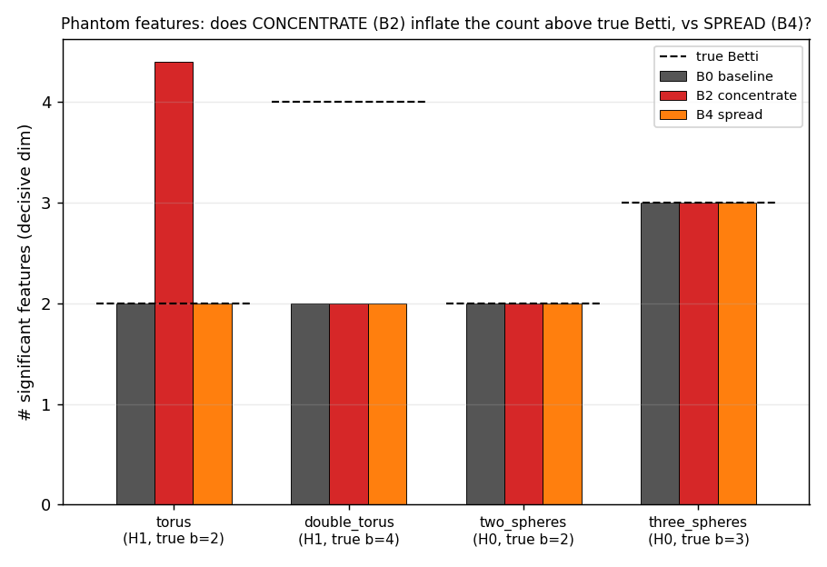
Significant-feature count vs. true Betti (low-dimensional shapes): concentrate (B2) inflates the torus H1 count (phantom handles), while spread (B4) and both non-topological priors (narrow B3, wide B5; Table 3) hold the true value—so the inflation is specific to the narrow-topological prior; the H0 shapes are unaffected.

Why spreading wins, and why concentration’s harm depends on dimension

What the importance scale actually varies.
A feature’s death simplex marks where its topology is fragile, but the feature’s support is larger—the bounding shell of a void, the whole tube of a handle. For the compact targets used here the feature’s death scale is of order the shape size, so even the concentrated field ($s=1$) already overlaps most of the surface. The scale $s$ therefore varies the peakedness of the field—and hence the differential protection the keep-map applies to feature geometry—far more than its literal spatial coverage. “Spreading” here means “protect the feature’s whole support evenly,” not “reach more of the surface.”

Voids: spreading (width) helps; topological placement is a small residual.
An enclosed void is destroyed by a hole anywhere on the 2-manifold shell that bounds it, so the void’s support—the geometry whose failure collapses it—is the entire shell, which for a compact shape is essentially the whole surface. As the peakedness caveat above notes, even the concentrated field ($s=1$) already overlaps most of that surface, so any wide field—topological or not—approximately spreads over the void’s support. The single principle “spread over the support” therefore predicts the void effect should look width-driven, with topological placement only a residual—and it is: a width-matched non-topological control (B5) recovers most of the spread prior’s gain (Section 5.2). That residual—placing the wide prior at the void locus (B4) rather than at random (B5)—should track how non-uniform the bounding shell is, and it does: largest for the cylinder (flat caps and a curved side; $≈$4.6$σ$), smaller for the near-uniform sphere ($≈$2.2$σ$), and absent for the cube (a tie).

The harm of concentrating, and why it scales with dimension.
What does depend on dimension is the damage a concentrating prior does, and it is governed by how readily over-tessellating a single locus fabricates a spurious feature of the same dimension:
- Loops (1-D): catastrophic, and here placement matters. A loop’s support is a thin tube, far smaller than the surface, so a narrow prior cannot spread along it and over-tessellates it into phantom handles—the significant-H1 count rises above the true value and the bottleneck worsens below baseline (Section 5.3). At the headroom budget this backfire is narrow-topological-specific: only the narrow-topological prior inflates the count ($N=700$: B2 $4.4$ vs. narrow-random B3 $2.0$; Table 3). Only under severe budget starvation does narrowness alone begin to over-tessellate a random prior too ($N=400$, 3 seeds: B2 $≈ 7.7$, B3 $≈ 5.7$, true value $2$; Figure 6). Either way the cure is width: a wide prior, topological or not, recovers the true count.
- Voids (2-D): mild. Over-tessellating one shell patch cannot create a second enclosed void, so concentrating fabricates no spurious H2; it merely under-protects the rest of the shell—an incomplete-protection shortfall behind spreading, never worse than baseline.
- Components (0-D): none. A component boundary is defined by the absence of geometry between shells; no placement of triangles on the shells adds or removes a component, so a placement prior has no purchase and the result is a null—neither topological prior beats the non-topological control (Section 5.2).
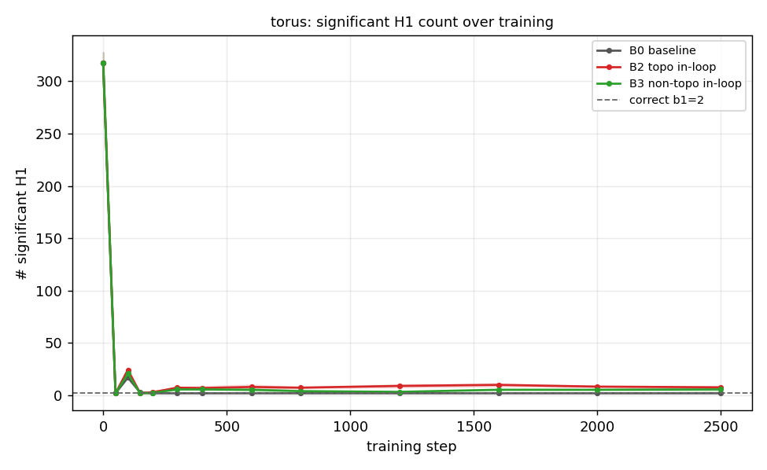
Independent budget sweep, torus at the tight budget $N=400$: both narrow priors inflate the significant-H1 count above the true value (phantom handles)—the narrow-topological B2 more than the narrow-random B3—while the baseline recovers the correct count. The over-tessellation is a narrowness effect, worsened by topological placement.

Interpretation: one principle, two observable regimes.
A single principle organizes all three cases—spread importance over the feature’s support, not its localized death simplex—and, together with the peakedness caveat, it predicts why voids look width-driven while loops look narrowness-driven: the difference is how much of the surface the support occupies. A void’s support is the whole bounding shell ($≈$ the entire compact surface), so any wide field already spreads over it and topological placement is only a residual (Section 5.2). A loop’s support is a thin tube, far smaller than the surface: a wide field does not specifically spread along that tube, and a narrow field over-tessellates it into phantom handles—so here narrowness is harmful and the wide (spread) prior recovers the correct topology (Section 5.3). The optimal prior is thus spread at every dimension (no crossover); only the observable signature—and the harm from being narrow—depends on the support’s extent. The genus-2 multi-loop case did not resolve at feasible budgets and is reported as inconclusive.

Limitations and future work

Synthetic targets.
All experiments use analytic shapes rendered into multi-view scenes, chosen so the ground-truth surface and its Betti numbers are exact and so geometry can be held fixed while topology varies—the control that makes the blindness result and the topological-vs-non-topological comparison clean. The cost is external validity: we do not yet demonstrate the method on captured or noisy real scenes, where the target persistence diagram itself must be estimated.

Non-determinism of the optimizer.
The CUDA rasterizer’s gradient atomics make vertex positions non-reproducible run-to-run; resampling structure ($F$) is deterministic but vertex positions ($V$) are not, so single-run differences can include a few drifting triangles. We mitigate with paired seeds and seed-averaging and a soup-sampled topology metric, but absolute numbers carry this run-to-run variance.

What the spread scale varies (limited dynamic range).
For the compact targets used here, topological death scales are of order the shape size, so even the concentrated field ($s=1$) already overlaps most of the surface. The scale $s$ therefore controls the peakedness of the importance field—and thus the differential protection applied by the keep-map—rather than its literal spatial coverage; our claims about “spreading” should be read in that sense. Characterizing the effect on targets whose features are small relative to the shape, where coverage and peakedness decouple, is left to future work.

Width vs. topological placement.
The void gain is primarily a kernel-width effect: a width-matched non-topological control recovers most of it, and the residual attributable to topological placement is small and shape-dependent—clear for the cylinder, modest for the sphere, absent for the cube (Section 5.2). Establishing that residual robustly, and whether it grows for targets with finer or off-centre voids, would need more shapes and seeds.

Precomputed, non-differentiable prior.
The importance field is distilled once from the target and is not differentiated through; the method biases sampling, it does not flow a topological gradient. Making persistent homology differentiable so the topological signal can backpropagate into vertex positions—rather than only steer resampling—is the natural next phase, building on existing differentiable-persistence machinery (Brüel Gabrielsson et al. 2020; Carrière et al. 2021; Poulenard et al. 2018).

Resolving multi-loop / genus-2 targets.
Our genus-2 double_torus stress test was inconclusive: at every feasible budget the soup recovered only 2 of its 4 loops and the decisive-dimension bottleneck did not discriminate between conditions (Section 5.3). Strengthening the spread-vs-concentrate finding on a richer multi-loop target needs a higher-resolution or longer-schedule re-run, which we leave to future work.
Alliez, Pierre, David Cohen-Steiner, Olivier Devillers, Bruno Lévy, and Mathieu Desbrun. 2003. “Anisotropic Polygonal Remeshing.” ACM Transactions on Graphics 22 (3): 485–93.
Attene, Marco. 2010. “A Lightweight Approach to Repairing Digitized Polygon Meshes.” The Visual Computer 26 (11): 1393–406.
Botsch, Mario, and Leif Kobbelt. 2004. “A Remeshing Approach to Multiresolution Modeling.” Eurographics/ACM SIGGRAPH Symposium on Geometry Processing (SGP).
Brüel Gabrielsson, Rickard, Bradley J. Nelson, Anjan Dwaraknath, and Primoz Skraba. 2020. “A Topology Layer for Machine Learning.” International Conference on Artificial Intelligence and Statistics (AISTATS), Proceedings of machine learning research, vol. 108: 1553–63.
Brüel-Gabrielsson, Rickard, Vignesh Ganapathi-Subramanian, Primoz Skraba, and Leonidas J. Guibas. 2020. “Topology-Aware Surface Reconstruction for Point Clouds.” Computer Graphics Forum 39 (5): 197–207.
Carrière, Mathieu, Frédéric Chazal, Marc Glisse, Yuichi Ike, Hariprasad Kannan, and Yuhei Umeda. 2021. “Optimizing Persistent Homology Based Functions.” International Conference on Machine Learning (ICML), Proceedings of machine learning research, vol. 139.
Clough, James R., Nicholas Byrne, Ilkay Oksuz, Veronika A. Zimmer, Julia A. Schnabel, and Andrew P. King. 2022. “A Topological Loss Function for Deep-Learning Based Image Segmentation Using Persistent Homology.” IEEE Transactions on Pattern Analysis and Machine Intelligence 44 (12): 8766–78.
Cohen-Steiner, David, Herbert Edelsbrunner, and John Harer. 2007. “Stability of Persistence Diagrams.” Discrete & Computational Geometry 37 (1): 103–20.
Dunyach, Marion, David Vanderhaeghe, Loïc Barthe, and Mario Botsch. 2013. “Adaptive Remeshing for Real-Time Mesh Deformation.” Eurographics 2013 — Short Papers.
Edelsbrunner, Herbert, and John L. Harer. 2010. Computational Topology: An Introduction. American Mathematical Society.
Edelsbrunner, Herbert, David Letscher, and Afra Zomorodian. 2002. “Topological Persistence and Simplification.” Discrete & Computational Geometry 28 (4): 511–33.
Edelsbrunner, Herbert, and Ernst P. Mücke. 1994. “Three-Dimensional Alpha Shapes.” ACM Transactions on Graphics 13 (1): 43–72.
Garland, Michael, and Paul S. Heckbert. 1997. “Surface Simplification Using Quadric Error Metrics.” Proceedings of SIGGRAPH 97, 209–16.
Held, Jan, Renaud Vandeghen, Adrien Deliège, et al. 2025. Triangle Splatting for Real-Time Radiance Field Rendering. arXiv:2505.19175.
Hoppe, Hugues. 1996. “Progressive Meshes.” Proceedings of SIGGRAPH 96, 99–108.
Hu, Xiaoling, Fuxin Li, Dimitris Samaras, and Chao Chen. 2019. “Topology-Preserving Deep Image Segmentation.” Advances in Neural Information Processing Systems 32 (NeurIPS).
Ju, Tao. 2004. “Robust Repair of Polygonal Models.” ACM Transactions on Graphics 23 (3): 888–95.
Kato, Hiroharu, Yoshitaka Ushiku, and Tatsuya Harada. 2018. “Neural 3D Mesh Renderer.” IEEE/CVF Conference on Computer Vision and Pattern Recognition (CVPR), 3907–16.
Kerbl, Bernhard, Georgios Kopanas, Thomas Leimkühler, and George Drettakis. 2023. “3D Gaussian Splatting for Real-Time Radiance Field Rendering.” ACM Transactions on Graphics 42 (4): 139:1–14.
Laine, Samuli, Janne Hellsten, Tero Karras, Yeongho Seol, Jaakko Lehtinen, and Timo Aila. 2020. “Modular Primitives for High-Performance Differentiable Rendering.” ACM Transactions on Graphics 39 (6): 194:1–14.
Liu, Shichen, Tianye Li, Weikai Chen, and Hao Li. 2019. “Soft Rasterizer: A Differentiable Renderer for Image-Based 3D Reasoning.” IEEE/CVF International Conference on Computer Vision (ICCV), 7708–17.
Loper, Matthew M., and Michael J. Black. 2014. “OpenDR: An Approximate Differentiable Renderer.” European Conference on Computer Vision (ECCV), 154–69.
Maria, Clément, Jean-Daniel Boissonnat, Marc Glisse, and Mariette Yvinec. 2014. “The Gudhi Library: Simplicial Complexes and Persistent Homology.” International Congress on Mathematical Software (ICMS), Lecture notes in computer science, vol. 8592: 167–74.
Nicolet, Baptiste, Alec Jacobson, and Wenzel Jakob. 2021. “Large Steps in Inverse Rendering of Geometry.” ACM Transactions on Graphics 40 (6).
Palfinger, Werner. 2022. “Continuous Remeshing for Inverse Rendering.” Computer Animation and Virtual Worlds 33 (5): e2101.
Poulenard, Adrien, Primoz Skraba, and Maks Ovsjanikov. 2018. “Topological Function Optimization for Continuous Shape Matching.” Computer Graphics Forum 37 (5): 13–25.
Sharf, Andrei, Thomas Lewiner, Gil Shklarski, Sivan Toledo, and Daniel Cohen-Or. 2007. “Interactive Topology-Aware Surface Reconstruction.” ACM Transactions on Graphics 26 (3): 43:1–10.

