**InfluLink**

**An Influencer Engagement and Sponsorship Coordination Platform**

To create a platform to connect Sponsors and Influencers so that sponsors can get their product/service advertised and influencers can get monetary benefit.

***TEAM MEMBERS***

*Sherphia Let S – RA2211026010137*

*Chandru S – RA2211026010098*

*Mohan Bhashya – RA2211026010133*

***Approach:***

The platform was designed with three main user roles: Admin, Sponsor, and Influencer. The Admin has the highest level of access, allowing them to monitor and manage all users and campaigns. Sponsors can create and manage campaigns, while Influencers can accept,reject or negotiate ad requests. The application was built using Flask for backend logic, Jinja2 and Bootstrap for frontend design, and SQLite for data storage. A user-friendly interface and seamless interaction between users were key goals.

***Frameworks and Libraries Used***

* ***Backend:***
  + ***Flask****: Web framework*
  + ***Flask-SQLAlchemy****: ORM for SQLite*
* ***Frontend:***
  + ***Jinja2****: Templating engine*
  + ***Bootstrap****: Styling framework*
  + ***JavaScript****: Dynamic behaviors*
* ***Database:***
  + ***SQLite****: Relational database*
* ***Authentication and Forms:***
  + ***Werkzeug****: Password hashing*
  + ***Flask-WTF****: Form handling*

*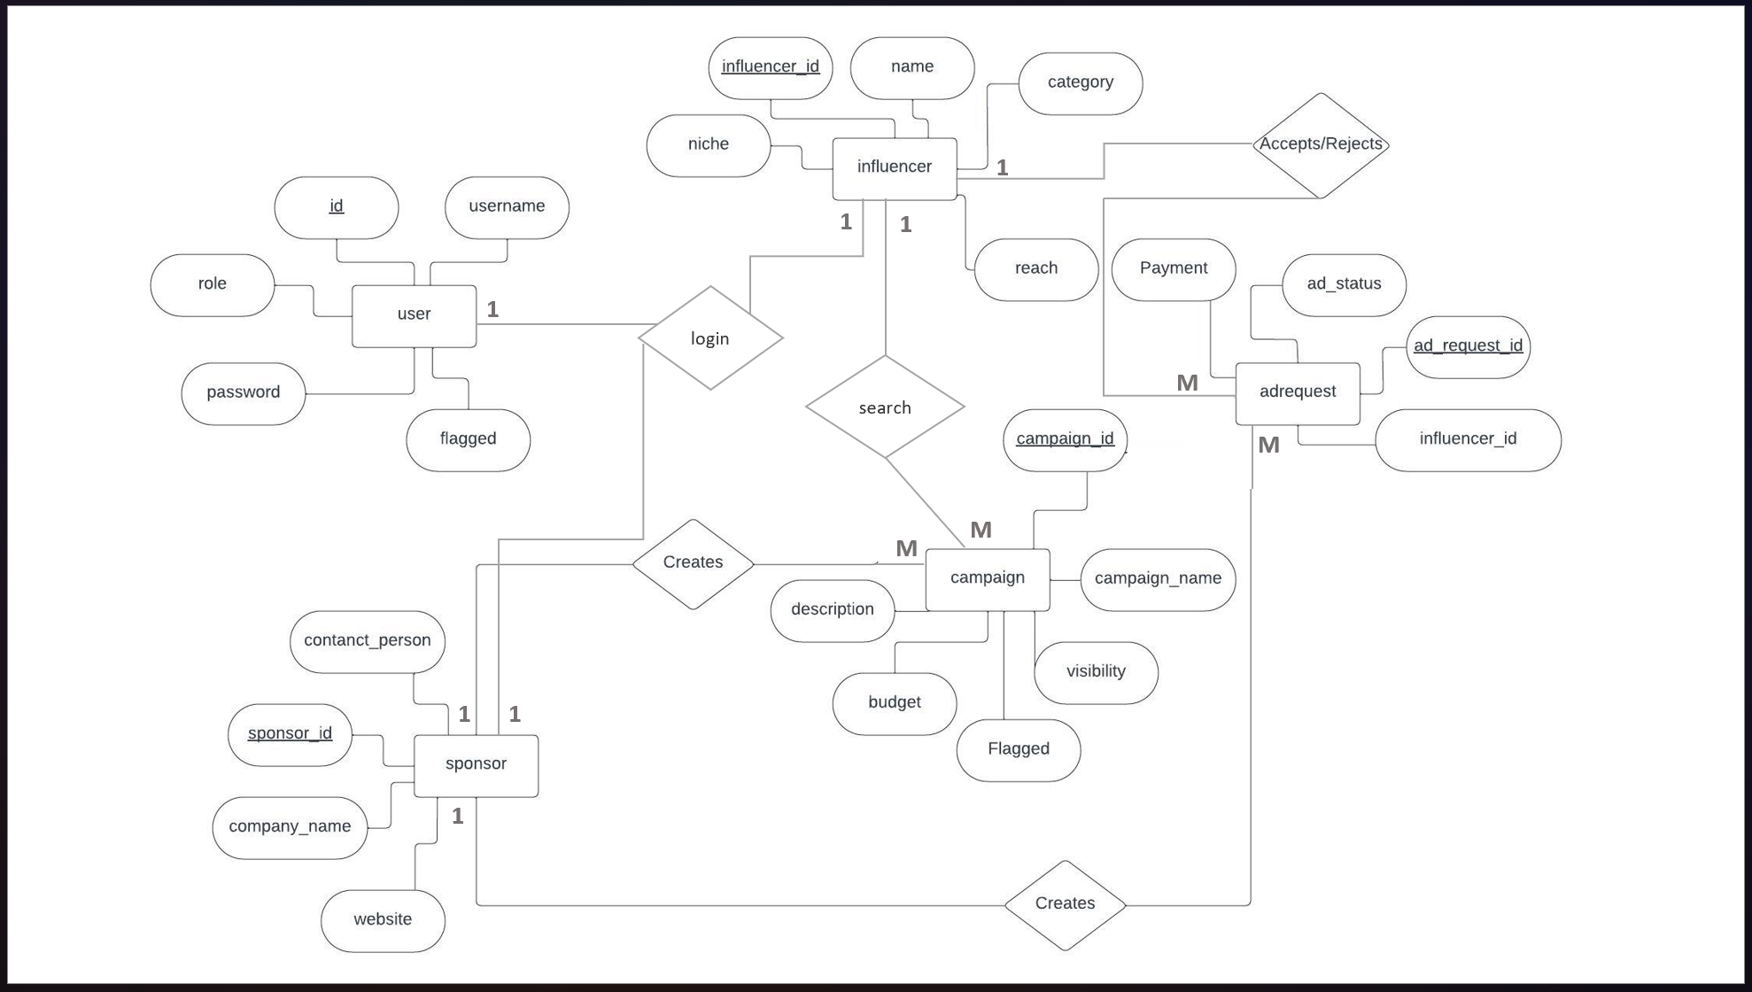****ER DIAGRAM:***

*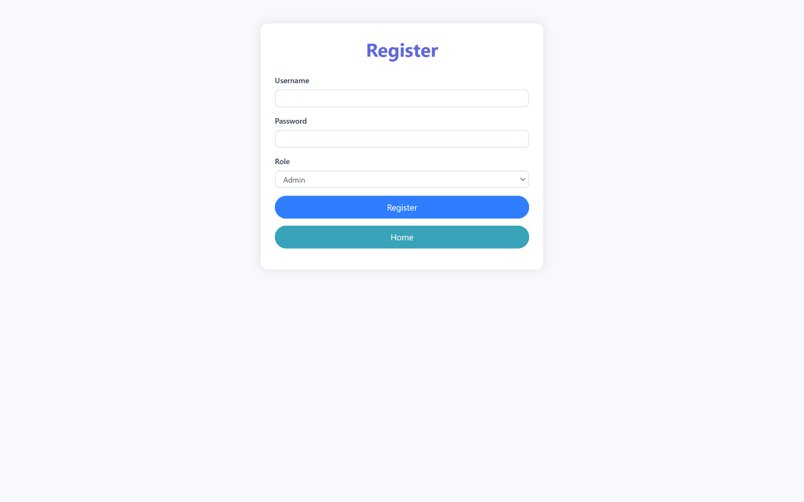****IMAGES:****