

**FLYINGFOX**

HOVER GAMES 2019



Soheil Bahrami, NXP Hamburg

Mahmoud Sherrah, NXP Hamburg

# INTRODUCTION

In the age of information we currently live in, the value of collection and usage of information is growing in exponential fashion. Even large-scale organizations can cough up millions and sometimes billions of dollars to acquire a huge data set that can assist in prediction of market trends and user preferences. Moreover, Artificial Intelligence (AI) will define the next generation of solutions to everyday life. Therefore, it is high time AI and machine learning is integrated into drone technology, not only for recreational activities but rather for rescue missions and potentially saving lives.

Enter FlyingFox: an autonomous robust quadcopter drone equipped with an HD camera and a powerful on-board AI module – Google Edge TPU - which is able to identify human gestures and instantly sends a summary of the gathered information through the Sigfox network to the fire brigade members before they even to the location of the fire outbreak.

# PROBLEM

“One of the main problems we face as firefighters is the lack of information during dispatch” – Dann Annan, Fire Brigade Lead, Hamburg, Germany.

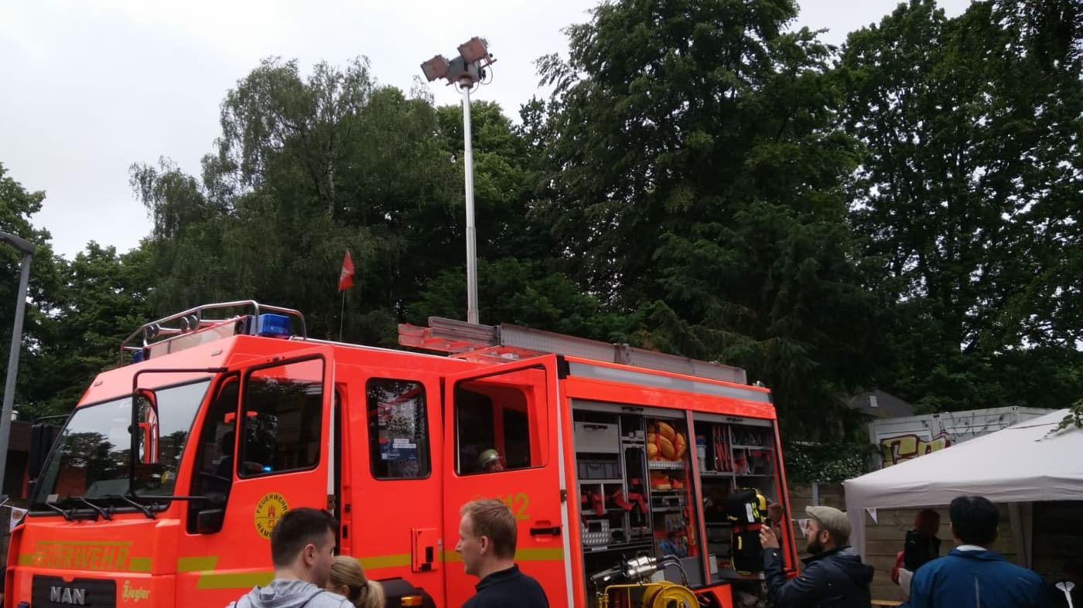

Figure 1: FlyingFox team meeting up with Hamburg's fire brigade

The average response time of fire brigades in Europe and the United States is in the region of 6 to 8 minutes from the start of the dispatch call to the arrival of the brigade to the location of the fire outbreak. In this period of time, very minimal information – if not completely lacking - is available to the dispatched fire brigade. Having already asked a leading figure in the fire brigade of Hamburg, Germany, it was confirmed that it is an issue to be

# SOLUTION

It is thus the motivation of the FlyingFox team to provide as much valuable information as possible about the fire outbreak to the fire brigade in advance. And what information is more important that human life!

The proposed solution is a robust autonomous quadcopter drone – FlyingFox- equipped with an HD camera and a powerful on-board artificial intelligence component, which is able to quickly identify human gestures and instantly sends a summary of the collected information through the internet to the fire brigade members before they even hit the road.

Each building has a FlyingFox sitting on the roof in sleep mode. Once a fire alarm is triggered in the building:

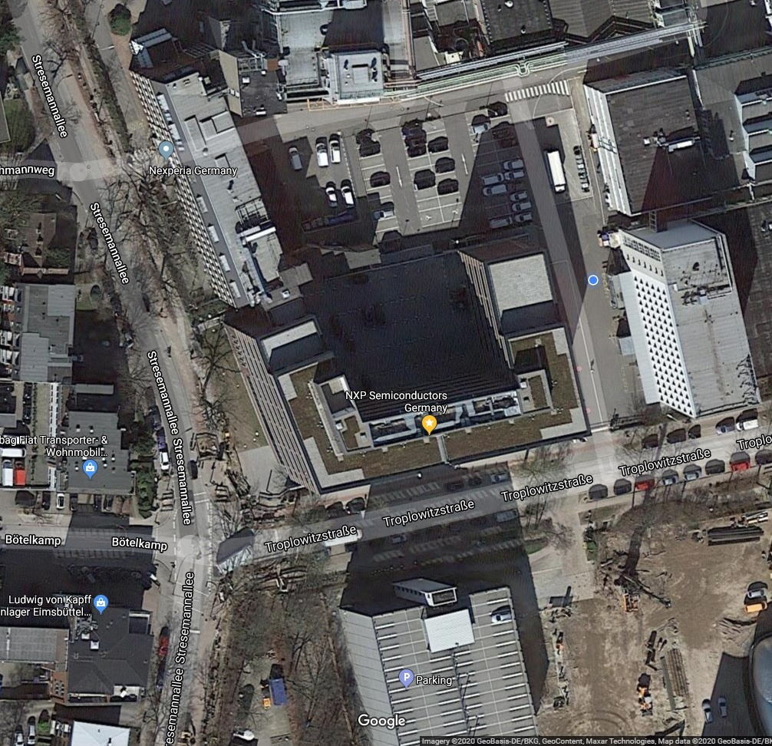

Figure 2: Aerial View of NXP Semiconductors GmbH Office building in Hamburg, Germany

* FlyingFox autonomously completes one circuit around the building in one minute, much shorter than the dispatch time.
* During the circuit, the camera feed is captured by the CPU and forwarded to an on-board real-time offline Machine Learning accelerator.
* The Machine Learning accelerator detects human poses from the camera feed, based on an SOS gesture.
* The number of detected humans is maintained.
* At the end of the circuit, the CPU pushes the AI-acquired data to the internet, where the fire brigade can have access to the data on the way to the distress location.

# SYSTEM COMPONENTS

The rich product portfolio of NXP inspired the FlyingFox team to use as much NXP technology and partner infrastructure as possible in order to create a coherent eco-system of fire-fighting drones.

Figure 3 shows the high-level system component diagram:

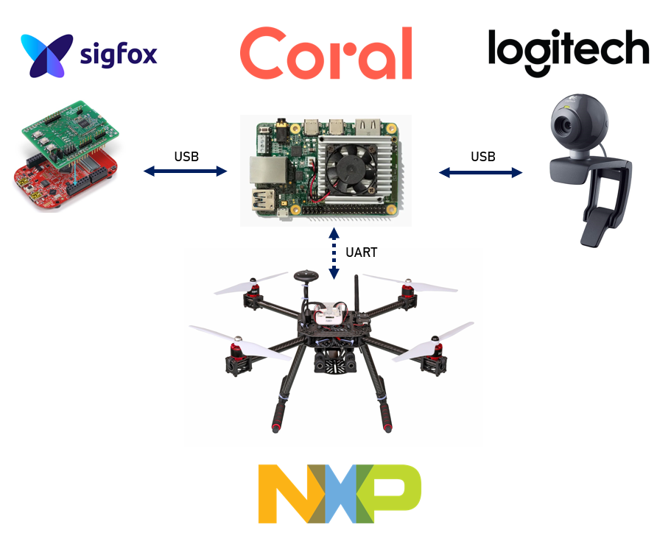

Figure 3:High-level component diagram

## GOOGLE CORAL EDGE TPU + CAMERA

The Google Coral Edge TPU development is the heart and the brain of FlyingFox.

The Coral board is a fully fledged Linux-based computer powered by the NXP i.MX 8M System-on-Chip (SOC). The Machine Learning add-on board (the EDGE TPU) is a TPU coprocessor capable of performing 4 trillion operations (tera-operations) per second. (TOPS), using 0.5 watts for each TOPS (2 TOPS per watt). For example, it can execute state-of-the-art mobile vision models such as MobileNet v2 at 400 FPS, in a power efficient manner.

## SIGFOX

Sigfox is a world-class worldwide service provider for Internet-of-Things (IoT).

The

NXP is an official partner to Sigfox and already has

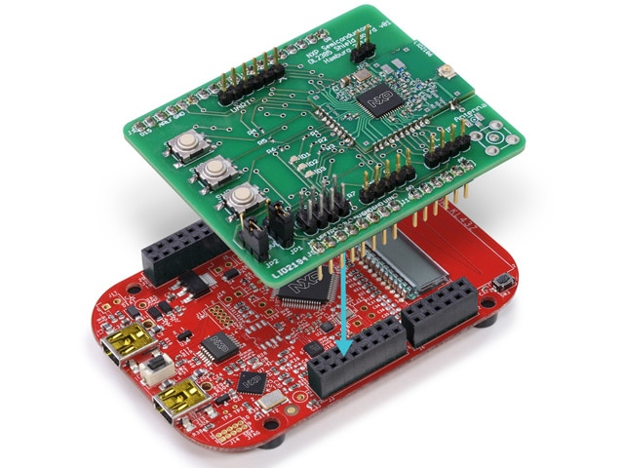

Figure 5: NXP OL2385 Sigfox board mounted on a NXP KL43 microcontroller board.



Figure 6: Sigfox coverage map

Figure 7 shows the final message presentation to the fire brigade, accessible

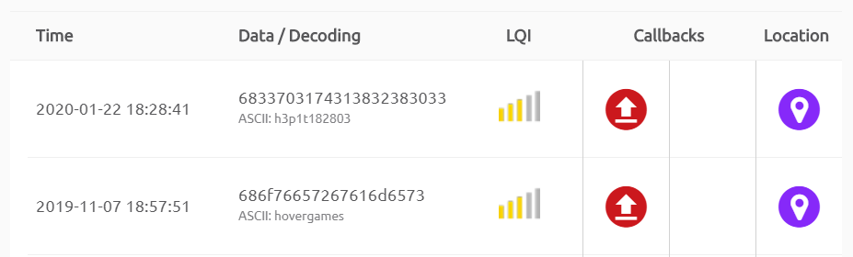

Figure 7:Sigfox message database accessible by the fire brigade through internet

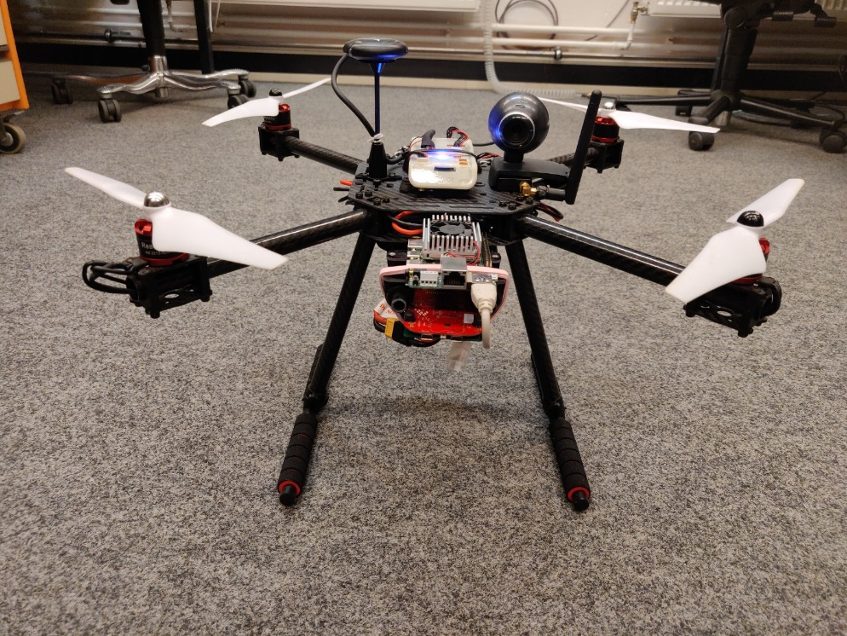

Google Edge TPU

Sigfox

FMU

CAMERA

Figure 8: FlyingFox - assembled NXP drone kit with FMU, Coral AI board and Sigfox IoT board.

# FLOW

## FIRST FLIGHT

The first task was to assemble the NXP drone kit. Task was successfully completed

[](https://www.youtube.com/watch?v=b3nBpN-8QPc)

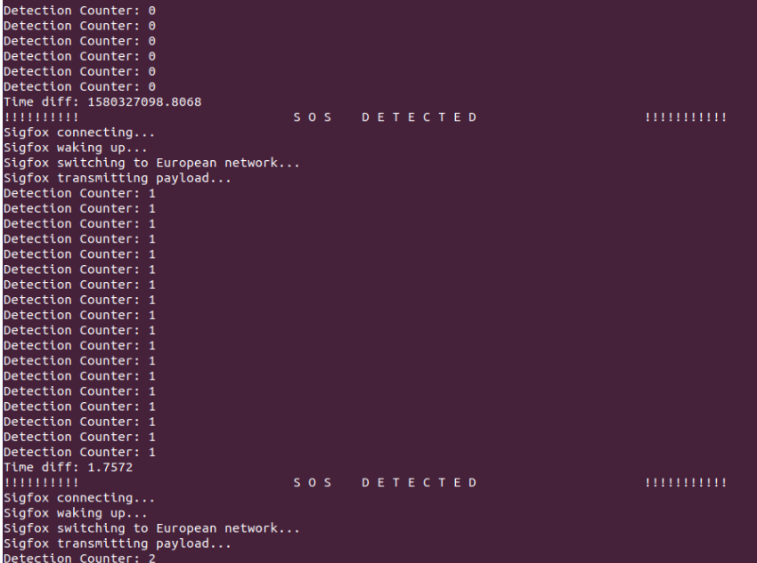

Figure 8:Coral Linux terminal output showing gesture detection and Sigfox interface

# OUTLOOK

This proof of concept is just the spark to finally introduce real-time offline Machine learning and AI capabilities to fire-fighting drones. As any proof of concept project, there is quite some room for improvement and optimization:

* Upgrade the camera to an ultra-high definition camera with 60 FPS with advanced low-light performance.
* Train the Machine learning algorithm to detect the floor on which a human gesture was detected.