When AI Misreads Us: A Behavioral Analysis of Multimodal Sentiment Models on Social Media Posts
Sherri Son
Fordham University, M.S. Data Science CISC 5800: Machine Learning · May 2026
Abstract
Multimodal sentiment analysis is increasingly deployed in production systems that influence what content is visible on social platforms. I benchmark five sentiment classifiers on MVSA-Single, a Twitter image-text dataset, comparing a CLIP zero-shot baseline, three RBF-kernel SVMs (text only, image only, and concatenated fusion), and an attention-gated multimodal MLP. Aggregate macro-F1 ranges narrowly between 0.383 and 0.668. However, a partition analysis splitting the test set by whether the unimodal classifiers agreed reveals that every model loses 23 to 45 macro-F1 points on the disagreement subset, the regime where sarcasm, irony, and cultural meaning live. SVM Fusion achieves the highest aggregate score (0.668) yet still drops 25 points on disagreement; the attention MLP, despite an interpretable gating mechanism, drops 23 points. I argue that the disagreement subset, not aggregate accuracy, is the fair test of multimodal understanding, and that the architectures studied here share a failure mode with the production moderation systems that decide which posts are amplified or suppressed. All code, embeddings, and case analyses are released at the accompanying GitHub repository.
Index Terms: multimodal sentiment analysis, CLIP, DistilBERT, attention fusion, content moderation, sarcasm detection, MVSA-Single.

I. INTRODUCTION
Social media platforms moderate billions of posts a day, and the overwhelming majority of that moderation is automated. The same multimodal architectures that drive content visibility on Instagram, TikTok, and YouTube, joint image-text encoders, attention-based fusion, classifier heads on frozen features, are also the architectures studied in the academic multimodal sentiment analysis literature. When these systems fail, real consequences follow: humanitarian content disappears from feeds, mental health awareness posts get demonetized, and posts in non-English or some ambiguous contexts are systematically misread.
This project asks a more focused version of that question: under what conditions does multimodal sentiment classification succeed, and under what conditions does it fail in ways that aggregate accuracy hides? I compare five models on the MVSA-Single benchmark, a CLIP zero-shot classifier, three SVM variants (text only, image only, and concatenated fusion), and an attention-gated MLP. My central methodological contribution is a partition analysis that splits the test set by whether the two unimodal models agreed, then evaluates every model on each subset separately. The disagreement subset, I argue, is the regime in which sarcasm, irony, and culturally-coded meaning actually live, and it is the regime in which model choice matters.
I make three contributions. First, I show that SVM Fusion achieved better performance than the neural fusion model (attention). Second, I introduce a behavioral case taxonomy that tags each test prediction with one of ten failure or success modes, enabling qualitative analysis of where the attention model succeeds (irony, visual culture) and where it fails (high-charge sentiment vocabulary). Third, I found that model accuracy decreased significantly in cases of conflicting sentiment and pictures, indicating that it is not good at detecting the linguistic signatures of sarcasm, irony, and culturally coded meaning.

II. BACKGROUND AND RELATED WORK
Multimodal sentiment analysis on social media was popularized by Niu et al. [1], who introduced the MVSA dataset and a label-reconciliation protocol for resolving disagreements between text and image annotators. Subsequent work has focused on improving fusion architectures, including MultiSentiNet [2], cross-modal attention models [3], and contrastive learning approaches [4]. The release of CLIP [5] enabled a new class of methods built on jointly pretrained image-text encoders, including zero-shot baselines and fine-tuned multimodal classifiers.
DistilBERT [6], a distilled version of BERT, provides efficient text representations that are competitive with the original model on sentence-level classification tasks while being substantially smaller. SVM-based fusion on pretrained features remains a strong baseline despite the popularity of end-to-end neural approaches, particularly on smaller datasets like MVSA-Single where parameter count exceeds training data.

III. DATASET AND PREPROCESSING

A. MVSA-Single
MVSA-Single [1] contains 4,869 paired image-text posts collected from Twitter. Each post receives two independent annotations, one for the text, one for the image, from a single annotator, with sentiment drawn from {positive, neutral, negative}. The dataset is small by modern standards but is widely used as a multimodal sentiment benchmark.

B. Label reconciliation
I adopt the standard MVSA reconciliation protocol from Niu et al. [1]. When both annotations agree, I keep the shared label. When one annotation is neutral and the other is positive or negative, I adopt the non-neutral label, treating neutral as the weaker signal. When the two annotations are directly contradictory (positive vs. negative), I drop the sample, since training on cases where human annotators cannot agree teaches the model conflicting signals.
This procedure removes 358 contradictory samples, leaving 4,511 usable posts. The resulting class distribution is 2,683 positive (59.5%), 1,358 negative (30.1%), and 470 neutral (10.4%). Neutral is severely underrepresented, a fact that drives several modeling choices below.
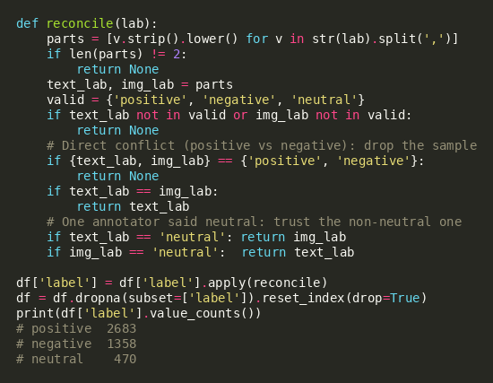
Listing 1. Label reconciliation function following the Niu et al. (2016) protocol.

C. Splits
I use a stratified 70/15/15 train/validation/test split, preserving the class distribution across splits. This yields 3,157 training, 677 validation, and 677 test samples. All experiments report results on the held-out test set; the validation set is used exclusively for hyperparameter tuning.

D. Feature extraction
I extract two pretrained embeddings per post and cache them to disk so that every downstream model trains on identical features. Image features come from the CLIP ViT-B/32 image encoder [5], producing a 512-dimensional vector per image. I L2-normalize the CLIP features so that downstream similarity computations behave as cosine similarity and so that magnitude differences do not dominate SVM training. Text features come from the DistilBERT base model [6], using the [CLS] token embedding from the final hidden layer (768 dimensions).
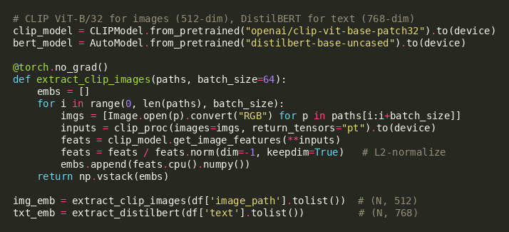
Listing 2. Feature extraction with frozen CLIP and DistilBERT encoders; L2 normalization on CLIP outputs is critical for downstream SVM stability.

IV. MODELS
I compare five sentiment classifiers, all of which operate on the same precomputed features described above. This ensures that observed performance differences reflect modeling choices rather than feature pipeline variations.

A. CLIP zero-shot baseline
As an untrained baseline, I use the CLIP model directly via prompt-based classification. I construct three template prompts, 'a photo expressing positive sentiment', 'a photo expressing negative sentiment', 'a photo expressing neutral sentiment', and encode each with the CLIP text encoder. For every test image, I compute cosine similarity to each prompt embedding and predict the argmax class. This requires no training data and serves as a floor on what pretrained multimodal alignment alone can achieve on this task.
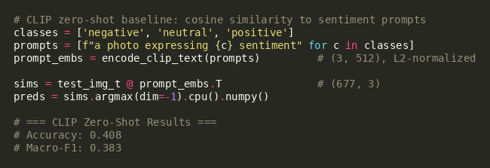
Listing 3. CLIP zero-shot classification. Test accuracy is 0.408, barely above chance on three classes.

B. RBF-kernel SVMs
I train three SVMs with RBF kernels: a text-only SVM on DistilBERT features (768-dim), an image-only SVM on CLIP features (512-dim), and a fusion SVM on concatenated features (1,280-dim). All three are trained with the same hyperparameter grid (C in {0.1, 1, 10, 100}, gamma in {scale, 0.001, 0.01, 0.1}) and the same balanced class weighting, a non-optional design choice given that neutral is only 10% of the data.
Hyperparameter selection uses scikit-learn's PredefinedSplit on the validation set rather than standard k-fold cross-validation. This ensures the SVM is tuned on exactly the same validation samples I report results on, avoiding subtle data-leakage effects when comparing against the deep model below.
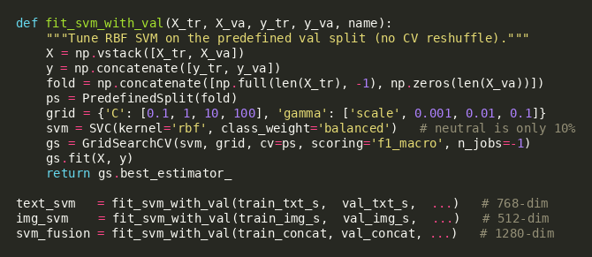
Listing 4. RBF SVM training with Predefined Split hyperparameter tuning and balanced class weighting.

C. Attention-gated MLP
To test whether learned attention across modalities outperforms simple concatenation, I implement a lightweight attention-gated MLP. Each modality is projected independently into a shared 256-dimensional space via a linear layer followed by a tanh activation. A second linear layer produces a scalar attention score per modality, and a softmax over these two scores yields per-post weights that sum to one. The fused representation is the attention-weighted sum of the two projected vectors, which is passed through a small classifier head (256 → 128 → 3) with ReLU activation and dropout.
The model is trained for up to 50 epochs with Adam (learning rate 1e-3, weight decay 1e-5), cross-entropy loss with balanced class weights, and early stopping on validation macro-F1 with patience 8. I return the attention weights from the forward pass so that, at inference time, I can inspect how much the model trusted each modality per prediction.
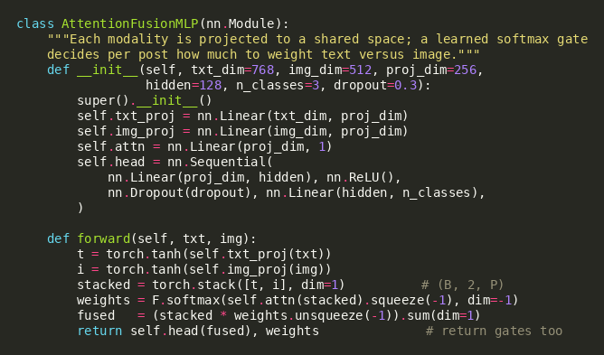
Listing 5. Attention-gated MLP. Per-post softmax over modality scores produces interpretable gating weights returned by the forward pass.

V. RESULTS

A. Aggregate performance
Table I reports accuracy and macro-F1 on the 677-sample test set for all five models. SVM Fusion achieves the highest macro-F1 at 0.668, followed by Image SVM (0.622), Attention MLP (0.603), Text SVM (0.575), and CLIP zero-shot (0.383). The attention model, contrary to my initial hypothesis, does not outperform the simpler concatenated SVM.
Table I. Test set performance (n=677). F1 agree and F1 disagree report macro-F1 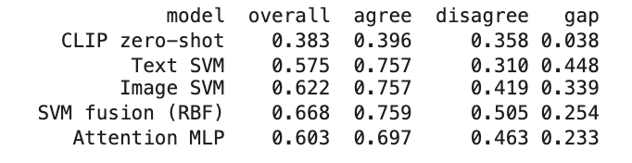
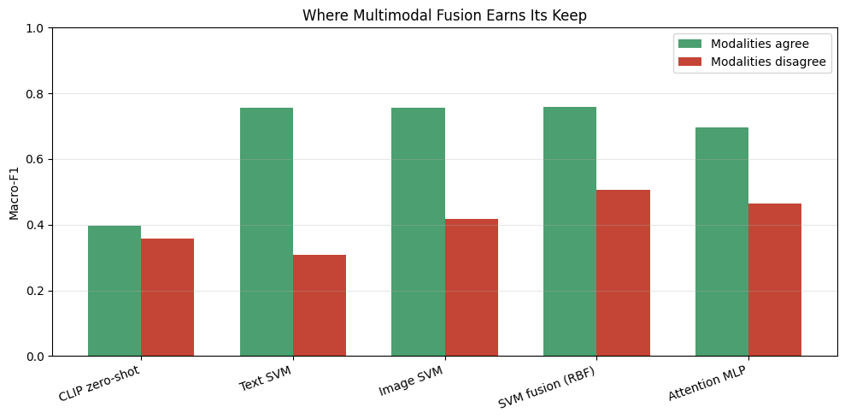

B. Partition analysis: where multimodal fusion earns its keep
Aggregate accuracy obscures the regime in which multimodal models matter. I partition the test set by whether the two unimodal classifiers agreed: 427 samples (63.1%) where Text SVM and Image SVM produced the same prediction (the agreement subset), and 250 samples (36.9%) where they disagreed (the disagreement subset).
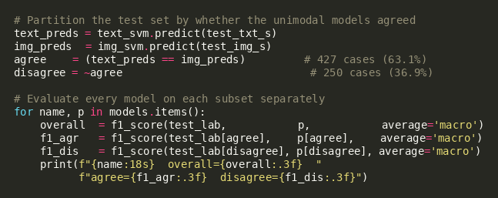
Listing 6. Partition analysis. The agree/disagree split defines two evaluation regimes; every model is evaluated on each subset separately.
The pattern in Table I and the partition columns is consistent. On the agreement subset, every trained model scores between 0.697 and 0.759 macro-F1, a narrow 6-point band in which model choice barely matters. On the disagreement subset, scores collapse to between 0.310 and 0.505, a 19-point band where the differences between models suddenly matter a great deal.
More strikingly, every model loses substantial macro-F1 between the two subsets: Text SVM loses 44.7 points, SVM Fusion loses 25.4 points, and even the attention model, my best on disagreement after the SVM fusion, loses 23.4 points. The drop is not a bug; it is the measurement. The disagreement subset is where the two channels actively conflict, and conflict is the linguistic signature of sarcasm, irony, and culturally coded meaning. My results suggest that none of these architectures reliably resolves such conflicts.

C. Behavioral case taxonomy
To move beyond aggregate metrics, I tag each test prediction with at most one of ten behavioral patterns organized into four groups: save (multimodal fusion adds value), harm (fusion makes things worse), pattern (interesting systematic failures), and baseline (control cases such as universal agreement or universal failure across all five models).
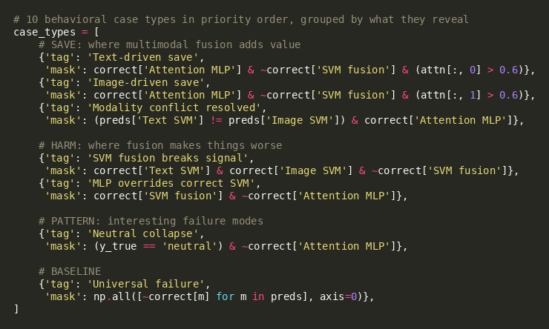
Listing 7. Behavioral case taxonomy. Each test sample is tagged with its first matching pattern, supporting the qualitative analysis in §V-D.

D. Qualitative findings
Four representative cases (selected from the 20-case gallery in the supplementary material) illustrate where the attention MLP succeeds and where it fails.
Text-driven save. Tweet: 'Heartbreaking moment when you realize you've got sparkling water instead of still ??', paired with a photo of a water bottle. True label: negative. All four other models predict positive; the attention MLP correctly predicts negative, with an attention weight of 0.94 on the text channel. The word 'heartbreaking' is the dominant signal, and the gating mechanism correctly downweighs the bland product image.
Image-driven save. Tweet: 'RT @kjo19: Hey Blue Jays Nation......', paired with the Gladiator 'Are you not entertained?' meme. True label: positive. The four other models predict negative; the attention MLP correctly predicts positive, with an attention weight of 0.98 on the image. With negligible text content, the gate correctly defers to the visual signal.
Lexical trap. Tweet: 'If everyone does their small part, we will change HEARTS AND MINDS about depression this year. Let's band together.' True label: positive (an awareness campaign). SVM Fusion correctly predicts positive; the attention MLP incorrectly predicts negative. The single high-charge word 'depression' overrides the surrounding context, and the gating mechanism cannot recover.
Label noise. Tweet: a sharply critical post about Christian Grey romanticizing domestic abuse, signed off with 'happy Valentine's Day:)'. True label: positive. All five models predict negative or neutral. The annotation almost certainly weighted the closing valentine over the content, suggesting a non-trivial fraction of universal-failure cases on MVSA-Single are label errors rather than model errors.

VI. DISCUSSION

A. Why does SVM Fusion beat Attention MLP?
My initial hypothesis was that an attention mechanism would outperform concatenation, since attention can learn per-post weighting of modalities. The empirical result is the opposite: concatenated SVM beats the attention MLP by 6.5 macro-F1 points on aggregate and by 4.2 points on the disagreement subset. I attribute this to three factors. First, MVSA-Single is small (3,157 training samples), and the attention MLP has more learnable parameters than the SVM's RBF kernel can effectively constrain on this dataset size. Second, both models use the same frozen pretrained features; the attention gate cannot recover information that the encoders have already discarded. Third, the SVM's RBF kernel implicitly captures non-linear interactions between text and image features in a way that the attention MLP's gated sum cannot, since the gate operates after each modality has been independently projected and pooled.

B. The disagreement subset is the fair test
I argue that aggregate accuracy on MVSA-Single rewards an easy regime (the agreement subset) and conceals systematic failure in a harder regime (the disagreement subset). Future work on multimodal sentiment models should report partition-level results, not only aggregate metrics. A model that performs well on the agreement subset and poorly on the disagreement subset has not learned multimodal reasoning; it has learned to copy the dominant signal when both channels point in the same direction.

C. Implications for automated content moderation
The architectures studied here, CLIP-derived encoders, attention-based fusion, classifier heads on frozen features, are not the systems Meta, YouTube, or TikTok deploy for content moderation, but they are close relatives. Moderation systems face the same multimodal reasoning problem as sentiment classification, only from a different angle: distinguishing humanitarian documentation from gratuitous violence, satire from hate, survivor testimony from glorification. My results suggest that this class of architecture struggles precisely where conflict between channels carries meaning, the regime in which a clothed photo with a violent caption, or a critical caption over a neutral image, requires reading the gap between modalities. If a small-scale benchmark with hand-labeled examples cannot be reliably classified in this regime, billion-post-a-day production pipelines applying the same family of techniques are unlikely to do better.

D. Label noise as a ceiling
In constructing the case gallery, I noticed at least one universal-failure example where the true label appears clearly mistaken where a sharply critical post was labeled positive. This is anecdotal rather than the result of a systematic audit, but it suggests that aggregate accuracy on MVSA-Single may be bounded above by label noise, and that a proper audit of the universal-failure subset would be a useful next step.

VII. LIMITATIONS
- Dataset scale. MVSA-Single contains only 4,511 usable posts after reconciliation. Conclusions about which fusion strategy is best may not transfer to larger benchmarks such as MVSA-Multiple or TumblrSet.
- Frozen encoders. I do not fine-tune CLIP or DistilBERT. Fine-tuning either encoder on the sentiment task might change the relative ranking of fusion strategies, particularly on the attention model, which has more capacity to exploit improved features.
- Unequal hyperparameter search. The three SVMs were tuned over a grid of C and gamma values using PredefinedSplit on the validation set, while the attention MLP used a fixed set of hyperparameters (learning rate, weight decay, projection dimension, hidden size, dropout). A fairer comparison would tune the MLP over a similar-sized grid.
- Single sentiment scheme. I use the three-class scheme defined by MVSA. Real-world moderation systems operate on multi-label policy categories, and the cross-task transfer of my findings is conjectural.
- No statistical testing across seeds. All results are reported from a single training run with fixed random seed. A more rigorous treatment would report variance across multiple seeds, particularly for the attention MLP, whose performance is more seed-sensitive than the deterministic SVMs.
- Label noise audit not performed. The label-noise concern raised in §VI-D is based on a single clearly mistaken case identified during gallery construction, not a systematic audit. A proper audit of the universal-failure subset would either strengthen or refute the claim that aggregate accuracy on MVSA-Single is bounded above by label quality.

VIII. CONCLUSION
I benchmarked five multimodal sentiment classifiers on MVSA-Single and found that aggregate accuracy understates the differences between models. Partitioning the test set by whether the unimodal classifiers agreed reveals that all models drop substantially on the conflict regime, and that this is the regime in which sarcasm, irony, and culturally coded meaning live. SVM Fusion modestly outperforms an attention-gated MLP overall, but both models lose 23-25 macro-F1 points on disagreement, suggesting that none of the studied architectures reliably resolve conflicts between text and image. My behavioral case taxonomy isolates specific patterns of success and failure: text-driven saves for sarcasm, image-driven saves for visual culture, lexical traps for high-charge sentiment words, and at least one clear instance of mistaken gold-label annotation. I argue that future evaluation of multimodal sentiment systems should report partition-level results, and that practitioners deploying related architectures in production content moderation should treat aggregate accuracy as a misleading measure of how those systems will behave on the cases that matter most.

REFERENCES
[1] T. Niu, S. Zhu, L. Pang, and A. El Saddik, “Sentiment analysis on multi-view social data,” in Proc. MultiMedia Modeling (MMM), 2016, pp. 15 to 27.
[2] N. Xu and W. Mao, “MultiSentiNet: A deep semantic network for multimodal sentiment analysis,” in Proc. ACM CIKM, 2017.
[3] Z. Yang et al., “Multimodal sentiment analysis representations learning via contrastive learning with condense attention fusion,” Sensors, vol. 23, no. 5, 2023.
[4] Y. Li et al., “CLMLF: A contrastive learning and multi-layer fusion method for multimodal sentiment detection,” in Findings of NAACL, 2022.
[5] A. Radford et al., “Learning transferable visual models from natural language supervision,” in Proc. ICML, 2021.
[6] V. Sanh, L. Debut, J. Chaumond, and T. Wolf, “DistilBERT, a distilled version of BERT: smaller, faster, cheaper and lighter,” in NeurIPS Workshop on Energy Efficient ML, 2019.
[7] C. Cortes and V. Vapnik, “Support-vector networks,” Machine Learning, vol. 20, no. 3, pp. 273 to 297, 1995.
[8] Human Rights Watch, “Meta's Broken Promises: Systemic Censorship of Palestine Content on Instagram and Facebook,” Dec. 2023.

APPENDIX A, REPRODUCIBILITY

A.1 Code and embeddings
All training, evaluation, and visualization code is released at the project's GitHub repository under the MIT license. The repository includes the embedding-extraction notebook, the SVM and attention MLP training scripts, the partition analysis, the case-gallery generator, and the full 20-case gallery with predictions and attention weights for each.

A.2 Environment
Experiments were run in Google Colab with a single T4 GPU. Key library versions: Python 3.12, PyTorch 2.4, transformers 4.46, scikit-learn 1.5. The full requirements.txt is included in the repository.

A.3 Reproducing the headline numbers
Running the notebooks in order reproduces all numbers reported in Table I, all figures, and the case gallery. The slowest step is extracting CLIP and DistilBERT embeddings, which is done once and cached to disk; all subsequent training and evaluation runs use those cached embeddings.

