**NAME:** MUHAMMAD SHARUL AIMAN BIN MAZLAN

**MATRICS:** 2019273606

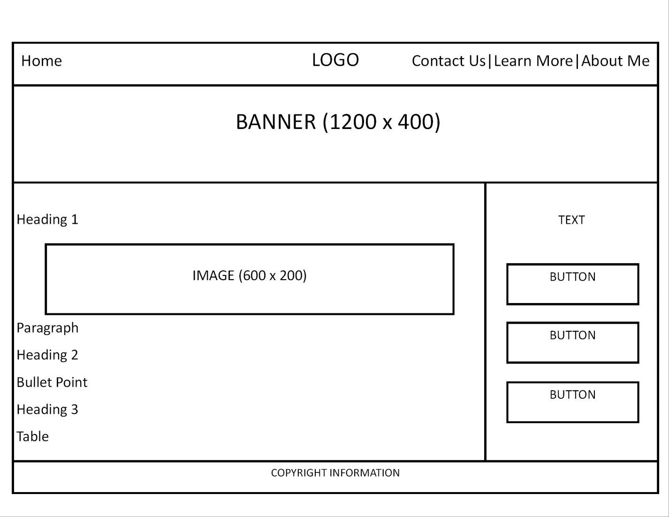

Homepage. In this page, user can read info about cryptocurrency and gain more knowledge, at the same time, with the table provided in this page, user also can see the example of the cryptocurrencies here. There are also buttons on the right side to redirect user to the certain pages related to the website.

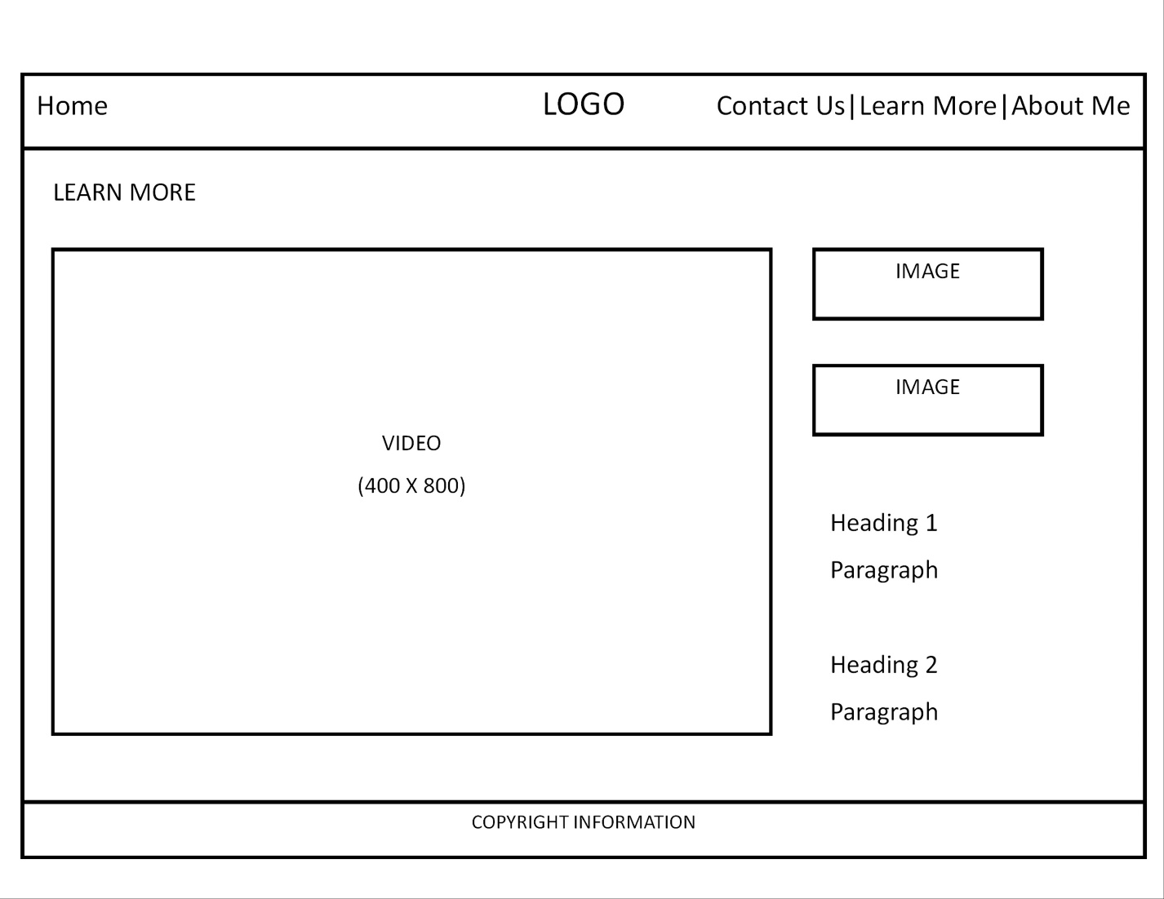

Learn more page. Here, user can watch the videos about cryptocurrency, and easily understand with the graphical explaination.

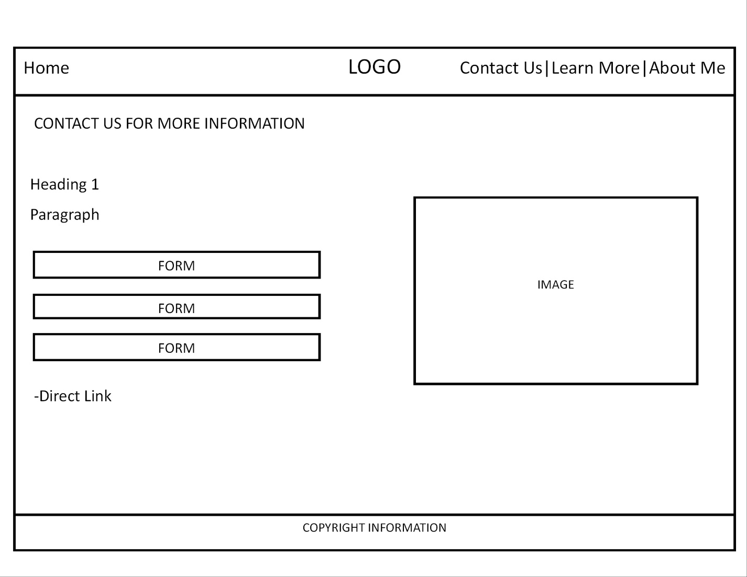

Contact us page, in this page, user can check the information about this website, or leave their info like email, phone number and name on this page. So they can stay updated to the website.

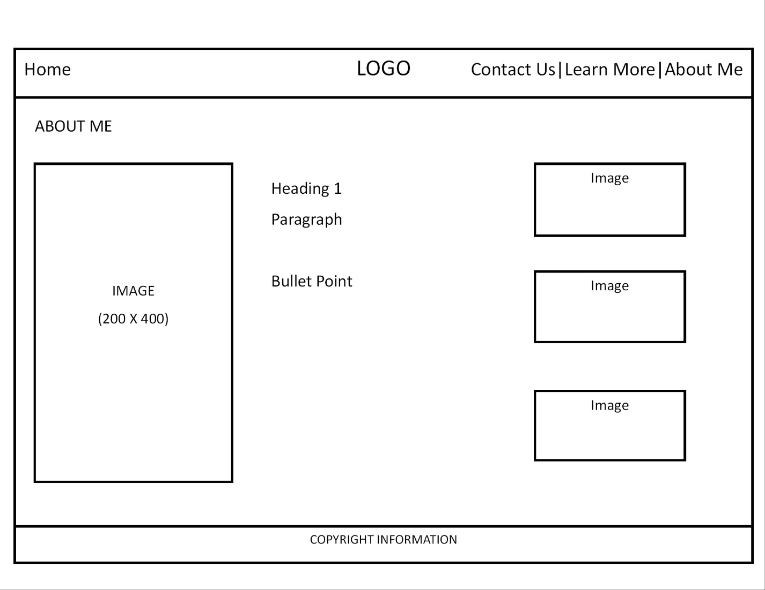

About me page allow user to know more about the author of the website. Here, more information about the creator is state in this page.

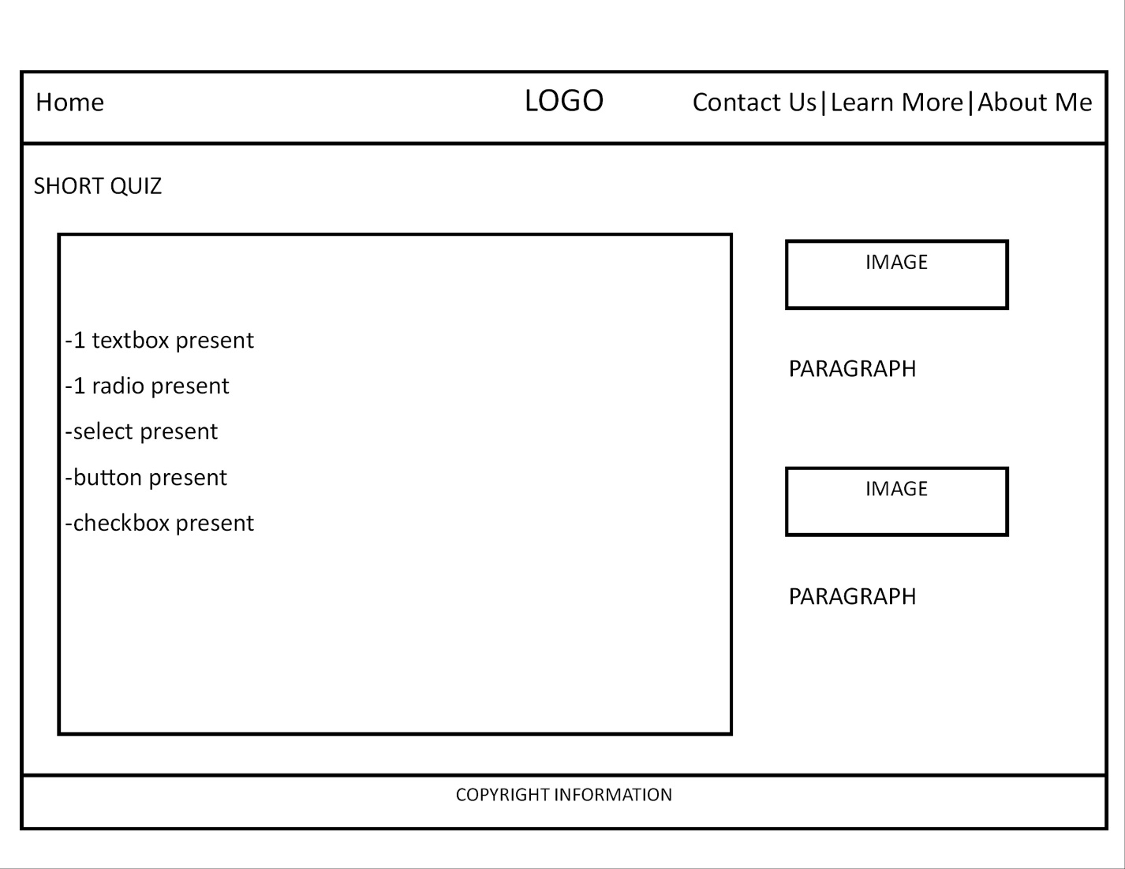

Short quiz section, allows user to answer short questions, so they can test their understanding about the cryptocurrency. They also can improve their knowledge about cryptocurrency once they took this short quiz.