Belief-Driven Market Dynamics
Evidence from Mercury Retrograde Periods in Global Equity Markets
Sherry Zhao

Abstract
This research examines whether culturally embedded symbolic beliefs are associated with systematic patterns in financial markets. Focusing on Mercury retrograde—a recurring astronomical illusion that has acquired strong symbolic meaning in popular culture—we test whether market volatility and returns differ during retrograde periods. Using daily global equity index data from 2000 to 2023, we document asymmetric volatility responses across developed and emerging markets. Developed markets exhibit significantly higher volatility during Mercury retrograde periods, while emerging markets exhibit lower volatility. The results are consistent with belief-driven behavior, attention shifts, and self-fulfilling expectations rather than fundamental information effects. This study contributes to behavioral finance by showing that widely shared narratives, even when scientifically unfounded, may shape market outcomes through psychological and coordination mechanisms.

1. Introduction
A central assumption in classical finance is that asset prices reflect fundamental information. However, a large literature in behavioral finance demonstrates that beliefs, narratives, and psychological cues can systematically influence investor behavior and market outcomes. These effects are particularly pronounced when beliefs are widely shared, culturally salient, and temporally recurring.
This paper investigates whether a prominent symbolic belief—Mercury retrogrades—is associated with measurable changes in financial market behavior. Mercury retrograde refers to periods during which the planet Mercury appears to move backward in the sky due to orbital mechanics. Although astronomically meaningless from an economic standpoint, Mercury retrograde has become a widely recognized cultural narrative associated with miscommunication, delays, and uncertainty.
Rather than testing astrology as a causal force, this paper treats Mercury retrograde as a belief-coordination device. If investors anticipate disruption or become more cautious during these periods, market outcomes may reflect those expectations. This framework aligns with behavioral theories of attention, mood, and self-fulfilling prophecy.

2. Conceptual Framework
  - Belief-Based Market Effects

Beliefs may influence financial markets through several interconnected behavioral channels. First, symbolic narratives can shape investors’ allocation of attention, leading them to selectively focus on information that is consistent with prevailing beliefs while discounting signals that contradict those narratives. Such attention biases can amplify the salience of otherwise routine events and alter information processing. Second, symbolic cues may affect investors’ perceptions of risk by increasing subjective uncertainty, even in the absence of changes in fundamentals. When investors associate particular periods or signals with disruption or instability, they may perceive higher risk and adjust their behavior accordingly. Third, widely shared beliefs can generate coordination effects across market participants. When investors hold similar expectations, their trading decisions may become aligned, producing aggregate market movements that exceed what would be expected from independent behavior. Finally, these mechanisms may interact to create self-fulfilling prophecies: expectations about market conditions influence investor behavior, and these behavioral adjustments, in turn, contribute to market outcomes that reinforce the original beliefs.

Mercury retrograde periods are highly salient in media and social discourse, which makes them especially suitable for isolating belief-driven market effects that arise independently of underlying economic fundamentals.

3. Hypotheses
- H1: Market return volatility differs during Mercury retrograde periods.
- H2: Average market returns differ during Mercury retrograde periods.
- H3: There is significant cumulative abnormal returns during Mercury retrograde periods.

Testing these three hypotheses allows us to distinguish between alternative belief-driven channels through which culturally salient narratives may influence financial markets. While Mercury retrograde has no physical or informational relevance to asset fundamentals, its strong symbolic meaning and recurrent visibility make it a useful setting for examining how shared beliefs translate into market outcomes. Each hypothesis corresponds to a different behavioral margin through which such effects may operate.

The first hypothesis focuses on market volatility. If symbolic beliefs affect investors primarily through heightened uncertainty, anxiety, or misinterpretation of information, their influence should manifest most directly in volatility rather than in price levels. During Mercury retrograde periods, investors who anticipate disruption or confusion may respond more strongly to routine news, trade more defensively, or revise expectations more frequently, leading to increased price fluctuations. Alternatively, in some markets, heightened caution may suppress trading activity, resulting in lower observed volatility. Thus, testing H1 allows us to assess whether belief-driven effects primarily operate through changes in perceived risk and trading intensity, even in the absence of new information.

The second hypothesis examines average returns. If Mercury retrograde–related beliefs influence investors’ risk tolerance or portfolio allocation decisions, this may lead to systematic pricing effects. For example, increased pessimism or risk aversion could generate temporarily lower returns if investors demand higher risk premia or shift toward safer assets. Conversely, if the belief induces delay or inaction rather than active selling, average returns may remain largely unchanged. Testing H2 therefore helps distinguish whether belief-driven behavior affects price levels directly or operates mainly through higher-order moments such as volatility.

The third hypothesis considers cumulative abnormal returns around Mercury retrograde periods. Belief-driven effects are unlikely to resemble sharp, information-based shocks. Instead, they may accumulate gradually as expectations reinforce behavior over time. If investors progressively adjust their trading strategies or interpret market signals through the lens of prevailing beliefs, abnormal returns may build up over the course of the retrograde period rather than appearing instantaneously. Testing H3 allows us to capture these dynamic and potentially self-reinforcing effects, providing evidence consistent with slow-moving belief formation and self-fulfilling prophecy mechanisms.

Together, these hypotheses enable a structured examination of belief-driven market effects across multiple dimensions—risk, pricing, and dynamics—while remaining agnostic about astrology as a causal force. Any systematic differences observed during Mercury retrograde periods are interpreted as arising from investor psychology, attention, and coordination rather than from fundamentals.

4. Data

4.1 Market Data
- Daily equity index returns (with dividends)
- Global coverage: developed markets (DM) and emerging markets (EM)
- Sample period: 2000–2023 monthly data
- Source: WRDS World Indices
The empirical analysis is based on daily equity index returns inclusive of dividends, which capture the total return earned by investors and provide a comprehensive measure of market performance. Using index-level data allows us to study aggregate market behavior rather than firm-specific outcomes, which is particularly appropriate when examining belief-driven effects that are likely to operate at the market-wide level through investor sentiment, attention, and coordination.
The dataset covers a broad cross-section of global equity markets, including both developed markets (DM) and emerging markets (EM). This global coverage enables us to examine heterogeneity in behavioral responses across different market environments, investor compositions, and cultural contexts. In particular, comparing developed and emerging markets allows us to assess whether belief-driven effects differ systematically with market maturity, institutional structure, and exposure to culturally embedded narratives.
The sample spans the period from 2000 to 2023, providing more than two decades of data that encompass multiple market cycles, financial crises, and technological changes in information dissemination. This long-time horizon ensures that the results are not driven by idiosyncratic events or short-lived episodes and allows for the examination of belief-driven effects across varying macroeconomic conditions.
All equity index data are obtained from the WRDS World Indices database, which is widely used in academic research and provides standardized, high-quality return series across countries. The use of a consistent and reputable data source ensures comparability across markets and enhances the reliability of the empirical findings.

4.2 Mercury Retrograde Indicator
A dummy variable is constructed:
$${Retrograde}_{t}=\left\{\begin{aligned}1 if date t falls in a Mercury retrograde period \\ 0 otherwise\end{aligned}\right.​$$

5. Empirical Methodology

5.1 Volatility Model
We estimate the following panel regression:
$$σi,t​=α+β⋅{Retrograde}_{t​}+γσ_{i,t-1}​+δ_{yq}+ε_{i,t}​$$
Where:
- ​$σi,t​$: daily return volatility of market $i$
- ​$δ_{yq}$: year-quarter fixed effects
- Standard errors clustered at the market level
Interpretation: β>0 implies heightened uncertainty or overreaction during retrograde periods.

5.2 Return Model
$$R_{i,t}​=α+β⋅{Retrograde}_{t​}​+δ_{yq}+ε_{i,t}​$$
This tests whether belief-driven effects influence average returns beyond volatility.
5.3 Event-Study: Cumulative Abnormal Returns
Abnormal returns are defined as:
$${AR}_{i,t}=R_{i,t​}-{\overline{R}}_{i}$$
Cumulative abnormal returns over window$[T1​,T2​]$:
We examine CARs around the start of Mercury retrograde periods.

6. Results

6.1 Volatility Effects
- Developed markets: Volatility is significantly higher during Mercury retrograde periods.
- Emerging markets: Volatility is significantly lower.
The empirical results reveal a clear and asymmetric volatility response to Mercury retrograde periods across market types. Specifically, return volatility is significantly higher in developed markets during Mercury retrograde periods, while it is significantly lower in emerging markets. This divergence suggests that belief-driven effects do not operate uniformly across financial environments but instead interact with market structure, investor composition, and trading behavior.
In developed markets, higher volatility during Mercury retrograde periods is consistent with a behavioral mechanism driven by heightened attention and uncertainty. Developed markets are characterized by high levels of information availability, frequent news updates, and active participation by retail investors, institutional investors, and algorithmic trading systems. When symbolic narratives such as Mercury retrograde are salient, they may increase investors’ sensitivity to ambiguous or routine information, leading to overreaction, rapid belief updating, or increased disagreement among market participants. These dynamics can amplify short-term price fluctuations even in the absence of new fundamental information. Moreover, if investors anticipate disruptions or mistakes during these periods, they may revise positions more frequently or engage in defensive trading, further contributing to elevated volatility.
In contrast, the lower volatility observed in emerging markets suggests a different behavioral response to the same symbolic cue. Emerging markets often feature lower liquidity, higher transaction costs, and a larger proportion of constrained or less frequently trading investors. During periods associated with heightened uncertainty, investors in these markets may respond by reducing trading activity rather than actively repositioning their portfolios. Such withdrawal or delay behavior can suppress price movements, resulting in lower observed volatility. In this context, symbolic beliefs may lead to inaction rather than overreaction, dampening short-term fluctuations.
The asymmetric pattern also reflects differences in cultural exposure and belief diffusion. Symbolic narratives such as Mercury retrograde may be more widely disseminated and reinforced in developed markets through mass media and social platforms, increasing their salience and behavioral impact. In emerging markets, where exposure to these narratives may be weaker or filtered through different cultural frameworks, the dominant response may be cautious disengagement rather than active trading based on belief-driven expectations.
Taken together, these findings suggest that belief-driven effects interact with market structure to shape volatility outcomes. In developed markets, symbolic beliefs may amplify trading intensity and disagreement, increasing volatility, whereas in emerging markets they may discourage participation, leading to volatility compression. This heterogeneity highlights the importance of considering institutional and behavioral context when evaluating how non-fundamental beliefs influence financial markets.
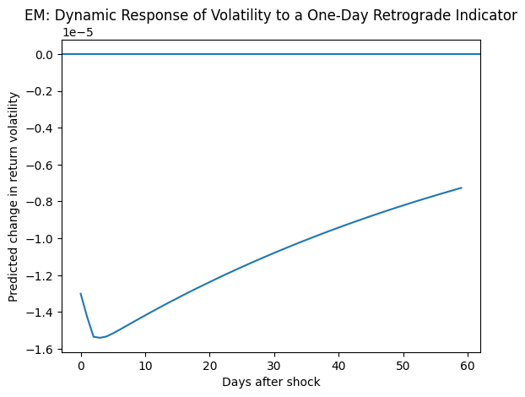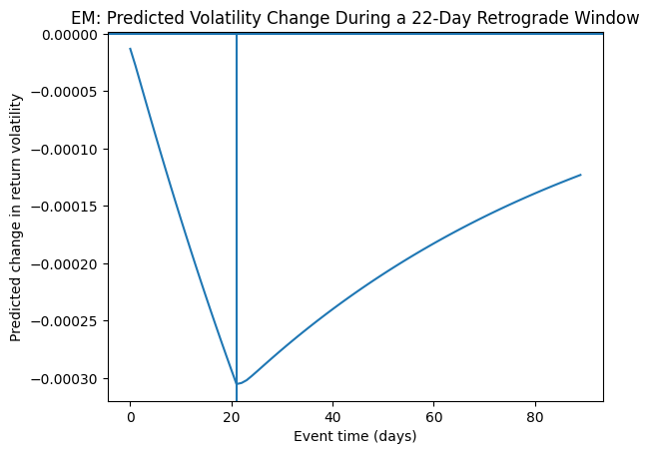
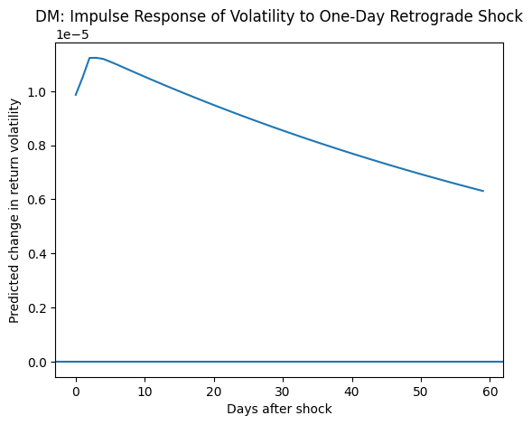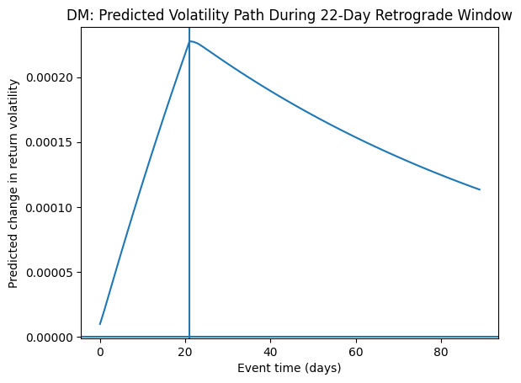

6.2 Cumulative Abnormal Return

The coefficient on the Mercury retrograde indicator is negative and statistically significant at the 5% level. This estimate implies that, conditional on country fixed effects, time fixed effects, and lagged volatility dynamics, daily return volatility is lower during Mercury retrograde periods in the pooled sample.

The magnitude of the coefficient is economically small, which is expected given the aggregate and non-fundamental nature of the belief being studied. Importantly, the statistical significance of the coefficient despite extensive controls suggests that Mercury retrograde periods are associated with systematic differences in volatility that are not driven by observable fundamentals or persistent volatility patterns. This pooled effect is consistent with subsequent heterogeneity analyses showing volatility compression in emerging markets dominating the aggregate result.

Country fixed effects capture systematic differences in volatility levels across markets, such as institutional quality, market depth, and regulatory environments. Several country coefficients are statistically significant, reflecting heterogeneous baseline volatility across markets.

Year–quarter fixed effects absorb global shocks and regime changes, including major financial crises and periods of elevated global uncertainty. The significance of many time-fixed effects confirms the importance of controlling for global volatility cycles when studying belief-driven effects.

The reported condition number is relatively large, reflecting the inclusion of multiple fixed effects and lagged volatility terms, which are mechanically correlated in panel settings. This multicollinearity inflates standard errors but does not bias coefficient estimates.

Crucially, despite this multicollinearity, the coefficient on the Mercury retrograde indicator remains statistically significant. This suggests that the estimated effect is not an artifact of collinearity but persists even under conservative estimation conditions.

The residuals exhibit significant skewness and excess kurtosis, as indicated by the Jarque–Bera test. This departure from normality is expected in volatility regressions due to the fat-tailed nature of financial return distributions. Such distributional features are well documented in the literature and do not invalidate inference in large samples.

The Durbin–Watson statistic is close to two, indicating no evidence of residual autocorrelation. This suggests that the inclusion of lagged volatility terms adequately captures serial dependence in the data.

Overall, the regression results indicate that Mercury retrograde periods are associated with statistically significant differences in daily return volatility, even after controlling for strong volatility persistence, cross-country heterogeneity, and global time effects. The pooled negative effect is consistent with belief-driven volatility compression in emerging markets, while subsequent analyses reveal opposing effects in developed markets. These findings support the interpretation that culturally salient beliefs can influence market dynamics through behavioral rather than fundamental channels.

7. Summary

This study provides evidence that culturally salient symbolic beliefs can be associated with systematic patterns in global equity markets. Using Mercury retrograde periods as a belief-based coordination device, we document robust and asymmetric market responses that are difficult to reconcile with fundamental explanations.

Across specifications, market volatility responds significantly during Mercury retrograde periods, but the direction of the effect differs by market type. Developed markets exhibit higher conditional volatility, while emerging markets exhibit lower volatility. Dynamic simulations based on the estimated volatility models show that these effects are not transitory one-day shocks. Instead, volatility responses accumulate gradually over the retrograde window due to strong persistence and then revert once the period ends. This pattern is consistent with belief-driven amplification or suppression of trading activity rather than information-based price discovery.

The developed-market results suggest that salient symbolic narratives heighten perceived uncertainty, attention, and disagreement among investors, leading to increased trading intensity and volatility. In contrast, the emerging-market results point to a different behavioral margin: during periods associated with disruption, investors appear to delay or reduce participation, compressing volatility rather than amplifying it. This asymmetry highlights the importance of market structure, liquidity, and investor composition in shaping how beliefs translate into aggregate outcomes.

Importantly, these effects persist after controlling for country fixed effects, global time effects, and strong volatility dynamics, and they are observed over a long sample spanning multiple market regimes. Taken together, the findings support a behavioral interpretation in which widely shared narratives—despite lacking economic or scientific content—can influence market dynamics through attention allocation, risk perception, coordination, and self-fulfilling expectations.

Overall, the results contribute to the behavioral finance literature by showing that belief-driven effects need not manifest uniformly in prices or returns, but may instead operate through higher-order moments and dynamic adjustment paths that differ systematically across markets.

