Project：
study how technology, time period, and socioeconomic structure affect human survival probability
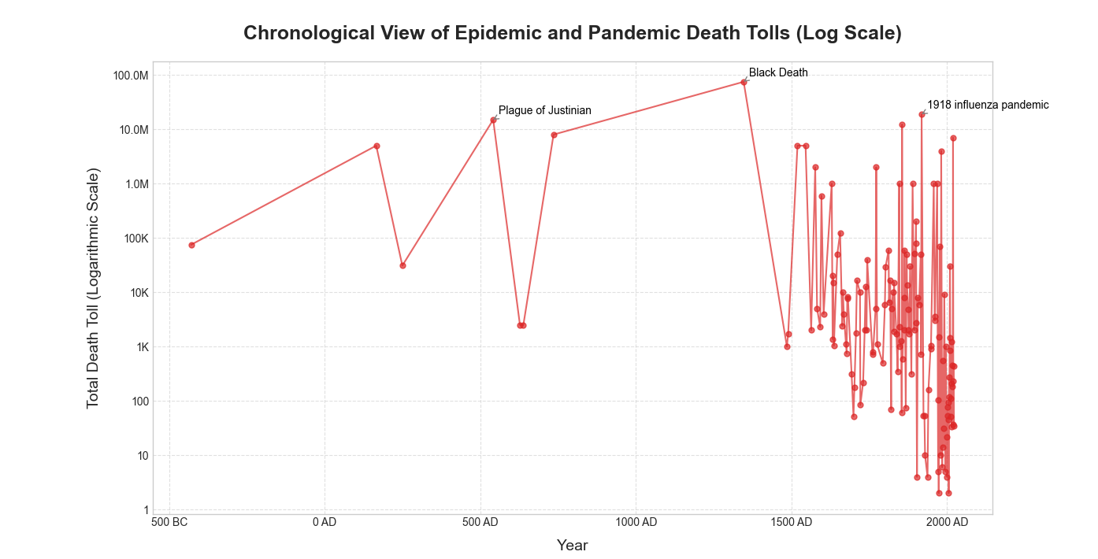
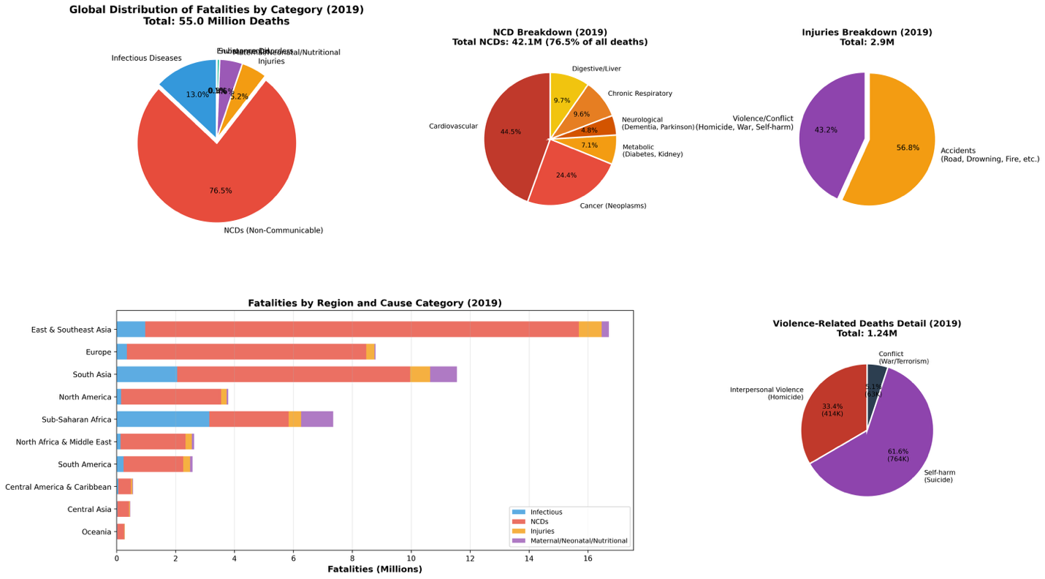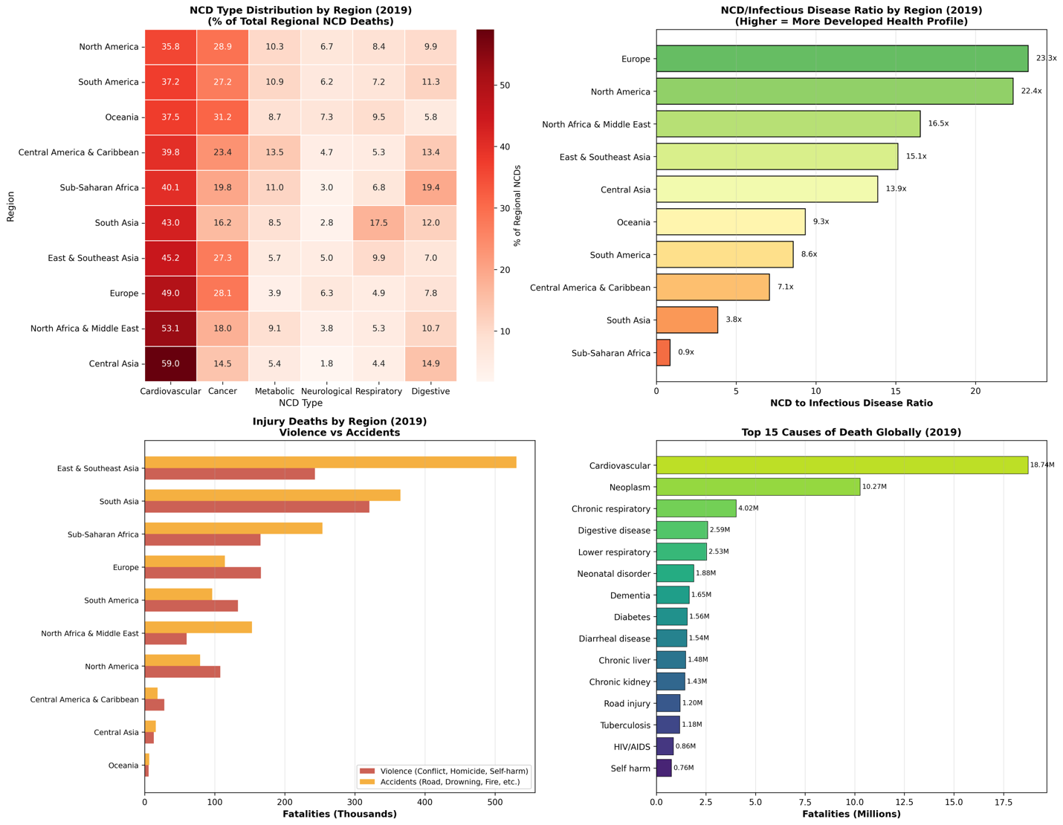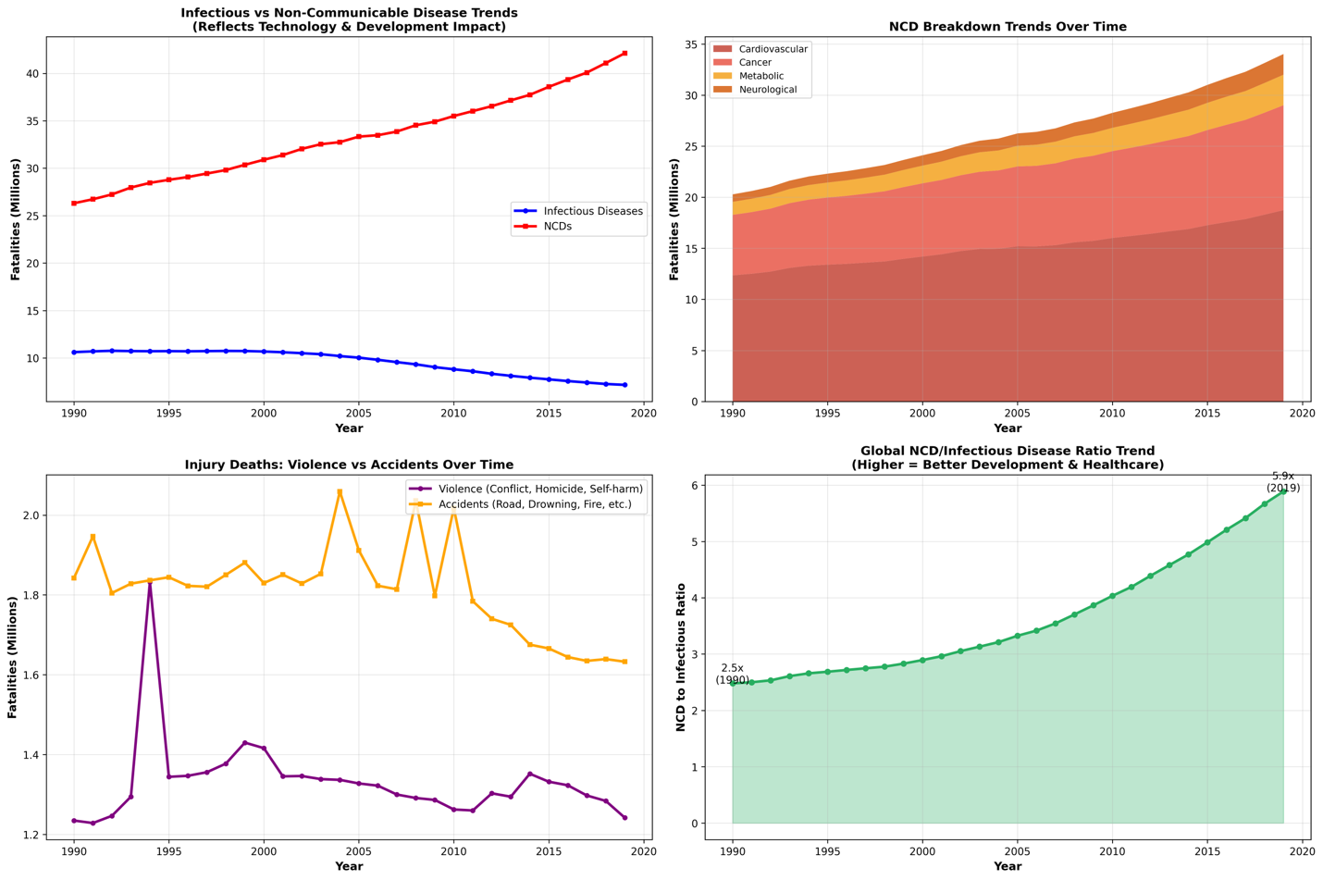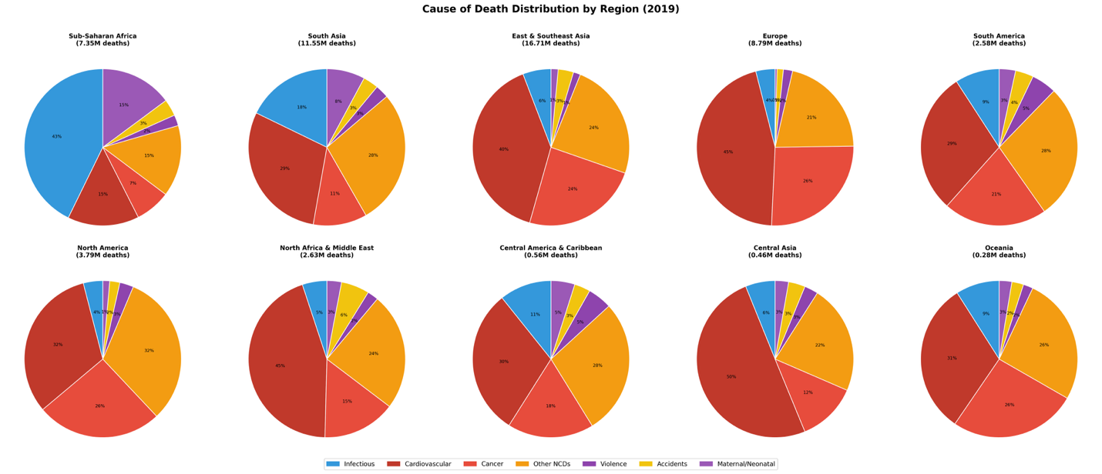

- BRCA Breast Cancer Dataset Analysis and ANN model Development
Variable Overview :
Target Variable:
Patient_Status: Alive or Dead (Survival outcome)
Clinical Features:
Age: Patient age at diagnosis (years)
Tumour_Stage: Cancer stage classification (I, II, III)
Histology: Cancer tissue type (Infiltrating Ductal/Lobular, Mucinous)
HER2 status: HER2 protein receptor status (Positive/Negative) (positive means: a high level of the HER2 protein, which can lead to faster growth and is more likely to spread)
Surgery_type: Surgical intervention type
Molecular Biomarkers:
Protein1/2/3/4: Expression level of protein marker 1/2/3/4
Objective: Predict breast cancer patient survival outcomes using clinical characteristics and molecular protein expression biomarkers through comprehensive data analysis and development of an ANN classification model with cross-validation by tumour stage.
Variable | Type | Description | Missing Values
Patient_ID | Text | Unique TCGA patient identifier | 7 (2.1%)
Age | Numerical | Patient age at diagnosis (29-90 years) | 7 (2.1%)
Gender | Categorical | Patient gender (all FEMALE) | 7 (2.1%)
Protein1 | Numerical | Expression level of protein marker 1 | 7 (2.1%)
Protein2 | Numerical | Expression level of protein marker 2 | 7 (2.1%)
Protein3 | Numerical | Expression level of protein marker 3 | 7 (2.1%)
Protein4 | Numerical | Expression level of protein marker 4 | 7 (2.1%)
Tumour_Stage | Categorical | Cancer stage (I = early, II = intermediate, III = advanced) | 7 (2.1%)
Histology | Categorical | Cancer histology type | 7 (2.1%)
ER status | Categorical | Estrogen Receptor (Positive/Negative) | 7 (2.1%)
PR status | Categorical | Progesterone Receptor (Positive/Negative) | 7 (2.1%)
HER2 status | Categorical | HER2 protein (Positive/Negative) | 7 (2.1%)
Surgery_type | Categorical | Type of surgical intervention | 7 (2.1%)
Date_of_Surgery | Date | Date of surgical procedure | 7 (2.1%)
Date_of_Last_Visit | Date | Most recent follow-up visit date | 24 (7.0%)
Patient_Status | Categorical | Survival outcome (Alive/Dead) | 20 (5.9%)

Patient Demographics:
Total Patients: 321 (after removing missing values)
Age range: 29-90 years
Mean age: 58.88 ± 12.96 years
Gender: 100% Female
Survived: 255 patients (79.44%)
Died: 66 patients (20.56%)

- Data visualization and exploratory analysis
Median Ages:
- ﻿﻿Survived group: 58.0 years
- ﻿﻿Deceased group: 58.5 years
- ﻿﻿Difference: Only 0.5 years
- The median age difference is very small, indicating that the age alone is not a very strong discriminator between survival and death.
Age Range:
- ﻿﻿Overall age range: 29-90 years
- ﻿﻿Both groups show similar distributions across most age ranges
- Slight concentration of deaths in the 50-70 age range
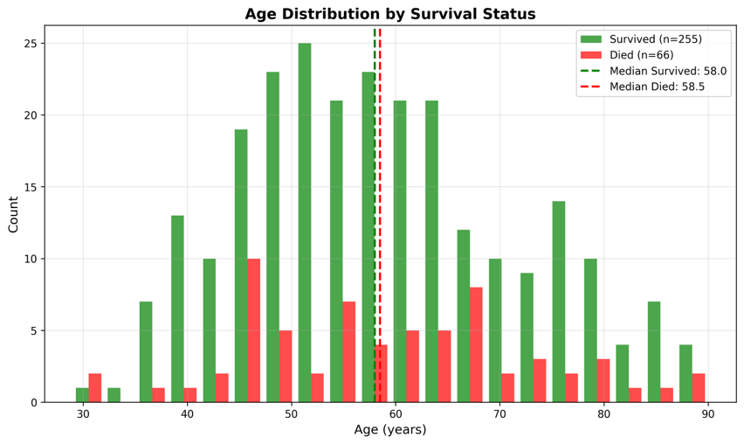
• In the younger age groups (e.g., 30s and low 40s), the proportion of patients who Died (red) appears to be relatively low.
• In the peak age range (approximately 45 to 65 years), the overall count is highest, and the Survived group dominates, although the red bars (Died) are consistently present.
• In the older age groups (e.g., 70s and 80s), while the total counts are lower, the proportion of patients who Died (red) relative to the total count in that bin may be slightly higher. After normalization of data for older age group, the died counts appear high that that of 50-60 year range.
Expect: younger patients may have better survival due to stronger and quicker immune response, better tolerance of aggressive treatments, and fewer negative side effects.
Observed: age shows a menial predictive value (-0.01 from heatmap), this might because: modern treatments effective across all age groups, and dataset represents treated patients (include selection bias) and sample size limitation (n=10 above age 80).

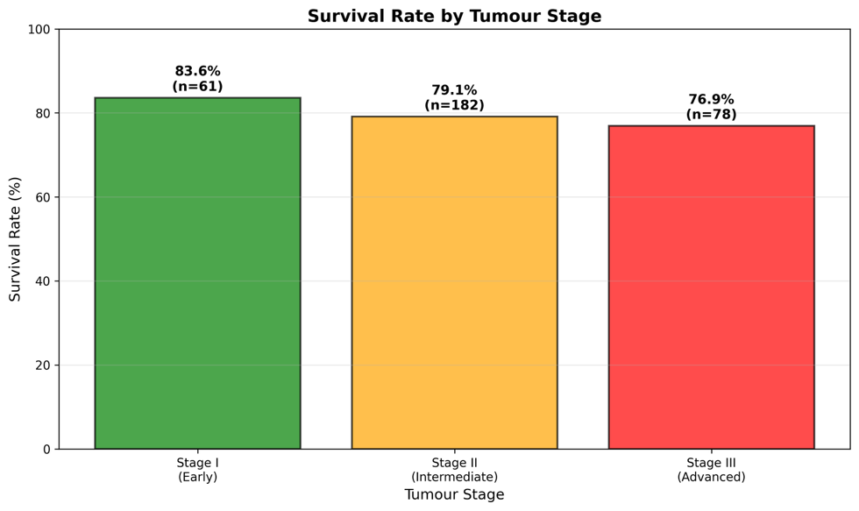
-Extensive regional spread
-Aggressive multi-modal treatment needed
-higher recurrence risk
-Regional lymph node involvement
-Requires combination therapy
-still highly treatable
- Tumor confined to breast
-treat: surgery + radiation
-excellent long-term outcomes

Stage | Patients (n) | Survival rate | Death
I | 61 (19.0%) | 83.6% | 10
II | 182(56.7%) | 79.1% | 38
III | 78(24.3%) | 76.9% | 18

Tumor stage correlation with survival: -0.05 ( from heatmap)
It surpirses me because the correlation is weaker than what I expected given the clear survival gradient. This might occur because:
- Survival does not edcline uniformly with stage -> non-linear relationship
- 56.7% of dataset is Stage II -> bias (stage II dominance) also moderate the overall correlation
Observation: Stage III survival (76.9%) is only 2.2% lower than Stage II (79.1%)
Possible explanations:
- Aggressive treatment: Stage III patients receive more intensive therapy
- Selection bias: Only patients healthy enough for aggressive treatment included
- Small sample: Stage III n=78 may not capture full mortality
- Modern therapy: Advances have improved Stage Ill outcomes significantly
- Short follow-up may not capture late recurrences

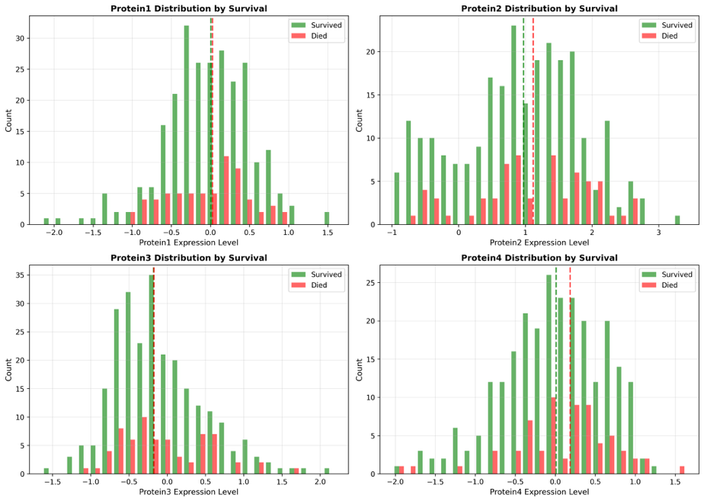

Protein type | Correlation with survival | Distribution | Interpretation
1 | +0.0164 | Wide (-2.0 to +1.5) | Minimal predictive value
2 | -0.0831 | Died and survived both peak at 1.0; diverse | Modest inverse relationship with survival
3 | +0.0500 | More clustered | Weak favorable prognostic marker
4 | -0.0796 | Median near 0.0 | Modest adverse prognostic marker

Statistical Analysis
Overall pattern: ALL protein correlations are WEAK (Irl < 0.10)
Ranking by absolute correlation:
- ﻿﻿﻿Protein2: -0.0831
- ﻿﻿﻿Protein4: -0.0796
- ﻿﻿﻿Protein3: +0.0500
- ﻿﻿﻿Protein1: +0.0164
Individual proteins lack discriminative ability.

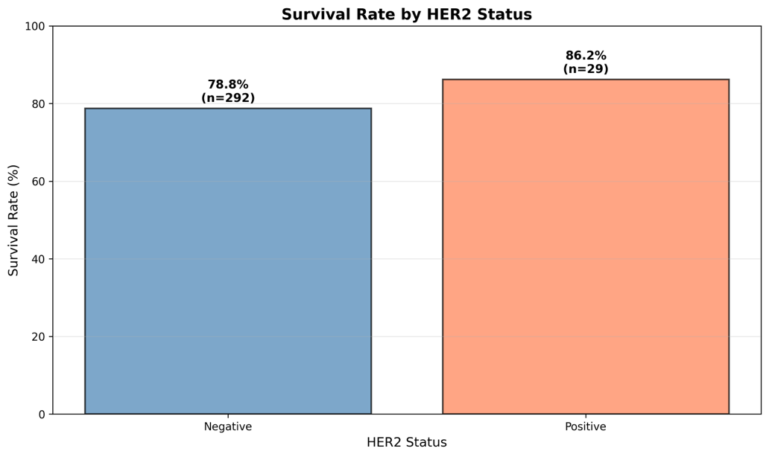

HER2 Status | Patients (n) | % of total | Survival rate | Death
Negative | 292 | 91.0% | 78.8% | 62
Positive | 29 | 9.0% | 86.2% | 4

Correlation with survival: +0.0528
Suprisingly, HER2-positive status shows better survival rate. HER2-positive was more agreeesive, but this dataset shows the opposite pattern. This is due to ONLY 29 HER2+ patients -> 4 death in patients.
Another potential factor that may needed to be included is the timeline of this dataset. Most of patients get surgery after 2000 yr, which took after the revolution of targetd therapy on HER2+: Trastuzumab (it was introduced in 1998). After the introduction of this therapy method, HER2+ outcomes were dramatically improved. If we expand the timeline or size of dataset, we will see a difference in HER2+ outcomes over the years in a long run term.

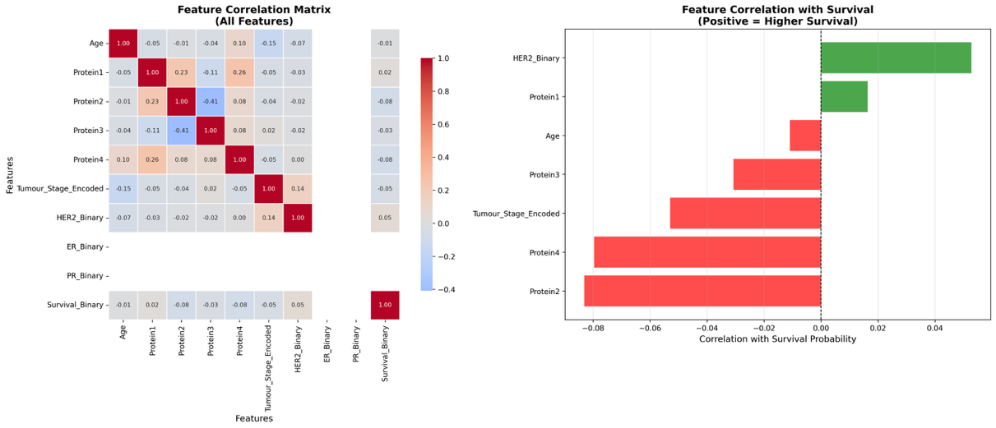
Strongest correlations between features:
1. Protein1 - Protein2: +0.23 (moderate positive)
2. Protein2 - Protein3: -0.41 (moderate negative)
- ﻿﻿Strongest inter-protein correlation
- ﻿﻿May represent opposing regulatory mechanisms
- Protein1 - Protein3: -0.11 (weak negative)
- Minor inverse relationship
4. All other correlations: < |0.10| (negligible)

- Build of ANN model
Data preprocessing:
- Removed 20 patients with missing age (5.9%)
- Removed patients with incomplete protein expression data

Feature Engineering:
- Ordinal encoding: tumor stage: I->1; II->2; III->3
- Binary encoding: HER2, ER, PR status: positive = 1; negative = 0
- One hot encoding: histology and surgery type
- Scaling: standard scaler: mean = 0, std = 1 applied to all numerical features
Cross validation strategy ( use of leave one stage out cross validation):
Fold | Test set | Train set | Test size | Train size
1 | Stage III | Stage I + II | 78 | 243
2 | Stage II | Stage I + III | 182 | 139
3 | Stage I | Stage II + III | 61 | 260

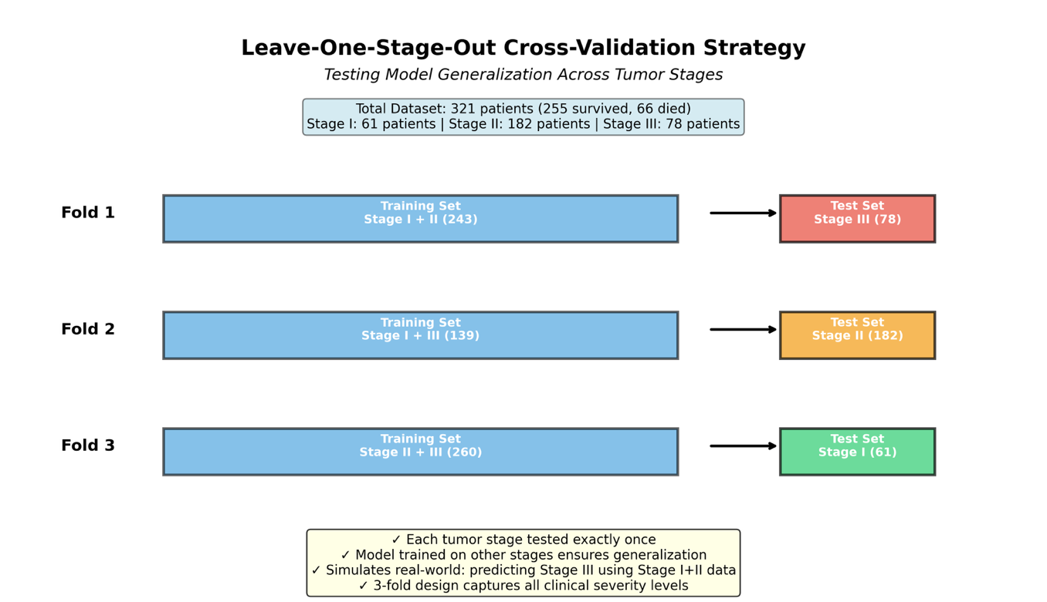
Rationale for using leave one stage out CV:
This dataset has a systematic and non-random structure, which is categorized into distinct stage. This method enforces a strong separation between the training and testing stes based on these inherent grouping factors. Plus, in clinical deployment, models trained on historical cohorts must predict outcomes for new oatients if varying severity (on differen stage).

Workflow:
(fold k = 1 2 3)

ANN configuration:
Input Layer: 14 neurons (one per feature)
Hidden Layer 1: 32 neurons (ReLU activation)
Hidden Layer 2: 16 neurons (ReLU activation)
Hidden Layer 3: 8 neurons (ReLU activation)
Output Layer: 1 neuron (Sigmoid activation)

- Training Loss curve
Consistent Convergence Pattern Across All Folds:
- Initial Loss: ~0.52 (random initialization)
- Final Loss: 0.39-0.41 (converged)
- Epochs: Consistently 22 epochs (early stopping triggered)
-》smooth and monotonic decrease in loss
-> stable optimization and early stopping efficacy
-> but final loss values of ~0.4. loss of 0,4 is halfway between perfect prediction (0) and random guessing ( -ln(0.5) = 0.693), which still leaves significantly uncertain or frequently wrong about the final prediction.

This is because model’s high loss value directly corresponds to its complete failure to classify the minority class (dead) -> we could refer to confusion matrix
- MAE progression:
Fold | Initial MAE | Final MAE | Stage
1 | 0.35 | 0.231 | III
2 | 0.35 | 0.209 | II
3 | 0.35 | 0.164 | I

Best MAE: stage I (0.164) -> easiest to predict with highest survival rate of 83.6%
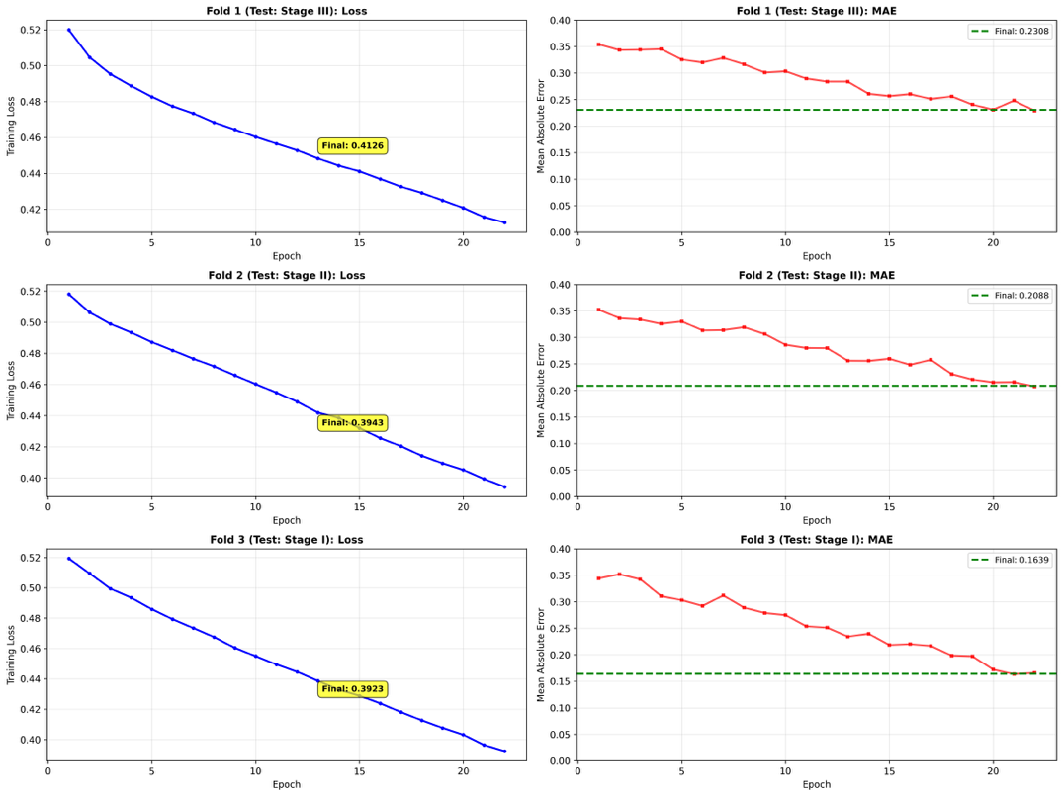
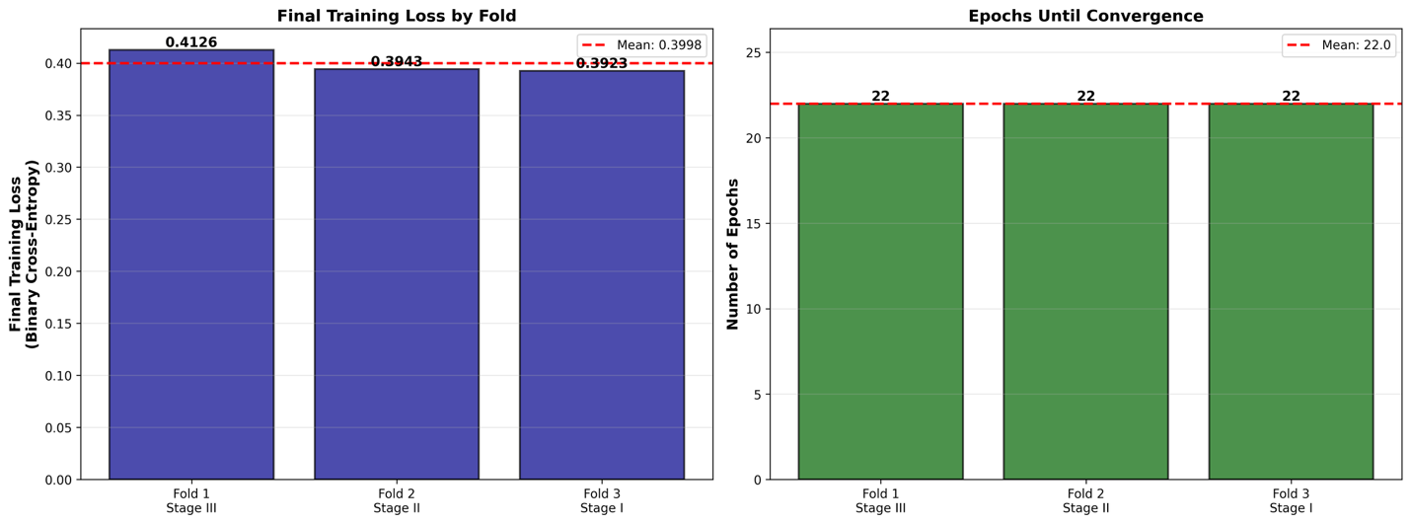

The gradient (Stage I < Stage II < Stage III in MAE) reflects:
- Class Imbalance Effects: Stage I (83.6% survival) has more extreme imbalance
- Biological Heterogeneity: Advanced tumors exhibit greater variability
- Sample Size: Stage III has fewer samples (n=78) for learning

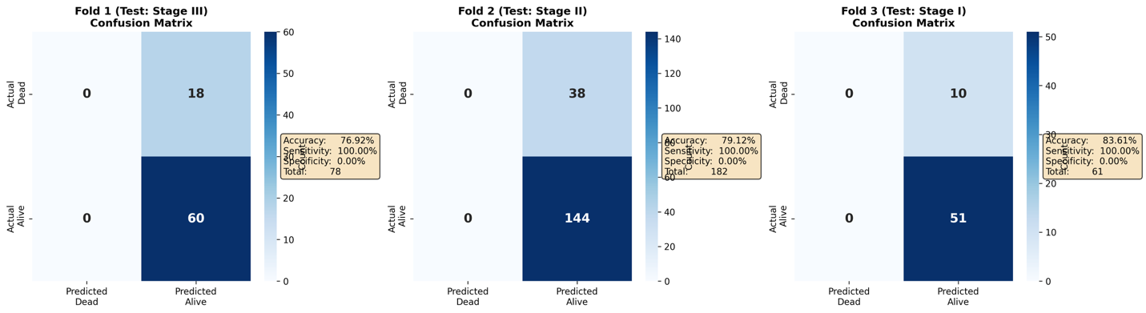
Surprisingly, EVERY single deceased patient is misclassified as “survived”, which means our model never predicts death. This is a case of majority class strategy:
- If always predict alive: 79.4% accuracy (match baseline of survival rate)
- ANN model: 79.9% average accuracy.
- ONLY 0.5% improvement
As our dataset in imbalanced between died and survived result, the majority class yields high accuracy without any discrimination.
Worsen than random classifier
Here, only focusing on accuracy will be misleading.

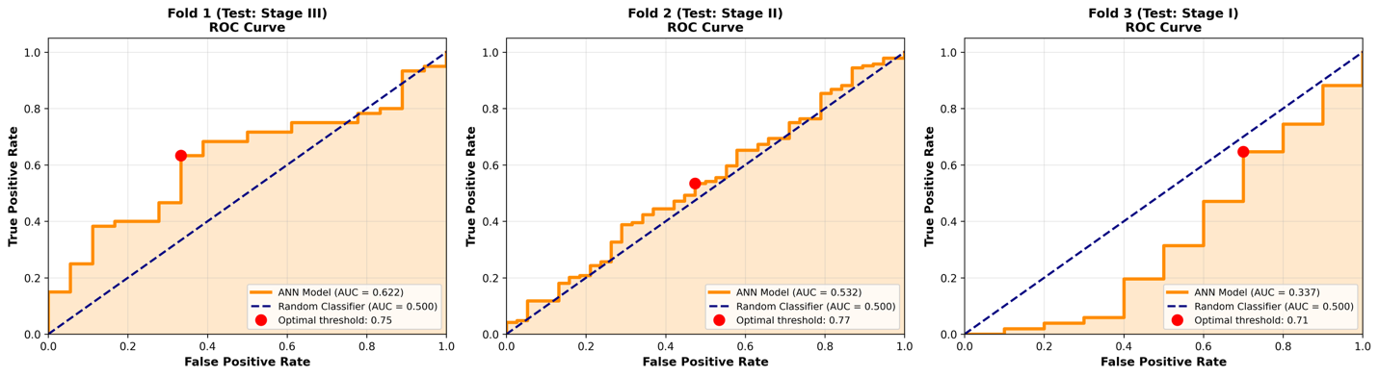

Fold | Test Stage | AUC Score | Optimal Threshold | Interpretation Relative to Random
Fold 1 | Stage III | 0.622 | 0.75 | Modestly better than random.
Fold 2 | Stage II | 0.532 | 0.77 | Slightly better than random.
Fold 3 | Stage I | 0.337 | 0.71 | Worse than random guessing.
Overall Mean |  | 0.497 |  | Equivalent to random guessing.

Interpretation:
- Overall failure in distinguishing: close to random guessing, indicates that the model cannot effectively distinguish between alive and dead patients. And it also fails to rank the likelihood of death accurately.
- When there is a small number of positive samples and AUC is so low, the optimal threshold values are irrelevant.

Summary of performance matrices:
Metric | Fold 1 (Stage III) | Fold 2 (Stage II) | Fold 3 (Stage I) | Average | Threshold | Status
Accuracy | 76.9% | 79.1% | 83.6% | 79.9% | 75% | PASS
Precision | 76.9% | 79.1% | 83.6% | 79.9% | N/A | (Misleading)
Recall | 100% | 100% | 100% | 100% | N/A | (Misleading)
F1 Score | 0.870 | 0.883 | 0.911 | 0.888 | N/A | (Misleading)
AUC-ROC | 0.622 | 0.532 | 0.337 | 0.497 | 0.70 | FAIL
MAE | 0.231 | 0.209 | 0.164 | 0.201 | 0.25 | PASS
Specificity | 0% | 0% | 0% | 0% | N/A | CRITICAL FAIL

- Accuracy, Precision, Recall, F1: All appear acceptable but are misleading because they reflect majority-class prediction.
- AUC-ROC: Correctly exposes zero discriminative power.
- MAE: Acceptable but does not reveal classification failure (consistent with predicting ~0.80 for all).
- Specificity: Zero across all folds—definitive proof of failure to identify any deceased patients.
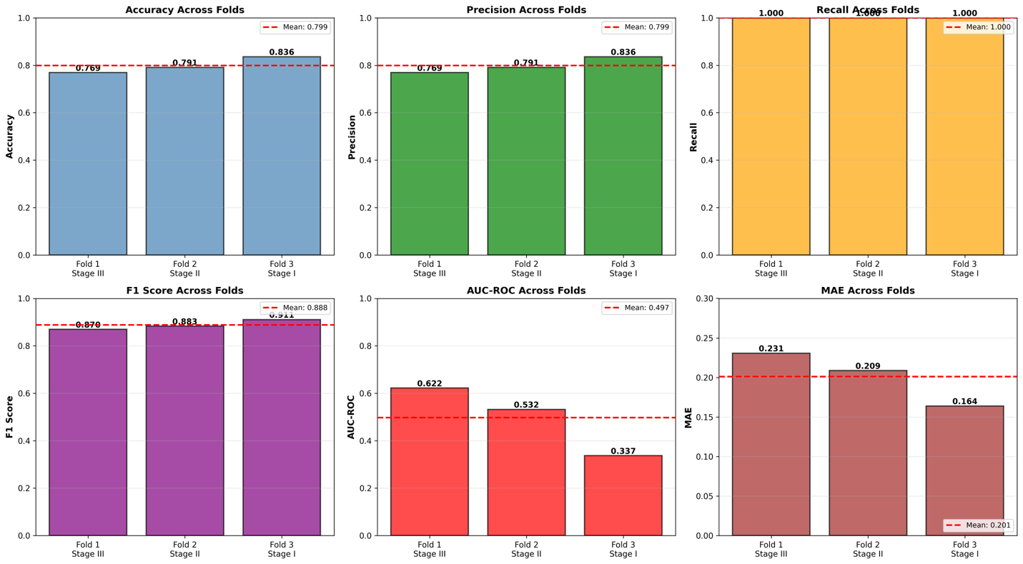
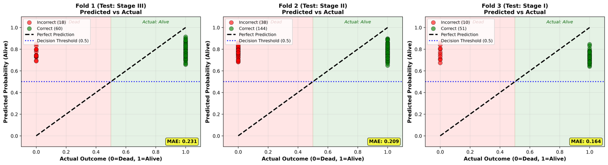
The model outputs nearly constant probabilities regardless of features, confirming the majority-class strategy.

Answer to topic question:
how technology, time period, and socioeconomic structure affect human survival probability
- HER2+ paradox:
  - Pre-2000s (no Herceptin): HER2+ = aggressive = poor survival
  - 2017-2019 (your dataset, with Herceptin): HER2+ = targeted therapy = better survival than HER2-
  - Therefore, a targeted therapy fundamentally altered survival trajectories to a specific genetic subtype

- Stabled survived across 2017-2019:
  - Onl 2.4% variation across year of 2017-2019
  - Modern multimodal therapy: surgert + chemo+ radiation + targeted therapy + hormonal therapy has standardized survival outcomes in the con temporoary era

2. Himalayan
