Yu Si

COMP 440

Assignment 2: SQL

Problem 1)

1) Write SQL statement to create the above tables in MySQL DBMS.

create table department(

DepartmentID int not null primary key,

DepartmentName varchar(25) not null unique);

create table employee(

EmployeeID int not null primary key,

LastName varchar(25) not null,

DeptId int,

foreign key(DeptId) references department(DepartmentId));

2) Write SQL Statement to insert the values into each table (5 pts).

insert into department (DepartmentID, DepartmentName)

values(31,'Sales'),

(33,'Engineering'),

(34,'Clerical'),

(35,'Marketing');

insert into employee (EmployeeID, LastName, DeptID)

values(1,'Rafferty',31),

(2,'Jones',33 ),

(3,'Heisenberg',33),

(4,'Robinson',34),

(5,'Smith',34),

(6,'Williams',null),

(7,'Brown',null);

3) Write SQL statement to add the FirstName column into the Employee table and add the following first names. The structure of the FirstName is similar to the LastName column (varchar(25), not null) (5 pts).

alter table employee

add column FirstName varchar(25) not null after EmployeeID;

update employee

set FirstName='John'

where EmployeeID=1;

update employee

set FirstName='Mary'

where EmployeeID=2;

update employee

set FirstName='David'

where EmployeeID=3;

update employee

set FirstName='Bob'

where EmployeeID=4;

update employee

set FirstName='Peter'

where EmployeeID=5;

update employee

set FirstName='Alice'

where EmployeeID=6;

update employee

set FirstName='Heather'

where EmployeeID=7;

4) Write the following join for them (deliver both SQL statements as well as the table result) (5 pts):

a. Cross Join

select * from employee

cross join department

where employee.DeptId = department.DepartmentID; 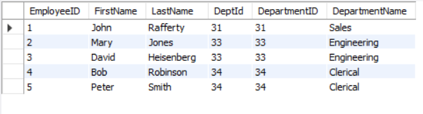

b. Inner Join

select * from employee

inner join department on employee.DeptId = department.DepartmentID; 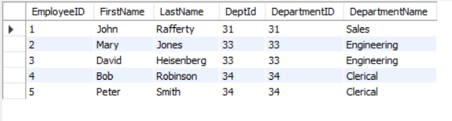

c. Left Join

select * from employee

left join department on employee.DeptId = department.DepartmentID; 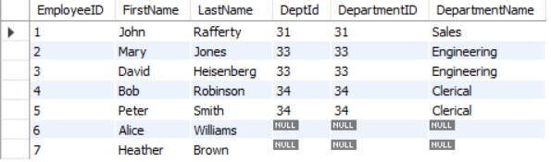

d. Right Join

select * from employee

right join department on employee.DeptId = department.DepartmentID; 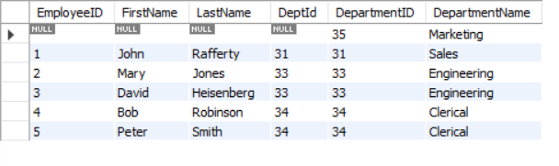

5) Delete the employee(s) with no department (Use only ONE SQL statement) (5 pts).

delete from employee where DeptId is null;

6) Delete the Sales department. If you are not able to delete this record, explain why? And how you can solve the problem (5 pts).

Can’t delete this record, because table employee has a foreign key(DeptId) references to table department(DepartmentId)). To solve this problem, we can

1. **temporarily disable the foreign keys:**

SET FOREIGN_KEY_CHECKS=0;

1. then, delete the sales department:

delete from department where DepartmentName='Sales';

1. when we need, we can enable the foreign key:

SET FOREIGN_KEY_CHECKS=1;

Problem 2)

Query 1) Find all instructors earning the salary higher than the average salary (10 pts).

select *

from instructor

where salary > (select avg(salary)

from instructor);

Equivalent Query:

select *

from instructor

having salary > (select avg(salary)

from instructor);

Query 2) Find the minimum, maximum, and average salary for each department (10 pts).

select *,min(salary),max(salary),avg(salary)

from department as d

join instructor as i on d.dept_name = i.dept_name

group by dept_name;

Equivalent Query:

select *,min(salary),max(salary),avg(salary)

from department as d

left join instructor as i on d.dept_name = i.dept_name

where salary is not null

group by dept_name;

Query 3) Find all the students who take credits between 30 and 100 and order them alphabetically by name (10 pts).

select *

from student

where tot_cred between 30 and 100

order by name;

Equivalent Query:

select *

from student

where tot_cred >29 and tot_cred<101

order by name;

Query 4) Find all the instructors with their department name and department building (10 pts).

select i.ID, i.name, i.salary, i.dept_name, d.bulding

from instructor as i

join department as d on i.dept_name=d.dept_name;

Equivalent Query:

select i.ID, i.name, i.salary, i.dept_name, d.bulding

from instructor as i

right join department as d on i.dept_name=d.dept_name

where i.ID is not null;

Query 5) Find all the students with their taken courses and grades (10 pts).

select s.ID, s.name, s.dept_name, s.tot_cred, t.course_id, t.grade

from student as s

join takes as t on s.ID=t.ID;

Equivalent Query:

select s.ID, s.name, s.dept_name, s.tot_cred, t.course_id, t.grade

from student as s

right join takes as t on s.ID=t.ID

where s.ID is not null;

Query 6) Find the instructor(s) who earns the second highest salary (10 pts).

select *, max(salary) as msalary

from instructor

where msalary < (select max(salary)

from instructor);

Equivalent Query:

select *,max(salary) as msalary

from instructor

where msalary not in(select msalary

from instructor);

Query 7) Increase all credits by 1 for those courses that are taught in semester Fall 2010 (10 pts).

update course as c

inner join section as s on c.course_id=s.course_id

set credits = credits + 1

where s.semester = "Fall 2010";

Query 8) Delete those instructors who have never taught (10 pts).

delete instructor, teaches from instructor

inner join teaches on teaches.ID=instructor.ID

where course_id is null;

Equivalent Query:

delete instructor from instructor

left join teaches on instructor.ID=teaches.ID

where course_id is null;