Ester Lee
Amrita George
Agentic AI Section 003
26 March 2026
Project Milestone 2: Multi-agent Workflow

Agent Architecture Diagram Screenshots:

Screenshot of Opal Editor

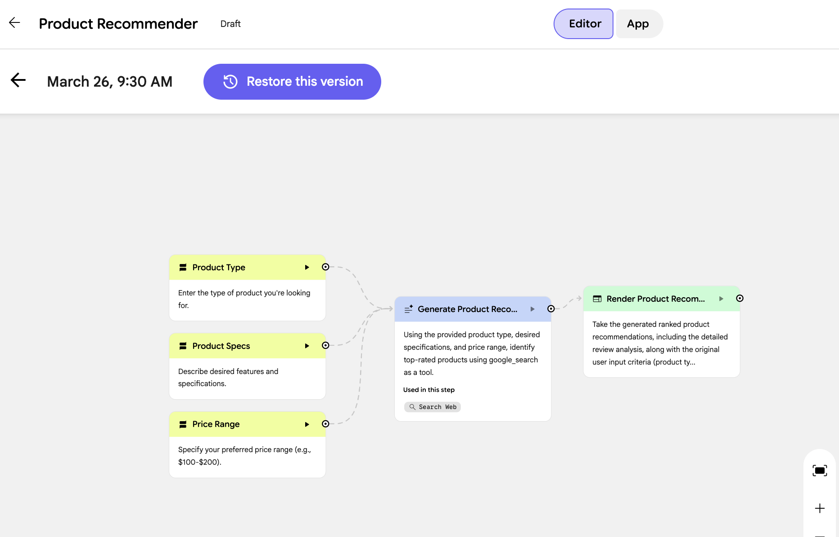

Sequential multi-agent pipeline/system (A → B → C) that I made on Draw.io

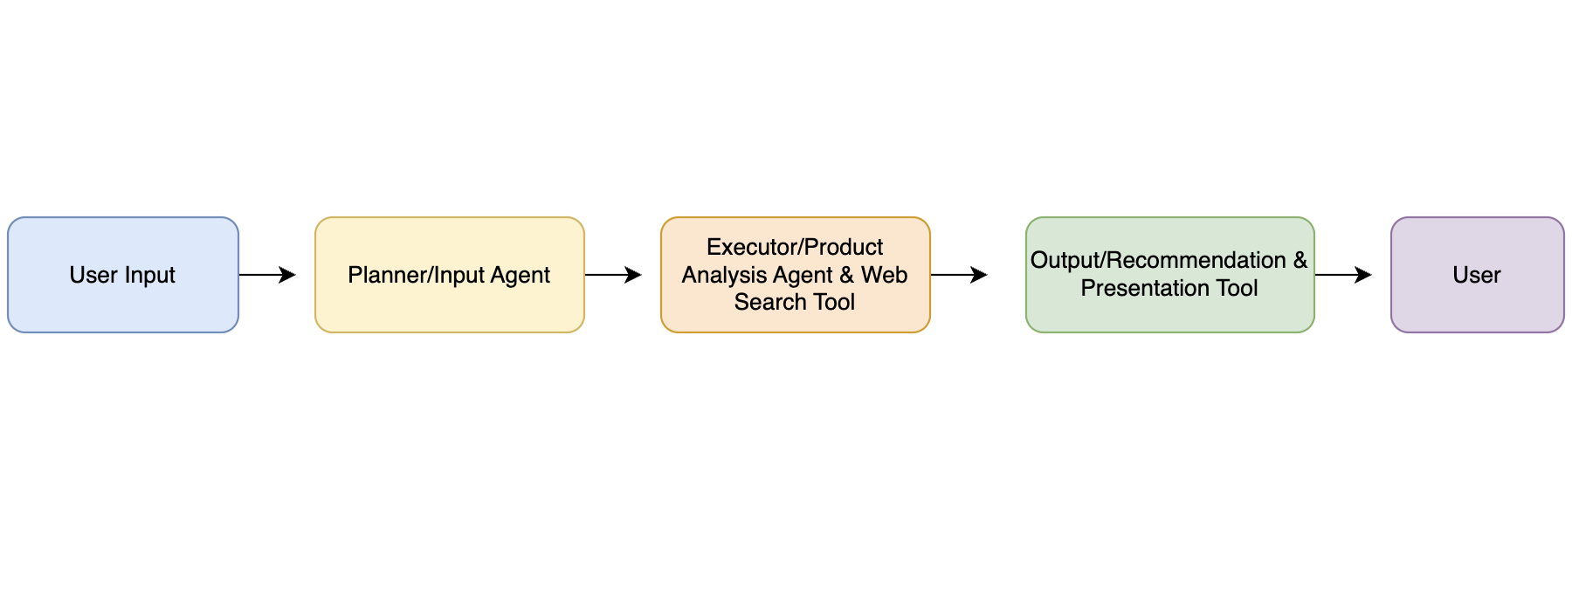
Explanation of Agent’s Role:

- Planner/Input Agent (Product Type, Product Specs, Price Range)
  - Role: It collects and intercepts user input (product type, specs, and price range).
  - Input: Product Type, Product Specs, and Price Range.
  - Output: Structured request/list of the user’s needs in a product.
  - Function: This agent is the entry/start point of the system. Where it will start to organize/gather the user’s preferences for the product they are looking for (product research & analysis).

- Executor/Product Analysis Agent & Web Search Tool (Generate Product Recommendations)
  - Role: It searches for and analyzes products that fit the user’s needs.
  - Input: Structured request from the Planner Agent.
  - Output: List of recommended products based on the price, features, and reviews (comparison and most recommended).
  - Tools Used: Web Search Tool (Google Opal integration).
  - Function: This agent will serve as the system's logic and reasoning, receiving product data and performing a web search to identify the best options/products that are most suited to the user’s needs.

- Output/Recommendation & Presentation Tool (Display the product recommendations)
  - Role: It formats and presents the results/recommendations to the user.
  - Input: Product recommendations from the Executor Agent.
  - Output: Structured product list with brief description and pricing. Will be formatted in a user-friendly interface (easily interpreted).
  - Function: This agent will convert the information from the generated list of recommendations into a user-friendly format.

Communication:

The agents will communicate through structured text output from within the Google Opal interface. At each stage/phase, they will receive the inputs and process the information accordingly (to their role). They will produce output that will directly be used for the next stage, which will ensure a smooth data flow.

Failure Handling and Limitations:

There is a heavy reliance on AI-generated outputs and web search (Google), which can introduce limitations to the system. To mitigate/lessen these risks, we will encourage users to be clear and specific (regarding their needed requirements/specs for the product). Explanations will also be provided for each product so users can interpret for themselves whether a product is well-suited to their needs. Our system is designed to streamline and make the product search process more efficient by suggesting options that align with user preferences; however, it does not guarantee the optimal or best result (it will provide the products that are most suitable according to the user’s preferences).

