Exercise 1:

1. Yes
2. No
3. No;No
4. No;No
5. No;No
6. Return the number of characters in the string

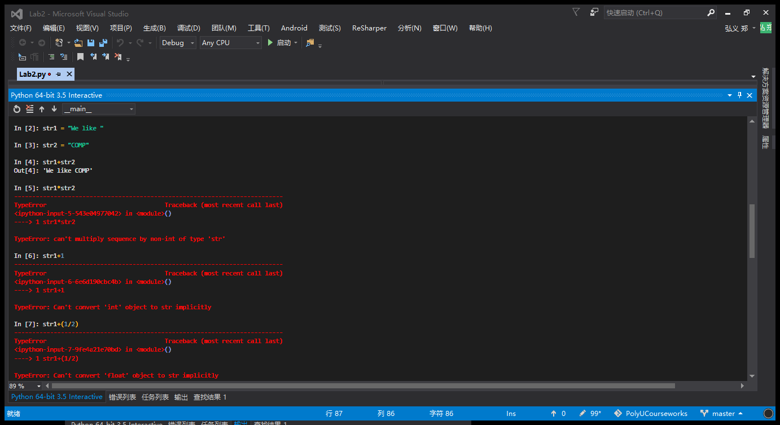

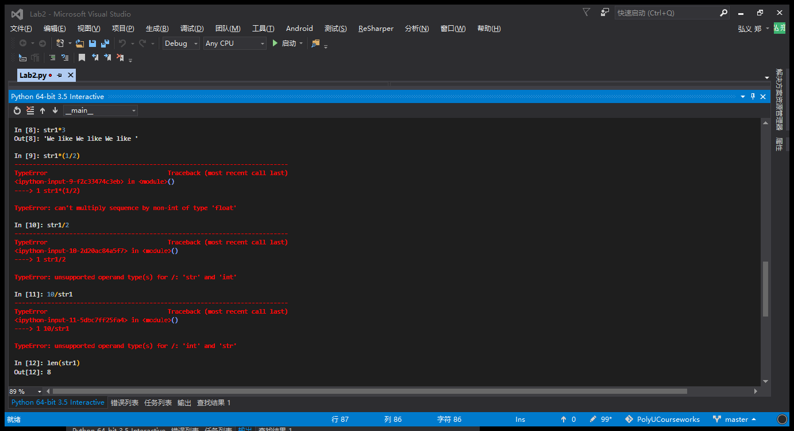

2.

a. sum(myList)/len(myList)

b. len(myList)

3.

a. output: ['Hong', 'Kong', 'Polytechnic', 'University']

It splits the strings in every space.

b. myWords = my.split()

c. myWords[3][3]

d. myWords[2]

e. len(myU)