**Help Document**

Application environment: VS2019, C#

**Steps to run the application**

1. Extract the application from the zip file
2. Open the solution in Visual Studio and press ‘F5’ to build and run it.
3. Verify the results on the console.
4. If the program was run successfully, the following two scenarios would occur.
5. Submitted list of all subscribers was accurate

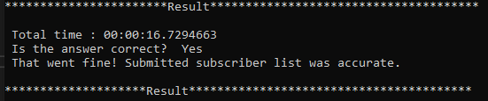

1. Submitted list was wrong

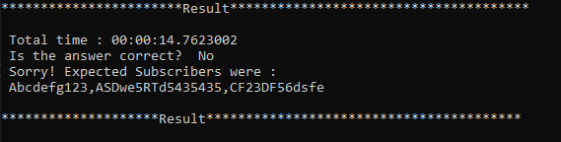

1. If an exception occurs during the execution, the following information will be displayed.

* Time when the exception occurred
* Exception message.

