Operational Data Analysis
Report
Week 1 Task: Operational Data Analysis Simulation
Analysis focus: E-commerce delivery performance, delay patterns, and operational process improvement

Prepared by | Shaghayegh Haghbin
Dataset | Olist Brazilian E-Commerce Public Dataset
Report date | June 2026

This report turns raw operational order data into practical insights and recommendations for improving delivery reliability, KPI visibility, and workflow control.

Report Structure:

- 1. Executive Summary
- 2. Introduction
- 3. Data Source
- 4. Methodology
- 5. Analysis and Findings
- 6. Visualizations
- 7. Recommendations
- 8. Conclusion

Dataset note: The analysis uses the full delivered-order dataset for the summary tables and dashboard, while the workbook includes a 2,000-row sample for transparency and editable review.

1. Executive Summary
This operational data analysis simulation examines delivery performance using the public Olist Brazilian E-Commerce dataset. The goal is to identify delay patterns, highlight operational hotspots, and recommend realistic process improvements that an operations team could apply to improve delivery reliability and customer experience.
The analysis covers 96,470 delivered orders. Overall, 7,826 orders were delivered late, producing an overall delay rate of 8.1%. The average delivery time was 12.6 days, while the average customer review score was 4.07 out of 5. The findings show that delay risk is not evenly distributed. It is concentrated by month, state, and product category, which means targeted process actions are more useful than a general improvement plan.

KPI Snapshot
Total Delivered Orders  96,470 | Delay Rate  8.1% | Avg Delivery Days  12.6 | Avg Review Score  4.07
Delayed Orders  7,826 | On-Time Orders  88,644 | Avg Delay Days  0.77 | Avg Freight Cost  R$ 22.79

Key Findings at a Glance
Finding | Evidence | Operational Impact | Suggested Action
Delay risk is concentrated in specific states. | Overall delay rate is approximately 8.1%, with RJ and BA showing higher delay rates than SP and MG. | Delays are not evenly distributed, so a general fix would be less effective. | Prioritize state-level delivery monitoring and route exception reviews.
Long-distance/last-mile phases appear to drive many late orders. | States with longer average delivery days also show weaker review scores and higher delay rates. | Customer satisfaction may fall when delivery dates are missed. | Create weekly delay dashboards and escalation triggers.
Some product categories have higher delay rates. | Audio, Home Comfort, Electronics, and Food show elevated delay rates among categories with meaningful volume. | Category handling, packaging, or carrier requirements may create bottlenecks. | Review category-specific packing standards, supplier readiness, and carrier SLAs.
Review scores can be used as an operational quality signal. | Lower review scores are more visible in areas with higher delay rates. | Operations issues may become customer experience issues quickly. | Track review score alongside delivery KPIs, not only sales/order volume.

2. Introduction
The operational problem analyzed in this report is late delivery performance in an e-commerce order fulfillment process. Late deliveries create avoidable customer dissatisfaction, increase follow-up workload for operations and customer service teams, and reduce the reliability of promised delivery dates.
The purpose of this simulation is to show how publicly available operational data can be transformed into practical business insight. The report focuses on operational KPIs such as on-time delivery, delay rate, delivery duration, delay days, state-level delivery risk, category-level delay risk, freight cost, and review scores.
The analysis is designed for an operations assistant, operations specialist, or business process role, where the main responsibility is to monitor process performance, identify bottlenecks, and recommend actions that improve workflow reliability.

3. Data Source
Item | Details
Primary public dataset | Olist Brazilian E-Commerce Public Dataset by Olist.
Source URL | https://www.kaggle.com/datasets/olistbr/brazilian-ecommerce
GitHub mirror used for CSV access | https://github.com/Ganesh7699/Brazilian-E-Commerce-OList
Tables used | Orders, customers, order items, reviews, products, and product category translation tables.
Reason for selection | The dataset is suitable for operations analysis because it includes dates, delivery estimates, actual delivery dates, product categories, customer locations, freight values, and review scores.
This dataset was selected because it closely reflects real operational decision-making in e-commerce, logistics, order fulfillment, and customer experience. It allows the analysis to move beyond sales reporting and focus on process efficiency, delivery reliability, and service quality.
Limitation: The dataset is anonymized and historical, so the recommendations are presented as a practical simulation rather than as a live company performance audit.

4. Methodology
The workbook analysis was completed using Excel and Google Sheets-compatible calculations. The main steps were:
- Filtered for delivered orders with valid purchase dates, estimated delivery dates, and actual delivery dates.
- Joined operational tables to connect order status, customer state, product category, freight value, item count, and review score.
- Translated product categories into English to make category-level analysis easier to interpret.
- Calculated Delivery Days as the difference between actual delivery date and purchase date.
- Calculated Delay Days as the positive difference between actual delivery date and estimated delivery date.
- Classified each order as on-time or delayed.
- Built monthly, state-level, and product category summaries to identify trends and hotspots.
- Created visualizations and an action plan to translate the findings into process improvement recommendations.
The core KPI definitions used in the workbook were: Delay Rate = Delayed Orders / Delivered Orders, On-Time Orders = orders delivered on or before the estimated date, and Avg Delivery Days = average time between purchase and delivery.

5. Analysis and Findings

5.1 Overall Delivery Performance
The overall delivery performance is strong but still leaves a visible opportunity for process improvement. Out of 96,470 delivered orders, 88,644 were delivered on time and 7,826 were delivered late. This means approximately 8.1% of delivered orders missed the estimated delivery date.
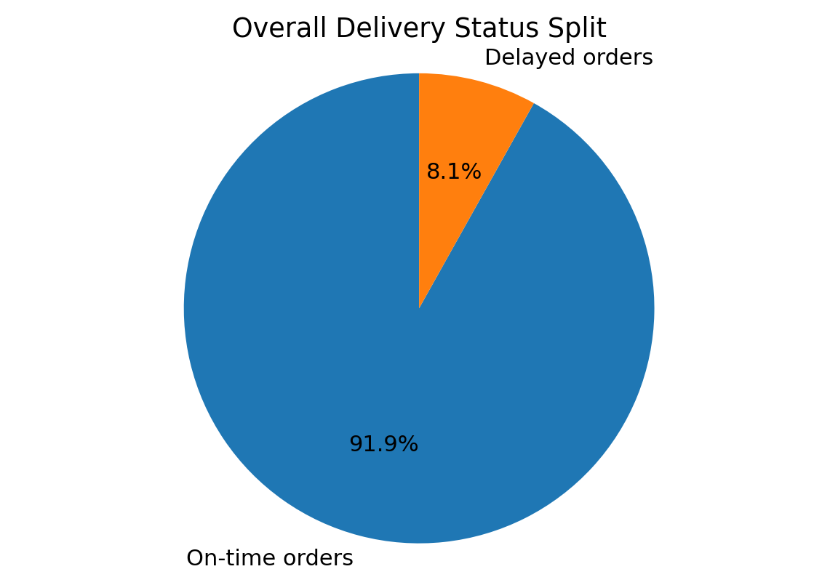
Figure 1. Overall delivery status split between on-time and delayed orders.

5.2 Monthly Delivery Trend
The monthly trend shows that delay risk changes over time rather than staying constant. The strongest delay spikes among meaningful-volume months occurred in 2018-03, 2018-02, 2017-11, and 2018-08. This pattern suggests that capacity planning, carrier performance, peak-period demand, or exception handling may be important causes to investigate.
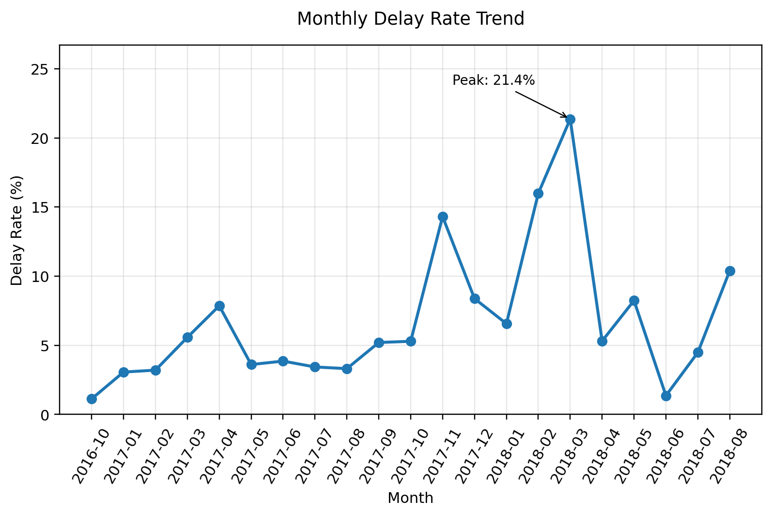
Figure 2. Monthly delay rate trend across delivered months with 100+ orders.
Month | Delivered Orders | Delayed Orders | Delay Rate | Operational Note
2018-03 | 7,003 | 1,496 | 21.4% | Delay spike: investigate capacity/carrier issues
2018-02 | 6,555 | 1,048 | 16.0% | Delay spike: investigate capacity/carrier issues
2017-11 | 7,288 | 1,043 | 14.3% | Delay spike: investigate capacity/carrier issues
2018-08 | 6,351 | 660 | 10.4% | Delay spike: investigate capacity/carrier issues
2017-12 | 5,513 | 462 | 8.4% | Monitor trend

5.3 State-Level Delay Hotspots
State-level performance shows that delayed orders are concentrated in specific locations. SP has the highest delayed-order count because it has the largest order volume, but its delay rate is lower than several smaller states. RJ, BA, CE, MA, PA, ES, and AL show higher delay rates and should be prioritized for route, carrier, and escalation reviews.
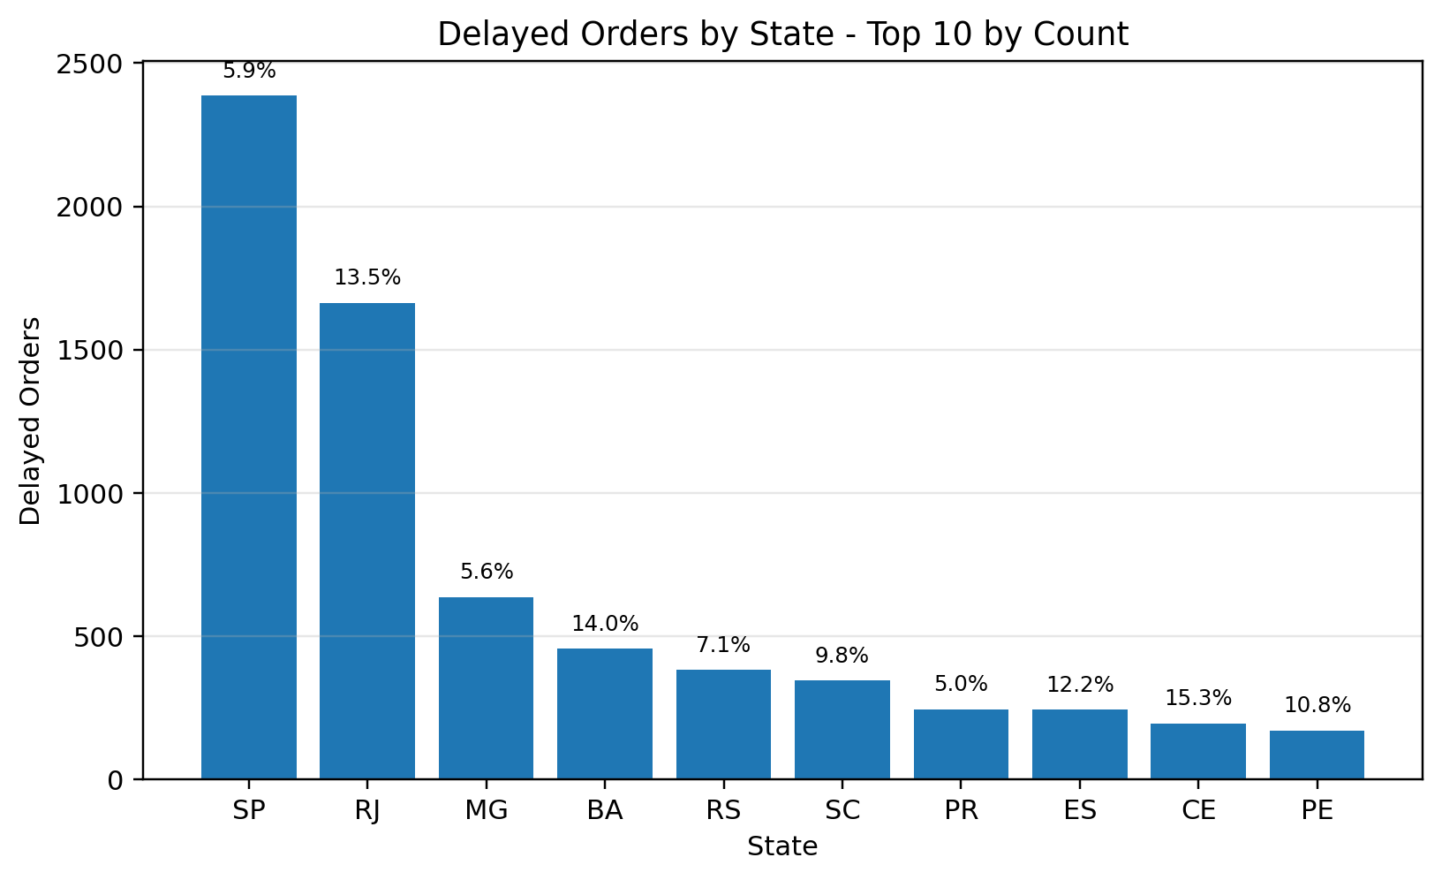
Figure 3. Delayed orders by state, with delay-rate labels.
State | Delivered Orders | Delayed Orders | Delay Rate | Avg Delivery Days | Priority
SP | 40,494 | 2,387 | 5.9% | 8.8 | High
RJ | 12,350 | 1,664 | 13.5% | 15.3 | High
MG | 11,354 | 637 | 5.6% | 12.0 | High
BA | 3,256 | 457 | 14.0% | 19.3 | High
RS | 5,344 | 382 | 7.1% | 15.3 | Medium
SC | 3,546 | 346 | 9.8% | 15.0 | Medium
PR | 4,923 | 246 | 5.0% | 12.0 | Low
ES | 1,995 | 244 | 12.2% | 15.8 | High

5.4 Product Category Delay Risk
The product category analysis shows that some categories have higher delay rates than others, even when filtered to categories with meaningful delivered-order volume. Audio, Books Technical, Home Comfort, Food, and Electronics appear among the higher-risk categories. This could point to category-specific packaging, supplier readiness, storage, handling, or carrier handoff issues.
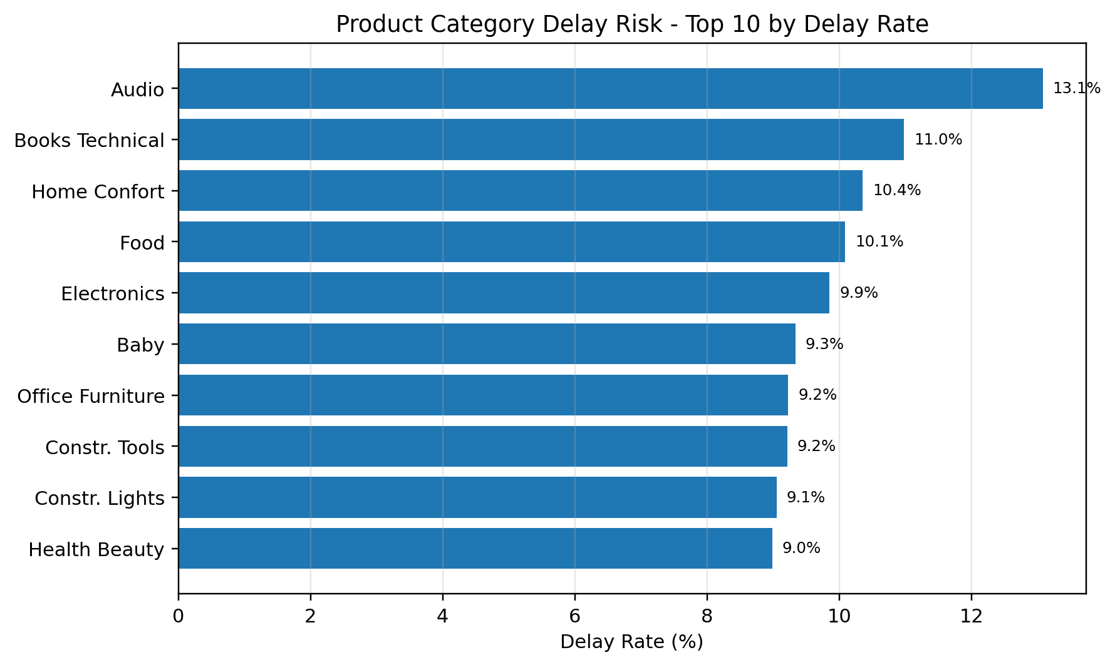
Figure 4. Product category delay risk ranked by delay rate.
Category | Delivered Orders | Delayed Orders | Delay Rate | Avg Review Score | Priority
Audio | 344 | 45 | 13.1% | 3.85 | High
Books Technical | 255 | 28 | 11.0% | 4.43 | High
Home Confort | 367 | 38 | 10.4% | 3.91 | High
Food | 436 | 44 | 10.1% | 4.32 | High
Electronics | 2,507 | 247 | 9.9% | 4.13 | Medium
Baby | 2,764 | 258 | 9.3% | 4.12 | Medium
Office Furniture | 1,246 | 115 | 9.2% | 3.65 | Medium
Construction Tools Construction | 727 | 67 | 9.2% | 4.13 | Medium

5.5 Delivery Performance and Customer Experience
Review score was included as a customer experience signal because late deliveries can create dissatisfaction even when the product itself is correct. The state-level scatter view shows that several high-delay states also have weaker review scores. This supports the recommendation to review operational KPIs together with customer satisfaction indicators instead of treating them as separate reports.
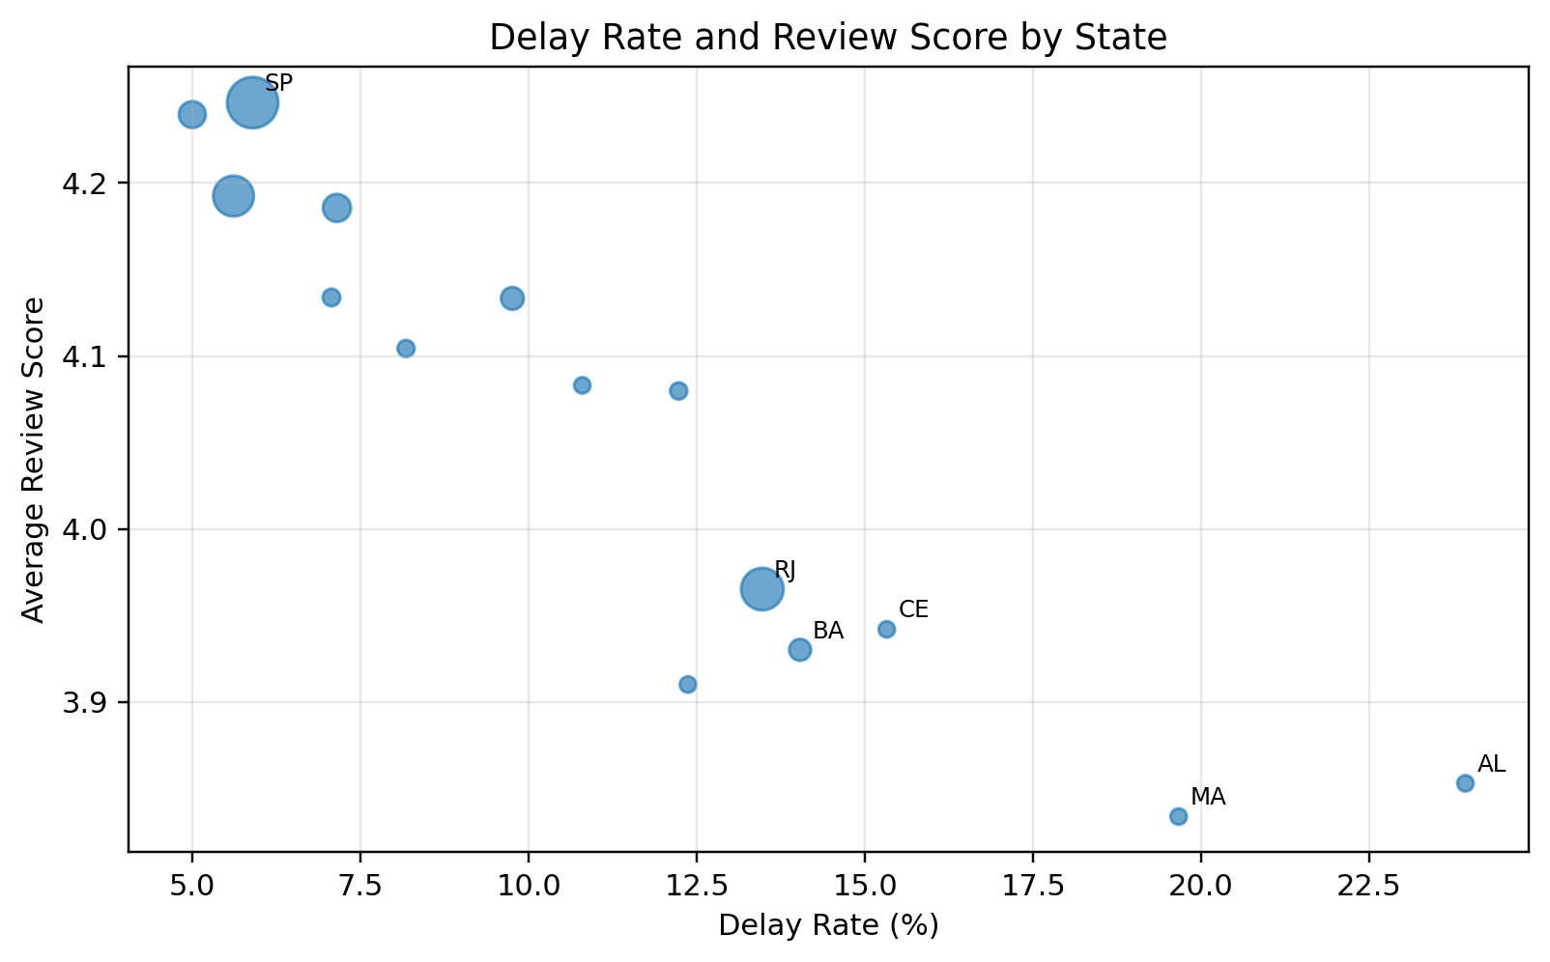
Figure 5. Relationship between state-level delay rate and average review score.

6. Visualizations
The workbook and this report include five main visualizations. Each visualization was selected to support a specific operational question:
Visualization | Operational Question | How it supports decision-making
Delivery status split | How large is the late-delivery problem overall? | Shows the total balance between on-time and delayed orders.
Monthly delay trend | When do delivery issues spike? | Helps identify seasonal, capacity, or process timing issues.
State delayed orders | Where are the largest delay volumes? | Prioritizes logistics investigation by state.
Category delay risk | Which product groups need handling review? | Highlights categories that may require packaging or supplier process checks.
Delay rate and review score | Do delivery issues connect to customer experience? | Encourages combined KPI tracking across operations and customer satisfaction.

7. Recommendations
The recommendations below are designed to be practical, measurable, and suitable for an operations team. They focus on improving KPI visibility, escalation discipline, carrier management, category-specific workflow control, and repeatable reporting.
Priority | Recommendation | Evidence | Expected Benefit | KPI / Timeframe
High | Create a weekly delivery delay dashboard by state. | RJ and BA show higher delay rates than the overall average. | Faster visibility of late delivery risk and better escalation before customer complaints. | Delay Rate by State | 2 weeks
High | Introduce exception alerts for orders at risk of missing estimated delivery dates. | Delayed orders are concentrated in specific periods and regions. | Reduces reactive follow-up and improves customer communication. | Orders At Risk | 2-4 weeks
Medium | Review carrier SLA performance in high-delay states. | States with higher average delivery days also show higher delay rates. | Better route planning, carrier accountability, and escalation. | Carrier On-Time Rate | 1 month
Medium | Audit categories with high delay rates for packaging and handling complexity. | Audio, Home Comfort, Food, and Electronics have elevated delay rates in this analysis. | Reduces category-specific bottlenecks and improves fulfillment consistency. | Category Delay Rate | 1 month
Medium | Track customer review score beside delivery KPIs. | Review scores are a useful customer experience signal after delivery. | Connects operational performance with customer satisfaction outcomes. | Review Score by Delay Status | 2 weeks
Low | Standardize a monthly operations report template. | Monthly delay rates show useful trends for decision-making. | Creates repeatable reporting and supports better management communication. | Monthly KPI Completion | Ongoing

Implementation Plan
Phase | Action | Owner | Output
Week 1-2 | Create a weekly dashboard and agree on KPI definitions. | Operations Analyst / Operations Assistant | Standard KPI report template
Week 2-4 | Set up exception alerts for orders close to the estimated delivery date. | Operations Specialist | At-risk order tracker
Month 1 | Review carriers in high-delay states and document SLA gaps. | Logistics Lead | Carrier action log
Month 1 | Audit categories with higher delay rates for packing, storage, and handoff issues. | Warehouse / Fulfillment Team | Category handling checklist
Ongoing | Review delay rate and review scores together every month. | Operations + Customer Success | Monthly performance review

8. Conclusion
This analysis shows how operational data can be used to identify delivery inefficiencies and convert them into practical improvement actions. The full delivered-order analysis showed a delay rate of 8.1%, with delays concentrated by month, state, and product category. This means the most effective response is not a broad generic process change, but a focused operational control system that tracks the right KPIs, identifies risk early, and assigns owners to the most important bottlenecks.
The strongest recommended actions are to build weekly delay monitoring by state, introduce exception alerts for at-risk orders, review carrier SLA performance in high-delay states, audit high-risk product categories, and connect delivery performance with review score trends. Together, these actions would support better visibility, faster escalation, stronger customer communication, and more reliable delivery operations.

