Digital Transformation and Operational Automation Plan
E-Commerce Order Fulfillment Operations
Week 6 Task: Digital Transformation and Operational Automation

Process focus | Order fulfillment, inventory visibility, delivery tracking, customer communication
Implementation horizon | 8 weeks
Primary objective | Move from manual tracking to a controlled, automated, KPI-driven operating model

Executive Summary
This report proposes a practical digital transformation plan for an e-commerce fulfillment operation that currently relies on manual inventory checks, manual order status updates, spreadsheet-based reporting, and reactive courier follow-ups. These manual steps create delays, data inconsistency, limited visibility, and slow response to quality or delivery issues. The recommended approach is to introduce a phased automation model using order management workflows, inventory alerts, barcode validation, Power BI dashboards, automated customer notifications, courier SLA tracking, and simple RPA workflows for repeated administrative tasks. The plan is designed for an 8-week implementation period, starting with process assessment and ending with post-rollout performance monitoring. The expected impact includes faster order processing, better inventory accuracy, fewer manual errors, earlier detection of delayed orders, stronger customer communication, and clearer operational accountability.
Task requirement | How this report addresses it
Manual processes selected for automation | Order status updates, inventory checks, delivery delay tracking, customer notifications, courier follow-ups, reporting, and quality checks.
Benefits of digital tools | Improved visibility, reduced manual workload, faster issue detection, better customer experience, and stronger KPI governance.
Implementation strategy | An 8-week phased plan with milestones, resources, training, pilot rollout, and post-rollout monitoring.
Risk management | A structured risk table covering data quality, security, cost, adoption, integration, and workflow disruption.

1. Introduction and Scope
The selected operational process is the e-commerce order fulfillment workflow, from order receipt to inventory validation, picking, packing, courier handoff, delivery tracking, customer updates, and performance reporting. This process was selected because it connects several core operations functions: inventory management, warehouse coordination, supplier and courier communication, customer service, quality control, and management reporting. When these activities are handled manually, teams often work with delayed information and duplicate tasks. The goal of this digital transformation plan is to create a more automated, visible, and reliable operating model that supports faster decision-making and continuous improvement.

2. Current Manual Processes Selected for Automation
The current-state process depends heavily on spreadsheets, manual handoffs, email updates, and reactive follow-up. The main processes selected for automation are listed below because they have a direct impact on fulfillment speed, order accuracy, customer communication, and reporting reliability.
Manual process | Current challenge | Automation opportunity
Manual order status updates | Updates are slow and inconsistent across warehouse, courier, and customer service teams. | Automated order management workflow with status triggers.
Manual inventory checks | Stock availability is checked too late and may not reflect real stock levels. | Inventory dashboard with reorder alerts and safety stock rules.
Manual picking and packing validation | Errors can be missed before dispatch. | Barcode scanning and digital quality checklist.
Manual courier follow-ups | Delays are often detected after the customer complains. | Courier SLA dashboard and exception alerts.
Manual customer notifications | Customers may not receive timely delay or delivery updates. | Email, SMS, or WhatsApp notification templates triggered by status changes.
Manual reporting | Reports are prepared after the issue has already occurred. | Power BI dashboard connected to operational data.

3. Problems with the Current Process
- Limited real-time visibility across inventory, fulfillment, and delivery stages.
- High risk of human error in order status updates, manual data entry, and complaint logging.
- Slow detection of delays because courier performance is reviewed after problems occur.
- Duplicated work between operations, warehouse, and customer service teams.
- Inconsistent customer communication, especially when orders are at risk of delay.
- Manual reporting cycles that make it difficult to identify recurring issues early.

4. Current-State Process Map
The diagram below shows the current manual workflow. The main weakness is that problems are identified late, often only after courier delays or customer complaints occur.
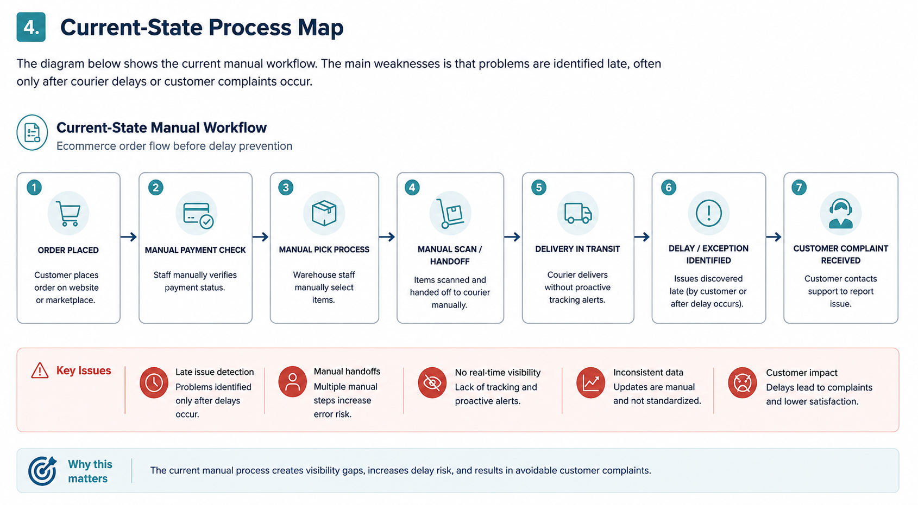

5. Proposed Automation Solutions
The automation plan focuses on practical tools that are realistic for an operations team. The objective is not to replace employees, but to reduce repetitive manual work and allow the team to focus on exceptions, improvement actions, and customer experience.
Area | Recommended digital solution | Operational value
Order tracking | Order management workflow with automatic status changes | Creates a single source of truth for order progress.
Inventory control | Inventory dashboard with reorder-point and low-stock alerts | Reduces stockout risk and improves purchasing decisions.
Picking and packing | Barcode scanning and digital dispatch checklist | Improves order accuracy before courier handoff.
Delivery monitoring | Courier SLA dashboard and exception alerts | Highlights delayed orders before customers complain.
Customer communication | Automated email, SMS, or WhatsApp status notifications | Improves transparency and reduces inbound support volume.
Reporting | Power BI dashboard with daily and weekly KPI refresh | Improves decision-making and management visibility.
Repeated admin tasks | RPA workflow using Power Automate, Zapier, or Make | Reduces manual copying, reminders, and recurring report preparation.
Analytics | Basic AI-assisted delay prediction and root-cause tagging | Supports earlier intervention for at-risk orders.

6. Future-State Automated Process Map
The improved future-state process introduces automated checks, barcode validation, delivery alerts, and automated reporting. Manual work remains only where judgment, escalation, or customer handling is needed.
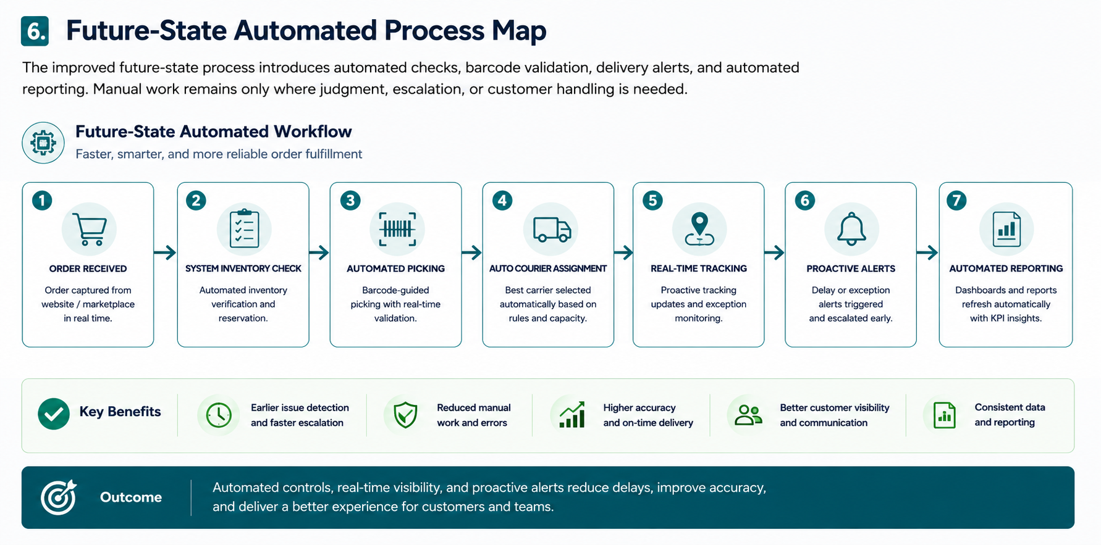

7. Implementation Strategy and Timeline
The project should be implemented in phases to reduce disruption. The first phase documents the current workflow and confirms the automation scope. The middle phases build the dashboards, automations, and templates. The final phases pilot the workflow, train users, roll it out, and monitor results.
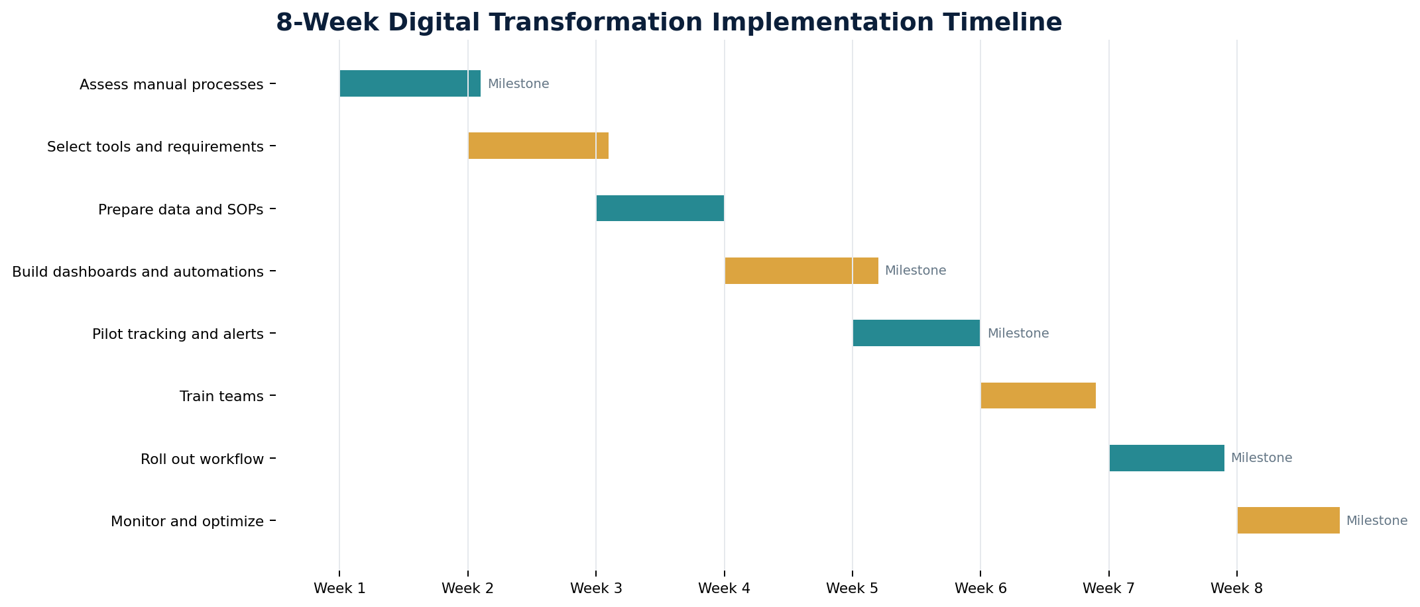
Week | Activity | Main deliverable
1 | Assess manual processes and confirm automation scope | Approved scope and process inventory
2 | Select tools and define system requirements | Tool shortlist and requirements document
3 | Prepare data fields, SOPs, and ownership rules | Data dictionary and SOP draft
4 | Build dashboards, alert logic, and automation templates | Dashboard prototype and notification templates
5 | Pilot order tracking, inventory alerts, and courier SLA monitoring | Pilot results and issue log
6 | Train warehouse, operations, and customer service teams | Training guide and attendance record
7 | Roll out automation across the workflow | Live automated workflow
8 | Monitor performance and finalize improvement report | Final KPI review and action plan

8. Resources Required
Resource type | Requirement | Purpose
People | Operations manager, operations assistant, warehouse lead, customer service lead, IT/data analyst, courier partner contact | Coordinate workflow design, testing, training, escalation, and rollout.
Technology | Excel or Google Sheets, Power BI, order management tool, inventory management system, barcode scanner, CRM/ticketing system, RPA tool | Support automation, data visibility, and workflow control.
Data | Order ID, SKU, stock level, pick time, pack time, dispatch time, courier status, delivery date, complaint reason, review score | Create complete tracking from order receipt to customer outcome.
Documentation | SOPs, dashboard guide, exception handling rules, communication templates, training guide | Standardize how teams use the new process.
Budget | Low to moderate cost depending on tool licensing and barcode hardware | Start with low-cost automation and scale after pilot results.

9. Risk Management Plan
Risk | Impact | Likelihood | Mitigation strategy
Poor data quality | High | Medium | Clean data fields before automation and define mandatory order tracking fields.
Staff resistance to change | Medium | Medium | Use simple SOPs, short training sessions, and show how automation reduces repetitive work.
Integration difficulties | High | Medium | Start with a pilot and use CSV/API-based integrations before full rollout.
Data security concerns | High | Low to Medium | Limit access rights, use approved tools, and avoid unnecessary customer data sharing.
Cost overrun | Medium | Medium | Prioritize low-cost dashboards and automations first, then expand based on value.
Workflow disruption during rollout | Medium | Medium | Roll out in phases, keep manual backup during pilot, and assign escalation owners.
Over-automation of exceptions | Medium | Low | Keep human review for complaints, high-risk orders, and unusual delivery failures.

10. Expected Benefits and KPIs
The expected benefits are based on realistic improvement targets for a simulated e-commerce operation. The final numbers should be validated after the pilot phase.
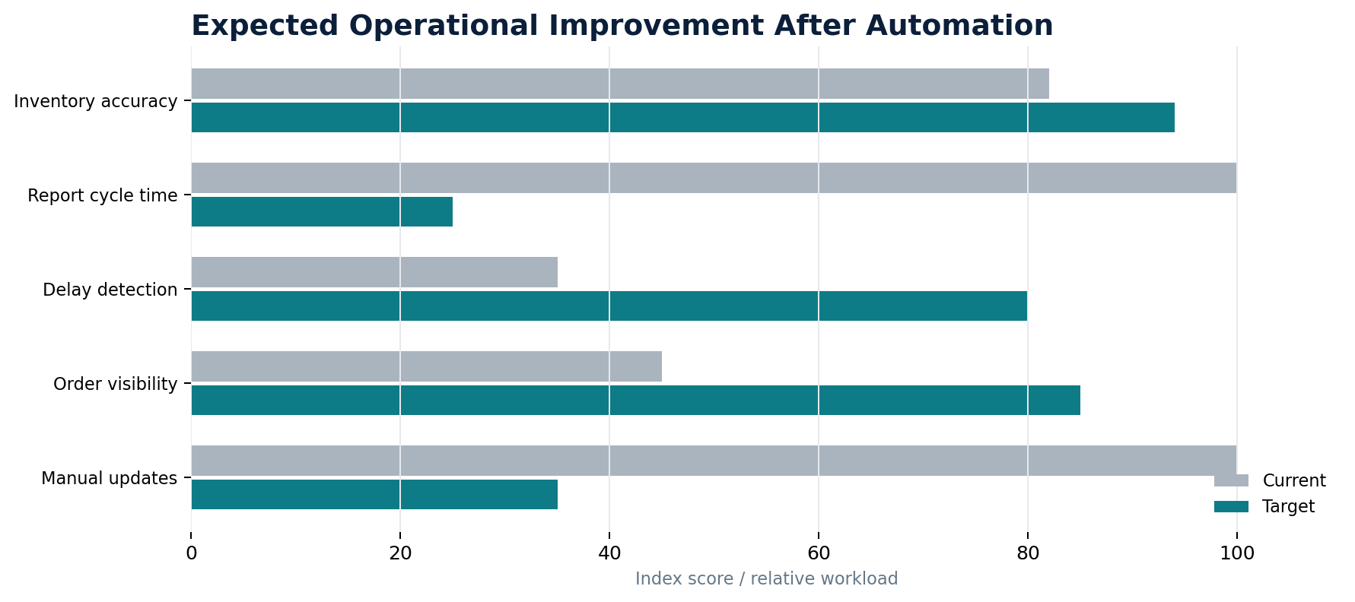
KPI | Current issue | Target after automation
Order status update time | Manual updates can be delayed by several hours | Status updated automatically or within 15 minutes
Delivery delay detection | Detected after customer complaint or late report | Detected through daily alert dashboard
Inventory accuracy | Depends on manual checks and spreadsheet updates | Improved through real-time or scheduled stock updates
Report cycle time | Weekly manual reporting | Automated daily dashboard refresh
Customer communication | Reactive and inconsistent | Triggered notifications for dispatch, delay, and delivery milestones
Quality control before dispatch | Manual and inconsistent checks | Barcode scan and digital checklist before handoff

11. Change Management and Governance
Successful automation depends on adoption, not only tool selection. The operations manager should sponsor the change, while the operations assistant coordinates progress tracking, meeting notes, issue logs, and stakeholder follow-up. Warehouse and customer service teams should be involved early so the new workflow reflects daily operational realities. A weekly governance meeting should review dashboard results, adoption feedback, open risks, and process adjustments.
Governance item | Cadence | Owner
Project progress review | Weekly | Operations manager
Issue and risk log update | Twice weekly during pilot | Operations assistant
Dashboard KPI review | Weekly after rollout | Operations manager and data analyst
Courier SLA review | Weekly | Operations assistant and courier contact
Customer complaint trend review | Weekly | Customer service lead
Post-implementation improvement review | End of Week 8 | Project team

12. Recommendations
- Begin with high-impact, low-cost automation: dashboard refresh, delivery alerts, and customer notification templates.
- Use a pilot group before changing the full fulfillment workflow.
- Create clear ownership rules for every order status change and escalation point.
- Introduce barcode validation before dispatch to reduce picking and packing errors.
- Review delayed orders daily and courier SLA performance weekly.
- Document SOPs in simple language so new team members can follow the automated workflow consistently.
- Measure success through a small KPI set: delay rate, order accuracy, inventory accuracy, complaint rate, and reporting cycle time.

13. Conclusion
This digital transformation plan provides a realistic roadmap for improving e-commerce fulfillment operations through automation. By moving from manual tracking and reactive reporting to automated order visibility, inventory alerts, barcode validation, courier monitoring, and KPI dashboards, the operation can reduce errors, detect delays earlier, improve customer communication, and strengthen operational control. The 8-week implementation timeline, resource plan, and risk management approach make the proposal practical and achievable for an operations team.

