Process Mapping and Improvement Analysis Report
E-Commerce Order Fulfillment and Delivery Process Improvement
Prepared by: Shaghayegh Haghbin
Date: June 2026
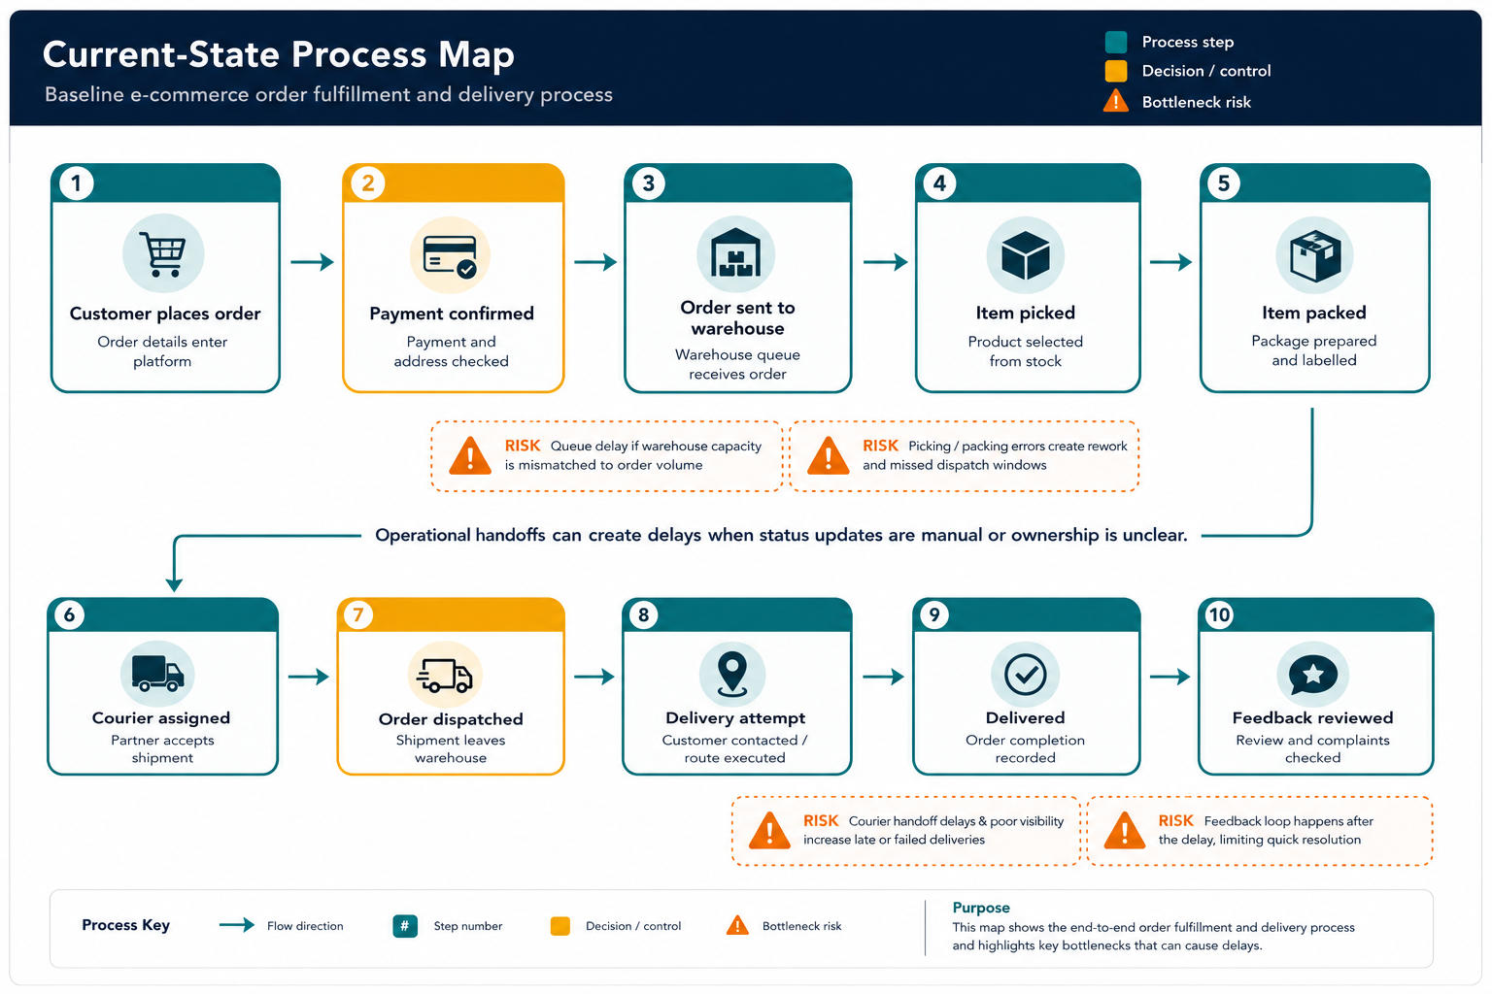

Executive Summary
This report maps the current e-commerce order fulfillment and delivery process and identifies opportunities to improve operational efficiency, delivery reliability, and customer experience. The selected process starts when a customer places an order and ends when delivery is confirmed and customer feedback is reviewed. The analysis shows that the most important operational risks usually appear at handoff points: payment/address validation, warehouse queueing, picking and packing, courier assignment, delivery attempts, and feedback review. These stages can create delays when ownership, visibility, and performance indicators are not clearly controlled.
The recommended future-state process introduces automated validation, exception queues, warehouse task prioritization, barcode-based pick and pack checks, courier SLA monitoring, proactive delay alerts, and a weekly KPI dashboard. These improvements are practical because they target common process gaps without requiring a full redesign of the business model. The expected impact is a faster, more transparent, and more measurable fulfillment workflow with fewer preventable delays and stronger customer communication.

1. Introduction
Operational teams are responsible for making sure that work moves smoothly from one step to the next. In e-commerce, the fulfillment and delivery process is especially important because customers experience operational performance directly through delivery speed, accuracy, communication, and issue resolution. A delay at any stage can affect customer satisfaction, review scores, repeat purchases, and team workload.
This task simulates the work of an operations analyst reviewing a real-world workflow. The aim is to break down the process into clear steps, identify bottlenecks and redundancies, connect each stage to measurable performance indicators, and recommend improvements that can realistically improve workflow efficiency.

2. Process Selected and Scope
Selected process: E-commerce order fulfillment and delivery.
Scope: The process begins when a customer places an order online and ends when the order is delivered and feedback is reviewed. The process includes order validation, warehouse handoff, picking, packing, courier assignment, dispatch, delivery attempt, delivery confirmation, and customer feedback review. The analysis does not cover marketing acquisition, product sourcing, supplier negotiations, or post-refund financial reconciliation.
Included in scope | Out of scope | Main operational goal
Order validation, warehouse processing, picking, packing, courier assignment, dispatch, delivery confirmation and feedback review | Marketing, supplier negotiations, product design, customer acquisition and financial reconciliation | Reduce delivery delays, improve handoff visibility, lower rework and strengthen KPI-based decision-making

3. Current-State Process Map
The current-state process map below shows the baseline workflow. The process is linear, but several steps depend on manual checking or delayed communication between teams and partners. These handoffs create risk because the problem may only become visible after the order is already late.
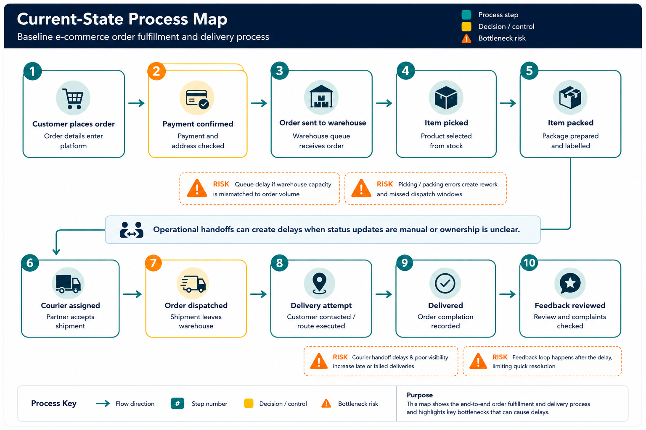
Figure 1. Current-state e-commerce order fulfillment and delivery process map.

4. Step-by-Step Process Explanation
Step | Process stage | What happens | Performance indicator
1 | Customer places order | The customer submits product, address, payment and delivery information through the online platform. | Order volume, abandoned orders
2 | Payment confirmed | Payment and address details are checked before the order moves forward. | Payment confirmation time, validation exception rate
3 | Order sent to warehouse | The warehouse receives the order and places it into the fulfillment queue. | Warehouse queue time, orders pending
4 | Item picked | Warehouse staff select the product from inventory. | Picking accuracy, picking time
5 | Item packed | The order is packed, labelled and prepared for dispatch. | Packing time, rework rate
6 | Courier assigned | A courier partner accepts the shipment and receives delivery information. | Courier acceptance time, SLA compliance
7 | Order dispatched | The package leaves the warehouse and tracking begins. | Dispatch time, status update accuracy
8 | Delivery attempt | The courier attempts delivery and communicates with the customer if needed. | First-attempt delivery rate, failed delivery rate
9 | Delivered | The order is marked as delivered and completion is recorded. | Delivery time, late delivery rate
10 | Feedback reviewed | Customer reviews, complaints and operational issues are reviewed after delivery. | Review score, complaint rate

5. Bottlenecks and Inefficiencies
The main inefficiencies are concentrated around handoffs, manual checks, and delayed visibility. These are important because each team may complete its own task, but the total customer experience still suffers if the full workflow is not coordinated end to end.
Process area | Inefficiency | Operational impact | Improvement action
Payment and address validation | Manual checking or incomplete customer details can hold orders before warehouse release. | Orders start late, warehouse planning becomes less accurate, and customer updates may be delayed. | Create automated validation rules and route only exceptions to manual review.
Warehouse queue | Orders may sit in the queue without priority rules based on due date, geography or delivery risk. | Late dispatch risk increases during peak order periods. | Use a daily warehouse task queue sorted by SLA risk and order age.
Picking and packing | Manual picking and packing can create errors, rework or missed dispatch windows. | Incorrect items, repacking, return risk and lower customer satisfaction. | Introduce barcode scans, pick lists and final quality checks before dispatch.
Courier assignment | Courier partners may be selected without enough visibility into SLA performance by region. | Carrier delays increase and teams cannot identify weak delivery lanes quickly. | Use a courier scorecard by state/area, delay rate and first-attempt success.
Delivery attempt | Failed delivery reasons may not be captured consistently or escalated quickly. | Repeated attempts, customer frustration and higher delivery cost. | Add at-risk delivery alerts and proactive customer communication.
Feedback review | Reviews are often checked after the issue instead of being linked to operational root causes. | The same problems can repeat across locations, categories or carriers. | Tag feedback by operational cause and review it during weekly KPI meetings.

6. KPI Framework
A strong process map should connect each stage to measurable indicators. The following KPIs can be monitored weekly by operations, warehouse, customer service and logistics teams.
KPI | Definition | Why it matters | Review frequency
Average delivery time | Average days from order approval to delivery confirmation. | Tracks customer-facing speed and process efficiency. | Weekly
Delay rate | Percentage of delivered orders completed after the estimated delivery date. | Shows overall reliability of fulfillment and courier performance. | Weekly
Warehouse processing time | Time between order approval and dispatch. | Identifies warehouse queueing or staffing gaps. | Daily / weekly
Picking accuracy | Percentage of orders picked without item or quantity errors. | Reduces rework, returns and customer complaints. | Weekly
Courier SLA compliance | Percentage of shipments delivered within agreed courier service levels. | Highlights weak carriers or delivery lanes. | Weekly
First-attempt delivery success | Percentage of orders delivered on the first attempt. | Reduces cost, delay and customer frustration. | Weekly
Review score linked to delivery | Customer review score compared with delivery timeliness. | Connects operations performance with customer satisfaction. | Monthly

7. Future-State Improved Process Map
The future-state process keeps the same core order flow but adds control points that make problems visible earlier. The biggest change is that the process no longer waits until the customer complains or the order is late. Instead, exceptions, SLA risks and feedback patterns are captured during the workflow and reviewed through a KPI dashboard.
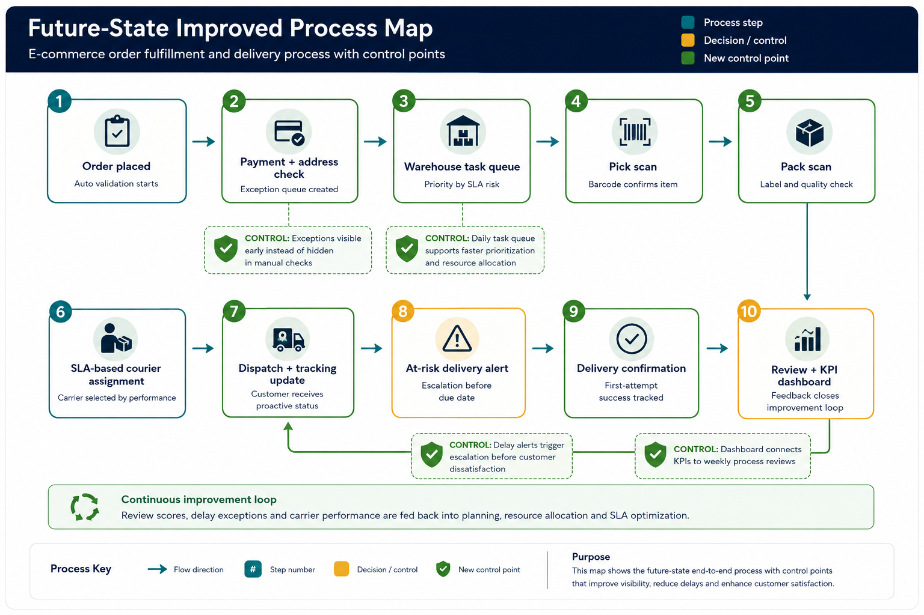
Figure 2. Future-state process map with automated controls, delay alerts and a KPI feedback loop.

8. Recommendations
Priority | Recommendation | Action detail | Impact | Effort
1 | Build an operational KPI dashboard | Track delay rate, average delivery time, warehouse processing time, carrier SLA compliance and customer feedback in one weekly view. | High | Medium
2 | Introduce at-risk order alerts | Flag orders close to estimated delivery date, stuck in warehouse queue or delayed at courier handoff. | High | Medium
3 | Standardize warehouse pick and pack checks | Use pick lists, barcode scanning and final quality checks to reduce manual errors and rework. | High | Low to medium
4 | Review courier performance by region | Compare courier delay rates, first-attempt success and customer complaints across delivery areas. | High | Medium
5 | Create a weekly root-cause review | Discuss the top causes of delay and assign owners for corrective actions. | Medium | Low
6 | Link customer feedback to process steps | Tag complaints and low review scores by root cause, such as late delivery, damaged item, wrong item or poor communication. | Medium | Low
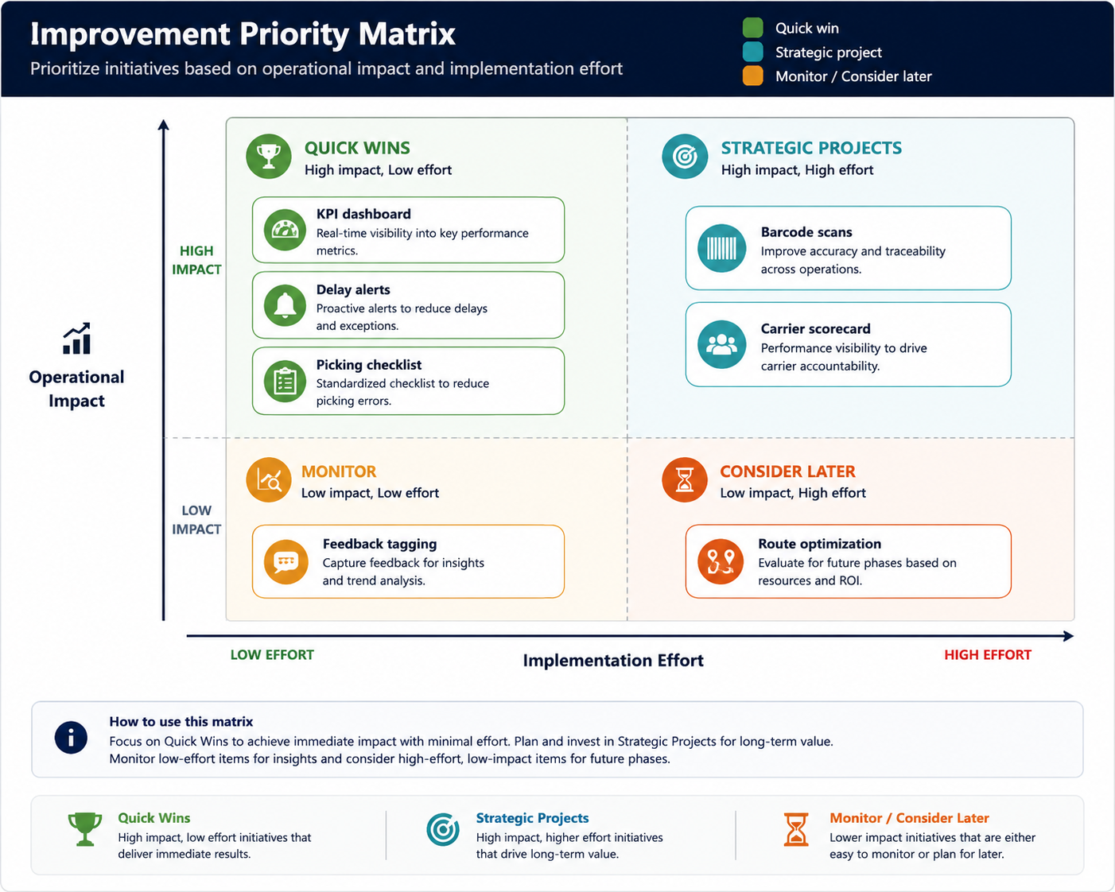
Figure 3. Priority matrix for selecting practical process improvements.

9. Implementation Roadmap
Timeline | Actions | Expected output
First 30 days | Map process ownership, define KPIs, create daily order exception list, and start weekly review meetings. | Clear baseline, shared accountability and faster visibility of delayed orders.
Days 31 to 60 | Add warehouse pick/pack checklist, categorize delay reasons, and begin carrier scorecard reporting. | Reduced rework, better root-cause tracking and stronger courier performance visibility.
Days 61 to 90 | Implement automated delay alerts, proactive customer notifications and dashboard-based process review. | Earlier escalation, fewer preventable delays and stronger customer communication.

10. Expected Operational Impact
The improvements are expected to strengthen the process in four practical ways. First, they improve visibility because delayed orders, courier issues and warehouse queues become easier to track. Second, they reduce rework by standardizing picking and packing checks. Third, they support faster decision-making because managers can focus on exceptions and weak points instead of reviewing every order manually. Fourth, they improve customer experience because customers receive more accurate updates and delivery problems are escalated earlier.
Impact area | Expected change | How it will be measured
Delivery reliability | Lower delay rate through earlier alerts and carrier SLA tracking | Delay rate and average delivery time
Warehouse efficiency | Reduced rework through standard pick and pack checks | Picking accuracy and warehouse processing time
Customer experience | More proactive communication and faster issue escalation | Review score and complaint rate
Management visibility | Clear weekly dashboard and root-cause ownership | Weekly KPI review completion and action tracking

11. Reflection and Conclusion
This process mapping exercise shows how operational efficiency depends on both process design and process visibility. A fulfillment workflow may appear simple when viewed as a straight line, but delays often happen at the points where work changes ownership between the platform, warehouse, courier and customer service teams. Mapping the process makes these handoffs easier to understand and gives the operations team a clearer way to prevent recurring problems.
The recommended future-state process is practical because it does not require replacing the whole workflow. Instead, it adds measurable controls at the most important points: validation, warehouse prioritization, pick and pack accuracy, courier SLA management, delay alerts and KPI review. These changes would help an operations team work more proactively, improve delivery performance and support better decision-making based on clear performance indicators.

Appendix: Submission Description
For this Week 2 submission, I prepared a process mapping and improvement analysis report focused on the e-commerce order fulfillment and delivery process. The report maps the current workflow from customer order placement through payment confirmation, warehouse processing, picking, packing, courier assignment, dispatch, delivery attempt, delivery confirmation and customer feedback review. I selected this process because it is a common operational workflow where delays, manual handoffs and poor visibility can directly affect customer satisfaction and business performance. The report includes a current-state process map, a step-by-step explanation of each stage, an analysis of bottlenecks and inefficiencies, a KPI framework, a future-state improved process map, recommendations, an implementation roadmap and expected operational impacts. The main improvement ideas include automated validation, exception queues, warehouse task prioritization, barcode-based pick and pack checks, courier SLA monitoring, at-risk order alerts, proactive customer notifications and weekly KPI reviews. These recommendations are designed to reduce delays, improve handoff visibility, lower rework and connect customer feedback to operational root causes. This submission demonstrates practical process mapping, workflow analysis and operational improvement planning.

