Operational Inventory and Resource Optimization Report
Week 4 Task | Inventory Forecasting, Reorder Planning and Resource Allocation

Scenario | E-commerce fulfillment center managing multi-category inventory
Primary tools | Excel forecasting workbook, moving average, safety stock, reorder point analysis
Planning horizon | January to March 2026
Dataset type | Simulated operational inventory data based on realistic fulfillment assumptions

Prepared as a practical operations simulation demonstrating inventory analysis, forecasting, resource planning and process improvement recommendations.

1. Executive Summary
This report presents an inventory optimization plan for a simulated e-commerce fulfillment operation. The objective is to forecast near-term inventory requirements, reduce the risk of stockouts and overstocking, and align warehouse resources with expected demand. The analysis uses a 3-month moving average with seasonal adjustment, safety stock calculation, reorder point analysis, and resource capacity planning.
The simulated operation manages eight product categories across a three-month planning horizon. January 2026 forecasted demand is 8,277 units, with total current stock of 12,200 units and 2,950 units already on order. The model recommends 1,331 additional units for selected categories, with Toys & Games requiring the strongest attention because it carries medium stockout risk. Sports & Outdoor shows high overstock risk, indicating a need for controlled purchasing and promotional planning.
Jan Forecast Demand | Current Stock | On Order | Recommended Order | Avg Lead Time
8,277 units | 12,200 units | 2,950 units | 1,331 units | 12.4 days

2. Introduction and Operational Context
Inventory planning is a critical part of operations management because poor inventory control can create stockouts, excess storage costs, slow fulfillment, and lower customer satisfaction. In an e-commerce environment, demand can change quickly due to promotions, seasonality, supplier lead times, and customer purchasing behavior. This report simulates how an operations assistant or operations specialist can support inventory decisions by using structured forecasting, resource planning, and clear operational recommendations.
The selected scenario continues the operational theme from previous tasks: improving fulfillment performance in an e-commerce order process. The inventory plan focuses on the point where customer demand, warehouse capacity, and supplier replenishment meet. The goal is to keep sufficient stock available for high-demand categories while avoiding unnecessary holding cost for slow-moving or seasonal categories.

3. Scenario and Key Assumptions
Assumption Area | Details
Product scope | Eight product categories: electronics, beauty, home, fashion, health, toys, office supplies, and sports
Planning period | January to March 2026
Forecasting approach | 3-month moving average adjusted for category seasonality
Replenishment logic | Safety stock and reorder point used to trigger purchase decisions
Resource planning | Warehouse and support headcount estimated from forecasted order units
Data source | Simulated operational dataset created for this assignment, with realistic e-commerce assumptions
The model assumes that historical monthly demand is available for January to December 2025 and that the business needs to plan inventory and staff capacity for the next three months. Supplier lead times vary by category, which means that categories with longer lead times require more careful replenishment planning.

4. Forecasting Methodology
The demand forecast was developed using a 3-month moving average because it is simple, transparent, and suitable for a practical operations simulation. The moving average smooths short-term fluctuations and is then adjusted using a seasonal factor for each product category. This approach is useful when a business needs a realistic planning estimate without requiring complex statistical software.
Method | How it was used
3-Month Moving Average | Average demand from the most recent three months is used to estimate the next planning period.
Seasonal Adjustment | The moving average is multiplied by a category-specific factor to reflect seasonal demand patterns.
Safety Stock | Demand variability, supplier lead time, and service factor are used to keep buffer stock for uncertainty.
Reorder Point | Expected demand during supplier lead time plus safety stock.
Recommended Order Quantity | Target coverage requirement minus inventory position, adjusted so it cannot fall below zero.
Resource Capacity Planning | Forecasted units are translated into staffing needs based on productivity assumptions.

5. Demand Forecast Analysis
Demand increases across most product categories during the final quarter of 2025, especially during the November and December period. The forecast then moderates in January 2026 before gradually increasing into February and March. This pattern suggests that the operation should not only react to peak demand, but should also plan purchasing, receiving, and picking capacity ahead of the next demand cycle.
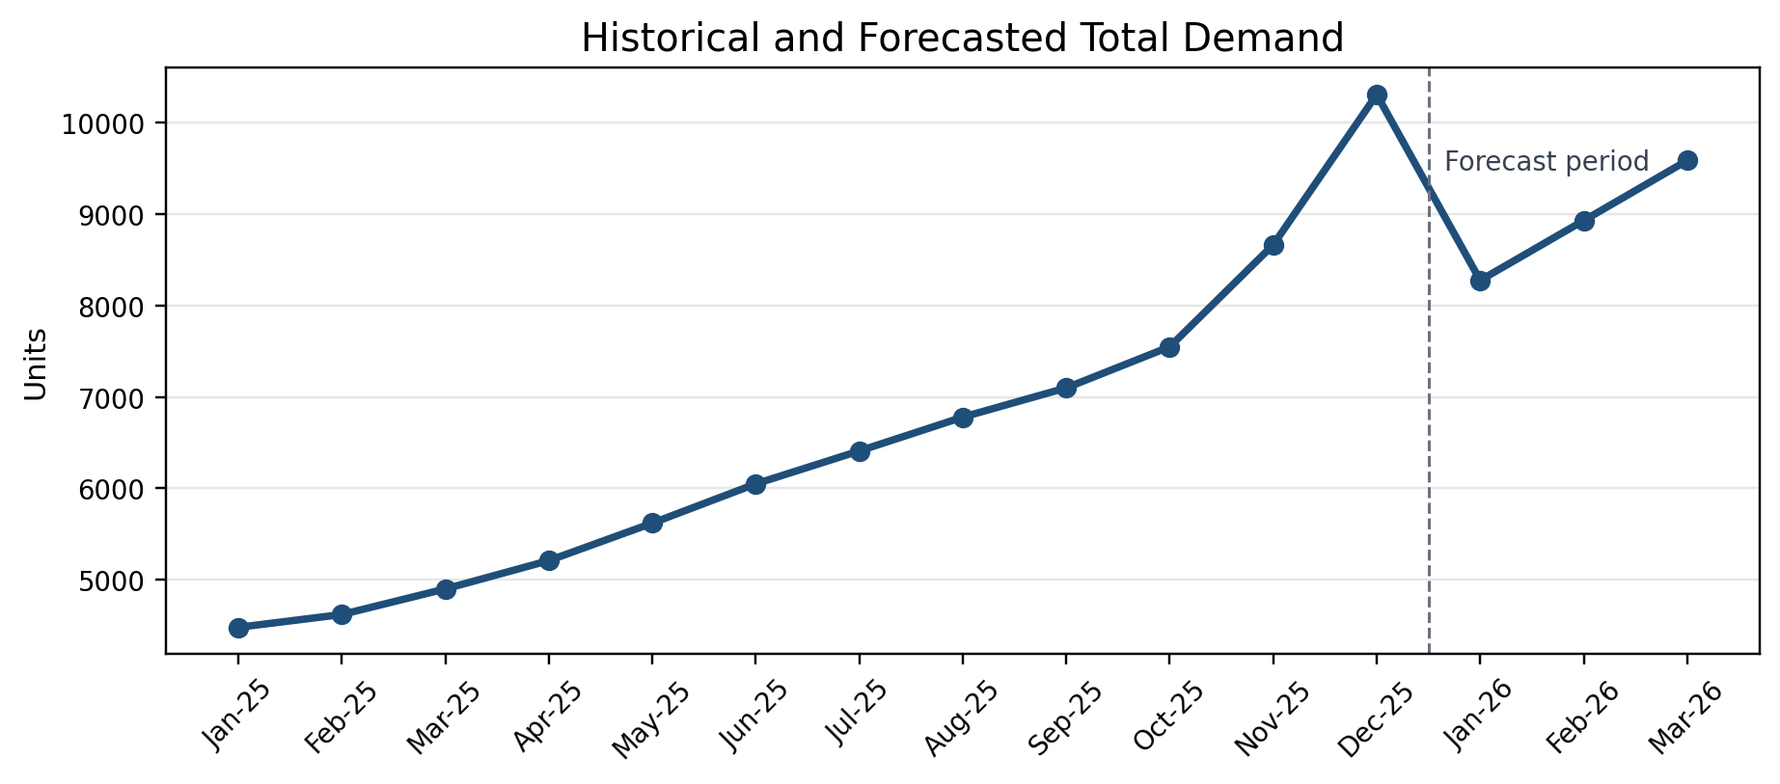
Category | 3-Month Avg | Jan-26 Forecast | Feb-26 Forecast | Mar-26 Forecast
Consumer Electronics | 1,663 | 1,464 | 1,644 | 1,749
Beauty & Personal Care | 1,365 | 1,297 | 1,391 | 1,455
Home & Kitchen | 1,160 | 1,044 | 1,158 | 1,290
Fashion Accessories | 1,240 | 1,091 | 1,226 | 1,384
Health & Wellness | 937 | 1,012 | 1,054 | 1,112
Toys & Games | 1,017 | 712 | 872 | 929
Office Supplies | 720 | 828 | 769 | 770
Sports & Outdoor | 740 | 829 | 817 | 899

6. Inventory Position and Reorder Analysis
The reorder analysis compares current stock, on-order inventory, forecasted demand, safety stock, and reorder point. A category is considered a stockout risk when inventory position is below the reorder point or when projected ending stock falls below safety stock. A category is considered an overstock risk when inventory position is materially above near-term demand and safety stock requirements.
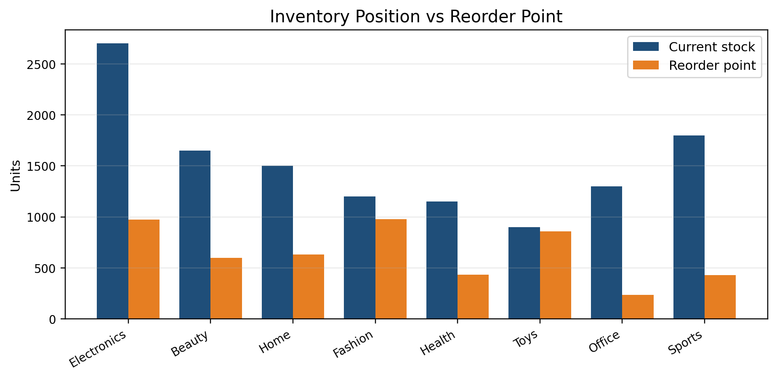
Category | ABC | Current | On Order | Jan Forecast | Safety Stock | Reorder Point | Order Qty | Risk | Priority
Consumer Electronics | A | 2,700 | 600 | 1,464 | 291 | 975 | 0 | Low | Monitor
Beauty & Personal Care | A | 1,650 | 400 | 1,297 | 167 | 600 | 133 | Low | Monitor
Home & Kitchen | B | 1,500 | 350 | 1,044 | 214 | 632 | 16 | Low | Monitor
Fashion Accessories | B | 1,200 | 500 | 1,091 | 398 | 980 | 436 | Low | Monitor
Health & Wellness | B | 1,150 | 300 | 1,012 | 129 | 433 | 229 | Low | Monitor
Toys & Games | C | 900 | 200 | 712 | 429 | 857 | 517 | Medium | Review within 1 week
Office Supplies | C | 1,300 | 250 | 828 | 42 | 236 | 0 | Low | Monitor
Sports & Outdoor | C | 1,800 | 350 | 829 | 70 | 430 | 0 | Low | Reduce / promote
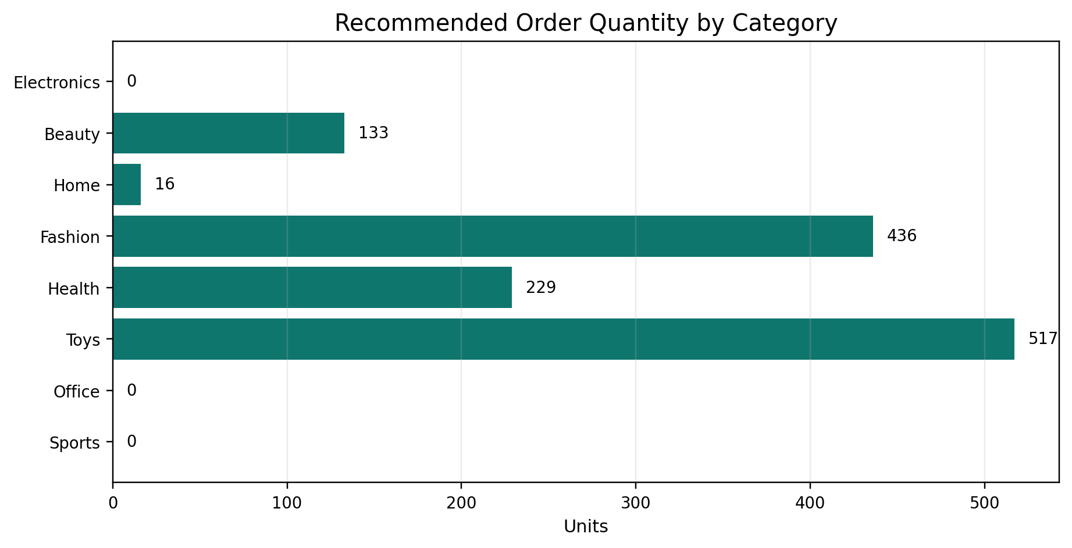

7. Resource Allocation Plan
Inventory optimization is linked to resource planning because forecasted demand affects warehouse receiving, picking, packing, inventory control, and customer service workload. The resource plan below estimates monthly staffing needs using productivity assumptions. The main operational focus should be to maintain enough pick/pack capacity while keeping receiving and inventory control coverage stable.
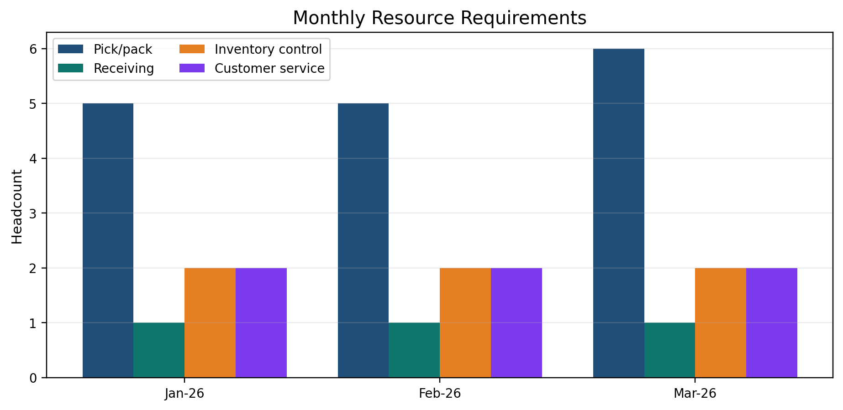
Month | Forecast Units | Service Tickets | Pick/Pack | Receiving | Inventory Control | CS Agents | Notes
Jan-26 | 8,277 | 662 | 5 | 1 | 2 | 2 | Maintain baseline coverage
Feb-26 | 8,931 | 714 | 5 | 1 | 2 | 2 | Maintain baseline coverage
Mar-26 | 9,588 | 767 | 6 | 1 | 2 | 2 | Peak resource level required

8. Risk Assessment and Mitigation
The main operational risks are linked to demand uncertainty, supplier delays, inaccurate stock counts, and resource availability. The risk register below identifies risks that could affect stock availability, warehouse efficiency, and customer experience.
Risk | Impact | Operational Effect | Mitigation Strategy | Owner
Demand spike higher than forecast | High | Stockouts and backorders | Use weekly forecast refresh and keep safety stock for A/B items | Operations Manager
Supplier lead time delays | High | Late replenishment and missed SLAs | Track supplier delivery commitments and create backup supplier list | Procurement Lead
Excess inventory after seasonal peak | Medium | Higher storage cost and working capital pressure | Use markdown plan and freeze buying for slow-moving SKUs | Inventory Controller
Inaccurate inventory counts | High | False availability and customer complaints | Run weekly cycle counts and barcode reconciliation | Warehouse Supervisor
Warehouse labor shortage | Medium | Picking delays during high-volume weeks | Schedule flexible staff based on forecasted demand | Operations Assistant
System update delays | Medium | Late KPI tracking and manual reporting | Use temporary Excel dashboard until automation is ready | Data Analyst

9. Recommendations
The recommendations focus on improving replenishment discipline, increasing visibility, and preventing avoidable operational delays. The actions are practical and can be implemented using Excel, Google Sheets, or a basic inventory management system.
No. | Recommendation | Action Details | Expected Benefit | Timing
1 | Set reorder-point alerts | Use the reorder point and safety stock fields to trigger weekly purchasing actions. | Fewer emergency orders and lower stockout risk | Immediate
2 | Review high-risk categories first | Prioritize categories with High or Medium stockout risk before placing broad orders. | Better use of budget and purchasing capacity | Immediate
3 | Use weekly rolling forecast | Refresh the 3-month moving average every week using the latest order and inventory data. | More accurate demand planning | 2 weeks
4 | Reduce overstock through promotions | Apply promotions or purchase freezes to categories with high overstock risk. | Lower storage cost and excess inventory | 2 to 4 weeks
5 | Align staff schedules with forecast | Plan picking, receiving, and customer service staffing based on monthly forecasted volume. | Faster fulfillment and fewer bottlenecks | Monthly
6 | Improve supplier visibility | Track lead times, late deliveries, and SLA compliance by supplier. | More reliable replenishment cycle | Monthly

10. Expected Benefits
Benefit Area | Expected Improvement
Stockout reduction | Reorder point alerts and safety stock reduce the chance of running out of key products.
Lower excess inventory | Overstock risk review helps avoid unnecessary purchasing and storage costs.
Better fulfillment speed | Staffing is planned from forecasted demand, reducing picking and packing bottlenecks.
Improved cash flow | Recommended order quantities prevent overbuying and improve purchasing discipline.
Clearer accountability | Owners are assigned for inventory checks, supplier follow-up, and risk mitigation.
Improved customer experience | Higher product availability and faster fulfillment can support better delivery reliability.

11. Implementation Plan
Timeline | Action | Responsible Team
Week 1 | Validate stock records and confirm supplier lead times | Inventory Controller, Warehouse Supervisor
Week 2 | Refresh 3-month moving average forecast and review seasonal factors | Operations Assistant, Data Analyst
Week 3 | Apply reorder point review and place priority purchase orders | Operations Manager, Procurement Lead
Week 4 | Adjust warehouse staffing schedule based on demand forecast | Warehouse Supervisor
Month-end | Review stockouts, overstock, purchase cost and service tickets | Operations Manager

12. Conclusion
This inventory optimization plan demonstrates how forecasting, reorder point analysis, and resource planning can support operational efficiency in an e-commerce fulfillment setting. The analysis shows that not all categories require the same purchasing response. Some categories need replenishment attention, while others require monitoring or overstock control. By using a structured Excel workbook and a clear planning process, the operation can make better purchasing decisions, reduce avoidable stockouts, manage surplus inventory, and align warehouse resources with expected demand.

Appendix: Workbook Sheets Included
Workbook Sheet | Purpose
Dashboard | KPI summary, demand trend, inventory position chart, and recommended order chart
Assumptions | Scenario inputs, forecasting method, productivity assumptions, and source note
Demand History | Historical monthly demand by category
Forecast Model | 3-month moving average and seasonal forecast calculations
Reorder Plan | Safety stock, reorder point, inventory position, recommended order quantity and risk classification
Resource Plan | Monthly staffing requirements for warehouse and customer support
Risk Register | Operational risks, impacts, owners and mitigation strategies
Recommendations | Action plan for inventory and resource optimization

The attached Excel workbook is editable and contains the supporting formulas, forecast tables, charts, dashboard, risk register and recommendations used in this Word report.

