Quality Control and Operational Performance Evaluation Report
Week 5 Task
Operational scenario: E-commerce order fulfillment quality control
Prepared as a simulated quality control report using monthly operational performance data, Pareto analysis, control chart analysis, root cause review, and corrective action planning.

1. Executive Summary
This report evaluates the quality performance of a simulated e-commerce order fulfillment process. The analysis focuses on common operational quality issues such as late deliveries, picking errors, packing errors, wrong item shipments, damaged items, processing errors, customer complaints, and average processing time. The purpose is to assess performance, identify failure points, and recommend corrective actions that support continuous improvement.
The simulated dataset covers 81,550 orders across twelve months. Across the period, the process recorded 12,692 quality incidents, giving an average defect rate of 15.6%. The analysis shows that late deliveries are the main quality issue, representing more than half of total incidents. Control chart results also show that November and December exceed the upper control limit, indicating special-cause variation during peak demand periods.
KPI | Result | Target | Interpretation
Total orders | 81,550 | N/A | Annual simulated order volume reviewed
Total quality incidents | 12,692 | Reduce | Main quality losses to control
Average defect rate | 15.6% | <= 15% | Slightly above target
Average order accuracy | 93.5% | >= 94% | Slightly below target
Average complaint rate | 5.3% | <= 5% | Above target and rising
Months above UCL | 2 | 0 | Peak months require special attention

2. Introduction
Quality control in operations focuses on monitoring process outputs, detecting defects, and applying corrective action before quality problems affect customers. In an e-commerce fulfillment environment, quality problems often appear as late deliveries, incorrect items, damaged packages, warehouse errors, long processing times, or customer complaints.
The operational process evaluated in this report begins when an order is confirmed and ends when the customer receives the item and feedback or complaints are recorded. This scope covers warehouse picking, packing, dispatch handoff, courier delivery, customer communication, and quality issue follow-up.

3. Quality Metrics Used
Metric | Definition | Why it matters | Target
Defect rate | Total quality incidents divided by total orders | Shows the proportion of orders affected by quality problems | <= 15%
Order accuracy | Orders without picking, packing, wrong-item or damage issues | Measures warehouse and dispatch accuracy | >= 94%
Complaint rate | Customer complaints divided by total orders | Captures customer-facing quality impact | <= 5%
First-time-right rate | One minus defect rate | Shows the share of orders completed without incident | >= 85%
Processing time | Average time from order confirmation to dispatch | Measures throughput and fulfillment speed | <= 24 hrs
Control status | Defect rate compared with UCL and LCL | Identifies stable or unstable process performance | Stay within limits

4. Methodology
The report uses simulated operational performance data for a 12-month e-commerce fulfillment process. The dataset was designed to reflect realistic fulfillment quality categories and seasonal demand patterns. The analysis was completed using spreadsheet-based calculations, Pareto analysis, a control chart approach, KPI comparison, and root cause evaluation.
- Step 1: Define quality metrics that are relevant to fulfillment operations.
- Step 2: Create monthly simulated data for order volume, quality incidents, complaints, and processing time.
- Step 3: Calculate defect rate, complaint rate, order accuracy, and first-time-right rate.
- Step 4: Use Pareto analysis to identify the highest-impact defect categories.
- Step 5: Use a control chart to determine whether the process is stable or affected by special-cause variation.
- Step 6: Identify root causes and recommend corrective actions linked to operational KPIs.

5. Simulated Performance Data
Month | Orders | Incidents | Defect Rate | Complaint Rate | Processing Time | Status
Jan 2026 | 5,200 | 701 | 13.5% | 4.2% | 22.5 hrs | Below LCL
Feb 2026 | 5,400 | 729 | 13.5% | 4.3% | 22.1 hrs | Below LCL
Mar 2026 | 5,750 | 784 | 13.6% | 4.3% | 21.7 hrs | Below LCL
Jun 2026 | 6,900 | 1,068 | 15.5% | 5.1% | 25.1 hrs | Stable
Oct 2026 | 7,400 | 1,203 | 16.3% | 5.5% | 26.2 hrs | Stable
Nov 2026 | 8,200 | 1,447 | 17.6% | 6.3% | 29.5 hrs | Above UCL
Dec 2026 | 9,100 | 1,681 | 18.5% | 7.0% | 31.8 hrs | Above UCL
The table shows selected months from the full simulated dataset. The full monthly dataset, formulas, and dashboard are available in the accompanying Excel workbook.

6. Quality Control Analysis

6.1 KPI Trend Analysis
The defect rate rises from 13.5% in January to 18.5% in December. Complaint rate follows a similar pattern, increasing from 4.2% to 7.0%. This indicates that quality issues are not only internal process problems but are also visible to customers.
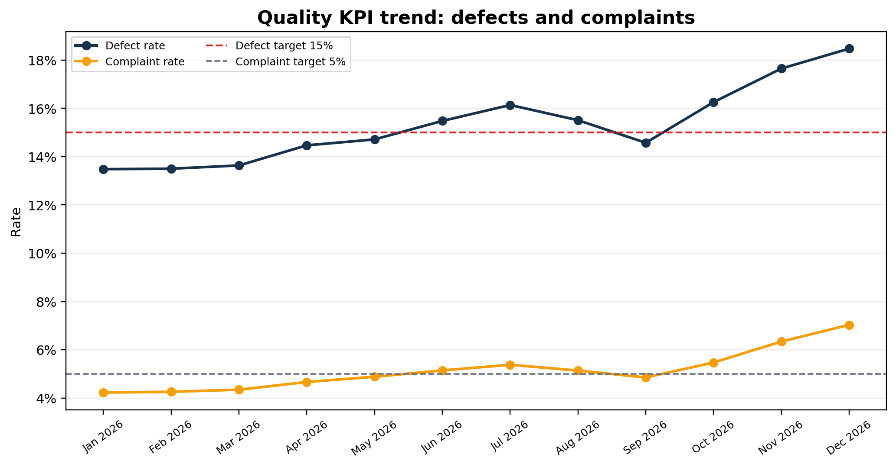

6.2 Pareto Analysis
Pareto analysis shows that late deliveries are the largest quality issue, with 6,700 incidents. Picking errors and packing errors are the next largest categories. This means that improvement should start with delivery reliability and warehouse quality gates before moving to lower-volume issue categories.
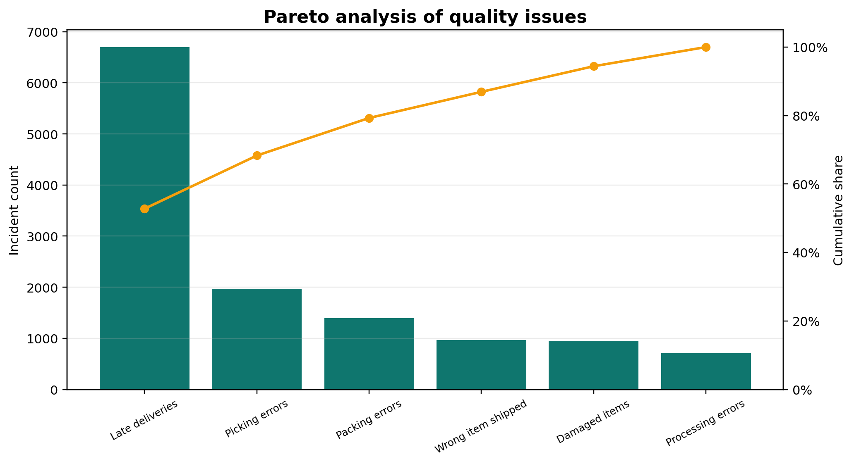

6.3 Control Chart Analysis
The control chart uses the monthly defect rate as the quality measure. The center line is the annual average defect rate of 15.6%. November and December exceed the upper control limit, which suggests that peak-season pressure is creating special-cause variation. January to March fall below the lower control limit, which may indicate lighter operational load, more stable staffing, or lower seasonal pressure.
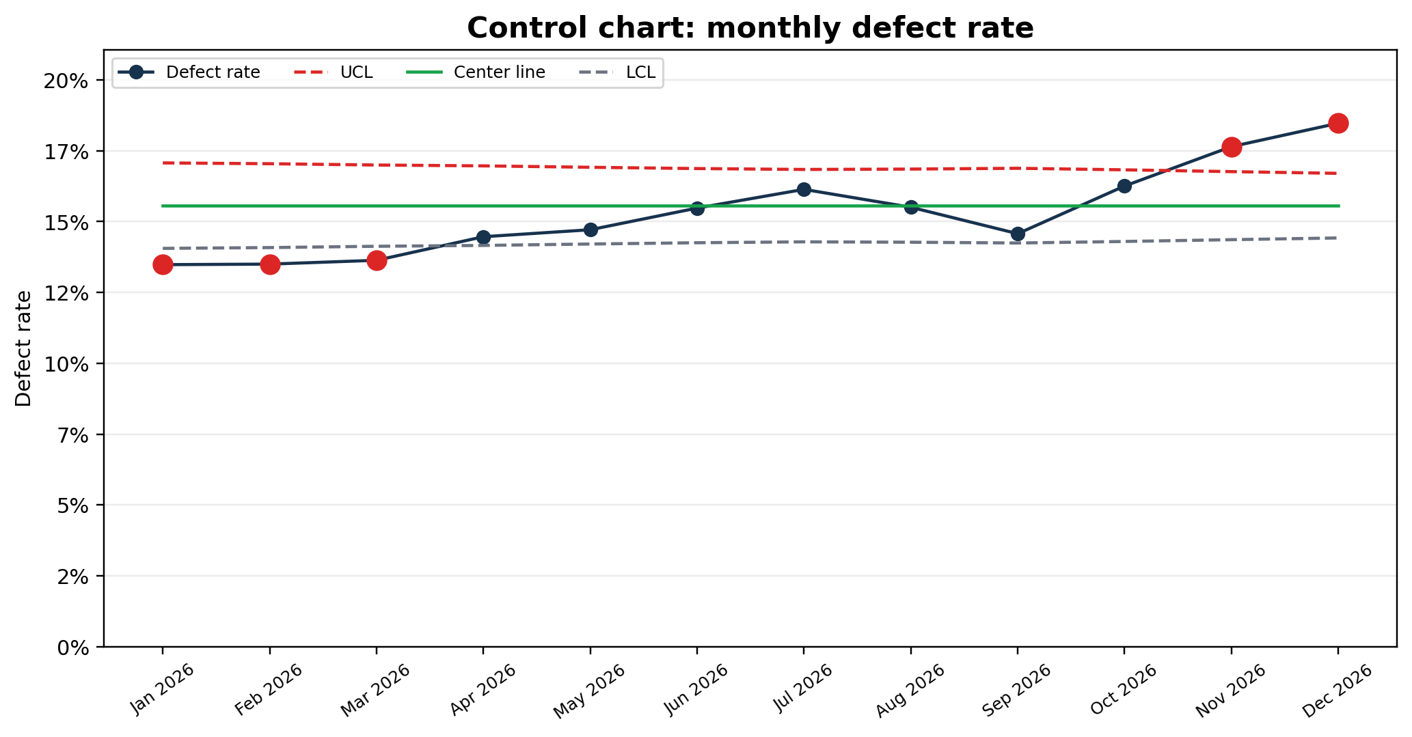

6.4 Issue Frequency Review
The issue distribution confirms that delivery reliability is the most urgent area for corrective action, followed by picking and packing accuracy. These categories directly influence delivery performance, returns, complaints, and customer satisfaction.
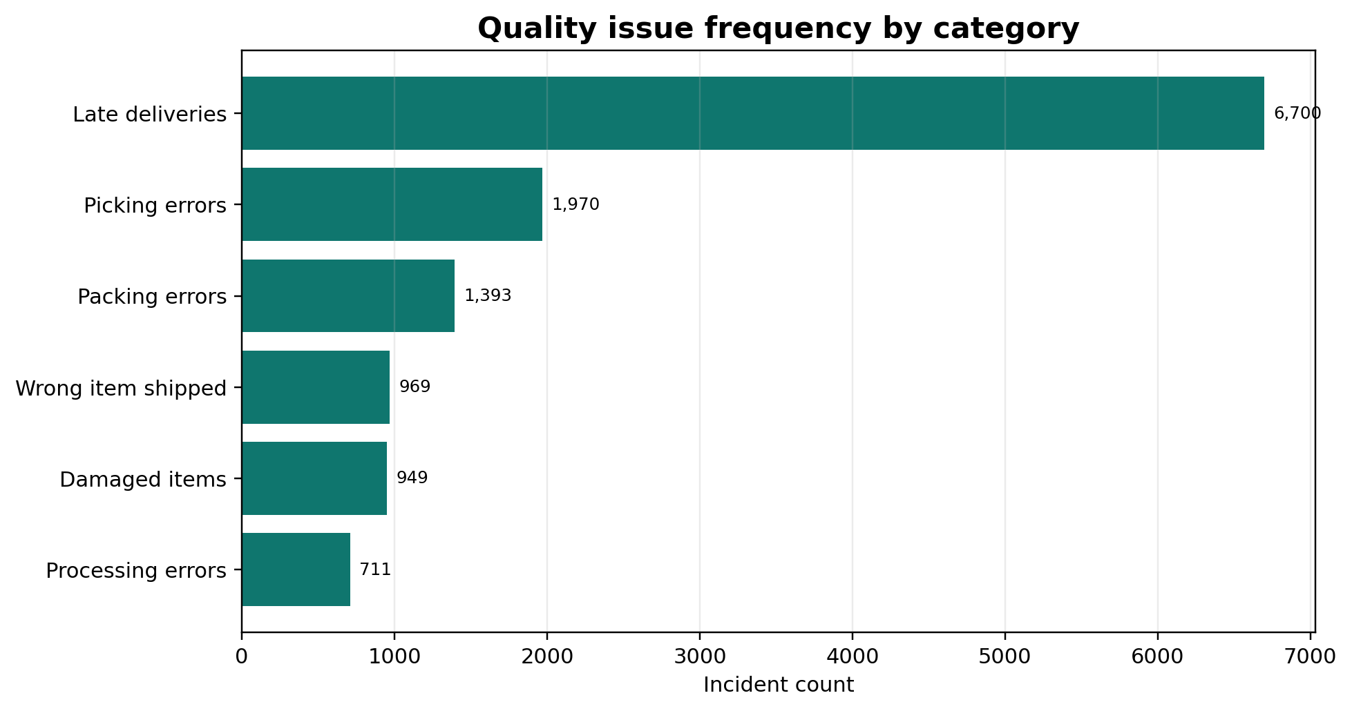

7. Process Weaknesses and Failure Points
Process Area | Weakness | Likely Root Cause | Operational Impact
Courier handoff | Late delivery incidents increase in high-volume months | Courier capacity and weak exception alerts | Lower customer satisfaction and higher complaint rate
Warehouse picking | Picking errors remain the second-largest issue | Manual checks and similar SKU storage | Wrong order contents and rework
Packing station | Packing errors rise during busy periods | No mandatory quality checklist before dispatch | Returns, complaints, and damaged customer trust
Dispatch validation | Wrong-item shipments continue across the year | SKU validation not repeated before handoff | Refunds, replacements, and avoidable service tickets
Packaging control | Damaged items increase with order volume | Packaging standards not aligned to item risk | Higher replacement cost and dissatisfaction
Status updates | Processing and cancellation errors occur repeatedly | Manual data entry and unclear ownership | Confusing customer communication and delayed issue resolution

8. Corrective Recommendations
Recommendation | Action | Owner | Priority | Expected Result
Courier SLA monitoring | Track late orders daily and review courier SLA weekly | Operations Coordinator | High | Reduce delivery delays and improve accountability
Barcode scan before packing | Require scan validation between pick and pack stage | Warehouse Supervisor | High | Reduce picking and wrong-item errors
Final packing checklist | Add standard packing and item confirmation checklist | Packing Lead | Medium | Reduce packing errors and damage
Peak-season staffing plan | Add temporary staff or overtime plan before demand spikes | Operations Manager | High | Reduce November and December instability
Quality dashboard | Monitor defect rate, complaint rate, accuracy, and control status weekly | Operations Assistant | High | Improve visibility and faster corrective action
Customer communication templates | Send proactive updates for delayed or exception orders | Customer Service Lead | Medium | Reduce complaint escalation and improve experience

9. Implementation Plan
Phase | Timeline | Main Activities | Deliverables | Success Measure
Phase 1: Baseline review | Week 1 | Validate metrics, confirm issue categories, review defect logs | Approved KPI baseline | Defect categories confirmed
Phase 2: Quick controls | Weeks 2-3 | Introduce packing checklist, barcode validation, delay alert list | Quality control checklist | Fewer picking and packing errors
Phase 3: Courier control | Weeks 3-4 | Review courier SLA, define escalation path, track delayed orders | Courier SLA tracker | Lower late delivery rate
Phase 4: Dashboard reporting | Weeks 4-5 | Build weekly dashboard and control chart review routine | Quality dashboard | Faster issue detection
Phase 5: Training and rollout | Weeks 5-6 | Train warehouse, packing, dispatch, and customer service teams | Training completion log | Improved adherence to process
Phase 6: Review | Weeks 7-8 | Compare post-action KPIs against baseline and refine actions | Performance review report | Defect rate trending down

10. Expected Impact on Operational Performance
The proposed changes are expected to reduce the most frequent and most visible quality issues. Delivery SLA monitoring should reduce late deliveries, while barcode verification and packing checklists should improve order accuracy. A weekly dashboard should also help the operations team detect problems before they become large customer-facing failures.
- Defect rate reduction through daily exception monitoring and weekly review.
- Improved order accuracy through barcode checks and stronger dispatch validation.
- Lower complaint rate through proactive communication and faster issue resolution.
- More stable peak-season operations through staffing and courier capacity planning.
- Better resource allocation because recurring defect categories become visible to supervisors.

11. Reflection
This quality control exercise shows how operational performance can be improved when process data is reviewed consistently. Instead of treating late deliveries, complaints, and errors as separate problems, the analysis connects them to the full fulfillment workflow. The use of Pareto analysis helps prioritize the most important issues, while the control chart shows whether performance is stable or affected by special events such as peak-season pressure.

12. Conclusion
The simulated quality control analysis found that the e-commerce fulfillment process is under pressure, especially during peak months. The average defect rate is slightly above the target level, order accuracy is slightly below target, and complaints increase as defect rates rise. Late deliveries are the largest quality issue and should be addressed first, followed by picking, packing, and dispatch validation improvements. The recommended corrective actions are practical, measurable, and suitable for continuous operational improvement.

