Project Coordination and Scheduling Report
Project Management Plan for Improving E-Commerce Order Fulfillment and Delivery Performance

Project Type | Operational improvement and scheduling simulation
Timeline | 15 June 2026 to 7 August 2026 (8 weeks)
Process Area | Order fulfillment, warehouse handoff, courier coordination and customer communication
Prepared For | Week 3 Task: Project Coordination and Scheduling
Prepared By | Shaghayegh Haghbin

This document presents a practical project management plan with phases, milestones, a Gantt timeline, resource allocation, risks, communication planning and expected operational impact.

1. Executive Summary
This project management plan simulates the coordination of an operational improvement project focused on reducing e-commerce fulfillment and delivery delays. The project connects the operational data analysis and process mapping work completed in earlier tasks by turning findings into a structured eight-week implementation plan.
The project is designed to improve visibility across the order journey, standardize warehouse-to-courier handoffs, introduce delay exception tracking, strengthen courier SLA monitoring and improve customer communication. The plan includes a realistic project timeline, milestones, deliverables, resource allocation, a risk register, mitigation strategies and a stakeholder communication plan.
The project is intentionally practical and suitable for an operations assistant or operations specialist environment. It focuses on coordination, follow-up, documentation, scheduling, issue escalation and measurable improvements rather than a purely technical system build.

2. Project Overview
Item | Details
Project Name | E-Commerce Fulfillment and Delivery Performance Improvement Project
Project Duration | 8 weeks, from 15 June 2026 to 7 August 2026
Operational Problem | Delivery delays and weak handoff visibility can reduce customer satisfaction and make it difficult for teams to identify where workflow issues occur.
Project Purpose | Improve coordination between warehouse, courier and customer service teams while creating a practical KPI tracking and escalation structure.
Project Approach | Assess current workflow, set KPIs, redesign handoff process, pilot improvements, train teams and complete rollout.

3. Project Objectives and Success Criteria
• Reduce delivery-delay risk by introducing earlier exception tracking and weekly KPI visibility.
• Improve warehouse-to-courier coordination through a clear handoff SOP and ownership checklist.
• Create a practical tracking structure for order delays, courier SLA issues and customer notification timing.
• Strengthen accountability by assigning owners, milestones and escalation triggers for each project phase.
• Pilot the improved process before full rollout so issues can be corrected before implementation at scale.
Success Measure | Target / Indicator
Schedule control | Major project milestones completed within the 8-week timeline.
Delay visibility | Delay exception tracker and KPI cadence ready by Week 4.
Process clarity | Future-state SOP, handoff checklist and escalation process approved by Week 6.
Pilot readiness | Pilot completed with issue log, corrective action record and sign-off by Week 7.
Handover quality | Final report, ownership notes and next-step recommendations submitted in Week 8.

4. Scope, Assumptions and Constraints
Area | Included in Scope | Out of Scope / Constraint
Order fulfillment | Order status flow, warehouse handoff, pick-pack-dispatch coordination. | This project does not redesign the full e-commerce platform.
Delivery coordination | Courier SLA review, delayed-order exception tracking and escalation rules. | Carrier contract renegotiation is outside the 8-week simulation scope.
Customer communication | Delay notification templates and customer service handoff guidance. | Full CRM automation is not assumed.
Data and reporting | Excel/Power BI KPI tracker, manual validation and weekly reporting cadence. | No custom IT development is assumed.

5. Project Phases and Timeline
The project is structured into six phases. Each phase has a defined operational purpose, named owners and clear deliverables. The schedule is designed to be realistic for a small operations improvement project because it includes time for review, design, piloting, training and final handover.
Phase | Dates | Main Activities | Key Deliverable
Project Initiation | 15 Jun to 19 Jun 2026 | Kickoff, scope confirmation, stakeholder register and project charter approval. | Approved project charter.
Current Process Review | 22 Jun to 30 Jun 2026 | Workflow review, stakeholder interviews, delay analysis and bottleneck identification. | Current-state assessment.
Data and KPI Setup | 01 Jul to 10 Jul 2026 | KPI field definitions, tracker setup, delay alert rules and data ownership validation. | KPI dashboard and exception tracker.
Workflow Improvement Design | 13 Jul to 21 Jul 2026 | Handoff SOP, courier SLA review process, notification templates and training pack. | Approved future-state process design.
Pilot Implementation | 22 Jul to 31 Jul 2026 | Pilot improved process, monitor daily issues and complete corrective action review. | Pilot sign-off and action log.
Rollout and Closure | 03 Aug to 07 Aug 2026 | Training, go-live briefing, full rollout and final handover. | Final performance review and handover report.

Figure 1. Phase-Level Gantt Timeline
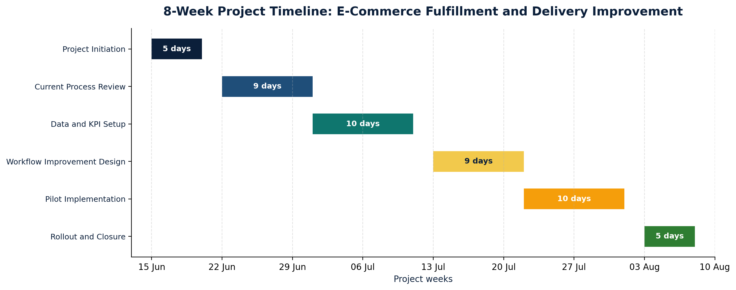

6. Detailed Task Schedule
The detailed schedule below shows task ownership, planned dates and deliverables. The Excel workbook provided with this report contains the full Gantt chart with timeline bars, task dates, dependencies, status fields and progress formulas.
ID | Phase | Task | Owner | Start | End | Deliverable
1 | Project Initiation | Project kickoff and sponsor alignment | Operations Manager | 15 Jun | 16 Jun | Kickoff notes and agreed project direction
2 | Project Initiation | Confirm scope, KPIs, baseline and target outcomes | Operations Assistant | 16 Jun | 17 Jun | Approved scope and KPI list
3 | Project Initiation | Build stakeholder register and communication plan | Project Coordinator | 17 Jun | 18 Jun | Stakeholder and communication matrix
4 | Project Initiation | Milestone: project charter approved | Operations Manager | 19 Jun | 19 Jun | Signed project charter
5 | Current Process Review | Review current order fulfillment workflow | Operations Assistant | 22 Jun | 24 Jun | Current-state process notes
6 | Current Process Review | Interview warehouse, courier and customer service stakeholders | Project Coordinator | 22 Jun | 25 Jun | Interview summary log
7 | Current Process Review | Analyze delivery delay dashboard and operational findings | Data Analyst | 24 Jun | 26 Jun | Baseline performance analysis
8 | Current Process Review | Identify bottlenecks, root causes and handoff risks | Operations Assistant | 26 Jun | 29 Jun | Bottleneck and root-cause summary
9 | Current Process Review | Milestone: current-state assessment approved | Operations Manager | 30 Jun | 30 Jun | Current-state assessment sign-off
10 | Data and KPI Setup | Define KPI fields, calculation rules and reporting cadence | Data Analyst | 01 Jul | 02 Jul | KPI definition sheet
11 | Data and KPI Setup | Prepare tracking template and Power BI/Excel source fields | Data Analyst | 02 Jul | 06 Jul | KPI tracking template
12 | Data and KPI Setup | Configure delay alert rules and exception tracker | Operations Assistant | 06 Jul | 08 Jul | Delay exception tracker
13 | Data and KPI Setup | Validate data quality and reporting ownership | Project Coordinator | 08 Jul | 10 Jul | Data quality checklist
14 | Data and KPI Setup | Milestone: KPI dashboard and tracker ready | Operations Manager | 10 Jul | 10 Jul | Dashboard sign-off
15 | Workflow Improvement Design | Redesign warehouse-to-courier order handoff SOP | Operations Assistant | 13 Jul | 15 Jul | Updated SOP draft
16 | Workflow Improvement Design | Define courier SLA review process and escalation path | Operations Manager | 14 Jul | 16 Jul | SLA review procedure
17 | Workflow Improvement Design | Create customer notification templates for delayed orders | Customer Service Lead | 16 Jul | 17 Jul | Notification templates
18 | Workflow Improvement Design | Prepare training materials, checklists and role guides | Project Coordinator | 17 Jul | 20 Jul | Training pack and checklist
19 | Workflow Improvement Design | Milestone: future-state design approved | Operations Manager | 21 Jul | 21 Jul | Future-state design sign-off
20 | Pilot Implementation | Pilot improved process with selected sample orders | Warehouse Lead | 22 Jul | 28 Jul | Pilot run report
21 | Pilot Implementation | Monitor daily issues, delays and exception tracker updates | Operations Assistant | 22 Jul | 30 Jul | Daily issue log
22 | Pilot Implementation | Hold pilot review and corrective action meeting | Project Coordinator | 30 Jul | 31 Jul | Corrective action log
23 | Pilot Implementation | Milestone: pilot sign-off | Operations Manager | 31 Jul | 31 Jul | Pilot approval
24 | Rollout and Closure | Team training and go-live briefing | Project Coordinator | 03 Aug | 04 Aug | Training attendance and briefing notes
25 | Rollout and Closure | Full rollout across fulfillment workflow | Operations Manager | 05 Aug | 06 Aug | Go-live confirmation
26 | Rollout and Closure | Final performance review and handover report | Operations Assistant | 07 Aug | 07 Aug | Final project report and handover pack

7. Key Milestones and Deliverables
Milestone | Target Date | Deliverable | Acceptance Criteria
Project charter approved | 19 Jun 2026 | Signed project charter | Scope, project goal and responsible owners confirmed
Current-state assessment approved | 30 Jun 2026 | Process review and bottleneck assessment | Root causes and handoff risks clearly documented
KPI dashboard and tracker ready | 10 Jul 2026 | KPI tracker and delay exception rules | Reporting fields validated and owners assigned
Future-state design approved | 21 Jul 2026 | SOP, SLA review process and templates | Improved process map and role handoffs approved
Pilot sign-off | 31 Jul 2026 | Pilot report and corrective action log | Pilot completed with documented lessons learned
Project closure and handover | 07 Aug 2026 | Final performance review and handover report | Final report submitted with next-step owner

8. Resource Allocation and Responsibilities
Resource planning is based on clear role ownership. The operations assistant supports coordination, documentation, tracker updates, stakeholder follow-up and handover reporting. The operations manager acts as the project sponsor and approves key milestones.
Workstream | Ops Manager | Ops Assistant | Project Coord. | Data Analyst | Warehouse Lead | CS Lead | Courier
Project initiation and governance | A | R | C | C | I | I | I
Current process review | A | R | R | C | C | C | C
KPI and dashboard setup | A | C | C | R | I | I | I
Warehouse handoff SOP redesign | A | R | C | C | R | C | C
Courier SLA and escalation process | A/R | C | C | I | C | I | R
Customer notification templates | A | C | C | I | I | R | C
Pilot monitoring and issue resolution | A | R | R | C | R | C | R
Training and rollout | A | R | R | I | R | R | C
Final handover and reporting | A | R | C | R | I | I | I

9. Risk Assessment and Mitigation Plan
The project risks are mostly related to schedule control, data quality, stakeholder adoption and courier performance. Each risk has an owner, mitigation strategy and contingency plan so the project can remain realistic and controlled.
Figure 2. Risk Heat Map
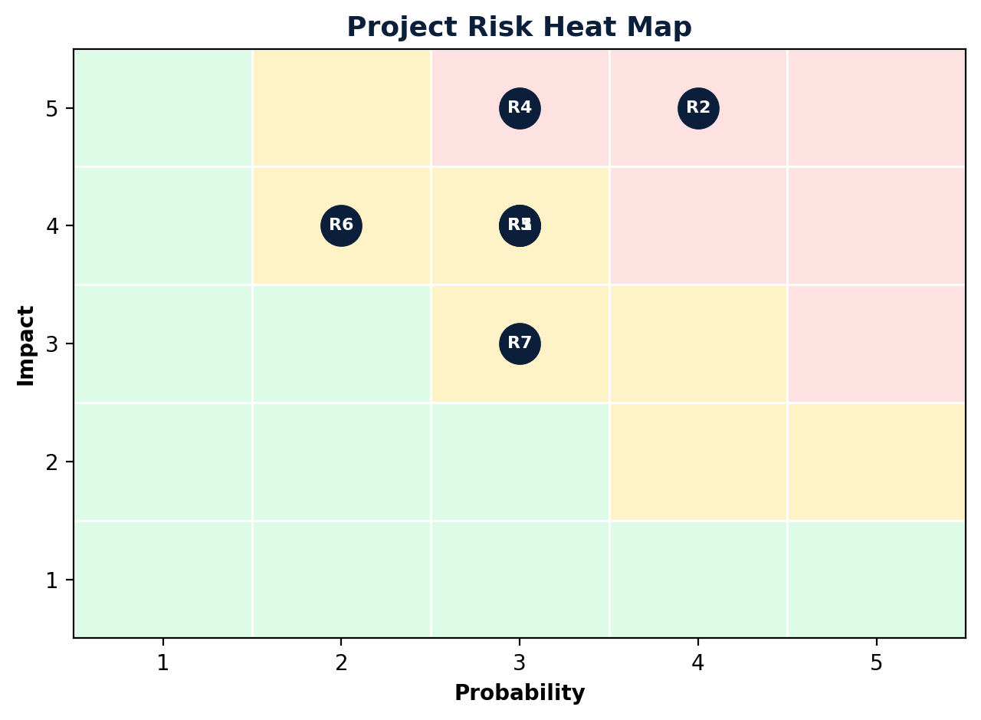
ID | Risk | Score | Owner | Mitigation / Contingency
R1 | Project tasks take longer than expected due to stakeholder availability. | 12 | Project Coordinator | Mitigation: Use weekly progress check-ins and confirm meeting availability in advance. Contingency: Escalate overdue tasks and adjust non-critical activities.
R2 | Order tracking fields are incomplete or inconsistent across teams. | 20 | Data Analyst | Mitigation: Standardize fields before dashboard setup and assign data ownership. Contingency: Use manual validation sample until automation is stable.
R3 | Warehouse or customer service teams resist the updated process. | 12 | Operations Manager | Mitigation: Keep SOP simple and provide short training with role-specific checklists. Contingency: Run additional coaching and collect feedback during pilot.
R4 | Delivery partner performance does not improve after SLA review. | 15 | Operations Manager | Mitigation: Review SLA performance weekly and create an escalation path for late orders. Contingency: Compare alternative carriers for high-delay locations.
R5 | Customers remain dissatisfied if delay notifications are sent too late. | 12 | Customer Service Lead | Mitigation: Set notification triggers before expected delivery is missed. Contingency: Send proactive service recovery messages for high-risk orders.
R6 | Power BI or tracker setup does not refresh as expected. | 8 | Data Analyst | Mitigation: Test refresh logic during setup and document ownership. Contingency: Use Excel tracker backup during pilot period.
R7 | Additional process changes are requested beyond the agreed project scope. | 9 | Operations Manager | Mitigation: Use change log and require approval for major scope additions. Contingency: Move non-critical ideas to the post-project improvement backlog.

10. Stakeholder Communication Plan
Communication is organized around weekly decision-making, pilot monitoring and escalation. This prevents project issues from staying hidden until the final phase.
Audience | Purpose | Format | Frequency | Owner | Escalation Trigger
Project sponsor / Operations Manager | Confirm scope, decisions and roadblocks | Weekly meeting + summary email | Weekly | Project Coordinator | Blocked tasks or timeline slip over 2 days
Warehouse team | Review handoff process, issues and checklist usage | Stand-up meeting | Twice weekly during pilot | Warehouse Lead | Repeated picking or handoff errors
Courier partner | Review SLA performance and delayed order exceptions | SLA review call | Weekly | Operations Manager | Late delivery rate exceeds target
Customer service team | Align delay notifications and customer response process | Briefing + template review | Weekly | Customer Service Lead | Customer complaints increase
Data analyst | Validate KPI fields, dashboard refresh and data quality | Working session | Weekly | Operations Assistant | Data gaps or dashboard refresh failure
All stakeholders | Share pilot outcome, rollout readiness and final handover | Final report and presentation | Project close | Operations Assistant | Open risks remain unresolved

11. Project Monitoring and Control
The project will be controlled through weekly progress reviews, status tracking, risk review and milestone sign-off. The Excel Gantt chart supports this by showing owners, dates, dependencies, status, priority and progress percentage.
Control Area | Method | Frequency | Owner
Schedule control | Review task status, overdue activities and upcoming dependencies. | Weekly | Project Coordinator
Risk control | Update risk score, mitigation actions and escalation status. | Weekly | Operations Manager
Data quality | Validate KPI fields, dashboard refresh and source data completeness. | Weekly | Data Analyst
Pilot control | Track daily exceptions, process gaps and corrective actions. | Daily during pilot | Operations Assistant
Decision control | Maintain decision log and approval record for scope or timeline changes. | As needed | Project Coordinator

12. Expected Impact
Impact Area | Expected Improvement
Delivery performance | Earlier exception tracking should help teams intervene before delayed orders become serious customer issues.
Workflow efficiency | Clear handoff steps and checklists reduce rework, missing information and follow-up confusion.
Management visibility | Weekly KPI reporting makes trends easier to monitor and supports faster operational decisions.
Customer experience | Delay notification templates improve consistency and reduce uncertainty for customers.
Accountability | Named task owners, RACI roles and escalation triggers create clearer responsibility across teams.

13. Reflection
This simulation demonstrates how project coordination supports operational improvement. The plan shows how an operations assistant can help organize timelines, prepare documentation, follow up with stakeholders, track risks, support KPI reporting and keep deliverables moving toward completion.
The strongest part of the plan is the connection between workflow analysis and project execution. Instead of only identifying delays, the project translates those issues into a practical implementation schedule with owners, milestones and risk controls. This reflects how operational improvements are often achieved in real workplace settings: through structured coordination, clear communication and consistent follow-up.

14. Conclusion
The proposed eight-week project plan provides a realistic structure for improving e-commerce order fulfillment and delivery performance. It includes clear phases, a Gantt timeline, task ownership, deliverables, resource allocation, risk mitigation and stakeholder communication. The plan is designed to support smoother operations, better visibility, stronger accountability and more consistent customer communication.

