Digital Chronic Care Follow-up and Monitoring Program
Week 5 Task: Post-Project Evaluation and Lessons Learned Documentation
Prepared by: Shaghayegh Haghbin
Final Evaluation Report
Document Purpose
This report reviews the completed digital healthcare project, compares planned outcomes with actual results, evaluates KPI performance, summarizes stakeholder feedback, and captures lessons learned for future improvement.

1. Executive Summary
The Digital Chronic Care Follow-up and Monitoring Program was designed to improve continuity of care, patient communication, appointment attendance, monitoring data collection, and stakeholder coordination through a structured digital healthcare service model. The project was implemented over a 12-week period and was evaluated against planned deliverables, service quality indicators, budget control, risk response, stakeholder feedback, and lessons learned.
Overall, the project was successful in achieving staff training, reporting discipline, budget control, stakeholder communication, and patient satisfaction targets. Some outcomes were slightly below target, including appointment attendance, onboarding completion, and technical issue resolution time. These gaps provide useful insight for improving future project delivery, especially in relation to patient instructions, reminder workflows, testing schedules, and issue escalation.
Overall Evaluation Result
The project was completed with most major deliverables achieved. Future improvement should focus on simplifying patient materials, strengthening appointment reminders, improving technical response times, and starting platform testing earlier in the delivery schedule.

2. Project Recap
This section summarizes the completed project, including the purpose, duration, stakeholders, deliverables, and final completion status.
Project Area | Summary
Project purpose | Improve chronic care follow-up, patient communication, and monitoring data collection through a structured digital care model.
Project duration | 12 weeks
Primary users | Patients requiring ongoing chronic care follow-up and health status tracking.
Core stakeholders | Patients, doctors, nurses, administrative team, IT team, project manager, data protection lead, and senior management.
Major deliverables | Project plan, implementation roadmap, communication plan, KPI framework, monitoring reports, and final evaluation report.
Overall status | Completed with improvement actions identified.

3. Evaluation Methodology
The post-project evaluation was conducted by reviewing planned deliverables, project timelines, KPI data, stakeholder feedback, issue records, budget status, training records, and communication logs. The aim was to identify performance strengths, delivery gaps, lessons learned, and practical recommendations for future healthcare projects.
Evaluation Method | Purpose
KPI review | Compared planned KPI targets with actual project results.
Document review | Reviewed project plans, meeting records, reporting outputs, risk logs, and issue logs.
Stakeholder feedback | Summarized feedback from patients, clinical staff, administrative staff, IT staff, and management.
Risk review | Assessed how planned and unexpected issues were handled during implementation.
Improvement analysis | Converted findings into lessons learned and future action points.

4. Planned vs Actual Results
The table below compares the expected outcomes from the planning phase with the actual results achieved by the end of the project. The evaluation shows that the project achieved most operational goals, although selected areas require continued improvement.
Area | Planned Result | Actual Result | Status
Patient onboarding | 90% completion | 88% completion | Slightly below target
Staff training | 100% completion | 100% completion | Achieved
Appointment attendance | 85% or higher | 82% | Needs improvement
Patient satisfaction | 4 out of 5 or higher | 4.2 out of 5 | Achieved
Issue resolution | Within 24 hours | Average 28 hours | Needs improvement
Budget control | Within 10% variance | 7% variance | Achieved
Reporting completion | 100% on time | 100% on time | Achieved

5. Performance Analysis
The performance analysis uses the KPI framework developed during the monitoring and reporting stage. The results show that the project performed strongly in staff readiness, reporting discipline, budget management, and patient satisfaction. Attendance and technical response performance were close to target but require stronger controls.
Figure 1. KPI Target vs Actual Result
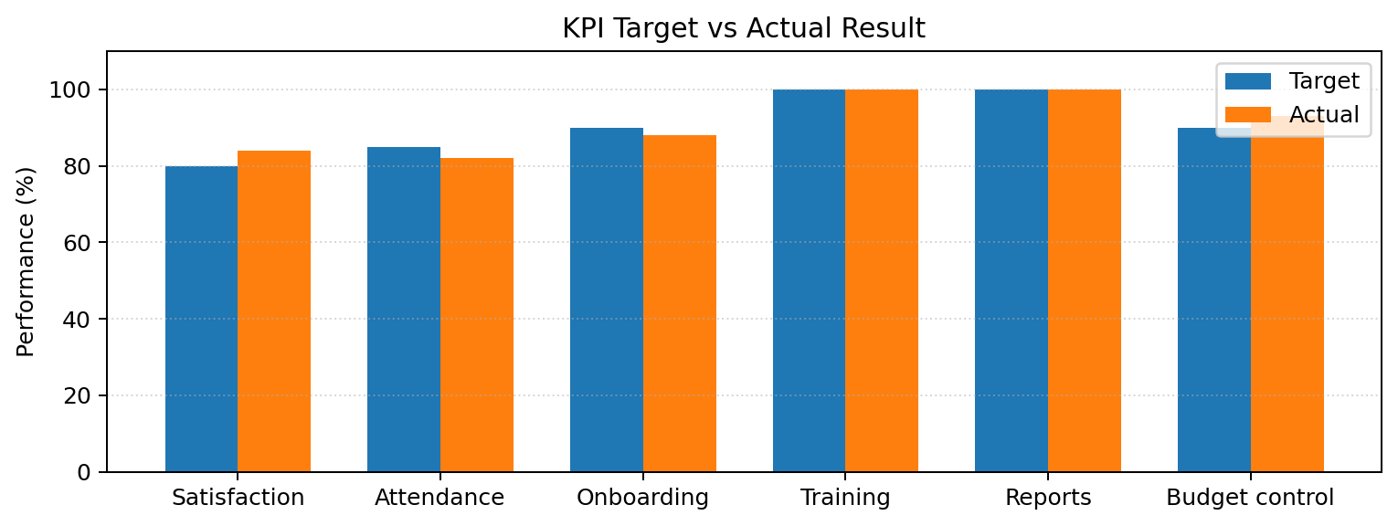
KPI | Target | Result | Evaluation
Patient satisfaction score | 4 out of 5 | 4.2 out of 5 | Positive patient experience, with strong satisfaction from clearer follow-up communication.
Appointment attendance rate | 85% | 82% | Below target due to missed appointments and schedule changes.
Onboarding completion rate | 90% | 88% | Close to target, but some users needed clearer instructions.
Staff training completion | 100% | 100% | Fully achieved and supported consistent process execution.
Technical issue resolution | 24 hours | 28 hours | Slight delay caused by issue prioritization and workload pressure.
Budget variance | Within 10% | 7% | Budget was controlled effectively.
Reports submitted on time | 100% | 100% | Reporting process worked well and supported accountability.

6. Risk and Issue Review
Risk management was a key part of the project because healthcare delivery requires reliable communication, accurate records, secure patient information, and clear escalation. Most risks were managed through early planning, issue tracking, staff training, and regular reporting. Some issues still require improvement in future versions of the project.
Risk or Issue | Impact | Response Taken | Outcome
Missed appointments | Reduced attendance rate and affected follow-up consistency. | Added reminder messages and follow-up calls. | Attendance improved in the final weeks, but the target was not fully achieved.
Technical delays | Slower response to platform and access issues. | Created an issue tracker and escalation process. | Issue visibility improved, but response time needs stronger ownership.
Incomplete patient forms | Created gaps in monitoring data. | Simplified instructions and added administrative checks. | Form completion improved after guidance was updated.
Staff workload pressure | Delayed responses during peak project activity. | Reassigned administrative tasks and clarified responsibilities. | Response consistency improved.
Privacy and consent concerns | Could create compliance risk if not managed properly. | Reviewed consent wording, access permissions, and data handling rules. | No major privacy incident was reported.

7. Stakeholder Feedback Summary
Stakeholder feedback was reviewed to understand what worked well and what should be improved. Feedback showed that the project created a stronger structure for chronic care follow-up, but future projects should use simpler patient materials, clearer escalation rules, and earlier technical testing.
Stakeholder Group | Positive Feedback | Improvement Needed
Patients | Clearer communication, easier follow-up, and improved reminder process. | More reminders, simpler forms, and easier instructions.
Doctors and nurses | Better visibility of patient follow-up status and more structured workflow. | More time for documentation and clearer handover points.
Administrative team | Improved scheduling structure and communication logs. | Need clearer escalation steps for missed appointments and incomplete forms.
IT team | Issue tracker helped organize support requests. | Testing should begin earlier and high-impact issues should be prioritized faster.
Senior management | Project stayed within budget and reporting was consistent. | Attendance and issue resolution targets need stronger performance controls.

8. Lessons Learned
The lessons learned below summarize the most important insights from the project. These lessons are practical and can be applied to future digital healthcare projects to improve planning, delivery, communication, reporting, and service quality.
Lesson Learned | Explanation | Future Recommendation
Patient instructions must be simple | Some patients did not complete forms correctly at first. | Use shorter guides, plain language, examples, and screenshots.
Testing should start earlier | Some technical issues appeared close to launch. | Complete full workflow testing before patient onboarding begins.
Appointment reminders are essential | Attendance was below the planned target. | Send reminders 24 hours and 2 hours before appointments and follow up on missed visits.
Staff training improves confidence | Staff completed training and followed the process more consistently. | Keep training as a mandatory step before launch.
KPI tracking helps identify problems early | Weekly reporting made performance gaps visible. | Continue weekly KPI reviews and corrective action tracking.
Escalation rules must be specific | Some issues took longer to close because ownership was unclear. | Define issue priority levels, owners, and response time expectations.

9. SWOT Analysis
The SWOT analysis highlights internal strengths and weaknesses, as well as future opportunities and external threats that may affect similar healthcare projects.
Strengths | Weaknesses
Clear project structure  Strong staff training completion  Budget controlled well  Regular reporting completed on time  High patient satisfaction score | Appointment attendance below target  Technical issue resolution slower than planned  Some patient forms incomplete  Staff workload needed better balancing  Escalation ownership not always clear
Opportunities  Expand service to more patient groups  Improve patient education materials  Strengthen dashboard reporting  Enhance scheduling and reminder process  Create reusable training content | Threats  Technology issues may affect patient experience  Low engagement may reduce long-term impact  Budget limits may affect future improvements  Data privacy risks require ongoing monitoring  Staff capacity may affect response times

10. Recommendations for Future Projects
Based on the evaluation findings, the following recommendations should be applied to future healthcare projects with similar scope and delivery requirements.
- Start technical testing earlier and complete end-to-end workflow checks before launch.
- Use simple patient guides with screenshots, plain language, and short step-by-step instructions.
- Strengthen reminder workflows for appointments, forms, and follow-up tasks.
- Assign a dedicated IT support window during the launch and early monitoring period.
- Maintain a weekly KPI dashboard for management review and corrective action tracking.
- Review workload distribution before patient onboarding begins to avoid response delays.
- Keep privacy, consent, and access control reviews as required checkpoints.
- Define clear escalation paths for attendance issues, data gaps, technical incidents, and budget concerns.

11. Conclusion
The Digital Chronic Care Follow-up and Monitoring Program was completed with strong results in staff training, reporting quality, budget control, stakeholder communication, and patient satisfaction. The project also provided useful evidence about the areas that need further improvement, particularly appointment attendance, technical issue resolution, onboarding clarity, and escalation ownership.
The final evaluation confirms that structured planning, clear communication, KPI tracking, and risk management are essential for successful healthcare project delivery. Future projects should build on these strengths while applying the lessons learned to improve reliability, patient engagement, staff coordination, and service quality.

Appendix A: Action Plan for Future Improvement
Improvement Area | Action | Owner | Timeline
Improve appointment attendance | Add two-step reminders and follow-up calls for missed appointments. | Admin Coordinator | Before next launch
Reduce issue resolution time | Set priority levels and daily IT issue checks during launch period. | IT Lead | Before next launch
Improve form completion | Create shorter patient instructions and add examples. | Healthcare Lead | Before onboarding
Strengthen escalation process | Create an escalation matrix with response time rules. | Project Manager | Planning phase
Improve reporting consistency | Use a fixed dashboard template and weekly data checks. | Project Manager | Weekly

