Compliance and Quality Assurance
Documentation Framework
Outpatient Clinic Administration

Prepared For | Healthcare Administration Team
Prepared By | Shaghayegh Haghbin
Document Type | Compliance and Quality Assurance Report

Purpose: strengthen compliance readiness, quality controls, risk tracking, audit documentation, and performance improvement across clinic administration.

Document Control
Field | Details
Document title | Compliance and Quality Assurance Documentation Framework
Facility type | Outpatient clinic
Primary users | Administration, records, clinic coordination, quality, nursing, billing, and supervisory staff
Review frequency | Quarterly, or earlier if a major process change occurs
Controlled copy location | Quality and administration document folder
Approval role | Administration Supervisor or Quality Lead

This framework should be reviewed against the facility's approved policies and applicable local requirements before formal adoption. It is designed as a practical documentation package for day-to-day healthcare administration controls.

Executive Summary
This report presents a complete compliance and quality assurance documentation framework for an outpatient clinic. The framework organizes critical controls for patient records, consent forms, appointment documentation, staff files, incident reporting, data protection, internal audits, corrective actions, and performance improvement.
The documentation package includes a compliance checklist, SOP register, internal audit process, risk assessment method, corrective action workflow, quality KPI report, and editable templates for ongoing monitoring. The goal is to reduce administrative errors, protect patient information, improve audit readiness, and support consistent service quality.

1. Objective and Scope
The objective is to create a structured system for monitoring compliance and documenting quality assurance activities in a healthcare administration setting. The framework supports clear accountability, evidence-based audits, timely correction of gaps, and consistent reporting.
- Maintain accurate, complete, and confidential patient and administrative records.
- Standardize SOPs, checklists, audit tools, and corrective action records.
- Identify risks early and assign practical controls before issues repeat.
- Track quality indicators such as documentation accuracy, consent completion, staff training, and action closure.
- Support regular internal review and continuous improvement.
The scope covers outpatient administration processes including patient record handling, appointment documentation, consent form review, incident reporting, staff documentation, document control, data access checks, and internal quality monitoring.

2. Compliance Areas and Control Standards
Compliance Area | Required Control | Evidence to Maintain
Patient Records | Patient identifiers, visit details, and administrative notes must be complete and accurate. | Patient record review log and correction notes
Consent Forms | Forms must be signed, dated, checked before service, and stored in the correct record. | Consent form audit checklist
Appointment Documentation | Department, provider, appointment type, status, and change history must be recorded. | Appointment log and change tracker
Data Protection | Access must be limited to authorized roles and reviewed on a scheduled basis. | Access list, review evidence, and audit trail
Staff Documentation | Licenses, training evidence, and role responsibilities must be current. | Staff file audit and training tracker
Incident Reporting | Events, delays, complaints, and corrective actions must be documented promptly. | Incident log and closure evidence
Infection Control Records | Cleaning logs and hygiene checks must be completed and signed. | Daily cleaning checklist
Document Control | SOP versions must be approved, current, and accessible to staff. | SOP register and change log

3. Governance and Responsibilities
Role | Key Responsibility | Output
Administration Supervisor | Approves the framework, monitors escalation, and confirms major corrective actions. | Approved action plans and management review notes
Quality Coordinator | Plans audits, tracks findings, manages the action log, and reports KPI outcomes. | Audit tracker, KPI dashboard, and action log
Records Supervisor | Reviews patient record accuracy, indexing, filing, and record correction evidence. | Patient record audit notes
Admin Officer | Checks consent documentation, patient forms, appointment entries, and front-desk controls. | Checklist evidence and correction notes
Clinic Coordinator | Monitors appointment documentation accuracy and department coordination issues. | Appointment accuracy report
HR/Admin Officer | Maintains training, license, and role documentation for staff files. | Staff documentation tracker
Department Leads | Complete assigned corrective actions and provide evidence for verification. | Closure evidence and signed updates

4. Standard Operating Procedure Register
The SOP register creates a controlled list of key procedures that support compliance, quality assurance, and audit readiness. Each SOP should have an owner, version, review date, and approval status.
SOP ID | SOP Title | Purpose | Owner | Review Cycle
SOP-001 | Patient Record Documentation | Ensure accurate record creation, update, filing, and correction. | Records Supervisor | Semi-Annual
SOP-002 | Appointment Verification | Prevent wrong department selection and incomplete appointment records. | Clinic Coordinator | Semi-Annual
SOP-003 | Consent Form Review | Confirm consent forms are complete before service delivery. | Admin Officer | Quarterly
SOP-004 | Incident Reporting and Escalation | Document service issues, errors, complaints, and corrective steps. | Quality Coordinator | Quarterly
SOP-005 | Internal Audit and Corrective Action | Standardize audit planning, evidence review, findings, and closure. | Quality Coordinator | Quarterly
SOP-006 | Data Access Control | Manage role-based access and access review evidence. | Administration Supervisor | Quarterly
SOP-007 | Document Control | Manage SOP version control, approvals, archiving, and staff access. | Quality Coordinator | Quarterly

5. Compliance Checklist
The checklist below can be used during monthly or quarterly internal reviews. Each item should be marked as compliant, partially compliant, non-compliant, or pending review. Evidence should be attached or referenced in the tracker.
Checklist Item | Evidence Required | Frequency | Responsible Role | Action if Gap Found
Patient ID and demographic fields are complete. | Patient record sample | Monthly | Records Officer | Correct missing details and document amendment.
Consent forms are signed, dated, and correctly stored. | Consent form sample | Monthly | Admin Officer | Request missing signature and update record.
Appointment department and status are accurate. | Appointment log | Weekly | Clinic Coordinator | Correct appointment record and notify affected team.
User access is limited to authorized roles. | Access list | Quarterly | Administration Supervisor | Remove unnecessary access and record approval.
Incidents are documented with closure evidence. | Incident log | Monthly | Quality Coordinator | Assign action owner and verify closure.
Staff training evidence is current. | Training tracker | Quarterly | HR/Admin Officer | Schedule training or upload evidence.
SOP versions are approved and current. | SOP register | Quarterly | Quality Coordinator | Archive outdated versions and issue update notice.
Cleaning and hygiene logs are completed. | Daily cleaning record | Daily | Nursing Lead | Complete missing entry and supervisor check.

6. Risk Assessment Method
Risks should be assessed using a simple likelihood and impact scoring method. A score of 1 means low likelihood or low impact, while a score of 5 means very high likelihood or impact. Risk score equals likelihood multiplied by impact.
Score Range | Risk Level | Required Response
1-5 | Low | Monitor during routine checks.
6-11 | Medium | Assign control owner and review by the next audit.
12-19 | High | Create corrective action with due date and supervisor review.
20-25 | Critical | Immediate escalation, action plan, and management review.

Risk | Likelihood | Impact | Risk Level | Control Measure | Owner
Incomplete consent form | 3 | 5 | High | Pre-service document check and same-day correction | Admin Officer
Incorrect patient record entry | 3 | 4 | High | Identifier double-check and record validation | Records Officer
Unauthorized record access | 2 | 5 | Medium | Role-based access control and quarterly review | Administration Supervisor

7. Internal Audit Procedure
Internal audits should be planned in advance and supported by evidence. The audit record must include the scope, sample size, checklist results, findings, risk rating, action owner, due date, and verification outcome.
- Plan the audit scope, date, responsible reviewer, and evidence requirements.
- Select representative records, logs, forms, or staff files.
- Review each item against the relevant checklist and SOP.
- Record findings, risk level, evidence reference, and responsible owner.
- Assign corrective action with a due date and closure evidence requirement.
- Verify completion and document supervisor approval.
- Update SOPs, checklists, or training if a recurring gap is identified.

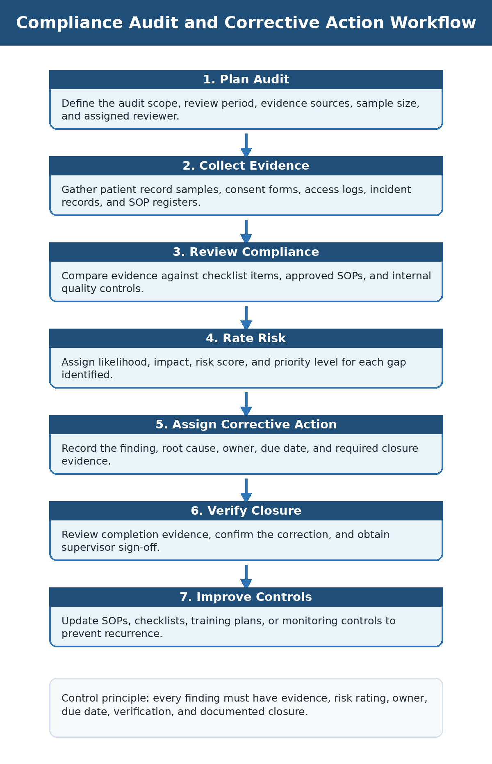
Figure 1. Compliance audit and corrective action workflow.
Audit Type | Frequency | Responsible Role | Primary Evidence
Patient record audit | Monthly | Records Supervisor | Patient record sample and amendment log
Consent form audit | Monthly | Admin Officer | Consent form checklist
Access control review | Quarterly | Administration Supervisor | User access list and approval record
Incident report review | Monthly | Quality Coordinator | Incident log and closure evidence
Staff documentation audit | Quarterly | HR/Admin Officer | Staff file checklist and training evidence
SOP control review | Quarterly | Quality Coordinator | SOP register and document control log

8. Quality Assurance KPI Report
The KPI report gives management a concise view of quality performance and compliance readiness. Targets should be reviewed monthly, and any KPI below target should trigger a documented action.
KPI | Target | Example Current Result | Action Trigger
Patient record completion rate | 95% or above | 94% | If below target, review missing fields and train responsible staff.
Consent form accuracy | 100% | 91% | If below target, complete pre-service check and update forms.
Appointment documentation accuracy | 95% or above | 96% | If below target, review department selection and change history.
Incident closure within deadline | 90% or above | 88% | If below target, escalate open cases before due date.
Staff training completion | 100% | 93% | If below target, schedule completion and collect evidence.
Corrective action closure | 90% or above | 86% | If below target, review overdue actions with owners.

9. Error-Checking and Corrective Action Process
Error-checking controls should prevent common administrative issues such as missing information, inaccurate records, outdated SOPs, delayed action closure, and incomplete evidence. The corrective action process should be documented from identification through final verification.
Stage | Action | Required Documentation
Identify | Record the gap, error, or non-conformance. | Finding description and evidence reference
Classify | Assign category, risk level, and urgency. | Risk assessment score
Assign | Name action owner and due date. | Corrective action log entry
Correct | Complete the agreed action. | Evidence of correction
Verify | Supervisor or Quality Coordinator confirms closure. | Verification date and sign-off
Prevent | Update SOP, checklist, or training if needed. | Change log or training record

No corrective action should be closed without evidence. Evidence may include corrected records, updated forms, training attendance, approval notes, screenshots of system updates, or signed checklists.

10. Performance Improvement Method
The framework uses the Plan, Do, Check, Act method to convert audit findings into measurable improvement.
Step | Meaning | Clinic Application
Plan | Identify the gap and define the desired improvement. | Example: reduce consent form errors by adding a pre-service check.
Do | Apply the corrective action in daily work. | Admin staff use the updated checklist before service.
Check | Measure results through audit and KPI review. | Quality Coordinator compares the next audit result to the baseline.
Act | Standardize the successful control or refine it. | Update SOP and train staff if the improvement is sustained.

11. Confidentiality and Document Control
- Patient information should only be accessed by authorized staff for an approved work purpose.
- Audit samples should use patient ID references whenever full identifiers are not required.
- Documents must be stored in controlled folders with clear version numbers and approval dates.
- Superseded SOPs should be archived to prevent staff using outdated instructions.
- Audit evidence, incident records, and access reviews should not be shared through open or unsecured channels.
- All amendments to records should include date, reason, responsible staff member, and verification where needed.

12. Case Application: Missing Consent Form and Record Correction
A monthly consent form audit identifies that three outpatient files have incomplete consent documentation. The Quality Coordinator records the finding, assigns a high risk level due to patient documentation requirements, and creates a corrective action for the Admin Officer.
Step | Action Taken | Outcome
Issue identified | Audit reviewer notes incomplete consent fields in selected files. | Finding recorded in audit tracker.
Risk rated | Likelihood and impact are scored using the risk matrix. | High priority assigned.
Action assigned | Admin Officer is given a due date to complete form review and obtain missing signatures where appropriate. | Corrective action created.
Patient record updated | Records Officer confirms the corrected documents are filed in the correct patient records. | Documentation gap resolved.
Closure verified | Quality Coordinator reviews evidence and signs off the action. | Action closed with evidence.
Prevention added | Consent form SOP is updated to include a pre-service checklist step. | Repeat risk reduced.

13. Implementation Plan
Timeline | Activity | Owner | Expected Output
Week 1 | Approve documentation framework and communicate responsibilities. | Administration Supervisor | Approved framework and role ownership
Week 2 | Launch checklist, risk register, audit tracker, and action log. | Quality Coordinator | Active trackers and first review schedule
Week 3 | Review SOP register and confirm controlled versions. | Quality Coordinator | Updated SOP register
Week 4 | Complete first compliance review and assign corrective actions. | Audit team | Audit results and action log
Monthly | Review KPIs, open findings, and closure evidence. | Administration Supervisor | Monthly quality summary

14. Conclusion
This compliance and quality assurance documentation framework provides a practical structure for healthcare administration teams to monitor critical controls, document evidence, assess risk, resolve gaps, and improve performance. By using standard checklists, SOP registers, audit trackers, risk assessments, and corrective action logs, the clinic can strengthen accountability, reduce administrative errors, improve patient record quality, and maintain readiness for internal and external review.

Appendix A: Editable Template Fields
Template | Key Fields Included | Purpose
Compliance Checklist | Area, item, evidence, frequency, owner, status, risk level, action, notes | Track compliance controls
Risk Assessment Register | Risk ID, area, likelihood, impact, score, level, controls, owner, status | Prioritize and control risks
Audit Tracker | Audit type, department, date, sample size, findings, compliance score, status | Document audit outcomes
Corrective Action Log | Finding, root cause, owner, due date, status, closure evidence | Manage action closure
SOP Register | SOP ID, title, owner, version, effective date, review date, status | Control approved procedures
Quality KPI Tracker | KPI, target, result, gap, owner, status, trend, notes | Monitor performance
Incident Log | Date, area, category, severity, summary, action, owner, status, lessons learned | Document and learn from quality events
Staff Training Tracker | Staff ID, role, training topic, completion, expiry, status, evidence | Maintain staff readiness evidence

