Healthcare Data Management
and Record Keeping Plan
Outpatient Clinic Administration
Professional record management framework for patient and departmental records
Document Type | Data management report with editable templates
Prepared For | Healthcare Administration Assistant role responsibilities
Setting | Outpatient clinic record management

1. Executive Summary
This plan presents a structured record management system for an outpatient healthcare setting. The system is designed to improve data accuracy, reduce duplicate records, support fast retrieval, protect confidential information, and make administrative record maintenance more consistent across departments.
The approach uses unique record identifiers, standardized entry fields, validation rules, audit logging, backup schedules, access controls, and routine quality checks. It also includes editable templates for patient records, appointment tracking, department requests, backup confirmation, and audit history.

2. Objective and Scope
The objective is to design and implement an efficient record management process for patient and departmental information. The system focuses on accuracy, organization, confidentiality, traceability, and timely updates.

Scope
- Patient registration and demographic records
- Appointment and visit status tracking
- Departmental requests and record update logs
- Document review, backup, and audit history
- Security controls for access, editing, and record retrieval

3. Record Categories and Data Structure
Record Category | Main Fields | Primary Owner | Update Frequency
Patient Master Record | Patient ID, name, date of birth, mobile number, department, visit status, consent, insurance status | Records Coordinator | At registration and at every visit update
Appointment Log | Appointment ID, Patient ID, appointment date, assigned team, status, notes | Admin Officer | Daily
Department Request Log | Request ID, department, request type, record reference, priority, due date, closure notes | Department Supervisor | Daily or when request status changes
Backup and Security Log | Backup date, backup type, responsible person, completion status, encryption check, access review | IT Support / Supervisor | Daily, weekly, and monthly
Audit Log | Timestamp, record ID, action, updated by, section, change summary, reviewer, status | Records Coordinator | Each time a record is created, updated, reviewed, or archived

4. Data Entry Standards and Validation Controls
All records should be entered using consistent field names, approved dropdown values, and required field checks. Each patient must have one unique Patient ID, and all related records should use that ID as the main reference key.
Field | Standard Format | Validation Control | Purpose
Patient ID | PT-0001 format | Unique value check | Prevents duplicate patient records
Full Name | Text only | Required field | Supports clear identification
Date of Birth | DD/MM/YYYY | Valid date format | Reduces date entry errors
Mobile Number | UAE mobile number format | Required field and length check | Supports patient contact accuracy
Department | Approved department list | Dropdown selection | Keeps categories consistent
Visit Status | Scheduled, completed, cancelled, follow-up needed | Dropdown selection | Supports reporting and tracking
Consent Received | Yes or No | Dropdown selection | Confirms required documentation
Updated By | Staff name or ID | Required field | Creates accountability

5. Storage, Retrieval, and Naming Protocol
Records will be stored in a secure workbook or database structure with separate registers for patient records, appointment logs, department requests, backup checks, and audit activity. Each register must use clear column headers and consistent date formats.
Area | Protocol
Storage | Use one controlled file structure with separate tabs for each register. Keep historical logs rather than overwriting past entries.
Retrieval | Search by Patient ID first, then full name, mobile number, visit date, department, or request ID.
File Naming | Use clear names such as PatientRecords_YYYYMM or DepartmentRequests_YYYYMM.
Version Control | Keep one active master file and monthly archived copies for review and recovery.
Retention | Retain records according to the healthcare organization policy and applicable privacy requirements.

6. Security, Access Control, and Backup Protocol
The record system must protect confidential information through controlled access, secure storage, password protection, backup routines, and clear ownership of each review task.
Control Area | Procedure | Responsible Role | Frequency
Role-Based Access | Limit editing rights based on staff responsibility and record sensitivity | Department Supervisor | Monthly review
Password Protection | Protect master files and restrict sharing to approved staff only | Records Coordinator | Ongoing
Daily Backup | Save an end-of-day backup copy in the approved secure location | Admin Officer | Daily
Weekly Encrypted Backup | Create a protected backup archive and verify it can be opened | Records Coordinator | Weekly
Monthly Audit Backup | Archive the final reviewed file and log the review outcome | Department Supervisor | Monthly
Audit Trail | Record who created, updated, reviewed, or archived each entry | Records Coordinator | Every record change

Access Control Matrix
Role | View | Edit | Approve | Backup Access | Notes
Admin Officer | Yes | Limited | No | No | Can create and update assigned administrative records
Records Coordinator | Yes | Yes | Limited | Yes | Maintains master registers and audit logs
Department Supervisor | Yes | Limited | Yes | Yes | Reviews corrections, approvals, and monthly quality checks
Clinician | Limited | Limited | No | No | Can view or update records linked to patient care tasks
IT Support | No patient details unless approved | No | No | Yes | Supports backup, access, and technical protection

7. Record Update and Maintenance Process
The following workflow should be used whenever a patient or departmental record is created, updated, reviewed, or archived.
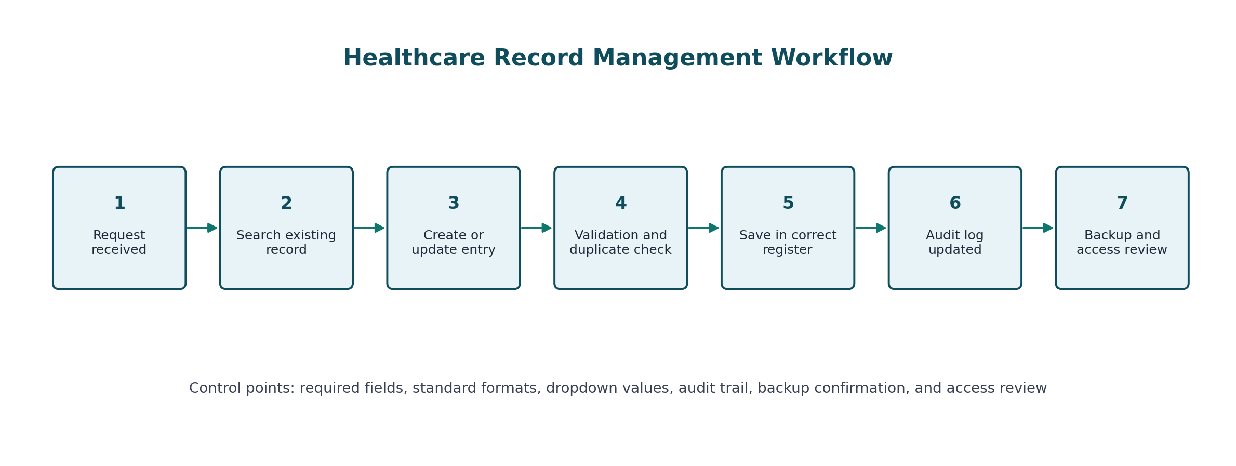
Figure 1. Healthcare record management workflow

8. Error Checking Mechanisms
Error checking should be built into the record template and supported by a weekly review routine. The objective is to identify issues before records are filed, reported, or shared with the relevant department.
Error Risk | Control Method | Review Output
Duplicate patient records | Unique Patient ID and duplicate flag formula | Duplicate alert for review
Missing required details | Required field count for key fields | Missing field total
Wrong department selection | Dropdown list from approved department values | Consistent department reporting
Invalid appointment reference | Patient ID lookup against master patient register | Patient ID not found alert
Delayed department requests | Due date and open status comparison | Overdue request alert
Unclear record changes | Audit log with timestamp, staff member, section, and change summary | Traceable record history

9. Sample Templates Included in the Workbook
The accompanying workbook provides editable registers, sample rows, validation lists, formulas, and dashboard controls. It is designed so the team can enter data directly while maintaining consistent quality checks.
Workbook Sheet | Purpose
Dashboard | Summarizes key control metrics, record quality alerts, backup completion, and review checklist
Patient_Records | Main patient register with duplicate checks, missing field checks, and record quality status
Appointment_Log | Appointment tracking with Patient ID matching control
Department_Records | Department request tracking with due date and overdue checks
Backup_Security_Log | Backup, encryption, access review, and completion tracking
Audit_Log | Traceable log of record creation, updates, reviews, approvals, and archive activity
Validation_Rules | Approved dropdown lists for departments, statuses, priorities, and actions
Process_Map | Step-by-step record update workflow

10. Anticipated Challenges and Control Measures
Challenge | Impact | Control Measure
Duplicate entries | Creates confusion and inaccurate reporting | Search existing records before creation and use duplicate check formulas
Incomplete data | Delays service and creates follow-up work | Use required fields, weekly quality checks, and clear ownership
Inconsistent labels | Makes filtering and reporting difficult | Use dropdown values for departments, statuses, priorities, and actions
Unauthorized edits | Reduces confidentiality and record reliability | Apply role-based access and track changes in the audit log
Delayed backups | Increases recovery risk | Follow daily, weekly, and monthly backup schedule with completion log
Slow retrieval | Affects patient service and departmental response time | Use Patient ID as the main search key and keep organized registers

11. Implementation Checklist
No. | Action | Owner | Status
1 | Confirm required record fields and department list | Department Supervisor | Ready to complete
2 | Set up patient, appointment, department, backup, and audit registers | Records Coordinator | Ready to complete
3 | Apply dropdown values and date formatting | Records Coordinator | Ready to complete
4 | Add duplicate, missing field, and overdue checks | Records Coordinator | Ready to complete
5 | Set access levels and storage location | Department Supervisor | Ready to complete
6 | Test record retrieval using Patient ID and department filters | Admin Officer | Ready to complete
7 | Start daily backup and audit review routine | Admin Officer | Ready to complete
8 | Run first weekly quality review and document findings | Records Coordinator | Ready to complete

12. Conclusion
This plan creates a reliable and organized approach to healthcare record management. By combining standardized templates, required fields, validation lists, duplicate checks, audit logging, backup procedures, and clear access controls, the system reduces administrative errors and supports timely, secure, and accurate record handling.
The result is a practical structure that improves data quality, supports faster retrieval, strengthens accountability, and helps healthcare administration teams maintain dependable patient and departmental records.

Appendix A. Sample Data Entry Template
Field | Example | Required | Validation Rule
Patient ID | PT-0001 | Yes | Unique format and no duplicate IDs
Full Name | Amina Hassan | Yes | Text entry
Date of Birth | 12/04/1988 | Yes | Valid date
Mobile Number | 0501234567 | Yes | Correct number length
Department | General Medicine | Yes | Dropdown list
Visit Status | Completed | Yes | Dropdown list
Insurance Status | Verified | Yes | Dropdown list
Consent Received | Yes | Yes | Yes or No
Updated By | S. Ahmed | Yes | Staff name or ID
Last Updated | 01/06/2026 10:30 | Yes | Date and time

Appendix B. Weekly Quality Review Checklist
Review Area | Check Question | Evidence
Duplicate Records | Are any Patient IDs flagged as duplicate? | Duplicate check column
Required Fields | Are required fields complete for active records? | Missing field count
Appointment Matching | Do all appointment Patient IDs exist in the patient register? | Record check column
Department Requests | Are any open requests overdue? | Overdue check column
Backup Completion | Were daily, weekly, and monthly backups completed as planned? | Backup and security log
Audit Trail | Are all changes traceable to a staff member and timestamp? | Audit log
Access Review | Are access permissions aligned with current roles? | Monthly access review notes

