Interdepartmental Communication Plan
Healthcare Administration

Outpatient Clinic Communication, Escalation, and Confidentiality Framework

Field | Details
Prepared by | Shaghayegh Haghbin
Department | Healthcare Administration
Document Type | Communication Coordination Report

Purpose
This plan establishes clear department roles, communication channels, escalation steps, documentation standards, and confidentiality controls for resolving appointment, records, approval, and patient service issues.

Executive Summary
This report presents a structured interdepartmental communication plan for a healthcare facility. The plan is designed to improve coordination between front desk, outpatient services, medical records, billing and insurance, nursing, doctor office, patient relations, and administration teams. It provides clear responsibilities, standard communication channels, escalation time targets, case documentation requirements, patient update templates, and confidentiality controls.
The report uses a practical case scenario involving an outpatient appointment assigned to the wrong department with a missing insurance approval. The process demonstrates how staff can verify information, coordinate with the correct departments, protect patient details, keep the patient informed, and close the case with proper documentation.

1. Objective and Scope
The objective of this communication plan is to support timely, accurate, and confidential information sharing across healthcare departments. The system focuses on reducing delays, preventing incomplete handovers, improving accountability, and maintaining patient satisfaction during coordination issues.

Scope of the Plan
- Appointment errors, schedule changes, and department mismatches.
- Patient record discrepancies requiring medical records review.
- Insurance approval or billing confirmation gaps.
- Doctor, nursing, or room availability changes.
- Patient waiting time concerns and service recovery actions.
- Shift handover for unresolved cases.

2. Departments and Communication Roles
Department | Communication Role | Key Outputs
Front Desk | Receives patients, verifies arrival details, opens communication cases, and updates patients. | Case ID, arrival note, patient update log
Outpatient Services | Checks appointment details, confirms correct department, and coordinates revised slots. | Corrected appointment status and slot confirmation
Medical Records | Verifies patient identifiers, corrects record discrepancies, and documents file updates. | Verified patient file and audit note
Billing and Insurance | Checks approval, insurance status, and payment requirements. | Approval status and billing update
Nursing | Confirms patient readiness, clinical preparation, and care handover requirements. | Readiness note and nursing handover
Doctor Office | Confirms provider availability and appointment acceptance. | Provider confirmation or reassignment note
Patient Relations | Supports patient communication when concerns or service delays occur. | Service recovery note and patient response
Administration | Reviews escalations, approves corrective actions, and monitors unresolved cases. | Escalation decision and closure review

3. Communication Channels
Each communication channel has a defined purpose. Staff should choose the channel based on urgency, confidentiality, and documentation needs.
Channel | Best Use | Documentation Requirement | Expected Response
Phone | Urgent coordination or immediate escalation. | Log call time, staff name, decision, and next action. | Immediate to 10 minutes
Internal Email | Formal requests, approvals, and record confirmation. | Save the message reference and update case tracker. | 15 to 30 minutes
Shared Tracker | Ongoing case status, owner updates, and handover. | All open cases must include Case ID, owner, and due time. | Updated after every action
Secure Messaging | Quick department update where approved by policy. | Summarize action taken in the tracker. | 5 to 15 minutes
In-Person Briefing | Sensitive or urgent on-site coordination. | Document the outcome after the discussion. | Immediate

4. Standard Communication Protocol
The following steps should be followed when a department identifies an issue that affects appointment flow, patient records, approvals, or patient service.
- Identify the issue and create a Case ID in the communication tracker.
- Verify the patient using approved identifiers before discussing any record or appointment detail.
- Classify the issue type and assign a priority level.
- Contact the responsible department using the approved channel.
- Record the request, response target, owner, and next action in the tracker.
- Escalate to the supervisor if the response target is missed or the case affects patient safety or satisfaction.
- Update the patient using approved language that avoids unnecessary internal details.
- Close the case only after corrective action is completed and evidence is documented.

5. Escalation Procedure
Issue Category | First Contact | Escalation Contact | Response Target | Escalation Trigger
Appointment Error | Outpatient Coordinator | Administration Supervisor | 15 minutes | Correct slot or department not confirmed.
Missing Approval | Billing Officer | Insurance Lead | 20 minutes | Approval cannot be found or requires payer review.
Record Mismatch | Records Officer | Records Supervisor | 15 minutes | Patient identifiers do not match.
Staff Availability | Clinic Coordinator | Operations Coordinator | 10 minutes | Provider or room availability affects the visit.
Patient Complaint | Front Desk Lead | Patient Relations Officer | Immediate | Patient expresses dissatisfaction or service concern.
Urgent Clinical Concern | Charge Nurse | Clinical Coordinator | Immediate | Patient condition requires prompt clinical review.

6. Case Scenario Analysis

Scenario
A patient arrives for an outpatient appointment. The front desk team notices that the appointment was assigned to the wrong department, and the insurance approval is missing from the patient file. The patient has already arrived, so the issue must be resolved quickly while maintaining confidentiality and keeping the patient informed.

Departments Involved
- Front Desk
- Outpatient Services
- Medical Records
- Billing and Insurance
- Doctor Office
- Patient Relations
- Administration Supervisor

Resolution Approach
- Front Desk verifies the patient identity and opens a communication case.
- Outpatient Services checks the appointment department and doctor availability.
- Medical Records verifies the patient file and checks whether the appointment was linked to the correct patient ID.
- Billing and Insurance checks the approval status and confirms whether a new approval request is needed.
- Doctor Office confirms whether the patient can be seen in the corrected department and time slot.
- Patient Relations supports the front desk if the waiting time exceeds the service target.
- Administration Supervisor reviews the case if the response target is missed or the patient requires service recovery.

Expected Outcome
The correct department is confirmed, the approval status is updated, the patient is informed, and the case is closed after the tracker includes the final resolution, time of closure, owner, and any follow-up action.

7. Communication Process Flowchart
The flowchart below summarizes how an issue moves from identification to verification, department action, patient update, escalation, and final closure.

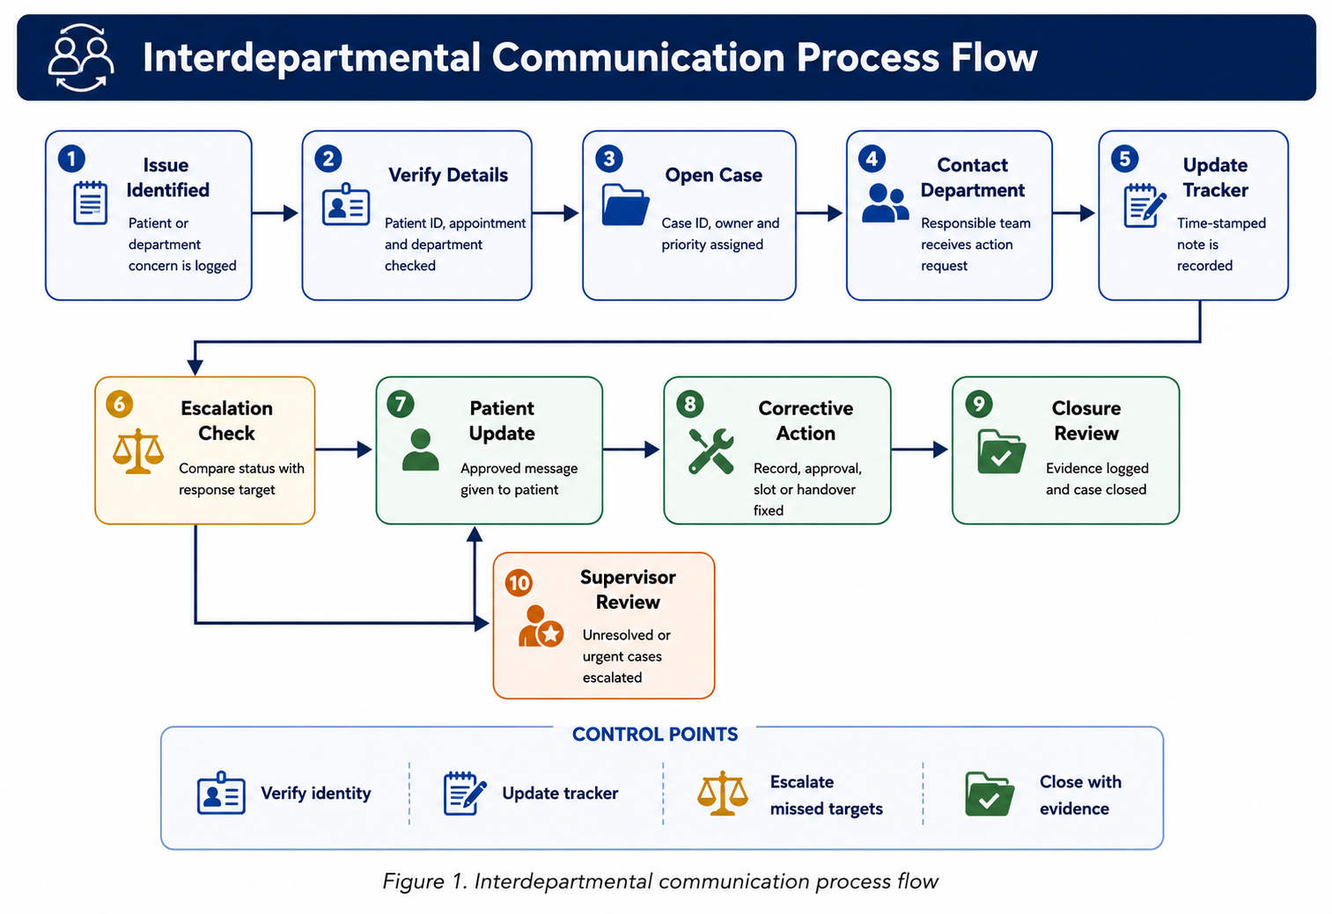
Figure 1. Interdepartmental communication process flow

8. Communication Templates
The templates below standardize communication and reduce missing information during urgent coordination.
Template | Use Case | Message
Internal Department Request | Request action from another department | Please review Case ID [Case ID] for Patient ID [Patient ID]. The issue is [Issue]. Kindly confirm action by [Time] and update the tracker.
Urgent Call Script | Escalate time-sensitive issue | This is an urgent coordination request for Case ID [Case ID]. The issue is [Issue]. Please confirm the next action and expected completion time.
Patient Update Script | Inform patient professionally | Thank you for your patience. We are verifying your appointment details with the relevant team and will update you as soon as the next step is confirmed.
Handover Note | Transfer open case to next shift | Case ID [Case ID] remains [Status]. Current owner: [Owner]. Next action: [Next Action]. Expected follow-up time: [Time].
Closure Note | Document completed case | Case ID [Case ID] was resolved on [Date/Time]. Final action taken: [Resolution]. Closed by [Staff Member].

9. Confidentiality and Data Protection Controls
Healthcare communication must protect patient information while still allowing departments to resolve operational issues quickly. Staff should share only the minimum necessary information required to resolve the case.
Control Area | Requirement | Reason
Identity Verification | Confirm approved patient identifiers before discussing records or appointments. | Prevents incorrect disclosure and record mismatch.
Minimum Necessary Information | Use Patient ID and Case ID where possible instead of full personal details. | Limits exposure of sensitive information.
Approved Channels | Use approved internal channels for case updates and document requests. | Maintains traceability and access control.
Public Area Communication | Avoid discussing confidential details at reception or in waiting areas. | Protects patient privacy.
Audit Trail | Record who updated the case, when, and what action was completed. | Supports accountability and quality review.
Handover Discipline | Transfer open cases with owner, due time, and next action. | Reduces delays and incomplete follow-up.

10. Monitoring and Performance Metrics
The supporting workbook includes a dashboard to monitor communication quality and case resolution performance. These metrics help supervisors identify delays, recurring issue types, and departments requiring additional support.
Metric | Definition | Target
Average Resolution Time | Average minutes from case opening to resolution. | Less than 30 minutes for standard cases
Escalation Rate | Percentage of cases requiring supervisor review. | Monitored weekly
Patient Update Compliance | Percentage of cases where patients received timely updates. | 95% or higher
Open Case Aging | Number of cases open beyond the response target. | Zero overdue critical cases
Documentation Completion | Percentage of cases closed with final action and owner. | 100%

11. Implementation Checklist
Action | Owner | Frequency | Completion Evidence
Review department contact list. | Administration Supervisor | Monthly | Updated contact sheet
Confirm response targets with departments. | Operations Coordinator | Monthly | Approved escalation matrix
Check open cases at start and end of shift. | Department Leads | Daily | Handover checklist
Review unresolved cases with owners. | Administration Supervisor | Daily | Dashboard and case log
Audit sample patient update records. | Patient Relations Officer | Weekly | Compliance review notes
Update communication templates. | Healthcare Administration | Quarterly | Revised template library

12. Supporting Workbook Structure
The accompanying Excel workbook provides editable tools for tracking communication cases, contacts, escalation steps, patient updates, and handover tasks.
Worksheet | Purpose
Dashboard | Displays open items, resolved items, escalated items, average resolution time, and patient update status.
Communication Tracker | Tracks daily department requests, case ownership, priority, due time, and next action.
Department Contacts | Lists primary and backup contacts by department.
Escalation Matrix | Defines escalation owners, response targets, and triggers.
Issue Resolution Log | Documents root cause, status, resolution time, escalation need, and closure notes.
Patient Update Log | Records patient-facing updates and message status.
Daily Handover | Supports shift-to-shift transfer of open cases.
Communication Templates | Provides standardized internal and patient update message formats.
Process Flow | Lists the workflow steps in an editable table.
Validation Lists | Provides dropdown categories for consistent data entry.

13. Conclusion
This communication plan provides a practical structure for handling interdepartmental coordination in a healthcare facility. By defining roles, channels, escalation rules, confidentiality controls, and documentation expectations, the plan reduces delays and improves the quality of patient service. The supporting workbook makes the process easier to manage through editable logs, templates, and dashboard metrics.

Appendix A: Quick Reference Protocol
Step | Action | Documentation
1 | Open the case and assign Case ID. | Communication Tracker
2 | Verify patient details using approved identifiers. | Tracker note
3 | Contact responsible department. | Call note or email reference
4 | Set response target and owner. | Due time and owner fields
5 | Update the patient using approved wording. | Patient Update Log
6 | Escalate if response target is missed. | Escalation Matrix and Issue Log
7 | Complete corrective action. | Resolution Summary
8 | Close case with evidence. | Closure note and time stamp

