Operational Efficiency Analysis
Outpatient Clinic Administrative Workflows
Focus Area: Patient Registration and Appointment Coordination
Prepared by | Shaghayegh Haghbin
Department | Healthcare Administration
Deliverable | Efficiency analysis report with supporting workbook

1. Executive Summary
This report analyzes operational efficiency in outpatient clinic administration, with emphasis on patient registration and appointment coordination. The current workflow creates avoidable delays because key checks are completed after patient arrival, appointment updates are repeated across separate trackers, and department availability is confirmed late.
The improved model introduces pre-visit verification, a shared appointment and insurance tracker, department capacity visibility, clear escalation rules, and weekly KPI review. Based on the analysis, the proposed workflow can reduce average registration time from 18 minutes to 10 minutes, reduce average patient waiting time from 35 minutes to 20 minutes, and improve same-day issue resolution from 70% to 90%.
The supporting workbook contains editable datasets, KPI formulas, bottleneck analysis, a savings calculator, improvement tracker, and dashboard charts that can be updated as actual clinic data becomes available.

2. Objective and Scope
Objective: Identify administrative bottlenecks, quantify their operational impact, and recommend practical improvements that reduce delays, eliminate repeated work, and support smoother coordination between clinic teams.
Scope: The analysis covers patient check-in, appointment verification, record retrieval, insurance review, department coordination, status updates, and escalation for unresolved issues.
Expected outcome: A more predictable workflow that improves patient service, staff productivity, data accuracy, and daily operational visibility.

3. Analysis Methodology
Method Step | Purpose | Output
Workflow mapping | Document each administrative step from arrival to service completion | Current and improved process maps
Time comparison | Compare current performance with target process times | Efficiency KPI table and chart
Bottleneck review | Identify delays, root causes, and process owners | Bottleneck analysis matrix
Improvement planning | Prioritize actions by impact and practicality | Improvement tracker and 30-60-90 day roadmap
KPI monitoring | Define weekly and monthly measures for follow-up | Dashboard and KPI tracker

4. Current Administrative Workflow
The current workflow is mainly reactive. The clinic team verifies appointment details, records, insurance status, and department availability after the patient arrives. This increases waiting time and creates repeated coordination work.
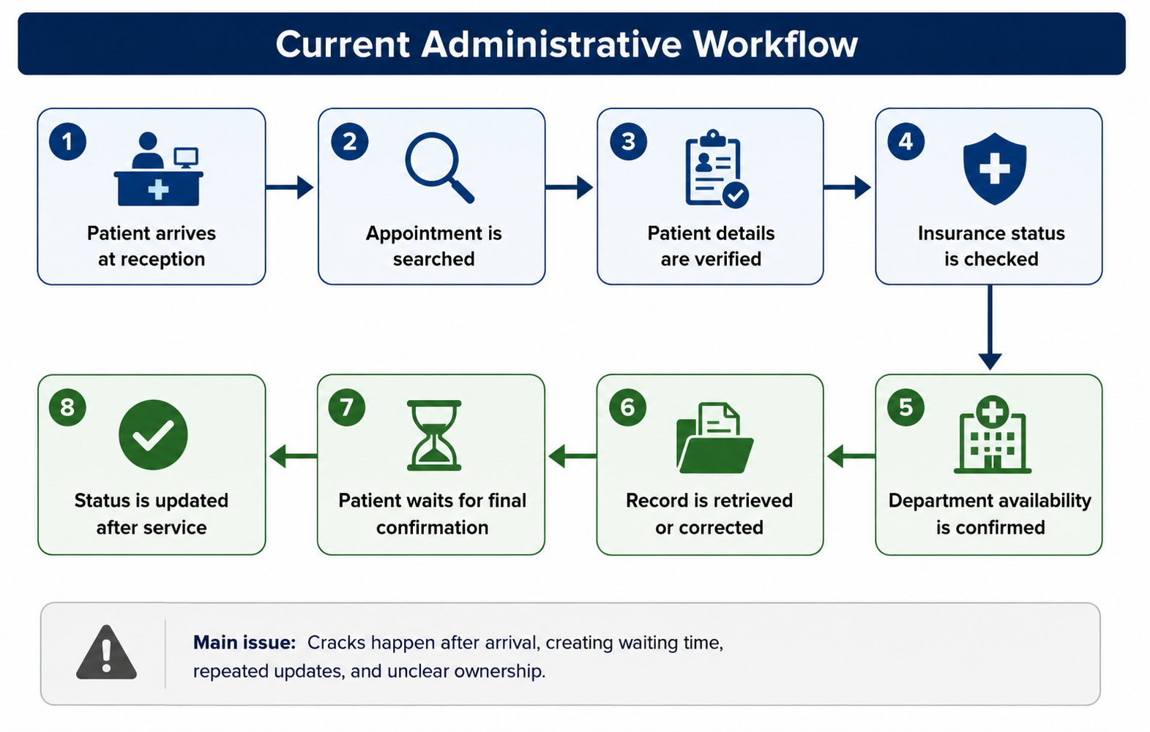
Step | Current Activity | Efficiency Concern
1 | Patient arrives and joins the reception queue | Queue pressure increases during peak hours
2 | Appointment is searched by name or appointment details | Search may take longer when records are incomplete
3 | Patient details are verified and updated | Repeated entry increases the risk of errors
4 | Insurance approval is checked at the counter | Approval issues are identified too late
5 | Department availability is confirmed | Team may rely on calls or messages
6 | Records are retrieved or corrected | Duplicate records can slow down selection
7 | Patient waits for final confirmation | Waiting time increases
8 | Appointment status is updated after service | Updates may be repeated in separate trackers

5. Bottleneck Analysis and Key Findings
The main delays are caused by late verification, limited visibility between departments, and duplicated administrative updates. The highest priority areas are check-in, insurance review, department confirmation, and appointment status control.
Bottleneck | Root Cause | Current Delay | Operational Impact | Priority
Patient check-in | No pre-visit checklist | 8 minutes | Longer queue and slower registration | High
Insurance review | Approval checked after arrival | 7 minutes | Patient waiting time increases | High
Department confirmation | No shared capacity view | 6 minutes | Handoffs are delayed | High
Status update | Separate trackers | 5 minutes | Repeated data entry | Critical
Record search | Duplicate record risk | 4 minutes | Incorrect file selection risk | Medium
Escalation | Unclear issue ownership | 5 minutes | Case resolution is delayed | Medium
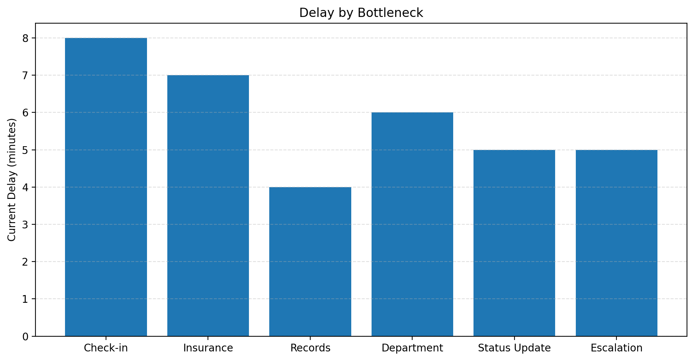

6. Current vs Improved Performance Targets
Metric | Current Performance | Improved Target | Expected Change
Average registration time | 18 minutes | 10 minutes | 8 minutes faster
Average patient waiting time | 35 minutes | 20 minutes | 15 minutes faster
Appointment confirmation delay | 25 minutes | 12 minutes | 13 minutes faster
Record retrieval time | 9 minutes | 5 minutes | 4 minutes faster
Insurance approval delay | 14 minutes | 7 minutes | 7 minutes faster
Duplicate record rate | 8% | 3% | 5 percentage points lower
Same-day issue resolution | 70% | 90% | 20 percentage points higher
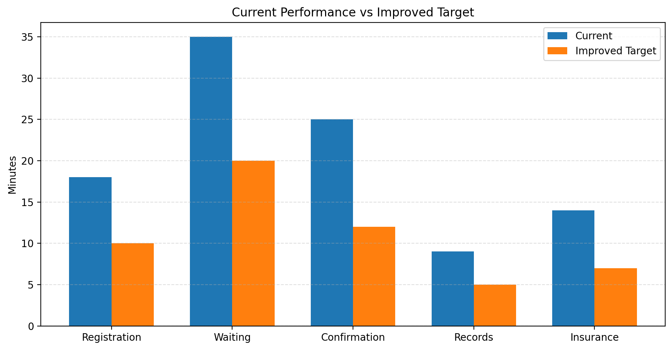

7. Improved Workflow Design
The improved workflow shifts key checks before patient arrival. It also uses one shared tracker and a structured escalation route so that front desk, billing, records, outpatient services, and quality teams work from the same status view.
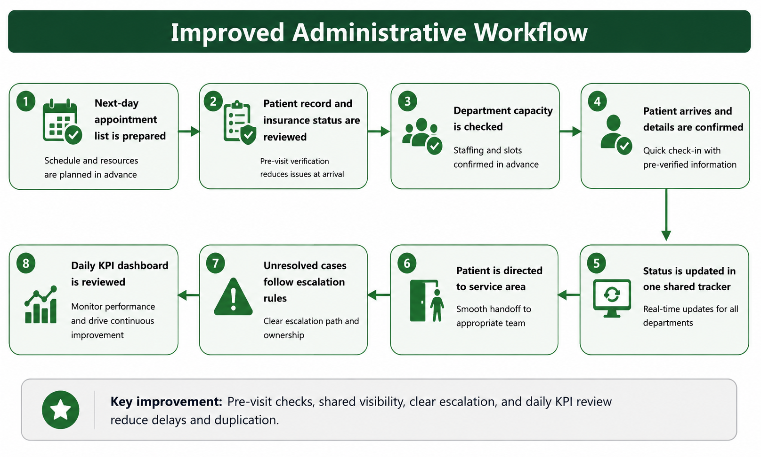
Improvement | How It Works | Expected Benefit
Pre-visit verification checklist | Next-day appointment list is reviewed for missing records, insurance issues, and incomplete details | Fewer issues appear at reception
Shared tracker | One tracker shows appointment status, insurance status, department owner, and next action | Reduces duplicate updates
Department capacity view | Daily capacity is checked during a short morning huddle | Faster department confirmation
Validation rules | Required fields and dropdown values are used for status, priority, and department | Lower error rate
Escalation rules | Unresolved issues are escalated based on issue type and time limit | Faster case closure
Weekly KPI review | Registration time, waiting time, delay causes, and resolution rates are reviewed | Continuous improvement

8. Recommendations
- Use a pre-visit checklist for patient ID, appointment status, insurance approval, required documents, and department readiness.
- Maintain one shared appointment status tracker for front desk, records, billing, outpatient services, and quality review.
- Add validation rules for department name, appointment status, priority level, responsible owner, and closure status.
- Hold a 10-minute morning huddle to review capacity, unresolved appointment issues, urgent changes, and staffing gaps.
- Track daily waiting time and weekly duplicate record rates to identify repeating causes of delay.
- Apply a time-based escalation matrix for unresolved records, insurance, and department confirmation issues.
- Review KPI results weekly during the first month and monthly after the improved process becomes stable.

9. 30-60-90 Day Implementation Roadmap
Phase | Timeframe | Actions | Success Measure
Phase 1 | Days 1-30 | Create checklist, tracker fields, KPI definitions, and daily huddle routine | Checklist used for at least 90% of next-day appointments
Phase 2 | Days 31-60 | Apply validation rules, train staff, run weekly KPI review, and update escalation rules | Registration time reduced by at least 25%
Phase 3 | Days 61-90 | Refine dashboard, review bottlenecks, standardize SOPs, and assign long-term ownership | Waiting time reduced to 20 minutes or lower

10. KPI Monitoring Plan
KPI | Target | Owner | Frequency | Action if Target Is Missed
Average registration time | 10 minutes or lower | Front Desk Lead | Weekly | Review checklist completion and staffing coverage
Average patient waiting time | 20 minutes or lower | Operations Supervisor | Weekly | Review delay reasons and department capacity
Appointment confirmation delay | 12 minutes or lower | Outpatient Coordinator | Weekly | Review tracker updates and department response time
Duplicate record rate | 3% or lower | Records Officer | Monthly | Review duplicate search rules and staff guidance
Same-day issue resolution | 90% or higher | Quality Coordinator | Weekly | Review escalation timing and open issue owners
Corrective action closure | 90% or higher | Quality Coordinator | Monthly | Escalate overdue actions to supervisor

11. Risks and Controls
Risk | Potential Effect | Control
Staff do not update the shared tracker consistently | Status information becomes unreliable | Assign tracker ownership and complete end-of-day review
Insurance pre-checks are missed | Patients experience avoidable waiting time | Use next-day appointment list and exception column
Departments do not provide capacity updates | Appointment confirmations remain delayed | Include department capacity in morning huddle
Duplicate records continue to appear | Record accuracy risk remains | Use patient ID, mobile number, and date of birth checks
KPI review is not maintained | Improvement is not sustained | Add KPI review to monthly administration meeting

12. Future Steps
- Expand the tracker to include missed appointments, rescheduling causes, and recurring department delays.
- Create standard operating procedures for registration, insurance pre-check, appointment updates, and escalation.
- Review staffing coverage during peak arrival windows and adjust front desk allocation where needed.
- Use patient feedback forms to measure service experience after the new process is introduced.
- Compare weekly performance with the dashboard and keep evidence for management review.

13. Conclusion
The proposed operational efficiency model reduces administrative delays by moving verification activities before patient arrival, creating one shared source of appointment status, and clarifying issue ownership. The approach is practical for an outpatient clinic because it does not require major structural change; it relies on standardized checks, better coordination, measurable KPIs, and continuous review.
The Word report explains the analysis, findings, recommendations, and implementation plan. The accompanying Excel workbook provides editable templates, charts, formulas, and a dashboard for ongoing monitoring.

Appendix A: Data Collection Template
Date | Patient Count | Average Registration Time | Average Waiting Time | Top Delay Reason | Corrective Action
YYYY-MM-DD | Number | Minutes | Minutes | Example: insurance delay | Action owner and deadline

Appendix B: Workbook Sheet Guide
Sheet | Purpose
Dashboard | Visual summary of KPI progress, bottlenecks, improvement status, and savings
Efficiency Data | Current and target process metrics with formulas for gap and improvement percentage
Bottleneck Analysis | Issue, root cause, delay, impact, priority, owner, and status
Improvement Tracker | Action plan with owner, due date, priority, progress, and expected benefit
Time Savings Calculator | Editable inputs and formulas for estimated time and cost savings
KPI Tracker | Baseline, target, current month, status, owner, and review frequency
Workflow Map | Current and improved workflow steps
Validation Lists | Dropdown values for status, priority, owner, process area, and risk level

