Strategy for Enhancing Patient Experience
Outpatient Clinic Administration
Prepared For | Healthcare Administration
Purpose | Patient service improvement planning
Planning Period | Three-month implementation cycle
Document Type | Strategic report with templates and monitoring tools

1. Executive Summary
This report presents a practical patient experience strategy for an outpatient clinic administration team. It focuses on improving the administrative touchpoints that shape patient satisfaction, including appointment confirmation, front desk check-in, record readiness, patient communication, billing guidance, feedback collection, and service recovery. The plan is designed to reduce waiting time, improve clarity, increase staff accountability, and provide measurable performance monitoring over a three-month implementation cycle.

2. Objective and Scope
The objective is to develop a structured improvement strategy that strengthens patient experience through more reliable administrative support. The plan covers the patient journey from appointment booking to feedback review and follow-up. It is suitable for an outpatient clinic setting where patients interact with front desk staff, scheduling teams, medical records, billing, nursing handover points, and patient relations staff.
- Reduce avoidable waiting time at check-in and service handover points.
- Improve appointment confirmation, reminder, and change update processes.
- Increase record readiness before the patient arrives.
- Standardize patient communication scripts and service recovery steps.
- Collect feedback consistently and translate it into action items.
- Monitor progress using patient experience KPIs and monthly review routines.

3. Current Patient Experience Challenges
Challenge | Patient Impact | Operational Impact | Priority
Long front desk waiting time | Patients feel delayed and uncertain | Queue pressure and slower check-in | High
Repeated document requests | Patients feel the process is unclear | Repeated work and record delays | High
Late appointment updates | Patients may arrive at the wrong time or wait longer | More rescheduling and complaints | High
Records not checked before visit | Patients are asked to wait while files are corrected | Handover delays | Medium
Inconsistent staff communication | Patient trust and confidence may decrease | More escalations to supervisors | Medium
Limited feedback review | Issues may repeat across weeks | Improvement actions are harder to prioritize | Medium

4. Patient Journey Improvement Map
The journey map below shows the proposed service flow. The core principle is to prepare information before the visit, give the patient clear updates during the visit, and use feedback after the visit to improve the next cycle.
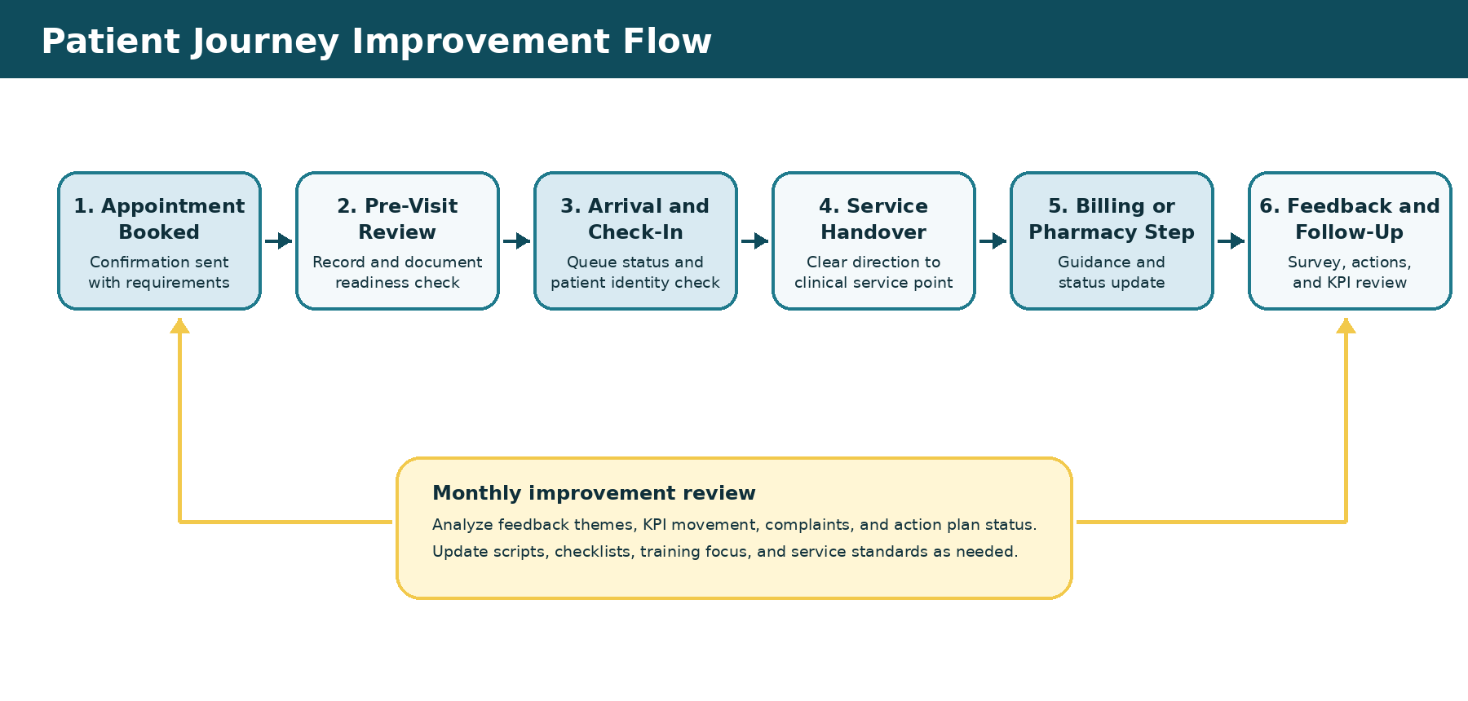

5. Strategic Improvement Plan
Service Area | Improvement Strategy | Responsible Team | Expected Outcome
Front desk operations | Use a check-in checklist, arrival time capture, and peak-hour queue monitoring. | Front Desk Lead | Faster check-in and clearer patient guidance.
Appointment scheduling | Confirm appointment details, department, location, and required documents through a standard update process. | Clinic Coordinator | Fewer missed appointments and fewer schedule misunderstandings.
Record management | Complete pre-visit document readiness checks one day before the appointment. | Records Officer | Fewer delays caused by missing or incomplete records.
Patient communication | Use approved update scripts for delays, changes, billing steps, and next-step guidance. | Patient Relations Officer | More consistent and reassuring communication.
Service recovery | Record complaints, assign owners, set deadlines, and verify closure. | Administration Supervisor | Faster complaint resolution and stronger accountability.
Feedback monitoring | Collect ratings and open comments, review themes monthly, and link findings to actions. | Quality Coordinator | Better visibility of patient concerns and improvement progress.

6. Technology and Process Enhancements
The strategy uses practical, low-cost tools that can be managed by an administration team. Each tool supports visibility, consistency, and accountability across the patient journey.
Tool or Template | Purpose | Key Fields | Benefit
Digital appointment tracker | Track confirmations, changes, reminders, and status. | Patient ID, date, department, confirmation status, reminder status | Improves scheduling visibility.
Document readiness checklist | Verify required patient documents before arrival. | Record status, consent status, insurance status, missing items | Reduces repeated requests.
Queue monitoring dashboard | Monitor arrival and check-in times. | Arrival time, check-in time, waiting time, counter owner | Helps identify peak-hour delays.
Patient feedback form | Capture satisfaction ratings and open comments. | Touchpoint, rating, theme, action required | Turns feedback into measurable actions.
Complaint tracker | Document and close patient complaints. | Category, owner, deadline, root cause, corrective action | Strengthens service recovery.
Monthly KPI dashboard | Track performance and improvement progress. | Baseline, monthly result, target, status, owner | Supports management review.

7. Implementation Timeline
The implementation plan is structured as a three-month cycle. It begins with assessment, continues with process improvements, and ends with training, monitoring, and refinement.
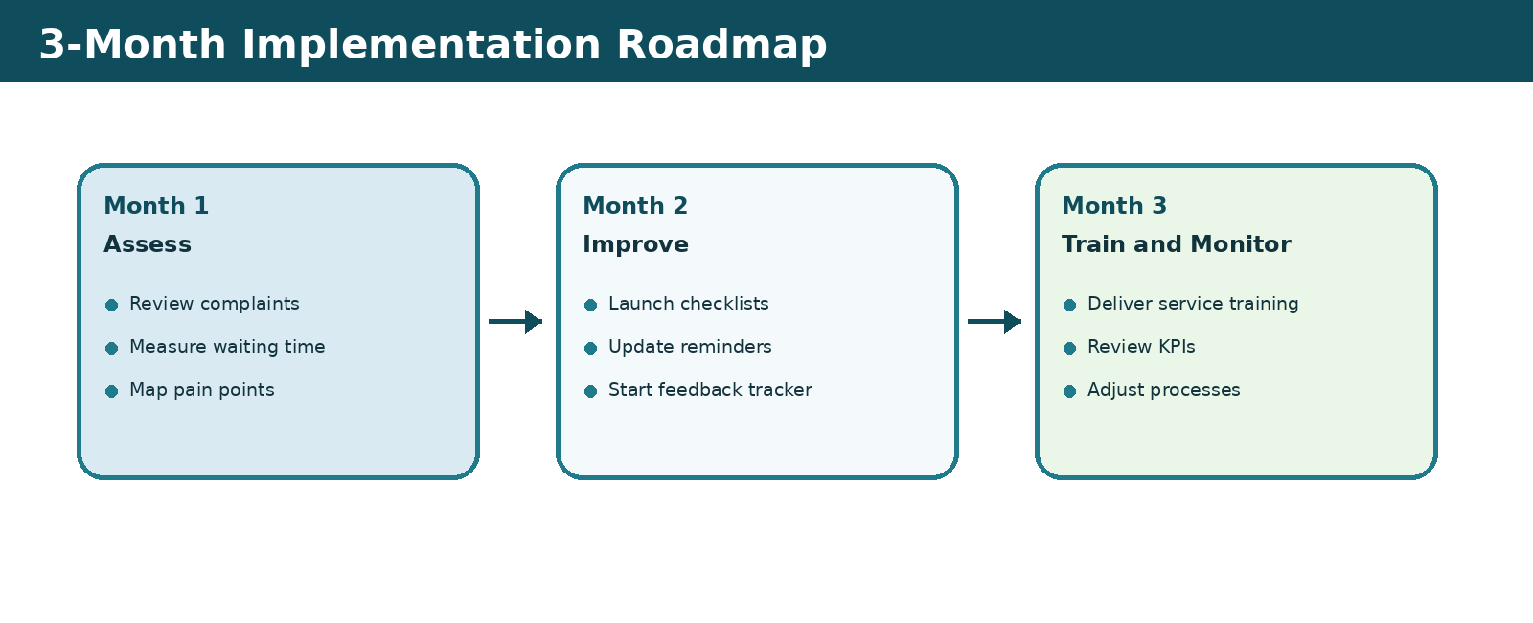
Phase | Timeline | Key Actions | Deliverables
Phase 1: Assessment | Month 1 | Review complaints, measure waiting time, identify service gaps, map touchpoints. | Feedback summary and baseline KPI report.
Phase 2: Process Improvement | Month 2 | Launch checklists, appointment reminders, patient update scripts, and shared trackers. | Updated templates and process controls.
Phase 3: Training and Monitoring | Month 3 | Train staff, collect feedback, review KPIs, adjust procedures, and report progress. | Training record, KPI dashboard, and action review.

8. Budget Outline
The budget below is a practical planning estimate for initial implementation. Amounts can be adjusted depending on the facility size, existing tools, and staff coverage requirements.
Budget Item | Estimated Cost | Purpose
Staff service training | AED 3,000 | Improve communication, complaint handling, confidentiality, and patient guidance.
Digital feedback form setup | AED 500 | Collect ratings and comments through a simple electronic form.
Queue tracking sheet and dashboard | AED 1,000 | Monitor patient arrival, check-in, and waiting time.
Reminder message process | AED 1,200 | Improve appointment confirmation and reduce missed visits.
Printed patient information materials | AED 800 | Provide clear steps, department directions, and document requirements.
Total Estimated Budget | AED 6,500 | Initial three-month improvement setup.

9. Staff Training Plan
Staff training supports consistency across patient-facing teams. The training plan focuses on how patients are welcomed, informed, guided, and supported when issues occur.
Training Topic | Audience | Purpose | Evidence of Completion
Patient communication etiquette | Front desk and administration staff | Improve clarity, tone, empathy, and professionalism. | Attendance sheet and supervisor observation.
Complaint handling and service recovery | Patient-facing staff | Resolve concerns calmly and document actions. | Scenario practice checklist.
Appointment coordination standards | Front desk and scheduling teams | Reduce scheduling confusion and late updates. | Scheduler quality review.
Confidentiality and data protection | All administration staff | Protect patient information and limit unnecessary sharing. | Signed acknowledgement form.
Feedback review and improvement actions | Leads and supervisors | Translate comments into tracked actions. | Monthly improvement meeting notes.

10. Patient Feedback Form Template
The feedback form should be simple, quick to complete, and easy to analyze. The ratings below can be captured in a digital form or paper form and then entered into the feedback tracker.
Question | Rating Scale | Purpose
How satisfied were you with the front desk service? | 1 to 5 | Measure greeting, guidance, and professionalism.
Was your appointment handled on time? | 1 to 5 | Measure appointment flow and waiting experience.
Were staff clear and helpful in their communication? | 1 to 5 | Measure clarity and patient confidence.
Was your waiting time acceptable? | 1 to 5 | Measure perceived efficiency.
Were your documents handled professionally? | 1 to 5 | Measure record handling and privacy.
Overall, how satisfied were you with your visit? | 1 to 5 | Measure total patient experience.
What can we improve for your next visit? | Open comment | Identify themes for action planning.

11. Performance Monitoring KPIs
The following KPIs will be reviewed monthly. Results should be discussed with department leads and used to update the action plan. Targets are set to create measurable progress while remaining practical for an outpatient administration setting.
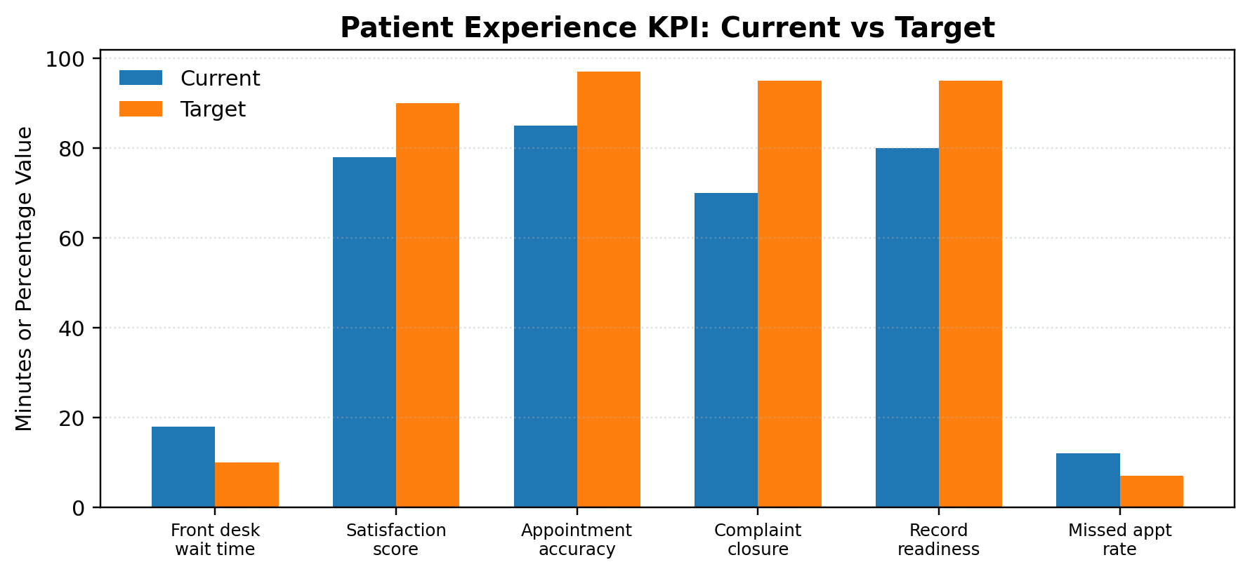
KPI | Current | Target | Measurement Method | Owner
Average front desk waiting time | 18 minutes | 10 minutes | Arrival time compared with check-in completion time. | Front Desk Lead
Patient satisfaction score | 78% | 90% | Average feedback score converted to percentage. | Patient Relations Officer
Appointment confirmation accuracy | 85% | 97% | Confirmed appointments with correct date, time, department, and contact details. | Clinic Coordinator
Complaint closure within 48 hours | 70% | 95% | Closed complaints compared with total complaints due within the period. | Administration Supervisor
Record readiness before appointment | 80% | 95% | Appointments with complete documents and verified records before arrival. | Records Officer
Missed appointment rate | 12% | 7% | Missed appointments divided by scheduled appointments. | Clinic Coordinator

12. Service Standards and Communication Scripts
Standard wording helps staff give patients clear, respectful, and consistent information. The examples below can be adapted by the clinic team.
Situation | Recommended Patient Message
Appointment confirmation | Your appointment is confirmed for [date] at [time] with [department]. Please bring [required documents].
Delay update | Thank you for your patience. We are reviewing your appointment status and will update you shortly.
Missing document | One required document is not available in your file. We will help you complete this step as quickly as possible.
Service handover | Your next step is [department/service point]. A staff member has been informed and is expecting you.
Complaint acknowledgement | Thank you for sharing this with us. We will record the concern, review it with the responsible team, and update you on the next step.

13. Risks, Mitigation, and Governance
Risk | Potential Effect | Mitigation | Owner
Staff do not use new templates consistently | Data may remain incomplete or inconsistent. | Supervisor review and weekly checklist audit. | Administration Supervisor
Feedback is collected but not reviewed | Patients may not see improvement. | Monthly feedback review meeting and action log. | Patient Relations Officer
Queue data is not captured accurately | Waiting time trends may be unreliable. | Assign counter owner and verify daily entries. | Front Desk Lead
Patient information is shared through unapproved channels | Privacy and trust may be affected. | Use approved communication process and provide confidentiality training. | Quality Coordinator
Improvement actions remain open too long | Service issues may repeat. | Assign deadlines, track status, and escalate overdue actions. | Administration Supervisor

Governance Routine
- Daily: Front desk reviews queue issues and appointment changes.
- Weekly: Team leads review open complaints, record readiness gaps, and action plan status.
- Monthly: Management reviews KPI movement, feedback themes, budget status, and training completion.
- Quarterly: Service standards and templates are updated based on evidence from feedback and KPIs.

14. Conclusion
This patient experience strategy provides a practical structure for improving healthcare administration service quality. By combining checklists, reminders, feedback capture, complaint tracking, staff training, and KPI monitoring, the clinic can reduce delays, increase patient confidence, and strengthen accountability across administrative touchpoints. The strategy is designed for immediate use and can be improved over time through regular review of patient feedback and performance results.

15. Appendix: Templates Included in Workbook
Workbook Sheet | Purpose
Dashboard | Visual summary of KPI targets, budget status, service focus, and priority actions.
Feedback Tracker | Log patient ratings, comments, action requirements, owners, and closure status.
KPI Monitoring | Track baseline, monthly results, targets, owner, and status.
Implementation Timeline | Manage the three-month rollout plan and progress.
Budget Tracker | Track planned cost, actual cost, and variance.
Staff Training | Track training topics, dates, completion, and evidence.
Complaint Resolution | Track cases, categories, deadlines, root causes, and corrective actions.
Patient Journey | Map each touchpoint, pain point, improvement action, and expected benefit.
Action Plan | Track initiatives, priority, owner, due date, dependency, and progress.

