Week 1 Task
Process Mapping and Analysis

Process Selected: Procurement Purchase Request to Purchase Order Process
Prepared by | Shaghayegh Haghbin
Date | 11 June 2026
Submission type | Microsoft Word report
Methodology focus | Lean Six Sigma process mapping and waste identification
Purpose | This report documents a common business procurement process, identifies waste and inefficiencies, and recommends initial Lean Six Sigma improvement opportunities to reduce delays, rework, and manual errors.

1. Executive Summary
This document analyzes the procurement purchase request to purchase order process. The process starts when a department identifies a need and ends when the supplier payment is processed after invoice matching. The purpose of the analysis is to map the current flow, identify waste, and propose practical Lean Six Sigma improvements that can make procurement faster, more accurate, and easier to control.
The main issues identified are incomplete purchase requests, slow approval cycles, manual supplier quote comparison, late budget checks, manual purchase order creation, and invoice matching exceptions. These problems create waiting time, defects, overprocessing, and rework. Recommended improvements include a standardized digital request form, approval service level targets, early budget validation, a supplier comparison template, automated purchase order generation, and KPI tracking.

2. Objective and Scope
Objective: Document a common procurement process, identify areas of waste, and recommend initial Lean Six Sigma improvement ideas.
Scope: The scope covers internal purchase requests, management approval, procurement review, supplier selection, budget approval, purchase order creation, supplier confirmation, receipt of goods or services, invoice matching, and payment processing.
Out of scope: Long-term strategic sourcing, supplier contract negotiation, vendor onboarding, product returns, and supplier performance audits are excluded from this Week 1 analysis.
Process Boundary | Included | Purpose
Start point | Department identifies a need for goods or services | Defines the trigger for the process
End point | Payment is processed after matching invoice, PO, and receipt | Confirms the process output and closure point
Main customer | Requesting department and internal business users | Shows who benefits from a faster, more reliable process
Main functions involved | Requesting department, manager, procurement, finance/AP, supplier, receiving team | Clarifies process ownership and handoffs

3. Process Overview
The process follows a controlled purchase cycle. A department first identifies a business need and submits a purchase request. The manager reviews whether the request is justified. Procurement then checks request details, identifies an appropriate supplier, and coordinates quotation comparison when needed. Finance confirms budget availability before procurement creates and sends the purchase order. After the supplier confirms the order, the receiving and finance teams complete receipt verification, invoice matching, and payment processing.

4. SIPOC Summary
Suppliers | Inputs | Process | Outputs | Customers
Requesting departments  Approved vendors  Finance team  Supplier representatives | Purchase need  Request form  Budget code  Supplier quote  Vendor information | Submit request  Approve request  Review supplier options  Create PO  Receive goods or services  Match invoice and pay | Approved purchase order  Supplier confirmation  Received goods or services  Matched invoice  Processed payment | Internal business users  Procurement  Finance/AP  Suppliers  Management

5. Visual Process Map

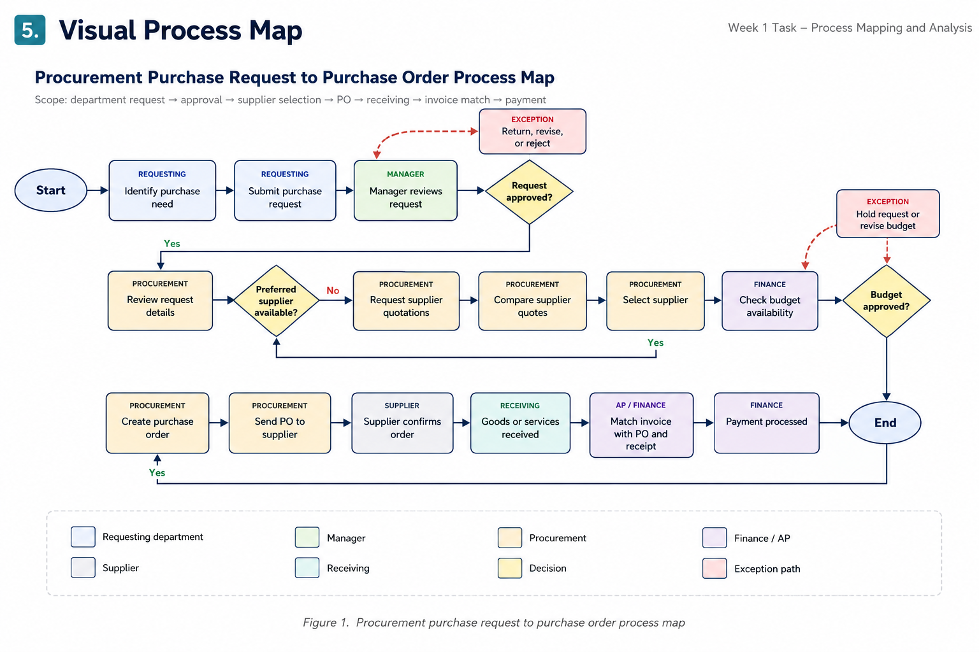
Figure 1. Procurement purchase request to purchase order process map

6. Editable Process Flow Summary
The table below provides an editable version of the process map. It can be updated directly in Word if the process steps, owners, inputs, or outputs need to be changed.
Step | Owner | Input | Activity or Decision | Output
1 | Requesting Department | Business need | Identify purchase need | Need confirmed
2 | Requesting Department | Need details | Submit purchase request | Purchase request submitted
3 | Manager | Purchase request | Review request for business justification | Approved, revised, or rejected request
4 | Procurement | Approved request | Review item details, supplier information, quantity, and delivery needs | Request accepted for sourcing
5 | Procurement | Supplier options | Check if a preferred supplier is available | Preferred supplier or quotation requirement identified
6 | Procurement | Supplier quotes | Compare supplier quotes using price, lead time, quality, and terms | Supplier selected
7 | Finance | Selected supplier and estimated cost | Check budget availability and cost center | Budget approved or held
8 | Procurement | Approved request and budget | Create purchase order | Purchase order generated
9 | Procurement / Supplier | Purchase order | Send PO and receive supplier confirmation | Confirmed supplier order
10 | Receiving / Finance | Delivery and invoice | Receive goods or services, match invoice with PO and receipt, and process payment | Completed procurement transaction

7. Waste and Inefficiency Analysis
Lean analysis focuses on activities that do not add value to the internal customer. The table below identifies waste points in the procurement process and explains their potential impact.
Process Step | Inefficiency Identified | Lean Waste Type | Likely Root Cause | Business Impact
Purchase request submission | Employees may submit incomplete request forms with missing supplier, quantity, budget code, or delivery information. | Defects / Rework | No standardized request form or mandatory fields. | Procurement must ask for missing details, which delays the request and increases admin effort.
Manager approval | Approval may take too long when requests are routed through email or informal messages. | Waiting | No approval SLA, reminders, or clear escalation path. | The purchase cycle slows down and urgent business needs may be delayed.
Supplier quotation | Procurement may manually request, track, and compare supplier quotes. | Overprocessing | No comparison template or supplier database. | Extra administrative work and inconsistent supplier selection decisions.
Budget check | Finance checks budget after procurement has already reviewed supplier options. | Waiting / Overprocessing | Budget validation happens too late in the process. | Procurement effort is wasted if the request is later placed on hold or rejected.
Purchase order creation | Manual re-entry of request details into a PO can cause supplier, price, quantity, or delivery errors. | Defects | Duplicate data entry and lack of system integration. | Incorrect POs may cause supplier confusion, delivery delays, invoice mismatches, and rework.
Invoice matching | Invoice, PO, and receipt information may not match due to quantity, pricing, or delivery discrepancies. | Defects / Waiting | Weak controls at receiving and inconsistent documentation. | Payment is delayed and finance must investigate exceptions before closing the purchase.

8. Lean Six Sigma Improvement Recommendations
The following improvement ideas are practical starting points that can be implemented without fully redesigning the procurement function. The goal is to reduce cycle time, defects, and rework while improving visibility across handoffs.
Issue | Lean Six Sigma Strategy | Recommended Action | Expected Benefit | Priority
Incomplete requests | Standard Work and Poka-Yoke | Create a digital purchase request form with required fields for item description, quantity, supplier, budget code, urgency, and delivery date. | Fewer missing details and less rework for procurement. | High
Slow approvals | SLA and Visual Management | Set approval turnaround targets, automated reminders, and escalation rules for overdue approvals. | Reduced waiting time and clearer accountability. | High
Manual quote comparison | Standardized Template | Use a supplier comparison table that scores price, lead time, quality, payment terms, and risk. | Faster and more consistent supplier selection. | Medium
Late budget rejection | Process Sequencing | Add an early budget pre-check before supplier sourcing begins. | Prevents wasted sourcing effort and improves financial control. | High
PO data entry errors | Automation and Error-Proofing | Generate the PO from approved request data and use dropdown fields for supplier, currency, cost center, and payment terms. | Reduces defects, invoice mismatch, and supplier confusion. | Medium
Invoice match exceptions | Standard Work and KPI Tracking | Use receiving confirmation rules and track three-way match exception rate weekly. | Fewer payment delays and better process control. | Medium

9. Improvement Priority Matrix
Improvement | Impact | Effort | Recommended Priority
Digital request form with mandatory fields | High | Low to Medium | Quick win
Approval SLA with reminders | High | Low | Quick win
Early budget pre-check | High | Medium | Quick win
Supplier quote comparison template | Medium | Low | Quick win
Automated PO generation | High | Medium to High | Phase 2 improvement
Procurement KPI dashboard | Medium to High | Medium | Phase 2 improvement

10. Suggested KPIs for Monitoring Improvement
KPI | Definition | Why It Matters | Suggested Target Direction
Purchase request cycle time | Average time from request submission to approved PO. | Shows whether process speed is improving. | Decrease
First-pass request accuracy | Percentage of requests submitted with all required information correct the first time. | Measures quality of request submission. | Increase
Average approval turnaround time | Average time managers take to approve or reject requests. | Highlights waiting and approval bottlenecks. | Decrease
PO error rate | Percentage of POs requiring correction after creation. | Measures defects caused by manual entry or unclear request details. | Decrease
Three-way match exception rate | Percentage of invoices that do not match PO and receipt data. | Tracks finance rework and payment delay causes. | Decrease

11. Conclusion
The procurement purchase request to purchase order process contains several handoffs between the requesting department, manager, procurement, finance, supplier, and receiving team. These handoffs create common waste points such as waiting, defects, rework, and overprocessing. The most important improvement opportunities are to standardize the request intake, reduce approval delays, validate budget earlier, simplify supplier comparison, and reduce manual purchase order entry errors.
By applying Lean Six Sigma principles such as standard work, mistake-proofing, visual management, process sequencing, and KPI tracking, the organization can improve process speed, reduce administrative effort, and increase purchasing accuracy. These improvements would also support better internal customer service and stronger financial control.

12. References
American Society for Quality (ASQ). Lean and the Seven Types of Waste. https://asq.org/quality-resources/lean
Lean Enterprise Institute. What are the 7 Wastes in Lean? https://www.lean.org/lexicon-terms/seven-wastes/
American Society for Quality (ASQ). What is Mistake Proofing? Poka-Yoke. https://asq.org/quality-resources/mistake-proofing

