WEEK 2 TASK
Root Cause Analysis and Problem Solving
Case Scenario: Delayed Purchase Order Approval in the Procurement Process
A professional RCA report using the 5 Whys method, Cause and Effect Diagram, corrective actions, and control measures.
Prepared by: Shaghayegh Haghbin
Program: Lean Six Sigma Green Belt Internship
Date: June 2026
Executive Summary
This report analyzes a hypothetical procurement process failure where purchase orders take 7 to 10 business days to approve instead of the target 2 to 3 business days. The analysis shows that the delay is caused by incomplete purchase requests, email-based approvals, late budget validation, manual purchase order creation, and limited KPI monitoring. Recommended corrective actions focus on standard work, poka-yoke controls, approval SLAs, process automation, and KPI dashboards.

1. Introduction and Case Context
The procurement purchase request to purchase order process is a critical business process because it connects department needs, budget approval, supplier selection, purchase order creation, and final supplier confirmation. When this process is delayed, departments wait longer for required goods or services, suppliers receive late instructions, and finance teams face additional rework.
This Week 2 report applies Root Cause Analysis to a hypothetical process inefficiency scenario: delayed purchase order approval. The purpose is to identify the underlying causes, rather than only describing the symptoms, and to recommend practical corrective actions based on Lean Six Sigma thinking.
Item | Description
Process selected | Procurement purchase request to purchase order process
Process issue | Purchase order approvals are taking longer than expected
Expected performance | Purchase request converted to approved purchase order within 2 to 3 business days
Current performance | Purchase request converted to approved purchase order within 7 to 10 business days
Primary impact | Late supplier orders, delayed deliveries, rework, staff frustration, and reduced process reliability
RCA tools used | 5 Whys analysis and Cause and Effect Diagram

2. Problem Statement
Problem statement: The organization is experiencing delays in approving purchase orders. Purchase requests are often submitted with missing information, approvals are handled manually through email, budget checks happen late, and procurement teams must repeatedly follow up with employees, managers, and finance. As a result, the purchase order cycle time increases from the target of 2 to 3 business days to approximately 7 to 10 business days.
The problem is not only a delay in one department. It is a cross-functional process issue involving people, process design, technology, policies, data quality, and measurement controls.
Problem Area | Observed Symptom | Likely Lean Waste
Purchase request submission | Requests are submitted without vendor name, quantity, budget code, delivery deadline, or approvals | Defects and rework
Approval workflow | Manager and finance approvals sit in email inboxes without clear deadlines | Waiting
Procurement review | Procurement spends time checking missing details instead of processing the purchase order | Overprocessing
Purchase order creation | Manual copy-paste from request forms into PO templates creates errors | Defects
Performance tracking | No clear aging report or dashboard showing how long each request has been pending | Lack of measurement control

3. Current State Process Snapshot
The current state process below shows the main handoffs from department request to supplier confirmation. The most visible delay points are the incomplete request form, email-based approval, late budget review, manual supplier quote comparison, and manual PO creation.
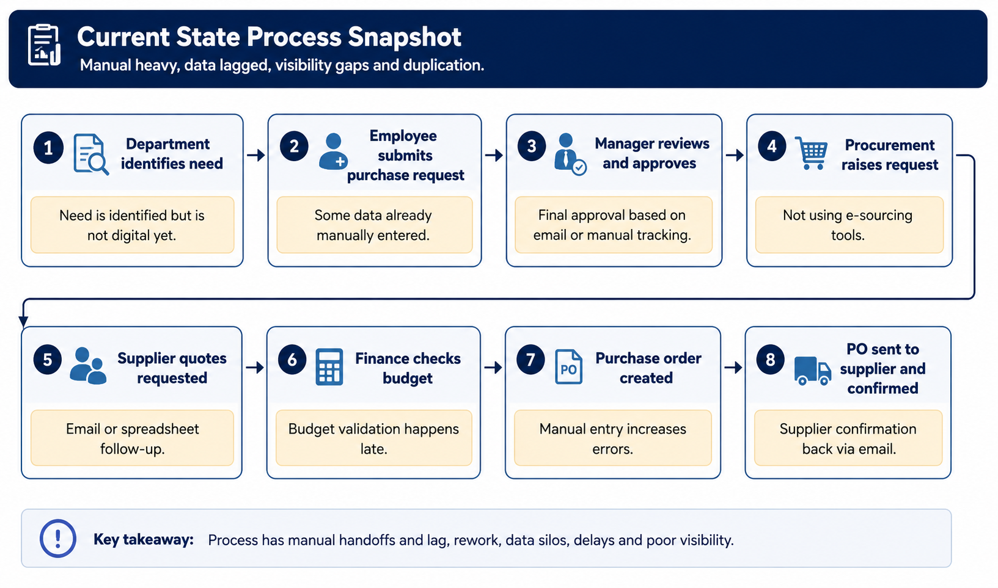

4. Root Cause Analysis Methodology
Root Cause Analysis is used to move beyond surface-level symptoms and identify why a problem repeatedly occurs. For this report, the analysis uses two practical RCA tools:
- 5 Whys Analysis: asks a sequence of why questions to trace the problem back to its underlying process cause.
- Cause and Effect Diagram: groups possible causes into categories so that the relationship between people, process, technology, policy, measurement, and data issues can be seen clearly.
The RCA does not assume that employees are the main problem. Instead, it evaluates whether the process has enough standardization, visibility, controls, and feedback mechanisms to support consistent performance.
RCA Step | Purpose | Output in this Report
Define the problem | Clarify what is going wrong and what performance gap exists | Problem statement and baseline performance
Map the current state | Understand the flow of work and handoffs | Current state process snapshot
Ask why repeatedly | Trace symptoms to deeper causes | 5 Whys table
Group causes | Identify cause categories and patterns | Cause and Effect Diagram
Recommend corrective actions | Address root causes instead of symptoms | Action plan, KPIs, and control plan

5. 5 Whys Analysis
The 5 Whys analysis traces the main symptom, delayed purchase order approval, back to the root cause pattern. The final cause points to weak process controls, not only individual delay.
Why Level | Question | Answer
1 | Why are purchase orders delayed? | Because purchase requests take too long to move from request submission to final approval.
2 | Why does approval take too long? | Because managers, procurement, and finance review requests manually through email and often wait for missing information.
3 | Why is missing information common? | Because the request form does not require key fields such as budget code, vendor details, quantity, delivery date, justification, and approval owner.
4 | Why does the workflow depend on manual email review? | Because there is no standardized digital approval workflow, automated reminders, aging tracker, or escalation rule.
5 | Why were these controls not defined? | Because procurement performance is not consistently measured using KPIs such as cycle time, approval aging, rework rate, and first-time-right request rate.
Root Cause | What is the underlying cause? | The process lacks standard work, required request fields, digital approval visibility, approval SLAs, early budget validation, and KPI-based control.

5.1 Supporting 5 Whys Branches
To avoid oversimplifying the issue, the table below separates the problem into three supporting branches: incomplete purchase requests, slow approvals, and manual PO errors.
Problem Branch | Why It Happens | Root Cause
Incomplete purchase requests | Employees submit requests without clear required fields or validation checks | No standardized digital request form with poka-yoke controls
Slow approval response | Approvers rely on email and do not receive reminders or escalation alerts | No approval SLA, no aging dashboard, and no escalation rule
PO creation errors | Procurement manually enters data from emails or forms into PO templates | No automated transfer of approved request data into the purchase order

6. Cause and Effect Diagram
The Cause and Effect Diagram below organizes the possible causes into six categories. The pattern shows that the delay is created by a combination of unclear ownership, weak process controls, manual technology, inconsistent policies, poor measurement, and incomplete data.
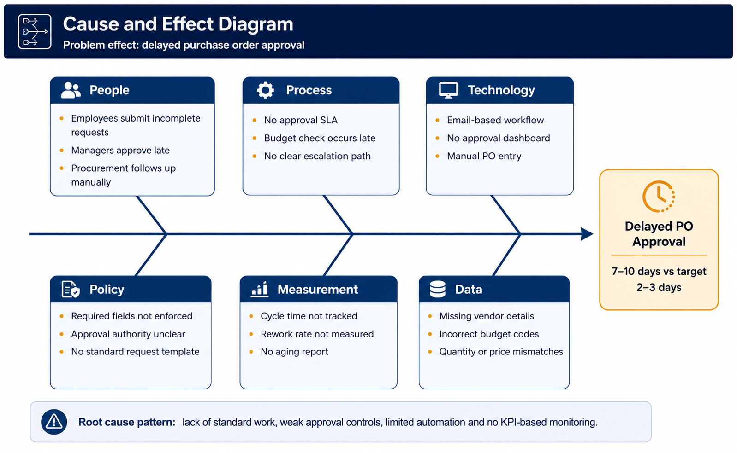

7. Root Cause Findings
The RCA findings show that the approval delay is not caused by one person or one department. The delay is created by several connected root causes that allow waiting, rework, and errors to repeat.
Root Cause Area | Finding | Evidence from RCA | Impact
Standardization | Purchase requests do not consistently include required information | 5 Whys levels 2 and 3; People and Data categories | Creates rework and repeated follow-ups
Approval control | Approvals do not have a defined SLA or escalation rule | 5 Whys level 4; Policy category | Requests remain pending without accountability
Technology | The workflow relies heavily on email and manual tracking | Technology category | Low visibility and longer waiting time
Budget validation | Finance checks budget late in the workflow | Process category | Procurement may complete work that later needs revision
Measurement | Cycle time, aging, and rework are not consistently tracked | 5 Whys level 5; Measurement category | Managers cannot see trends or control performance

8. Corrective Actions and Recommendations
Corrective actions should remove or reduce the root causes identified above. The priority should be to create a controlled, visible, and measurable approval process rather than adding more manual follow-up work for procurement staff.
Root Cause | Corrective Action | Lean Six Sigma Tool | Expected Benefit | Owner
Incomplete request details | Create a standardized digital purchase request form with mandatory fields for vendor, item, quantity, budget code, delivery date, and justification | Standard Work and Poka-Yoke | Reduces defects, missing data, and rework | Procurement
Slow approval response | Set approval SLAs, such as 24 to 48 hours per approval stage, with automated reminders | Standard Work and Visual Management | Reduces waiting and improves accountability | Department Managers
Email-based workflow | Use a digital approval tracker or procurement workflow tool showing request status and aging | Process Automation | Improves visibility and reduces manual chasing | Procurement and IT
Late budget validation | Add budget code validation before supplier sourcing begins | Process Redesign | Prevents wasted procurement effort and late rejection | Finance
Manual PO data entry | Generate the purchase order directly from approved request data where possible | Automation and Error Proofing | Reduces data entry defects and cycle time | Procurement and IT
No KPI monitoring | Create a simple monthly dashboard for cycle time, aging, rework rate, and first-time-right request rate | DMAIC Control and KPI Dashboard | Supports continuous improvement and management control | Operations Manager

8.1 Corrective Action Priority Matrix
The priority matrix helps decide which actions should be implemented first based on business impact and implementation effort. The fastest wins are the standardized digital request form and approval SLA with reminders.
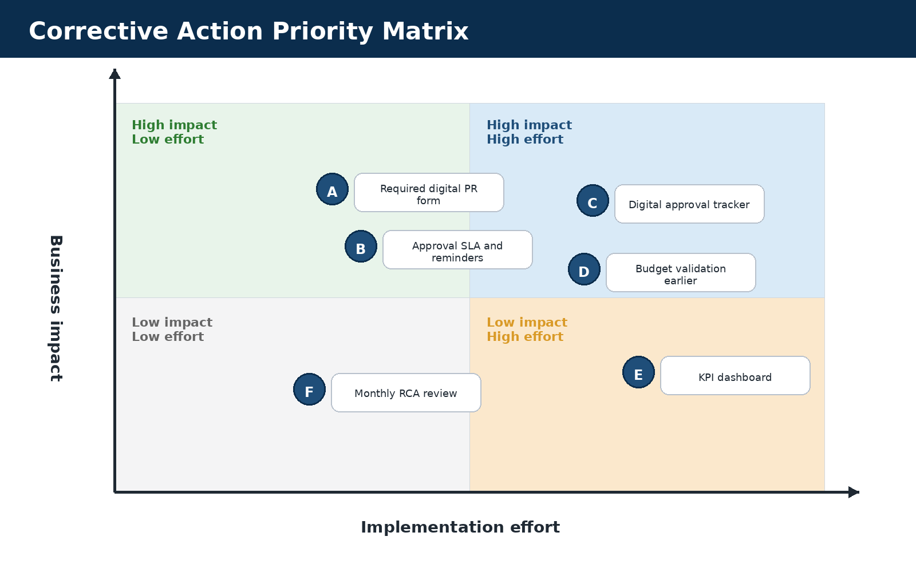

9. Implementation Plan and Control Measures
The implementation plan should start with low-effort controls before moving toward heavier system automation. This makes the improvement realistic for a small or medium operations team.
Timeline | Action | Deliverable | Success Indicator
Week 1 | Review current purchase request templates, approval emails, and recent delayed requests | Current-state issue log | Top delay reasons identified
Week 2 | Design a standardized purchase request form with required fields | Digital PR form draft | Required fields agreed by procurement and finance
Week 3 | Define approval SLA, escalation rule, and approval ownership matrix | Approval control policy | SLA communicated to all approvers
Week 4 | Pilot the improved workflow with one department | Pilot tracker and status report | Requests visible by status and owner
Week 5 | Review pilot results and fix form or workflow gaps | Pilot improvement summary | Reduced missing information and shorter approval time
Week 6 | Roll out the improved process to all departments | Final workflow and KPI dashboard | Cycle time trending toward 2 to 3 business days

9.1 KPI Control Plan
After the corrective actions are implemented, the process should be monitored using a simple control plan. The purpose is to make delays visible early and prevent the same root causes from returning.
KPI | Definition | Target | Review Frequency | Action if Off Target
PO cycle time | Average time from request submission to approved purchase order | 2 to 3 business days | Weekly | Review aging report and escalate delayed approvals
Approval aging | Number of requests pending approval beyond SLA | 0 requests older than 48 hours per stage | Weekly | Send automated reminder and escalate to department head
First-time-right request rate | Percentage of requests submitted with all required information | 90 percent or above | Monthly | Retrain requesters and improve required fields
Rework rate | Percentage of requests returned for correction | Below 10 percent | Monthly | Analyze common missing fields and update form controls
PO error rate | Percentage of POs corrected after release | Below 2 percent | Monthly | Review data entry process and automate where possible

9.2 Risk and Mitigation
Implementation Risk | Potential Effect | Mitigation
Employees may resist the new form | Low adoption and continued email requests | Provide a short guide and reject incomplete requests politely but consistently
Managers may ignore SLA reminders | Approvals continue to age | Use escalation rules and weekly aging reports
Automation may be delayed by system limitations | Process remains partly manual | Start with a shared tracker before full system integration
Finance and procurement may disagree on budget validation timing | Pilot process may stall | Agree on budget code checks before supplier sourcing begins

10. Conclusion
The Root Cause Analysis shows that the delayed purchase order approval problem is mainly caused by a weak process design rather than a single employee or department. The major root causes are incomplete purchase requests, no standardized digital workflow, slow email-based approvals, late budget validation, manual PO creation, and limited KPI monitoring.
The recommended corrective actions are practical and aligned with Lean Six Sigma principles. A standardized request form, approval SLA, digital tracker, early budget validation, automated PO generation, and KPI dashboard can reduce waiting, defects, rework, and overprocessing. If these actions are implemented and controlled through weekly and monthly KPIs, the process can move closer to the target cycle time of 2 to 3 business days while improving accuracy, accountability, and supplier responsiveness.

References
- American Society for Quality. Root Cause Analysis and 5 Whys guidance.
- Lean Enterprise Institute. Lean thinking, waste identification, standard work, and continuous improvement concepts.
- Project Management Institute. Process improvement and corrective action planning concepts.

