Week 3 Task
Lean Six Sigma Project Planning
Project Title: Reducing Purchase Order Approval Delays in the Procurement Process
Prepared by: Shaghayegh Haghbin
Process Area: Procurement Purchase Request to Purchase Order
Framework: DMAIC | Lean Six Sigma Green Belt

Project Aim: Reduce the average purchase order approval cycle time from 7 to 10 business days to 3 business days by standardizing request submission, improving approval visibility, and implementing KPI-based control.

1. Executive Summary
This project plan outlines a structured Lean Six Sigma improvement initiative focused on reducing delays in the procurement purchase request to purchase order process. The current process takes approximately 7 to 10 business days, while the desired target is 3 business days. Key issues include incomplete request forms, manual email-based approvals, late budget checks, unclear escalation rules, and limited KPI visibility.
The project follows the DMAIC framework: Define, Measure, Analyze, Improve, and Control. The expected outcome is a faster, more reliable procurement approval workflow with fewer errors, stronger accountability, better stakeholder visibility, and improved operational performance.

2. Project Charter
Charter Element | Description
Business Case | Delayed purchase order approvals slow down internal purchasing, increase follow-up workload, and affect supplier coordination. Reducing approval delays will improve operational efficiency and internal service quality.
Problem Statement | Purchase requests that should become approved purchase orders within 2 to 3 business days currently take 7 to 10 business days due to process variation, missing information, manual approvals, and limited tracking.
Goal Statement | Reduce average PO approval cycle time to 3 business days and reduce incomplete purchase requests by at least 50% within the project period.
Project Start Point | Department identifies a purchasing need and submits a purchase request.
Project End Point | Approved purchase order is created and sent to the supplier.
Primary Stakeholders | Department requesters, department managers, procurement team, finance team, project sponsor, and IT/admin support.

3. Project Scope
Scope Category | Included / Excluded
In Scope | Purchase request submission, manager approval, finance budget validation, procurement review, PO creation, approval tracking, and KPI reporting.
Out of Scope | Supplier delivery delays, supplier contract negotiations, invoice payment processing, vendor performance management, and full ERP implementation.
Assumptions | The organization can use existing tools such as Microsoft Forms, Excel, SharePoint, Google Forms, or Google Sheets to create a low-cost digital workflow.
Constraints | Limited budget, stakeholder availability, dependence on department managers for timely approvals, and possible resistance to process changes.

4. Project Objectives and KPIs
Objective | Baseline | Target | Measurement Method
Reduce average PO approval cycle time | 7 to 10 business days | 3 business days | Track request submission date to PO approval date
Reduce incomplete request rate | 30% estimated | 15% or lower | Count requests returned for missing information
Improve approval visibility | Limited email visibility | 100% tracked in shared tracker | Review tracker completeness weekly
Reduce manual follow-up emails | 4 to 6 emails per request | 2 or fewer | Sample email count per request
Improve on-time PO approval rate | 40% estimated | 85% | Percentage of POs approved within SLA

5. DMAIC Roadmap
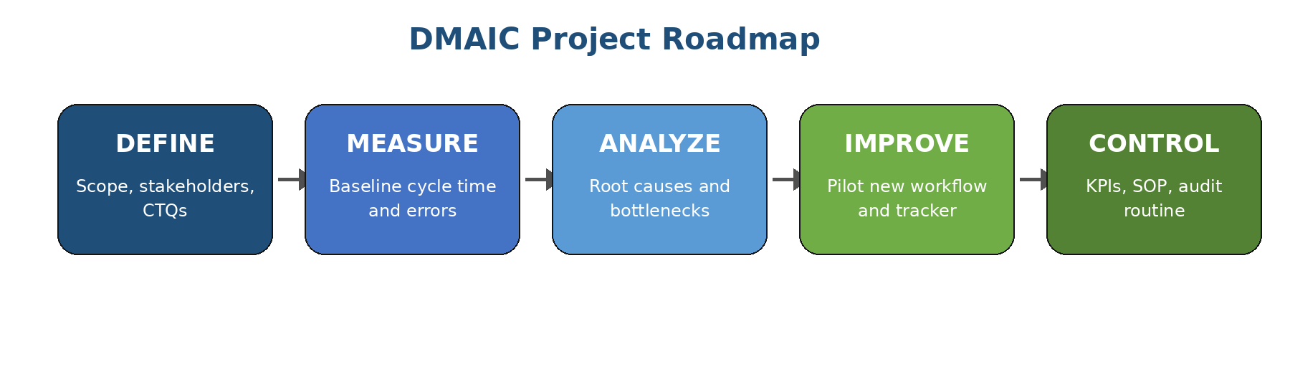
DMAIC Phase | Key Activities | Deliverables | Success Criteria
Define | Confirm project scope, stakeholders, problem statement, customer requirements, and project goals. | Project charter, SIPOC, stakeholder list, high-level process map. | Approved scope and clear business problem.
Measure | Collect baseline data for cycle time, request completeness, approval delay, and follow-up volume. | Baseline KPI report and data collection plan. | Reliable baseline established.
Analyze | Use 5 Whys, fishbone diagram, and bottleneck review to identify root causes. | Root cause summary and prioritized problem areas. | Validated root causes linked to data.
Improve | Design standardized request form, approval SLA, early budget check, tracker, and escalation rules. | Future-state workflow, pilot plan, training notes. | Pilot shows shorter approval time and fewer rework cases.
Control | Create SOP, KPI dashboard, weekly review routine, and ownership structure. | Control plan, updated SOP, KPI dashboard. | Improved process remains stable after rollout.

6. Timeline and Milestones
Week | DMAIC Phase | Milestone | Output
Week 1 | Define | Confirm project charter, scope, stakeholders, and target metrics. | Approved project charter.
Week 2 | Measure | Collect sample data on approval cycle time, incomplete requests, and follow-ups. | Baseline KPI table.
Week 3 | Analyze | Complete root cause analysis and identify major bottlenecks. | Root cause findings.
Week 4 | Improve | Design improved workflow, digital form, approval SLA, and tracker. | Future-state process design.
Week 5 | Improve | Pilot the improved process with one department and collect pilot feedback. | Pilot performance summary.
Week 6 | Control | Finalize SOP, KPI dashboard, control plan, and handover recommendations. | Final project report and control plan.

7. Roles and Responsibilities
Role | Responsibility | RACI Position
Project Sponsor | Approves project direction, removes barriers, and supports adoption. | Accountable
Lean Six Sigma Green Belt Intern | Leads analysis, documentation, project planning, KPI design, and improvement recommendations. | Responsible
Procurement Team | Provides process knowledge, validates workflow gaps, and supports new PO process design. | Responsible
Finance Team | Reviews budget check process and supports earlier budget validation. | Consulted
Department Managers | Approve purchase requests within agreed SLA and support compliance. | Responsible
IT/Admin Support | Assists with digital form, shared tracker, and dashboard setup. | Consulted
Department Requesters | Submit complete purchase requests using the standardized form. | Informed / Responsible

8. Resource Allocation and Budget Considerations
Resource / Budget Item | Purpose | Estimated Cost | Notes
Microsoft Word | Project plan, SOP, and final documentation. | No additional cost | Use existing office software.
Excel or Google Sheets | KPI tracker, approval tracker, and simple dashboard. | No additional cost | Suitable for a low-budget pilot.
Microsoft Forms or Google Forms | Standardized purchase request submission with required fields. | No additional cost | Reduces missing information and rework.
Staff Training Session | Brief training for requesters, managers, procurement, and finance. | Internal time cost | Can be delivered in 30 to 45 minutes.
Optional Procurement System | Future automation if manual tools are insufficient. | Future cost to be assessed | Not required for initial pilot.

9. Risk Assessment and Mitigation Plan
Risk | Impact | Likelihood | Mitigation Plan
Managers do not approve within SLA | Delays continue and targets are missed. | Medium | Use automated reminders, escalation rules, and sponsor support.
Employees continue submitting incomplete requests | Rework remains high. | Medium | Use mandatory fields, examples, and a short submission checklist.
Teams resist the new workflow | Low adoption and inconsistent results. | Medium | Communicate benefits, provide training, and pilot with one department first.
KPI data is not updated consistently | Control phase becomes weak. | Medium | Assign tracker ownership and conduct weekly KPI reviews.
Finance budget check remains late | Requests may be rejected after procurement effort is already spent. | Low to Medium | Move budget validation earlier in the workflow.
Tool limitations affect tracking quality | Manual work continues. | Low | Start with a simple tracker and improve only if needed.

10. Control Plan
Control Item | Owner | Frequency | Control Method
PO approval cycle time | Procurement Team | Weekly | Monitor submission-to-approval duration in tracker.
Incomplete request rate | Procurement Team | Weekly | Count requests returned for missing details.
Approval SLA compliance | Department Managers | Weekly | Review pending approvals older than agreed SLA.
Budget validation timing | Finance Team | Weekly | Check whether budget validation occurs before procurement sourcing.
Process adherence | Project Sponsor / Process Owner | Monthly | Review KPI dashboard and resolve recurring bottlenecks.

11. Expected Outcomes
Expected Outcome | Operational Benefit
Faster purchase order approval | Reduces waiting time and improves purchasing reliability.
Fewer incomplete requests | Reduces rework and follow-up communication.
Clearer approval ownership | Improves accountability and reduces hidden delays.
Earlier budget validation | Prevents wasted procurement effort on requests that cannot be approved.
KPI-based monitoring | Supports continuous improvement and long-term process control.

12. Conclusion
This Lean Six Sigma project plan provides a structured approach for reducing purchase order approval delays in the procurement process. By applying the DMAIC framework, the project connects the problem statement, baseline measurement, root cause analysis, improvement design, and control planning into one practical roadmap. The recommended improvements focus on standardization, early budget validation, approval SLAs, digital tracking, and KPI monitoring.
If implemented effectively, the project is expected to reduce cycle time, decrease rework, improve stakeholder communication, and strengthen operational excellence in the procurement function.

13. References
American Society for Quality (ASQ). Lean Six Sigma and DMAIC methodology overview.
Lean Enterprise Institute. Lean thinking and waste reduction principles.
Project Management Institute. Project planning, risk management, and stakeholder responsibility concepts.

