Week 4 Task
Implementation of Lean Tools and Techniques
Project Title: Implementing Value Stream Mapping, 5S, and Kanban to Improve the Procurement Purchase Order Process
Prepared by: Shaghayegh Haghbin
Process Area: Procurement Purchase Request to Purchase Order
Framework: Lean Six Sigma | Operational Excellence | DMAIC Improve Phase

Implementation Aim: Apply Value Stream Mapping, 5S, and Kanban to reduce waiting, rework, manual follow-up, and process variation in the procurement approval workflow.

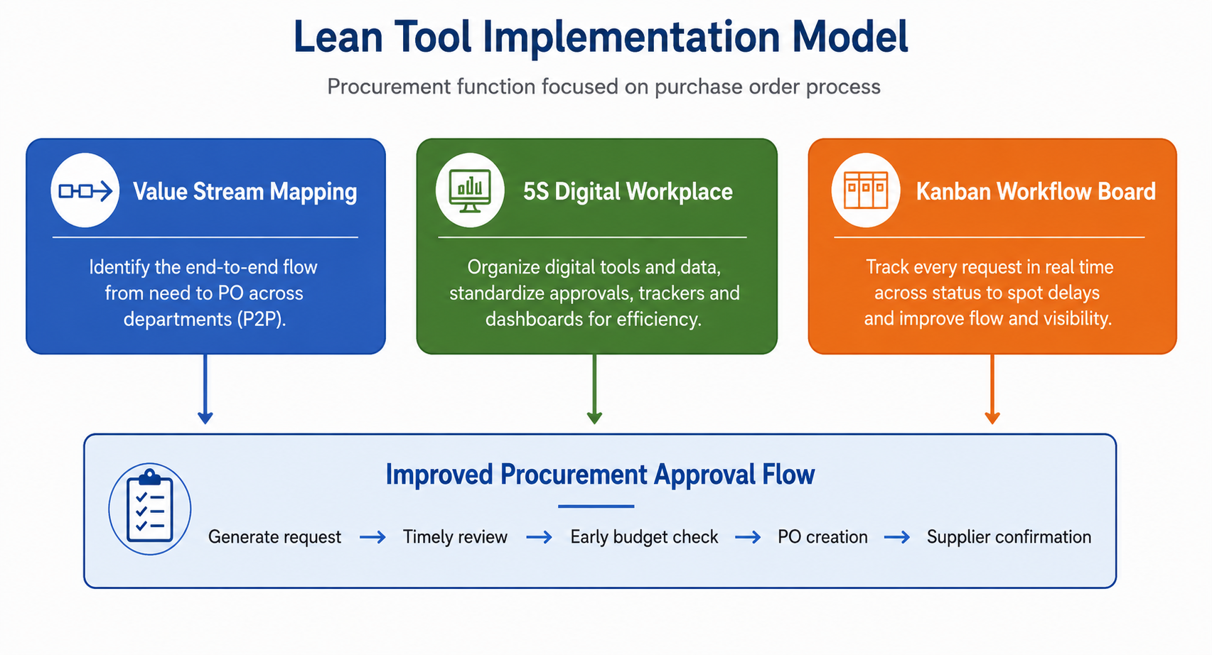

1. Executive Summary
This report presents a practical Lean implementation plan for improving the procurement purchase request to purchase order process. The current process is affected by incomplete purchase requests, email-based approvals, late budget checks, manual follow-up, and limited visibility of request status. These issues increase cycle time and create unnecessary administrative work for procurement, finance, managers, and requesters.
The proposed Lean approach combines three tools: Value Stream Mapping, 5S, and Kanban. Value Stream Mapping is used to identify waste and redesign the flow. 5S is used to organize procurement forms, supplier information, approval folders, and tracking documents. Kanban is used to create a visual control system for every request from submission to completion. The expected result is faster approval, fewer defects, clearer ownership, and stronger process control.

2. Process Scenario and Problem Definition
Area | Description
Selected Process | Procurement purchase request to purchase order process.
Current Problem | Purchase orders that should be approved within 2 to 3 business days currently take approximately 7 to 10 business days.
Operational Impact | Delayed supplier orders, frequent follow-ups, employee frustration, lower visibility, and possible disruption to internal operations.
Main Waste Types | Waiting, defects, rework, overprocessing, unnecessary motion, and poor information flow.
Improvement Goal | Use Lean tools to reduce approval cycle time, improve request quality, and make workflow status visible to all process owners.

3. Selected Lean Tools and Rationale
Lean Tool | How It Will Be Used | Why It Fits the Problem
Value Stream Mapping | Map the current approval flow, separate value-added and non-value-added activities, and redesign the future state. | The process has delays across handoffs, approvals, budget checks, and manual follow-up.
5S | Organize digital files, request forms, approval templates, supplier information, and shared trackers. | The process suffers from inconsistent documents and time wasted searching for the correct form or supplier details.
Kanban | Create a visual board showing each request stage, owner, aging status, and escalation need. | The process lacks real-time visibility, which causes requests to become delayed or forgotten.

4. Current-State Issues and Waste Analysis
Issue | Waste Type | Impact on Process | Lean Tool Response
Incomplete purchase request details | Defects / Rework | Procurement must return forms and ask for missing information. | 5S and standardized digital form with required fields.
Email-based approval flow | Waiting | Requests sit in inboxes with no clear visibility or ownership. | Kanban board and approval SLA.
Late finance budget validation | Waiting / Overprocessing | Procurement effort may be wasted if finance rejects the request late. | Value Stream Mapping and future-state redesign.
No shared request tracker | Motion / Waiting | Staff spend time asking for status updates manually. | Kanban workflow board with request aging.
Manual PO creation | Defects | Supplier, quantity, price, or delivery details may be entered incorrectly. | Standard templates and poka-yoke checks.

5. Value Stream Mapping Implementation
Value Stream Mapping will be used first because it gives a clear view of the full process flow and makes delays visible. The team will map each step from purchase request submission to PO creation and supplier confirmation. Each step will be reviewed for cycle time, waiting time, handoff owner, information quality, and rework frequency.
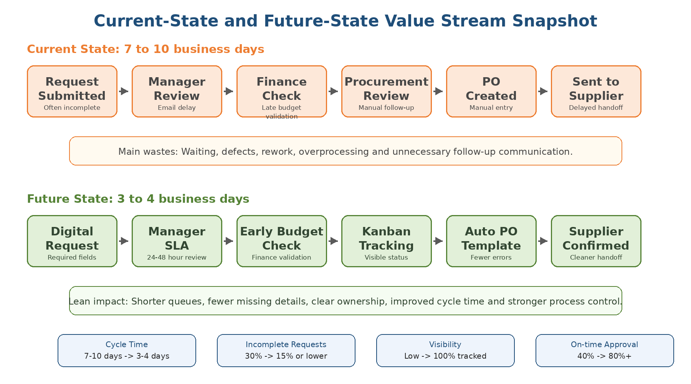

Implementation Step | Action | Expected Output
Step 1: Map current state | Document the existing flow from request submission to supplier confirmation. | Current-state map with process steps and handoffs.
Step 2: Identify waste | Mark delays, rework loops, manual checks, and unnecessary approvals. | Waste list and bottleneck summary.
Step 3: Measure baseline | Collect cycle time, incomplete request rate, approval delay rate, and follow-up volume. | Baseline KPI table.
Step 4: Design future state | Move budget check earlier, remove repeated handoffs, and define clear approval ownership. | Future-state map.
Step 5: Validate with stakeholders | Review the future state with procurement, finance, managers, and requesters. | Approved implementation design.

6. 5S Digital Workplace Implementation
5S will be applied to the digital procurement workspace rather than a physical shop floor. The purpose is to make forms, supplier details, approval files, and tracking documents easy to find, easy to use, and consistently maintained.
5S Stage | Procurement Application | Expected Benefit
Sort | Remove outdated forms, duplicate supplier files, old templates, and unused approval folders. | Reduces confusion and prevents use of outdated documents.
Set in Order | Create a clear folder structure for requests, supplier quotes, approved POs, budget checks, and SOPs. | Reduces searching time and improves document control.
Shine | Clean the tracker, remove incomplete records, standardize file names, and archive old items. | Improves data quality and professional presentation.
Standardize | Use one purchase request form, one PO checklist, one supplier comparison template, and one approval tracker. | Reduces variation and rework.
Sustain | Assign a process owner to review folders, templates, and tracker quality weekly. | Maintains the improvement after rollout.

7. Kanban Workflow Implementation
Kanban will be used to control flow and improve visibility. Each purchase request will become a card on a shared Kanban board. The card will show the requester, request date, department, current owner, priority, aging status, and next action. This prevents requests from being hidden in email inboxes.
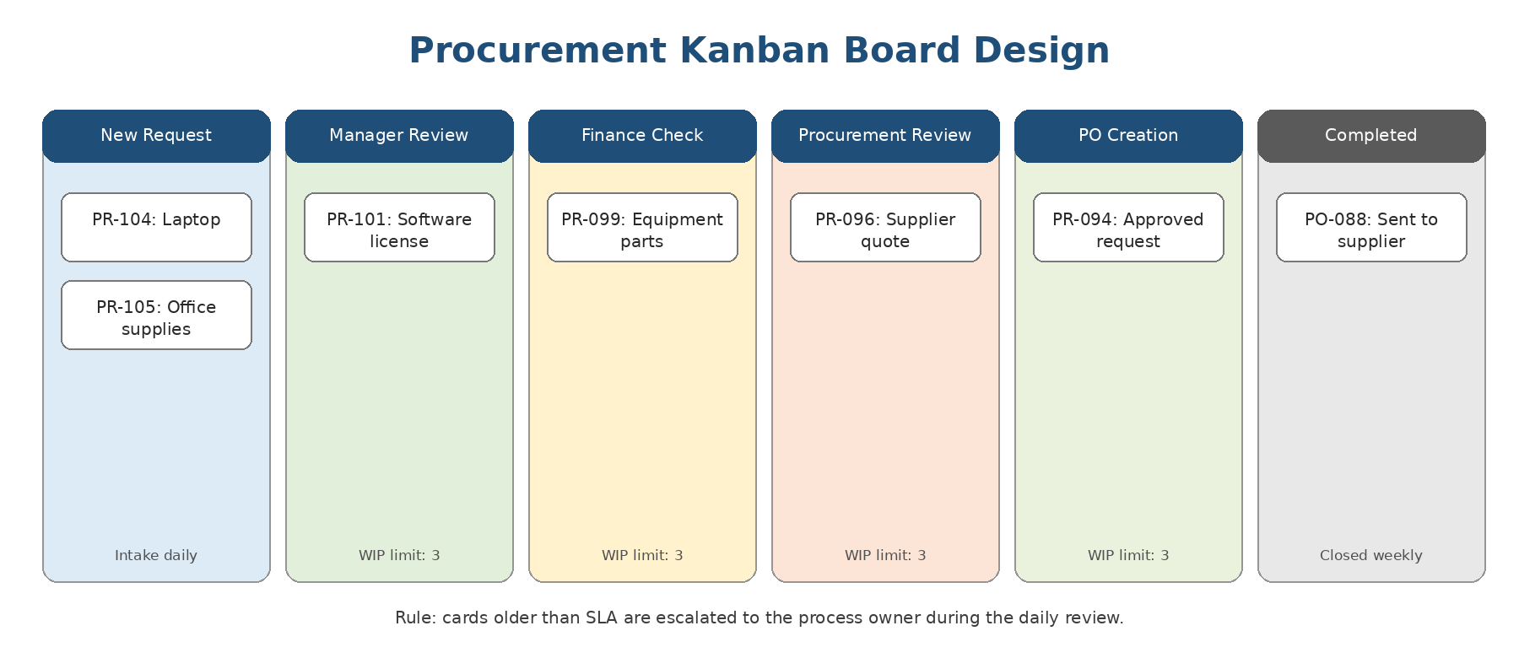
Kanban Rule | Purpose | Control Method
Standard workflow stages | Ensure all requests move through the same visible process. | New Request -> Manager Review -> Finance Check -> Procurement Review -> PO Creation -> Completed.
WIP limits | Prevent too many requests from waiting at one stage. | Limit active cards in Manager Review, Finance Check, and Procurement Review.
SLA aging flags | Highlight requests that exceed the approval deadline. | Use red flag or status tag after 48 hours without action.
Daily review | Keep ownership clear and prevent silent delays. | Procurement checks board every morning and escalates blocked cards.
Closed-card review | Capture lessons and process issues. | Review completed cards weekly for cycle time and rework trends.

8. Step-by-Step Implementation Roadmap
Phase | Action | Owner | Output
Preparation | Confirm stakeholders, collect sample requests, and agree on improvement objectives. | Green Belt Intern / Sponsor | Implementation scope and stakeholder list.
Current-State Review | Run a Value Stream Mapping session and document process waste. | Procurement Team | Current-state map and waste register.
5S Setup | Clean and organize digital procurement documents, templates, and folders. | Procurement / Admin Support | Standardized digital workspace.
Kanban Build | Create board columns, card fields, WIP limits, SLA flags, and ownership rules. | Green Belt Intern / IT Support | Functional Kanban tracker.
Training | Train requesters, managers, finance, and procurement on the new workflow. | Process Owner | Training attendance and user guide.
Pilot | Test the improved process with one department for 2 to 3 weeks. | Procurement / Pilot Department | Pilot KPI results and feedback.
Rollout | Adjust the process based on pilot findings and roll out across departments. | Sponsor / Process Owner | Full implementation plan.
Control | Monitor KPIs weekly and review process adherence monthly. | Process Owner | Control dashboard and audit routine.

9. Training and Change Management Plan
Successful implementation depends on user adoption. The change plan should make the new process simple, practical, and clearly connected to stakeholder benefits. Training should focus on how to submit complete requests, how to approve within SLA, and how to update the Kanban board correctly.
Stakeholder Group | Training Need | Change Management Strategy
Requesters | How to submit complete purchase requests using the standardized form. | Provide a one-page checklist and examples of complete requests.
Managers | How to review requests within SLA and update approval status. | Use reminders, escalation rules, and sponsor support.
Finance Team | How to complete early budget validation and avoid late-stage rejection. | Agree on budget check timing and standard response categories.
Procurement Team | How to manage the Kanban board, apply 5S standards, and monitor KPIs. | Assign tracker ownership and schedule a daily board review.
Senior Sponsor | How to support adoption and remove blockers. | Review weekly KPI summary and intervene on repeated delays.

10. Expected Outcomes and KPI Impact
KPI | Current State | Expected Future State | Operational Impact
Average PO approval cycle time | 7 to 10 business days | 3 to 4 business days | Faster procurement response and fewer supplier delays.
Incomplete request rate | 30% estimated | 15% or lower | Less rework and fewer returned requests.
Manual follow-up emails | 4 to 6 per request | 2 or fewer | Reduced administrative workload.
Approval visibility | Low and email-dependent | 100% tracked on Kanban board | Clearer accountability and status control.
On-time PO approval rate | 40% estimated | 80% or higher | More reliable and predictable procurement service.

11. Potential Challenges and Mitigation Strategies
Challenge | Risk | Mitigation Strategy
Employees do not use the new request form | Incomplete requests continue and rework remains high. | Make key fields mandatory and provide examples of correct submission.
Managers do not update the Kanban board | Board becomes inaccurate and approvals remain hidden. | Use daily reminders, SLA flags, and escalation to process owner.
Finance response remains slow | Budget validation remains a bottleneck. | Move finance check earlier and agree response categories such as approved, revise, or hold.
Stakeholders resist the new workflow | Low adoption reduces improvement impact. | Start with a pilot, explain benefits, and use sponsor support.
Tracker is not maintained | KPI data becomes unreliable. | Assign one process owner and run weekly data quality checks.
Too many requests enter the system at once | Work-in-progress overload causes new delays. | Use WIP limits and priority rules on the Kanban board.

12. Impact Analysis
The three Lean tools work together to improve the procurement process. Value Stream Mapping identifies the largest sources of waiting and rework. 5S improves document discipline and reduces variation in how requests are submitted and processed. Kanban adds visual control, accountability, and early escalation when requests become delayed.
Lean Tool | Primary Benefit | Expected Performance Improvement
Value Stream Mapping | Makes delays, handoff gaps, and rework loops visible. | Reduces non-value-added waiting and supports future-state process design.
5S | Creates a clean and standardized digital procurement workspace. | Reduces searching time, use of outdated forms, and document variation.
Kanban | Tracks all requests by status, owner, and aging. | Improves visibility, SLA compliance, and accountability.
Combined Effect | Connects process redesign, standardization, and workflow control. | Supports sustainable reduction in cycle time, rework, and manual follow-up.

13. Control and Sustainability Plan
Control Activity | Owner | Frequency | Evidence of Control
Review Kanban aging report | Procurement Process Owner | Daily | List of delayed cards and escalations.
Check incomplete request rate | Procurement Team | Weekly | Count of returned or corrected requests.
Audit 5S folder structure and templates | Admin / Process Owner | Weekly | Updated folders, archived old files, and current templates.
Review approval SLA compliance | Sponsor / Managers | Weekly | Percentage of approvals completed within target.
Update KPI dashboard | Green Belt Intern / Process Owner | Weekly during pilot, monthly after rollout | KPI dashboard showing trend data.

14. Conclusion
The implementation of Value Stream Mapping, 5S, and Kanban provides a practical Lean approach for reducing procurement approval delays. The proposed plan focuses on improving flow, reducing rework, standardizing documents, and making request status visible across departments. These tools directly address the major sources of waste identified in the purchase request to purchase order process.
If implemented with proper training, stakeholder support, and KPI monitoring, the improved process can reduce cycle time from 7 to 10 business days to approximately 3 to 4 business days, lower incomplete request rates, and improve operational reliability. The control plan helps ensure that the improvement is sustained beyond the initial pilot.

15. References
American Society for Quality (ASQ). Lean and Six Sigma quality improvement concepts.
Lean Enterprise Institute. Lean thinking, waste reduction, value stream mapping, and visual management concepts.
Project Management Institute. Change management, stakeholder roles, and project implementation planning concepts.

