Week 5 Task
Performance Measurement and Data Analysis
Project Title: Measuring Procurement Purchase Order Approval Performance
Process Area | Procurement purchase request to purchase order process
Methodology | Lean Six Sigma performance measurement framework
Analysis Focus | KPI selection, simulated data, variance analysis, trend analysis, and control chart monitoring
Prepared by | Shaghayegh Haghbin

1. Executive Summary
This report presents a performance measurement and data analysis framework for the procurement purchase request to purchase order process. The selected improvement initiative focuses on reducing purchase order approval delays by using standardized request forms, approval service level agreements, a Kanban tracker, 5S documentation control, and weekly KPI monitoring.
A simulated before-and-after dataset is used to evaluate operational performance. The analysis compares six weeks of baseline performance before implementation with six weeks of post-implementation performance after Lean tools were introduced. The results show measurable improvement in cycle time, request completeness, approval discipline, manual follow-up workload, and on-time purchase order approval rate.
Key Result Summary
The simulated analysis indicates that average purchase order approval cycle time decreased from 8.67 days to 3.27 days, representing a 62.3% reduction. On-time approval increased from 38.2% to 82.5%.

2. Process Overview and Measurement Scope
The process being measured begins when a department submits a purchase request and ends when the approved purchase order is sent to the supplier. This scope allows the analysis to focus on internal procurement speed, request quality, approval visibility, and administrative effort before supplier delivery begins.
Process Step | Measurement Relevance
Purchase request submission | Measures request completeness and accuracy at the start of the process.
Manager approval | Measures approval waiting time and compliance with approval SLA.
Finance budget check | Measures budget approval delay and late-stage rejection risk.
Procurement review | Measures rework caused by missing data, unclear quantities, or supplier issues.
PO creation and release | Measures process completion time and order readiness for supplier action.

In scope: purchase request submission, manager review, finance budget check, procurement review, PO creation, and PO release.
Out of scope: supplier delivery time, contract negotiation, invoice matching, and payment processing. These are excluded so the analysis remains focused on the internal purchase order approval process.

3. KPI Performance Measurement Framework
The selected KPIs are designed to measure process speed, quality, delay, administrative workload, and reliability. Together, they provide a balanced view of operational performance and help determine whether Lean Six Sigma improvements are working.
KPI | Definition | Calculation Method | Target
PO approval cycle time | Average number of business days from request submission to approved PO release. | Sum of approval days / number of requests | 3 business days or less
Incomplete request rate | Percentage of purchase requests submitted with missing or incorrect information. | Incomplete requests / total requests x 100 | 15% or lower
Approval delay rate | Percentage of requests exceeding the expected approval SLA. | Delayed approvals / total requests x 100 | 20% or lower
Manual follow-up emails | Average number of follow-up emails required per purchase request. | Total follow-ups / number of requests | 2 or fewer per request
On-time PO approval rate | Percentage of POs approved within the target cycle time. | On-time approvals / total approvals x 100 | 85% or higher

Why These KPIs Were Selected
These KPIs cover the most important dimensions of procurement performance: speed, quality, delay control, administrative workload, and reliability.

4. Hypothetical Dataset Scenario
The dataset below is hypothetical and is used to simulate process performance before and after Lean tool implementation. Six weeks of baseline data are compared with six weeks of post-implementation data. The simulated improvement reflects the expected effect of standardized request forms, approval SLAs, Kanban visibility, and weekly KPI review.
Week | Phase | Cycle Time  (days) | Incomplete  Rate (%) | Approval Delay  Rate (%) | Follow-ups  /Request | On-Time  Approval (%)
1 | Before | 9.4 | 33 | 49 | 5.6 | 36
2 | Before | 8.9 | 31 | 47 | 5.4 | 38
3 | Before | 8.3 | 30 | 46 | 5.1 | 39
4 | Before | 8.7 | 32 | 48 | 5.5 | 37
5 | Before | 8.1 | 29 | 45 | 5.2 | 41
6 | Before | 8.6 | 31 | 47 | 5.1 | 38
7 | After | 3.8 | 17 | 24 | 2.6 | 72
8 | After | 3.5 | 15 | 21 | 2.2 | 78
9 | After | 3.3 | 14 | 19 | 2.0 | 82
10 | After | 3.1 | 13 | 17 | 1.8 | 85
11 | After | 3.0 | 12 | 15 | 1.6 | 88
12 | After | 2.9 | 11 | 14 | 1.5 | 90

KPI | Before Average | After Average | Improvement
Average PO approval cycle time | 8.67 days | 3.27 days | 62.3% reduction
Incomplete request rate | 31.0% | 13.7% | 55.9% reduction
Approval delay rate | 47.0% | 18.3% | 61.0% reduction
Manual follow-up emails per request | 5.3 | 2.0 | 63.3% reduction
On-time PO approval rate | 38.2% | 82.5% | +44.3 percentage points

5. Statistical Analysis Findings
The analysis uses three practical statistical methods appropriate for a Lean Six Sigma process improvement report: variance analysis, trend analysis, and control chart monitoring. These methods are simple enough for operational teams to maintain and strong enough to highlight whether the process is improving.

5.1 Variance Analysis
Variance analysis compares KPI performance before and after implementation. The main formula used is: ((Before average - After average) / Before average) x 100 for KPIs where lower values are better. For on-time approval rate, the result is shown as a percentage point increase because a higher value is better.
Metric | Before | After | Direction | Interpretation
Cycle time | 8.67 days | 3.27 days | Improved | Approval became faster after standard forms, SLA reminders, and Kanban tracking.
Cycle time variation | SD 0.46 | SD 0.34 | Improved | Lower variation means the process became more predictable.
Incomplete request rate | 31.0% | 13.7% | Improved | Mandatory fields reduced missing information and rework.
Approval delay rate | 47.0% | 18.3% | Improved | Approval SLA and escalation rules reduced waiting.
Manual follow-up emails | 5.3 | 2.0 | Improved | Kanban tracking reduced status-checking emails.
On-time approval rate | 38.2% | 82.5% | Improved | More requests were approved within the target time.

5.2 Trend Analysis
The weekly trend shows that the process improved after the implementation point. Cycle time decreased steadily from high baseline levels to a more stable range below 4 business days. On-time PO approval also increased as process visibility and approval discipline improved.

5.3 Control Chart Analysis
The post-implementation control chart uses the after-period cycle time data. The center line is 3.27 days, the upper control limit is 4.28 days, and the lower control limit is 2.25 days. All post-implementation cycle time values remain within these control limits, which suggests that the improved process is stable in this simulated scenario.
Main Finding
The strongest improvement is in cycle time and on-time approval. This suggests that the Lean tools addressed the main operational issue: excessive waiting and weak visibility in the approval workflow.

6. Visual Analysis and Charts
The following charts provide a visual summary of the simulated analysis. The first chart compares KPI averages before and after implementation. The second chart shows weekly cycle time trends. The third chart shows the control chart for post-implementation cycle time stability. The fourth chart shows the improvement in on-time approval rate.
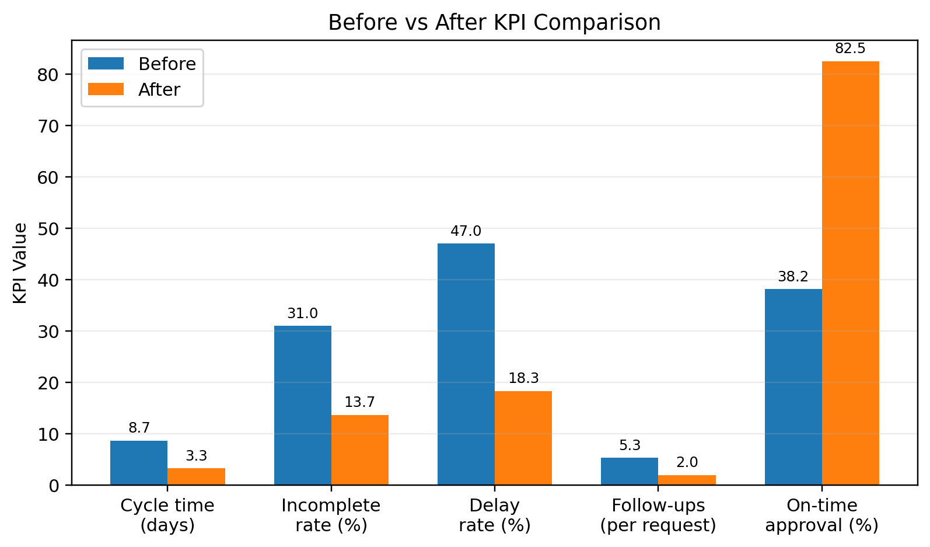
Figure 1. Before vs after KPI comparison.
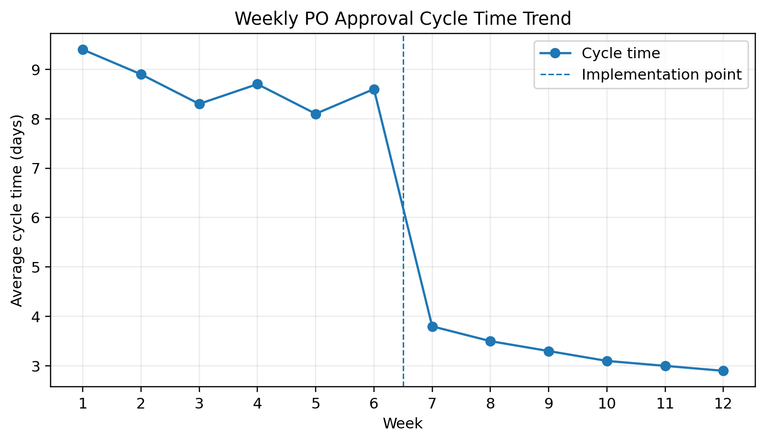
Figure 2. Weekly PO approval cycle time trend.
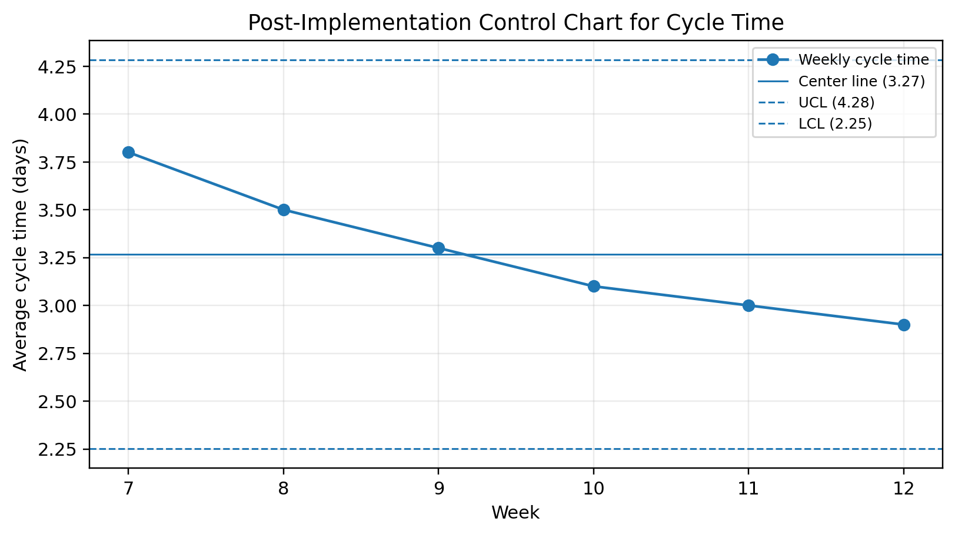
Figure 3. Post-implementation control chart for approval cycle time.
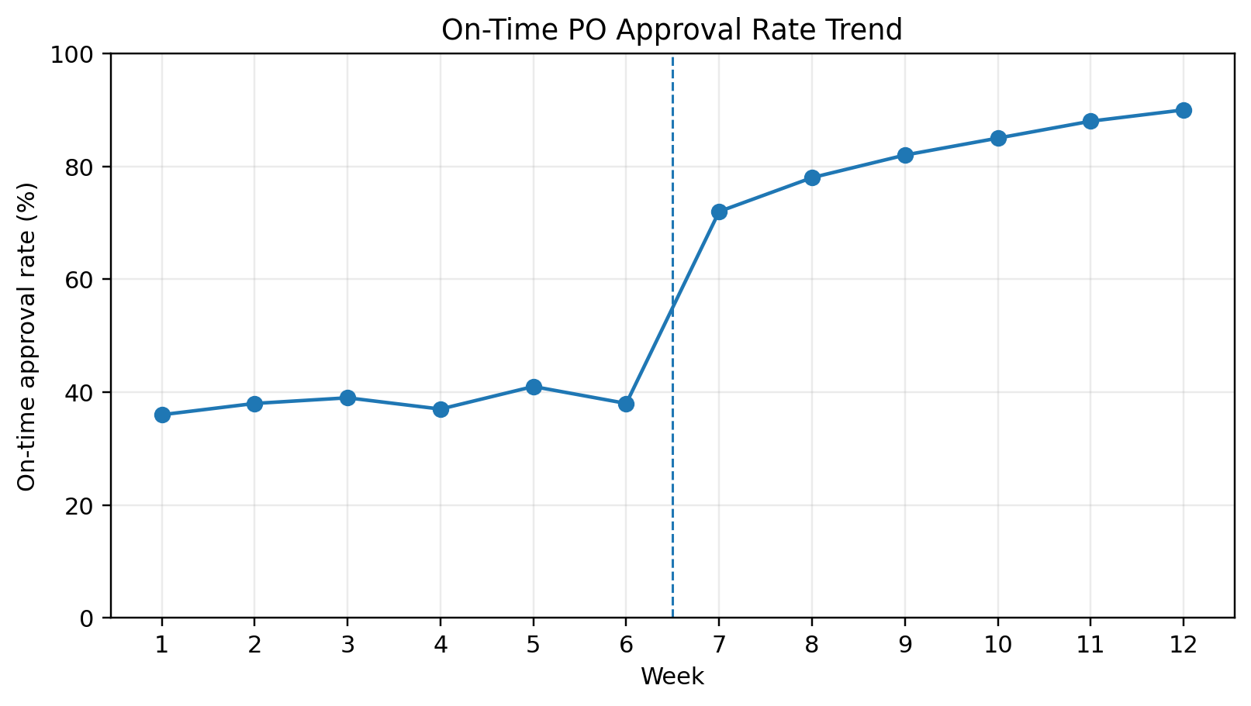
Figure 4. On-time PO approval rate trend.

7. Control Chart Monitoring Method
A control chart should be used after implementation to confirm whether the improved process remains stable over time. The procurement team should update the chart weekly using average PO approval cycle time. If performance stays within the control limits and near the center line, the process is considered controlled. If performance exceeds the upper control limit or shows repeated negative movement, the process owner should investigate the cause.
Control Chart Element | How It Is Used
Data point | Weekly average PO approval cycle time.
Center line | Average post-implementation cycle time.
Upper control limit | Threshold that signals unusually high delay when exceeded.
Lower control limit | Lower expected process boundary; practically limited to zero days.
Response rule | Investigate if a point is outside the limits or if several points show a negative trend.

The control chart is useful because it prevents the team from relying only on one-time improvement results. It supports continuous improvement by showing whether the process stays stable after the pilot period.

8. KPI Dashboard and Continuous Monitoring Plan
The KPI dashboard should be reviewed weekly by procurement and monthly by the project sponsor. The dashboard should highlight whether each KPI is meeting target, approaching risk, or requiring corrective action.
KPI | Latest Simulated Result | Target | Status | Action Required
PO approval cycle time | 2.9 days | 3 days or less | Green | Maintain SLA reminders and weekly tracker review.
Incomplete request rate | 11% | 15% or lower | Green | Keep mandatory fields active in request form.
Approval delay rate | 14% | 20% or lower | Green | Continue escalation for delayed approvals.
Manual follow-up emails | 1.5 | 2 or fewer | Green | Use Kanban board as the main status source.
On-time approval rate | 90% | 85% or higher | Green | Maintain weekly KPI dashboard.

Monitoring Area | Method | Frequency | Owner
PO approval cycle time | KPI dashboard and control chart | Weekly | Procurement Lead
Incomplete request rate | Review rejected or returned request forms | Weekly | Procurement Coordinator
Approval delay rate | Kanban board and SLA tracker | Daily / Weekly | Department Managers
Budget approval bottlenecks | Finance pending approval report | Weekly | Finance Representative
Manual follow-up workload | Email count sample and status tracker review | Monthly | Green Belt Intern / Process Analyst
Overall process health | Monthly KPI review meeting | Monthly | Project Sponsor

9. Insights and Recommendations
The simulated analysis provides clear evidence that the improved procurement process performs better when it is measured consistently. The data shows that Lean tools should not be treated as a one-time activity. They should be supported by weekly dashboards, clear ownership, and control chart monitoring.
- Standardized purchase request forms reduce defects by preventing missing supplier, quantity, budget, and justification details.
- Approval SLAs and escalation rules reduce waiting time by making approval responsibilities visible.
- Kanban tracking reduces manual follow-up emails because stakeholders can see request status without asking procurement for updates.
- 5S documentation control improves the organization of forms, supplier records, approval folders, and KPI files.
- Control charts help the team identify whether performance remains stable after the improvement pilot.
Recommendation | Priority | Expected Operational Benefit
Continue weekly KPI reviews for the first three months after implementation. | High | Sustains improvement and catches early signs of process drift.
Assign one process owner responsible for maintaining the dashboard and Kanban tracker. | High | Improves accountability and data reliability.
Use mandatory fields in the digital request form for budget code, supplier, quantity, delivery date, and justification. | High | Reduces incomplete requests and rework.
Review delayed approvals with department managers in monthly performance meetings. | Medium | Strengthens approval discipline and reduces bottlenecks.
Consider future automation if manual workload remains high after the pilot. | Medium | Supports scalability once the basic process is stable.

10. Conclusion
This Week 5 report demonstrates how performance measurement and data analysis can support Lean Six Sigma process improvement. By selecting relevant KPIs, using a hypothetical pre- and post-implementation dataset, and applying variance analysis, trend analysis, and control chart monitoring, the procurement team can evaluate whether improvements are producing measurable results.
The simulated results show that the procurement purchase order approval process can become faster, more predictable, and more reliable when Lean tools are supported by a structured performance measurement framework. The recommended monitoring plan will help sustain the gains and encourage continuous improvement across the procurement workflow.

11. References
American Society for Quality (ASQ). Lean Six Sigma and quality improvement resources.
Lean Enterprise Institute. Lean concepts including value, waste reduction, value stream mapping, and continuous improvement.
George, M. L. (2002). Lean Six Sigma: Combining Six Sigma Quality with Lean Production Speed. McGraw-Hill.
Montgomery, D. C. (2019). Introduction to Statistical Quality Control. Wiley.

Appendix A: KPI Formula Summary
KPI | Formula
PO approval cycle time | Approval completion date - request submission date
Incomplete request rate | (Incomplete requests / total requests) x 100
Approval delay rate | (Requests exceeding SLA / total requests) x 100
Manual follow-up emails per request | Total follow-up emails / total requests
On-time PO approval rate | (POs approved within target time / total POs) x 100
Percentage reduction | ((Before average - After average) / Before average) x 100

