Week 6 Task
Continuous Improvement and Sustainability
Sustaining Lean Six Sigma Improvements in the Procurement Purchase Order Process
Prepared by | Shaghayegh Haghbin
Process selected | Procurement purchase request to purchase order process
Improvement focus | Sustaining reduced approval delays, improved visibility and lower rework
Frameworks used | PDCA, DMAIC Control, KPI monitoring, feedback loops and standard work
Final Sustainability Report
Lean Six Sigma Green Belt

1. Executive Summary
This report presents a continuous improvement and sustainability plan for the procurement purchase request to purchase order process. The previous Lean Six Sigma work identified delays caused by incomplete requests, email-based approvals, late budget checks, limited status visibility and inconsistent KPI tracking. The sustainability plan focuses on making the improved process part of daily work through standard work, governance, KPI dashboards, feedback loops, employee training and periodic process reviews.
The goal is to preserve the improvements achieved through standardized request forms, approval service level agreements, Kanban tracking, 5S documentation controls and performance measurement. This plan also provides mechanisms for detecting performance drift, capturing feedback, prioritizing future improvements and keeping employees engaged in continuous improvement.
Sustainability objective
Maintain a stable procurement process where purchase orders are approved within 3 business days, incomplete request rates remain below 15 percent, and all active requests are visible through the tracking system.

Document Structure
Section | Purpose
Process overview | Summarizes the procurement process and the original operational problem.
Continuous improvement framework | Explains how PDCA and DMAIC Control will guide ongoing improvement.
Sustainability plan | Defines governance, monitoring, training, feedback and standard work actions.
Monitoring and feedback | Shows how performance data and employee input will be translated into action.
Change management and roadmap | Provides practical actions to sustain adoption over time.

2. Process Overview and Improvement Context
The selected process covers the flow from a department identifying a purchasing need to the point where the approved purchase order is sent to the supplier. This process is important because delays in purchase order approval can slow down operations, affect supplier coordination and create unnecessary administrative follow-up.
Process Stage | Main Activity | Sustainability Focus
Request submission | Employee submits a purchase request using the standard form. | Ensure required fields prevent missing details.
Manager approval | Department manager reviews business need and urgency. | Maintain approval SLA and escalation rules.
Finance budget check | Finance validates budget availability before procurement sourcing. | Keep budget review early in the process.
Procurement review | Procurement confirms supplier, quantity, pricing and compliance details. | Use 5S document structure and supplier data control.
PO creation and release | Approved request is converted into a purchase order and sent to supplier. | Monitor cycle time and data accuracy.

Original Problem and Improvement Baseline
Problem Area | Baseline Issue | Lean Improvement Introduced
Cycle time | Purchase orders were taking 7 to 10 business days to approve. | Approval SLAs, Kanban visibility and weekly KPI review.
Request quality | Incomplete purchase requests caused rework and clarification emails. | Mandatory digital form fields and standardized submission guidance.
Approval visibility | Requests were difficult to track when handled by email. | Visual Kanban tracker with status ownership.
Budget review | Finance validation occurred late, causing wasted procurement effort. | Earlier budget validation in the workflow.
Process control | Performance was not consistently monitored. | KPI dashboard, control chart and monthly review cadence.

3. Continuous Improvement Framework
The sustainability framework combines the PDCA cycle with the Control phase of DMAIC. PDCA provides an ongoing rhythm for testing and standardizing improvements, while DMAIC Control ensures that the process remains measurable, stable and owned by the right stakeholders.
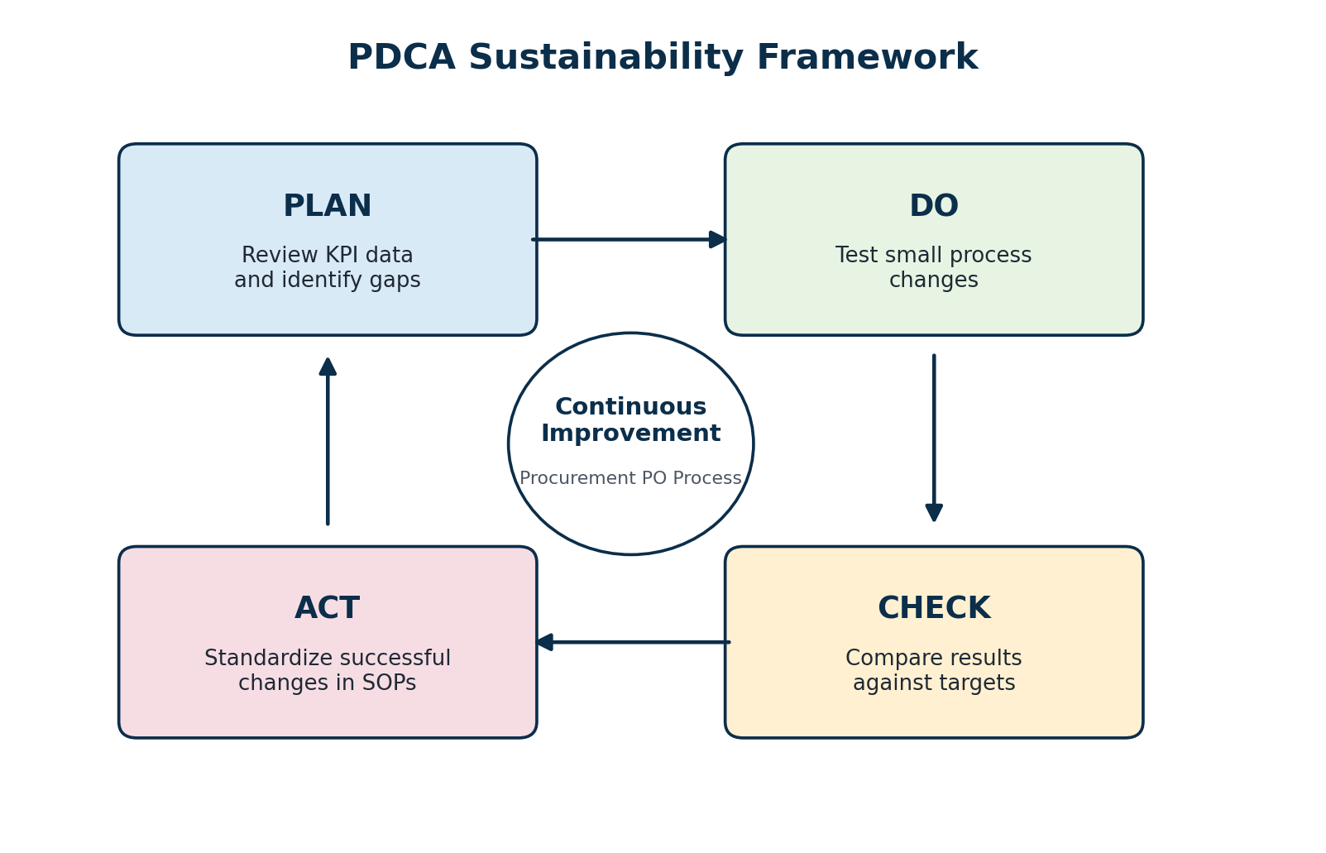
Figure 1. PDCA framework applied to the procurement purchase order process.
Framework Element | How It Will Be Used | Expected Output
Plan | Review KPI trends, employee feedback and recurring bottlenecks. | Prioritized improvement opportunities.
Do | Pilot practical changes such as revised request fields, reminder rules or tracker updates. | Tested improvement action.
Check | Compare results against cycle time, incomplete request rate and on-time approval targets. | Evidence of whether the change worked.
Act | Update SOPs, user guides, training materials and ownership rules. | Standardized improved process.
DMAIC Control | Monitor process stability and escalate when performance exceeds tolerance limits. | Sustained control and accountability.

4. Sustainability Governance and Roles
A sustainability plan needs clear ownership. Without defined roles, teams may return to old habits, KPI updates may stop and process issues may not be escalated. The governance model below assigns ownership for daily operation, data monitoring, feedback review and continuous improvement decisions.
Role | Sustainability Responsibility | Review Frequency
Project Sponsor | Reviews overall benefits, removes barriers and approves major changes. | Monthly or as needed
Procurement Process Owner | Owns SOPs, KPI dashboard, Kanban board and process compliance. | Weekly
Procurement Coordinator | Checks request completeness, updates tracker and records rework reasons. | Daily
Department Managers | Approve requests within SLA and respond to escalations. | Daily
Finance Representative | Validates budget early and flags budget-related delays. | Daily to weekly
Employees / Requesters | Submit complete requests and provide feedback on form clarity. | Ongoing
IT or Admin Support | Maintains forms, tracker access and dashboard templates. | Monthly

5. Sustainability Plan
The sustainability plan focuses on the controls that will keep the improved procurement process working after implementation. It covers standard work, KPI monitoring, feedback loops, employee engagement, process audits and documentation updates.
Sustainability Area | Action Plan | Success Indicator
Standard Work | Maintain a controlled SOP for request submission, approval rules, finance review and PO creation. | SOP reviewed quarterly and used in onboarding.
Digital Request Form | Keep mandatory fields for item description, quantity, supplier, budget code, urgency and approver. | Incomplete request rate stays at or below 15 percent.
Approval SLA | Maintain 24 to 48 hour approval expectations with automatic reminders and escalation. | Approval delay rate stays below 20 percent.
Kanban Tracking | Use a shared board with stages from new request to PO sent to supplier. | 100 percent of active requests visible in tracker.
KPI Dashboard | Review cycle time, on-time approval, rework and follow-up metrics weekly. | Dashboard updated every week.
Control Chart | Monitor weekly average PO approval cycle time and investigate out-of-limit signals. | Cycle time remains within control limits.
Employee Training | Provide refresher training and simple user guides for requesters and approvers. | Training completion rate above 90 percent.
Quarterly Audit | Audit sample requests for SLA compliance, form completeness and documentation quality. | Audit findings converted into action items.

Sustainability Control Summary
Control | Trigger for Action | Corrective Response
Cycle time control chart | Weekly average exceeds 4 business days or shows a negative trend. | Investigate bottleneck, review pending approvals and update action log.
Incomplete request monitoring | Incomplete request rate exceeds 15 percent. | Review form fields, retrain requesters and update guidance notes.
Approval delay escalation | Approver does not respond within SLA. | Automated reminder followed by escalation to manager or sponsor.
Kanban data quality check | Tracker fields are missing or status is outdated. | Assign owner to update board and confirm process compliance.

6. Monitoring Mechanisms and KPI Control
Monitoring will ensure that process performance remains visible and that problems are detected before they become repeated delays. The KPI dashboard should be simple enough to maintain, but specific enough to guide corrective action.
Metric | Monitoring Method | Frequency | Owner | Target
PO approval cycle time | Dashboard and control chart | Weekly | Procurement Lead | <= 3 business days
Incomplete request rate | Request form error log | Weekly | Procurement Coordinator | <= 15 percent
Approval delay rate | Kanban tracker aging report | Daily / Weekly | Department Managers | <= 20 percent
Manual follow-up emails | Email log sample review | Monthly | Procurement Team | <= 2 per request
On-time PO approval rate | KPI dashboard | Weekly | Project Sponsor | >= 85 percent
Budget review delay | Finance review aging report | Weekly | Finance Representative | <= 1 business day
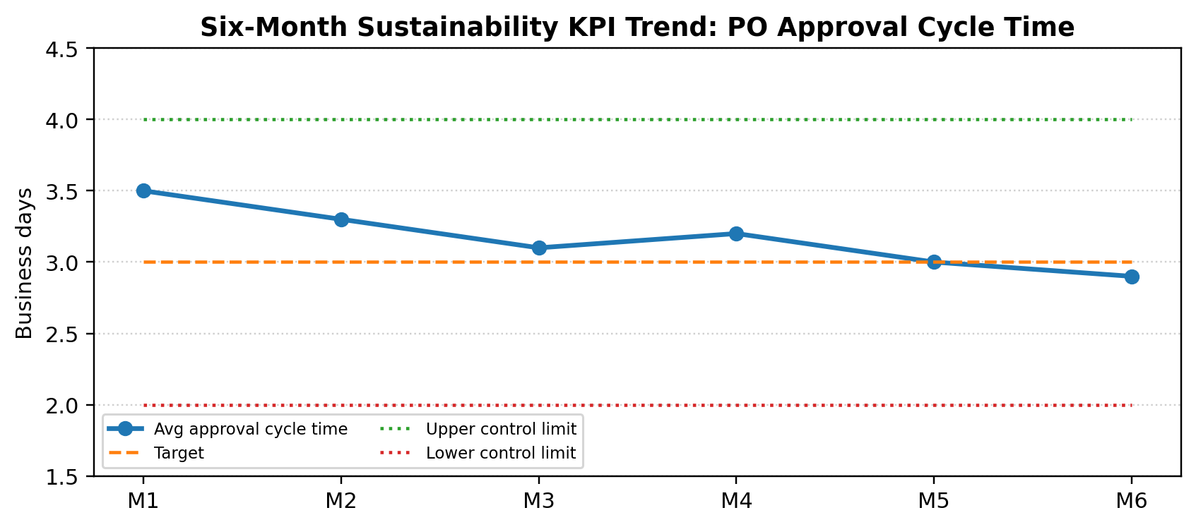
Figure 2. Example sustainability KPI trend for procurement approval cycle time.

Dashboard Interpretation Rules
Signal | Meaning | Required Action
Green | Performance is meeting target and process appears stable. | Continue normal monitoring and share good practices.
Amber | Performance is close to tolerance limit or trending negatively. | Review recent causes and assign short corrective action.
Red | Performance is outside target or control limit. | Escalate to process owner, perform quick RCA and update improvement log.

7. Feedback Loop and Iterative Improvement
Feedback will be collected from employees, approvers, finance and procurement users. The feedback loop converts operational pain points into improvement actions, which are then tested, checked and standardized when successful.
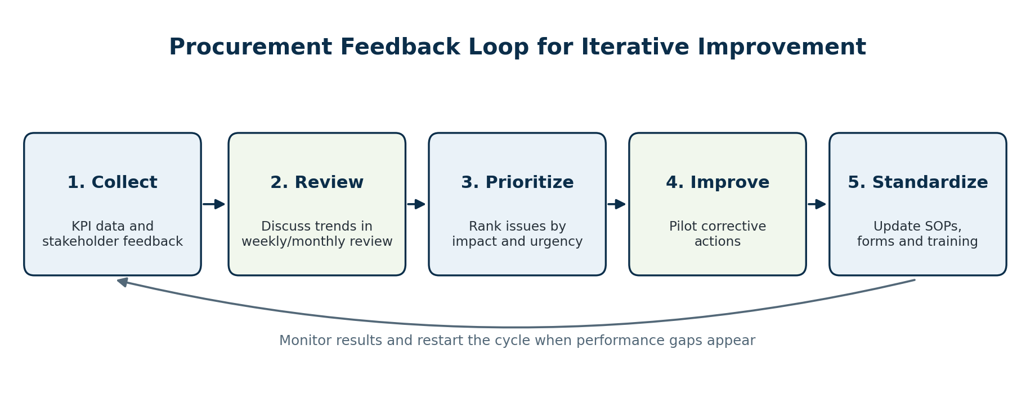
Figure 3. Feedback loop for turning process data and user feedback into improvement actions.
Feedback Source | Collection Method | How It Will Be Used
Requesters | Short monthly survey and comments field in request form | Identify unclear fields, repeated missing information and usability issues.
Managers | Monthly review meeting and approval aging discussion | Identify approval workload issues and SLA challenges.
Finance Team | Budget review exception report | Identify budget code issues and common reasons for delayed finance checks.
Procurement Team | Weekly process huddle | Capture rework reasons, supplier data gaps and tracker issues.
KPI Dashboard | Weekly review of trend and control data | Identify performance drift and recurring bottlenecks.

Improvement Backlog Management
Backlog Category | Examples | Prioritization Criteria
Form improvements | Add clearer budget code guidance or supplier selection fields. | Rework reduction and ease of implementation.
Approval improvements | Adjust reminder timing or escalation rules. | Impact on cycle time and stakeholder acceptance.
Training needs | Short refresher guides for requesters and approvers. | Frequency of user errors and audit findings.
Automation opportunities | Automated dashboard refresh or system integration. | Cost, effort, risk and long-term benefit.

8. Employee Engagement and Training Plan
Sustained Lean Six Sigma improvement depends on employee participation. Employees must understand why the process changed, how to follow the improved workflow and how their feedback contributes to better performance.
Audience | Training or Engagement Activity | Purpose | Frequency
Employees / Requesters | 15-minute request form training and one-page user guide. | Reduce incomplete requests and rework. | Onboarding and quarterly refresher
Department Managers | Approval SLA briefing and escalation rule guide. | Reduce waiting time and delayed approvals. | Quarterly
Finance Team | Budget review alignment session. | Keep budget validation early and consistent. | Quarterly
Procurement Team | Kanban, dashboard and SOP ownership training. | Maintain tracker quality and process control. | Monthly during first quarter, then quarterly
All Stakeholders | Monthly improvement review and recognition of compliant teams. | Build continuous improvement culture. | Monthly

Engagement Tactics
- Make the new process easy to follow by using required fields, clear examples and simple submission guidance.
- Share KPI wins, such as reduced cycle time or fewer incomplete requests, so teams can see the value of the improvement.
- Recognize departments that consistently submit complete requests and approve within SLA.
- Use short monthly review meetings to collect improvement ideas instead of waiting for large problems to occur.

9. Change Management and Risk Mitigation
The main sustainability risk is that employees and approvers return to informal email habits. The change management plan below focuses on practical controls that make the improved process easier to follow than the old process.
Change Risk | Potential Impact | Mitigation Strategy
Employees bypass the digital form | Missing information and rework return. | Make the form the only accepted request channel and provide quick guidance.
Managers delay approvals | Cycle time increases and supplier orders are delayed. | Use reminders, escalation and manager-level KPI visibility.
Tracker is not updated | Status visibility becomes unreliable. | Assign daily tracker owner and check aging report during weekly huddle.
KPI review becomes inconsistent | Performance drift is not detected early. | Schedule recurring dashboard review with process owner and sponsor.
SOP becomes outdated | Teams follow different process versions. | Review SOP quarterly and store one controlled version.
Stakeholders resist change | Low adoption and informal workarounds. | Explain benefits, share results and collect feedback during pilot reviews.

Escalation Path
Trigger | First Response | Escalation
Request incomplete | Procurement returns request with missing-field checklist. | Repeated issue is discussed in requester training.
Approval exceeds SLA | Automated reminder to approver. | Escalate to department manager and process owner.
Budget check delayed | Finance receives exception notification. | Escalate to finance representative and project sponsor.
KPI outside control limit | Process owner performs quick root cause check. | Monthly review assigns corrective action and due date.

10. Lessons Learned Integrated from Previous Project Work
The sustainability approach builds on the outputs from the earlier Lean Six Sigma tasks. Each previous activity contributes a practical control that supports long-term improvement.
Previous Task / Method | Key Lesson Learned | How It Supports Sustainability
Process Mapping | The workflow must be visible before waste can be reduced. | The updated process map becomes part of SOP training and audit review.
Root Cause Analysis | Delays were caused by process design issues, not only individual behavior. | Controls focus on standard forms, SLAs and early budget checks.
DMAIC Project Planning | Improvement work needs clear scope, roles, timeline and KPIs. | Governance and review cadence keep ownership clear.
Lean Tools Implementation | 5S, Kanban and Value Stream Mapping improve organization and visibility. | These tools remain part of daily management.
Performance Measurement | KPI trends and control charts reveal whether improvements are sustained. | Dashboard review triggers timely corrective action.

11. Continuous Improvement Roadmap
The roadmap defines the operating rhythm for sustaining the procurement improvement. It ensures that performance is reviewed frequently, feedback is captured regularly and larger improvement decisions are made using evidence.
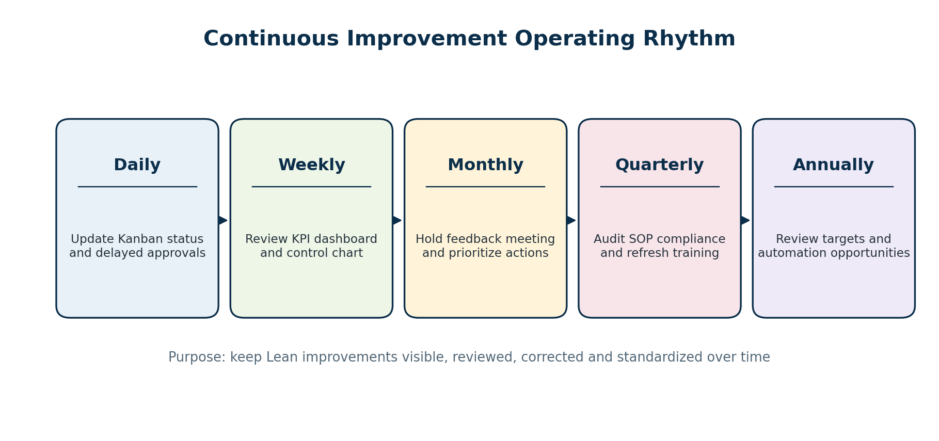
Figure 4. Operating rhythm for sustaining continuous improvement in procurement.
Timeframe | Activity | Deliverable
Daily | Update Kanban board, review overdue approvals and follow up on urgent blockers. | Accurate live tracker and reduced waiting.
Weekly | Review KPI dashboard, control chart and delayed request aging report. | Weekly action log for performance gaps.
Monthly | Hold stakeholder feedback meeting and review improvement backlog. | Prioritized improvement actions.
Quarterly | Audit SOP compliance, form completeness, SLA performance and training needs. | Audit findings and SOP updates.
Every 6 months | Reassess KPI targets, resource needs and automation opportunities. | Updated improvement roadmap.
Annually | Review overall benefits, lessons learned and next Lean Six Sigma opportunities. | Annual sustainability review report.

12. Expected Long-Term Benefits
Benefit Area | Expected Long-Term Result
Faster approvals | Purchase orders consistently approved within the target of 3 business days.
Lower rework | Incomplete purchase requests reduced through required fields and user guidance.
Better visibility | Stakeholders can see request status through the Kanban board instead of relying on email follow-up.
Stronger accountability | Managers, finance and procurement owners understand their responsibilities and SLA expectations.
Sustained process control | KPI dashboards and control charts help detect performance drift early.
Continuous improvement culture | Employees contribute feedback and improvement ideas through regular review cycles.

13. Conclusion
This continuous improvement and sustainability plan provides a structured approach for maintaining Lean Six Sigma improvements in the procurement purchase order process. The plan ensures that performance gains are not treated as a one-time project outcome, but are embedded into daily operations through standard work, process ownership, KPI monitoring, control charts, feedback loops and periodic audits.
By maintaining a clear PDCA rhythm, engaging employees, updating SOPs and reviewing dashboard data regularly, the organization can sustain reduced approval delays, lower rework and improved procurement visibility. The long-term success of the project will depend on consistent ownership, practical training and the discipline to use performance data as the basis for continuous improvement decisions.

14. References and Public Resources
- American Society for Quality (ASQ). Plan-Do-Check-Act (PDCA) Cycle overview.
- American Society for Quality (ASQ). Control chart and process monitoring concepts.
- Lean Enterprise Institute. Lean thinking, standardized work and continuous improvement resources.
- iSixSigma. DMAIC, control phase and process improvement guidance.

