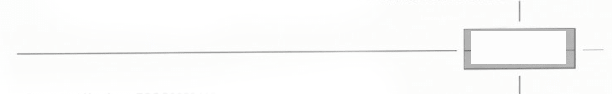
Certificate of Motor Insurance Munster
Motor insurance

- Document Number
- Description of Vehicle
- Name of Policyholder
- Effective Date of the Commencement of Insurance
for the purpose of the Acts
- Date of expiry of Insurance
MIDNIGHT:
- Person or Classes of Persons entitled to drive as defined below
D- Any person who is driving with the document holder's consent
Provided that the person driving holds a licence to drive the Vehicle or has held and is not disqualified from holding or obtaining such a licence.
- Limitations to use as defined below
Use only for Private Hire meaning the conveyance of passengers for hire or reward
Use for social, Domestic, and Pleasure purposes only
- The policy does not cover
Carriage of passenger for hire and/or reward
Racing, pace-setting, speed trials, motor rallies, competitions or trials
In connection with the motor trade
Towing for reward a mechanically propelled vehicle
Semi-Trailer being part of an articulated vehicle
I hereby certify that the Document to which this Certificate relates satisfies the requirements of the relevant law applicable in Great Britain, Northern Ireland, the Isle of Man, the Island of Guernsey, the Island of Jersey and the Island of Alderney.

Munster Motor Insurance
Thomond Parc House
Limerick
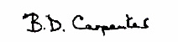

Underwriter
Advice to Third Parties
Nothing contained in this certificate affects your right as Third Party to make a claim.
NOTE: YOU SHOULD REFER TO YOUR POLICY FOR FULL DETAILS OF YOUR INSURANCE COVER

