Smart Parking Platform Project Management Plan
Homework 1
1. Existing Software Landscape Research
ParkMobile
Overview
ParkMobile is a mobile parking application that lets users locate, reserve, and pay for parking spaces through a smartphone app.
Strengths
- Easy mobile payments
- Large user base
- Supports reservations
Weaknesses
- Limited real-time occupancy information
- Availability varies by city

SpotHero
Overview
SpotHero enables drivers to find and reserve parking spaces before arriving at a destination.
Strengths
- Strong reservation functionality
- Extensive parking network
Weaknesses
- Focused mainly on major cities
- Limited occupancy analytics

BestParking
Overview
BestParking helps users compare parking rates and locate nearby parking facilities.
Strengths
- Price comparison tools
- Wide geographic coverage
Weaknesses
- Limited management features for operators
- Few reporting capabilities

How Our Application Will Be Different
The Smart Parking Platform will include:
- Real-time occupancy tracking
- Interactive availability maps
- Parking occupancy forecasting
- Dynamic pricing recommendations
- Enhanced operator dashboards
- Advanced analytics and reporting
- Reservation reminders and notifications
- Navigation integration

2. Vision and Scope
Project Acquisition
WE ARE $oftware Corp. was contracted by a consortium of parking facility operators and city transportation stakeholders seeking a modern parking management solution. The goal is to reduce time spent searching for parking while improving parking facility management.

Company Background
WE ARE $oftware Corp. is a fictional software development company specializing in web and mobile applications. For this academic project, the company has unlimited development resources and budget.

Vision Statement
The vision of the Smart Parking Platform is to create convenient, efficient, and intelligent parking experience for drivers while providing operators with powerful management and reporting tools.

Project Overview
The Smart Parking Platform will provide:
- Mobile application
- Web application
- Real-time parking availability
- Parking reservations
- Digital payment processing
- Notifications and alerts
- Administrative dashboards
- Analytics and reporting

Scope
In Scope
- User registration
- Authentication
- Parking search
- Real-time parking availability
- Reservations
- Payments
- Receipts
- Notifications
- Operator dashboards
- Reports and analytics
Out of Scope
- Parking hardware installation
- Vehicle maintenance services
- Traffic law enforcement
- Autonomous vehicle parking

3. Software Requirements Specification (SRS) Draft
Purpose
The purpose of this system is to help drivers locate, reserve, navigate to, and pay for parking spaces while allowing parking operators to manage occupancy and revenue.
Actors
- Driver
- Parking Operator
- System Administrator
- Finance Personnel
- Payment Provider

Use Cases
UC-01 User Registration
Actor: Driver
Description: Create a new account.
UC-02 User Login
Actor: Driver
Description: Log in to the system.
UC-03 Password Reset
Actor: Driver
Description: Reset a forgotten password.
UC-04 Search for Parking Locations
Actor: Driver
Description: Search for nearby parking.
UC-05 View Availability
Actor: Driver
Description: View of available parking spaces.
UC-06 Reserve Parking Space
Actor: Driver
Description: Reserve a parking space.
UC-07 Modify Reservation
Actor: Driver
Description: Change reservation details.
UC-08 Cancel Reservation
Actor: Driver
Description: Cancel reservation.
UC-09 Navigate to Location
Actor: Driver
Description: Receive directions to a parking facility.
UC-10 Process Payment
Actor: Driver
Description: Pay for parking electronically.
UC-11 Receive Receipt
Actor: Driver
Description: Receive a digital receipt after payment.
UC-12 Receive Notifications
Actor: Driver
Description: Receive reminders and alerts.
UC-13 Manage Parking Inventory
Actor: Parking Operator
Description: Add and update parking spaces.
UC-14 Monitor Occupancy
Actor: Parking Operator
Description: View occupancy in real time.
UC-15 Generate Reports
Actor: Parking Operator
Description: Create utilization and revenue reports.
UC-16 Dynamic Pricing
Actor: Parking Operator
Description: Adjust pricing based on demand.
UC-17 Manage User Accounts
Actor: System Administrator
Description: Manage system users.
UC-18 Payment Reconciliation
Actor: Finance Personnel
Description: Verify payment transactions.
UC-19 Predict Availability
Actor: Driver
Description: View expected future parking availability.
UC-20 Audit Logs
Actor: System Administrator
Description: Review system activity logs.

Homework 2 Section

4. Work Breakdown Structure (WBS)

1.0 Smart Parking Platform Project

1.1 Project Management

1.1.1 Project Charter
- Define project objectives
- Define stakeholders
- Obtain approval

1.1.2 Planning
- Create schedule
- Develop risk plan
- Develop communication plan

1.1.3 Monitoring & Control
- Weekly status reviews
- Progress tracking
- Change management

1.2 Requirements & Design

1.2.1 Requirements Gathering
- Stakeholder interviews
- Surveys
- Requirement documentation

1.2.2 System Design
- Architecture design
- Database design
- API design

1.2.3 UI/UX Design
- Mobile wireframes
- Web wireframes
- Dashboard mockups

1.3 Authentication Module

1.3.1 User Registration
- Create account
- Email verification
- Password validation

1.3.2 Login
- Username/password login
- MFA support
- Session management

1.3.3 Account Recovery
- Password reset
- Account unlock

1.4 Parking Management Module

1.4.1 Parking Search
- Search nearby garages
- Filter results
- View parking details

1.4.2 Availability Tracking
- Real-time updates
- Occupancy monitoring
- Availability forecasting

1.4.3 Reservation System
- Create reservation
- Modify reservation
- Cancel reservation

1.5 Payment Module

1.5.1 Payment Processing
- Credit card payments
- Digital wallet payments
- Transaction verification

1.5.2 Billing
- Receipt generation
- Refund processing
- Payment history

1.5.3 Financial Reporting
- Revenue summaries
- Transaction reports

1.6 Operator Dashboard

1.6.1 Garage Management
- Add garage
- Edit garage
- Remove garage

1.6.2 Occupancy Monitoring
- Real-time occupancy
- Capacity management

1.6.3 Pricing Management
- Set pricing
- Dynamic pricing

1.7 Reporting & Analytics

1.7.1 Occupancy Reports
- Daily reports
- Weekly reports
- Monthly reports

1.7.2 Revenue Reports
- Revenue summaries
- Financial exports

1.7.3 Analytics Dashboard
- Utilization metrics
- Forecasting

1.8 Testing & Deployment

1.8.1 Testing
- Unit testing
- Integration testing
- Security testing

1.8.2 User Acceptance Testing
- Stakeholder review
- Issue tracking

1.8.3 Deployment
- Production deployment
- Monitoring
- Support

5. Project Timeline
Week | Activity
1 | Project Charter & Stakeholders
2 | Research & Competitive Analysis
3 | Requirements Gathering
4 | Vision and Scope Finalization
5 | WBS Development
6 | Schedule & Gantt Chart
7 | System Architecture
8 | UI/UX Design
9 | Backend/API Planning
10 | Payment Integration Planning
11 | Security Planning
12 | Quality Assurance Planning
13 | Risk Management
14 | Communication Plan
15 | Final Project Review
16 | Final Submission

Milestones

Project Milestones

Milestone 1
Project Initiation Complete
- Week 2

Milestone 2
Requirements Approved
- Week 5

Milestone 3
Architecture Complete
- Week 8

Milestone 4
Testing Plan Complete
- Week 12

Milestone 5
Final Project Document Complete
- Week 16

Gantt Chart
Task | W1 | W2 | W3 | W4 | W5 | W6
Competitive Analysis Research | X | X
Vision & Scope Development |  | X | X
SRS & Use Cases |  | X | X
Work Breakdown Structure (WBS) |  |  | X
Project Timeline Development |  |  | X | X
System Design & Architecture |  |  |  | X | X
UI/UX Planning |  |  |  | X | X
Payment Integration Planning |  |  |  |  | X
Security Planning |  |  |  |  | X
Testing Strategy |  |  |  |  |  | X
Final Documentation Updates |  |  |  |  |  | X

Homework 3
8.1 Product Backlog
The Product Backlog contains all features identified for the Smart Parking Platform. Features were organized into Login, User Interface, Backend Services, and Reporting categories.
Login
- User Registration
- User Login
- Password Reset
- Multi-Factor Authentication
- Session Management
UI
- Driver Dashboard
- Operator Dashboard
- User Profile
- Edit Profile
- Parking Search
- Map View
- Garage Details
- Reservation Screen
- Reservation History
- Payment Screen
- Receipt Screen
- Notifications
- Garage Management
- Occupancy Dashboard
- Pricing Management
Backend
- User Authentication Service
- Account Management
- Parking Availability Service
- Reservation Processing
- Reservation Cancellation
- Inventory Management
- Payment Gateway Integration
- Payment Validation
- Receipt Generation
- Notification Service
- Occupancy Monitoring
- Analytics Collection
- Report Generation
- Role-Based Access Control
- Audit Logging
Reporting
- Daily Occupancy Report
- Weekly Occupancy Report
- Monthly Occupancy Report
- Revenue Report
- Reservation Report
- Cancellation Report
- Peak Usage Report
- Utilization Report
- User Activity Report
- Financial Export Report

8.2 Sprint 1 Backlog
Sprint 1 focuses on core user functionality required for initial platform operation.
- User Registration
- User Login
- Password Reset
- Driver Dashboard
- Parking Search
- Map View
- User Authentication Service
- Account Management
- Parking Availability Service
- Reservation Processing
- Notification Service

8.3 Trello Board
Figure 2. Smart Parking Platform Product Backlog and Sprint 1 Backlog

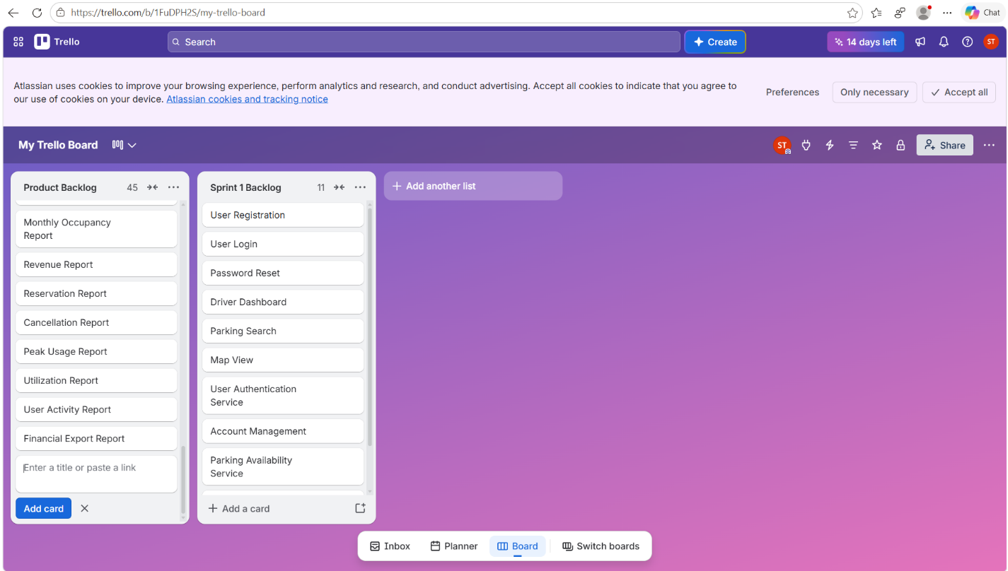

Homework 4

9. Risk Management Plan

9.1 Risk Categories

Technical Risks
- Third-party API failure (mapping or payment services)
- Real-time parking data inaccuracies
- Security vulnerabilities and data breaches
- System performance issues under high user load

Schedule Risks
- Delays in requirements gathering
- Integration testing takes longer than planned
- Stakeholder feedback delays
- Scope creep increases project duration

Financial Risks
- Unexpected cloud infrastructure costs
- Third-party service fee increases
- Additional security compliance costs
- Cost overruns from additional project requirements

People Risks
- Key team member unavailable
- Communication breakdown between teams
- Lack of stakeholder engagement
- Insufficient testing resources

9.2 Risk Register
Use this directly in Word:
ID | Risk Description | Probability | Impact | Owner | Response Strategy | Status
R1 | Payment API Failure | Medium | High | Payment Team | Backup payment provider | Open
R2 | Mapping Service Outage | Medium | High | Mapping Team | Secondary map provider | Open
R3 | Real-Time Data Delay | High | Medium | Backend Team | Monitoring and optimization | Open
R4 | Security Breach | Low | Very High | Security Team | Security audits and encryption | Open
R5 | Scope Creep | High | High | Project Manager | Change control process | Open
R6 | Delayed Testing | Medium | High | QA Team | Early testing schedule | Open
R7 | Stakeholder Feedback Delays | Medium | Medium | Project Manager | Scheduled reviews | Open
R8 | Key Team Member Loss | Low | High | Project Manager | Cross-training | Open
R9 | Cloud Service Downtime | Low | High | Infrastructure Team | Redundant hosting | Open
R10 | Cost Estimate Changes | Medium | Medium | Finance Team | Budget reserve planning | Open

10. Communication Plan

Purpose
The Communication Plan defines how project stakeholders and team members will communicate throughout the Smart Parking Platform project.

Team Meeting Cadence
Team | Meeting Type | Frequency
Project Management | Status Meeting | Weekly
Mobile Development Team | Scrum Meeting | Daily
Web Development Team | Scrum Meeting | Daily
Backend/API Team | Scrum Meeting | Daily
Mapping Team | Technical Review | Weekly
Payment Team | Integration Review | Weekly
QA Team | Testing Review | Weekly
Stakeholders | Progress Review | Bi-Weekly

Reporting Methods

Weekly Status Reports
Used to communicate:
- Progress
- Risks
- Issues
- Upcoming work

Stakeholder Presentations
Provided every two weeks and include:
- Project status
- Milestone progress
- Risk updates

Project Repository
GitHub serves as the primary documentation repository.

Video Updates
Weekly stakeholder videos summarize completed work and upcoming activities.

