CS23532-COMPUTER NETWORKS-LAB MANUAL
PRACTICAL – 9

AIM:
To design and implement multiple subnets in Cisco Packet Tracer, assign static IP addresses to devices, connect the subnets using a router, and simulate packet transmission to observe communication with and without a router.

PROCEDURE:
- Create the Network Topology:
  - Open Cisco Packet Tracer.
  - Place the following devices:
  - 1 Router — Cisco 2911
  - 2 Switches — Cisco 2960
  - 4 PCs
  - Connect the devices

- Create the subnets:
The network 192.168.10.0/24 was divided into two /25 subnets.
Subnet 1
- Network Address: 192.168.10.0
- Subnet Mask: 255.255.255.128
- Usable IP Range: 192.168.10.1 – 192.168.10.126
- Broadcast Address: 192.168.10.127
Subnet 2
- Network Address: 192.168.10.128
- Subnet Mask: 255.255.255.128
- Usable IP Range: 192.168.10.129 – 192.168.10.254
- Broadcast Address: 192.168.10.255
- Assign Static IP Addresses:

Configure the PCs through:

PC → Desktop → IP Configuration

- Configure the Router:
Open:
Router0 → CLI
Command prompt:
enable
configure terminal
interface gigabitEthernet 0/0
ip address 192.168.10.1 255.255.255.128
no shutdown
exit
interface gigabitEthernet 0/1
ip address 192.168.10.129 255.255.255.128
no shutdown
exit
end
show ip interface brief
Outcome:
GigabitEthernet0/0 192.168.10.1 up up
GigabitEthernet0/1 192.168.10.129 up up

- Test Communication Between Different Subnets:
Open:
PC0 → Desktop → Command Prompt
Command:
ping 192.168.10.130
Outcome:
Packets: Sent = 4
Received = 4
Lost = 0
- Test Communication Within Subnet 2:
Open:
PC2 → Desktop → Command Prompt
Command:
ping 192.168.10.140
Outcome:
Packets: Sent = 4
Received = 4
Lost = 0
- Simulate Packet Transmission:
- Switch from Realtime mode to Simulation mode.
- Select Add Simple PDU.
- Click PC0 and then PC2.
- Click Auto Capture / Play.
- Observe the packet travelling through:
- PC0 → Switch0 → Router0 → Switch1 → PC2

- Test Communication Without the Router:
- Return to Realtime mode.
- Disconnect the cable between Switch0 and Router0.
- Do not delete the router or switches.
- From PC0 → Desktop → Command Prompt : ping 192.168.10.130
Outcome:
Packets: Sent = 4
Received = 0
Lost = 4

SCREENSHOTS:

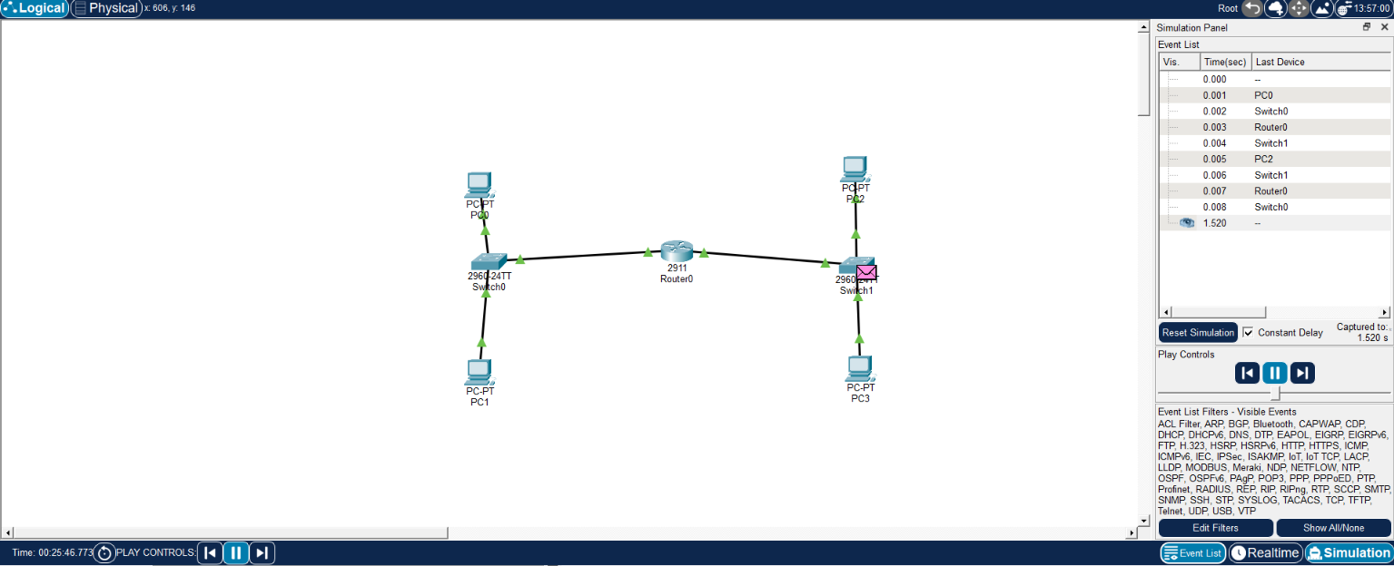
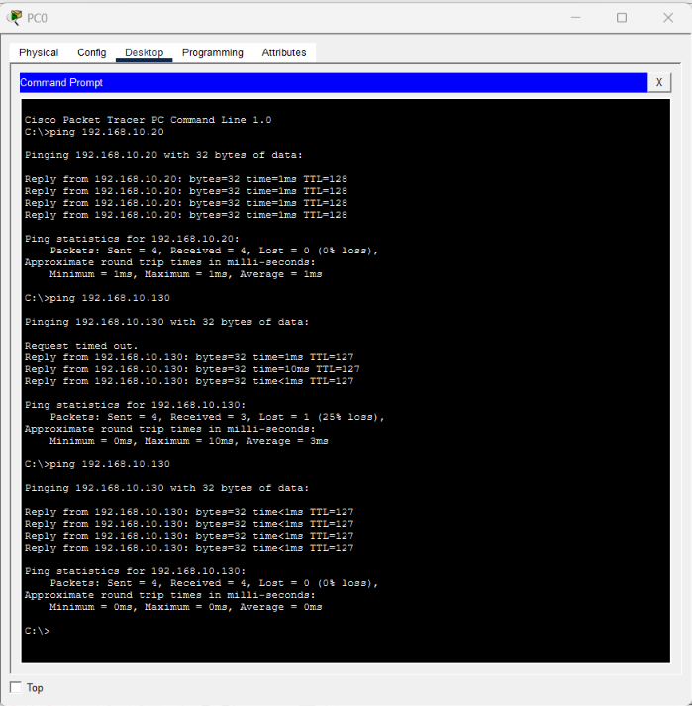

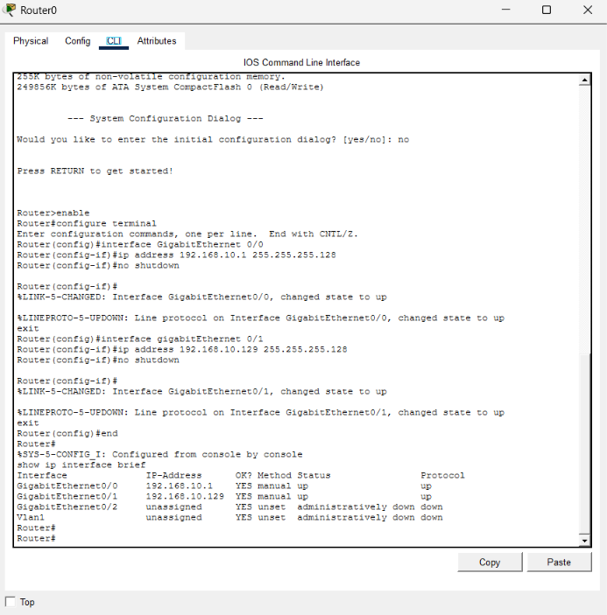

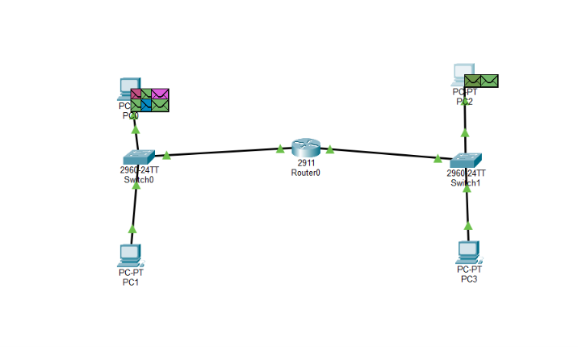

RESULT:
Thus, the experiment successfully demonstrated subnetting, static IP addressing, router-based inter-subnet communication, and the importance of a router for communication between different subnets.

