Experiment – 4 : Basic Data Modelling and Form Design

Aim
To design and develop a basic Event Registration Form using Zoho Creator by creating a structured form with essential participant, contact, and institution fields and applying basic validation rules.

Theory
Data modelling and form design involve organizing information into suitable fields and sections for efficient data collection and management. Zoho Creator provides different field types such as single-line fields, dropdowns, numbers, email, phone, address, date, time, and checkboxes.
In this experiment, an Event_Registration_Form is designed with four basic sections. These sections collect participant details, contact and institution information, event preferences, and scheduling and acknowledgement information.
The basic form contains the following sections:
- Section A – Participant Details
- Section B – Contact & Institution Details
- Section C – Event Preferences
- Section D – Scheduling & Acknowledgement
Sections and Fields
Section A – Participant Details
- Participant Name – Name field
- Participant Type – Radio/choice field
  - Student
  - Faculty
  - Professional
- Team Size – Number field
Section B – Contact & Institution Details
- Email Address – Email field
- Contact Number – Phone field
- College Organization Name – Single Line field
- Institution Address – Address field
- Postal Code – Single Line/Number field
- Country – Dropdown field
Section C – Event Preferences
- Event Track – Dropdown field
- Areas of Interest – Multi-select field
- Expectations From Event – Multi Line field
Section D – Scheduling & Acknowledgement
- Preferred Session Date – Date field
- Preferred Session Slot – Time field
- Agree To Code Of Conduct – Checkbox field
Basic Validations
- Participant Name should be entered.
- Participant Type should be selected.
- Team Size should contain a valid number.
- Contact Number should follow a valid phone format.
- College Organization Name should be provided.
- Institution Address should be entered.
- Event Track should be selected.
- Areas of Interest should be selected.
- Expectations From Event should be provided.
- Preferred Session Date should contain a valid date.
- Preferred Session Slot should contain a valid time.
- Agreement to the Event Code of Conduct should be accepted.

Procedure
- Open Zoho Creator and create the Event Registration & Participant Management application.
- Create the Event Registration Form.
- Create Section A – Participant Details.
- Add the Participant Name, Participant Type, and Team Size fields.
- Create Section B – Contact & Institution Details.
- Add the Email Address, Contact Number, College Organization Name, Institution Address, Postal Code, and Country fields.
- Create Section C – Event Preferences.
- Add the Event Track, Areas of Interest, and Expectations From Event fields.
- Create Section D – Scheduling & Acknowledgement.
- Add the Preferred Session Date, Preferred Session Slot, and Agree To Code Of Conduct fields.
- Configure the required fields and basic validations.
- Save and preview the form.
- Enter sample participant details.
- Submit the completed form.
- Create the Event Registration Report.
- Verify that the submitted participant record is displayed correctly in the report.

Screenshots

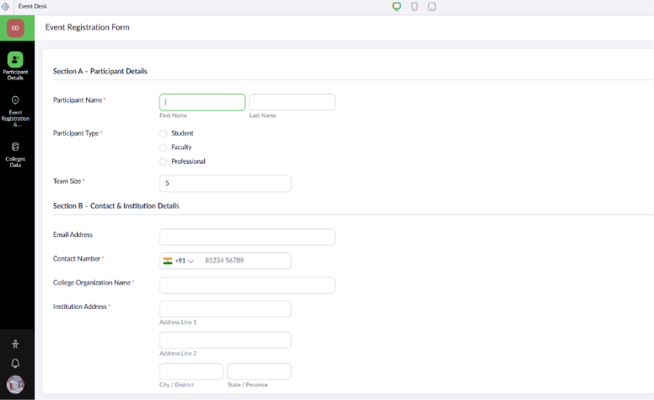
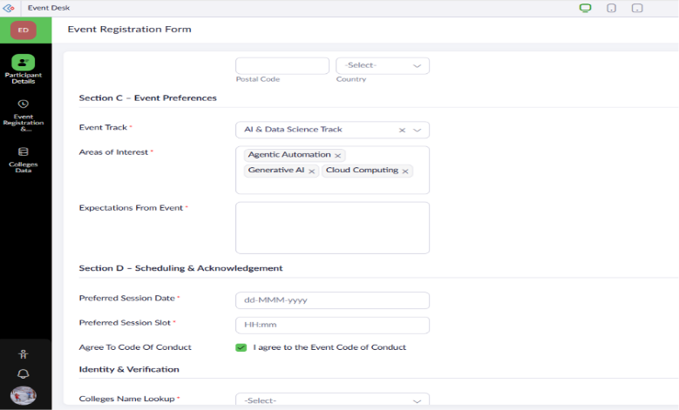
Event Registration Form

Event Registration Report
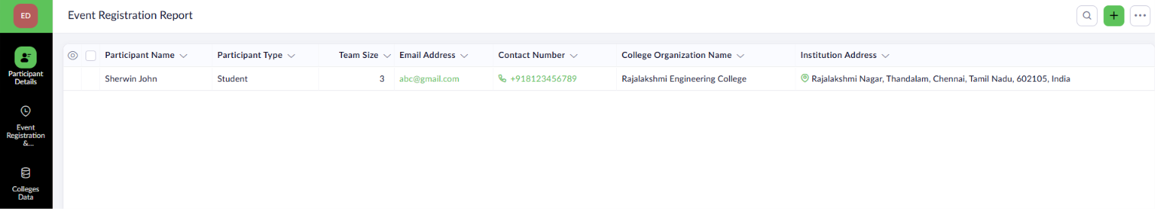

Result
The Event Registration Form was successfully created in Zoho Creator with a structured data model, appropriate validations, and organized sections. Participant records were successfully submitted and displayed in the Event Registration Report, enabling efficient participant verification and event management.



