Experiment – 4 : Advanced Data Modelling and Form Design

Aim
To extend the Event Registration Form in Zoho Creator by implementing advanced field types and features such as lookup fields, image and file uploads, numeric validation, subforms, URL fields, video/file uploads, fee and accommodation details, rich text content, and digital signatures.

Theory
Advanced data modelling in Zoho Creator involves using specialized field types and advanced form components to collect, manage, and validate detailed participant information.
In this experiment, the basic Event Registration Form is extended with advanced sections. These sections demonstrate the use of lookup fields, image upload, file upload, decimal/number fields, subforms, URL fields, media upload, fee-related fields, rich text fields, and digital signature fields.
The advanced form contains the following sections:
- Section E – Identity & Verification
- Section F – Team & Media Details
- Section G – Fee & Accommodation
- Section H – Declaration & System Generated Values
Sections and Fields
Section E – Identity & Verification
- Colleges Name Lookup – Lookup field
- Profile Photo – Image upload field
- ID Proof Upload – File upload field
- Academic CGPA – Decimal/Number field
Section F – Team & Media Details
- SubForm – Used to enter team member information
  - Member Name
  - Member Email
  - Member Role
- LinkedIn URL – URL field
- Team Intro Video – File/Video upload field
Section G – Fee & Accommodation
- Requires Accommodation – Checkbox field
- Registration Fee Paid – Currency/Amount field
- Early Bird Discount Percent – Number/Percentage field
Section H – Declaration & System Generated Values
- Event Guidelines Display – Rich Text/HTML field
- Participant Digital Signature – Signature field

Procedure
- Open the Event_Registration_Form created for the Event Registration application.
- Add Section E – Identity & Verification.
- Add the Colleges Name Lookup field.
- Add the Profile Photo image upload field.
- Add the ID Proof Upload file field.
- Add the Academic CGPA numeric field.
- Create Section F – Team & Media Details.
- Add a SubForm for team member details.
- Configure Member Name, Member Email, and Member Role inside the SubForm.
- Add the LinkedIn URL field.
- Add the Team Intro Video upload field.
- Create Section G – Fee & Accommodation.
- Add the Requires Accommodation checkbox.
- Add the Registration Fee Paid field.
- Add the Early Bird Discount Percent field.
- Create Section H – Declaration & System Generated Values.
- Add the Event Guidelines Display rich text field.
- Add the Participant Digital Signature field.
- Configure the required advanced field properties and validations.
- Save and preview the completed form.
- Enter sample data into the advanced fields.
- Add sample team members through the SubForm.
- Upload the required image/file information.
- Provide the required URL, fee, accommodation, declaration, and signature information.
- Submit the completed form.
- Verify the submitted information in the Event Registration Report.
Screenshots

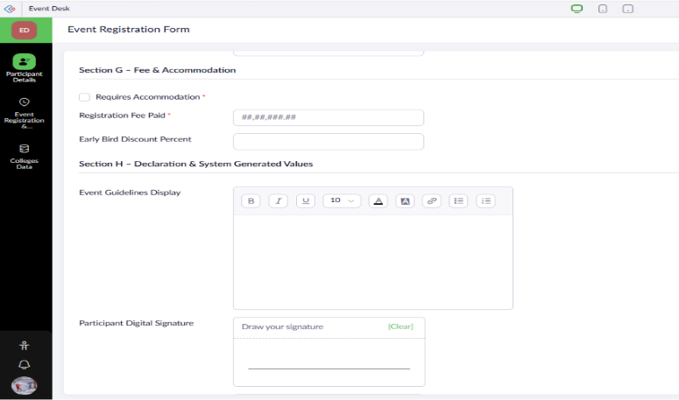
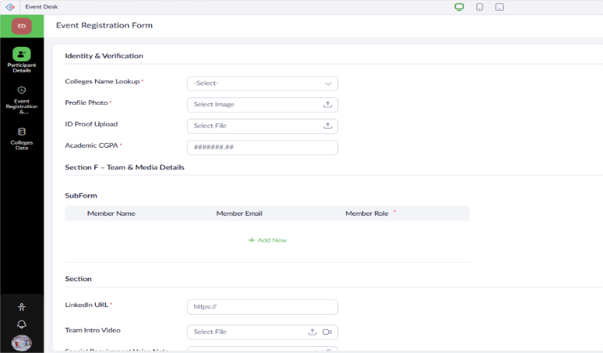
Event Registration Form

Event Registration Report
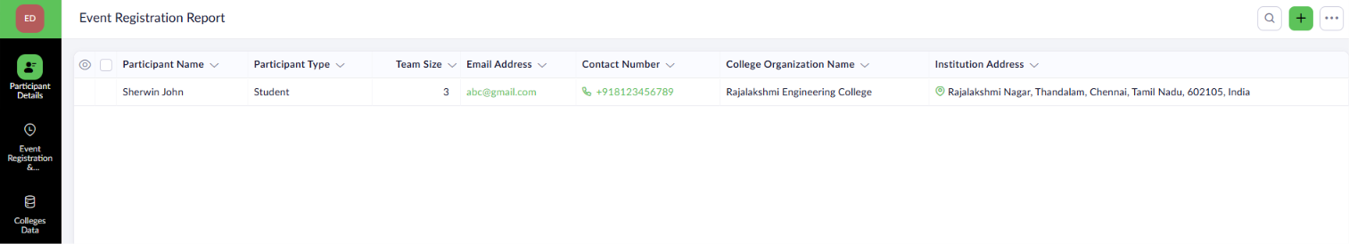

Result
The Event Registration Form was successfully created in Zoho Creator with a structured data model, appropriate validations, and organized sections. Participant records were successfully submitted and displayed in the Event_Registration_Report, enabling efficient participant verification and event management.
.

