Experiment – 4 : Data Modelling and Form Design

Aim
To design and develop an Event Registration Form using Zoho Creator by creating a structured form, applying suitable validations, and generating a report for managing event participants.

Theory
Data modelling and form design involve organizing information into suitable fields and sections for efficient data collection and management. In Zoho Creator, different field types can be used to collect and validate participant information.
In this experiment, an Event_Registration_Form is designed to collect participant details, contact and institution information, event preferences, scheduling details, areas of interest, and acknowledgement of the event code of conduct. The form is divided into four sections: Participant Details, Contact & Institution Details, Event Preferences, and Scheduling & Acknowledgement.
Validation rules are applied to ensure accurate data entry, including mandatory fields, valid email and phone formats, team size between 1 and 6 members, valid session dates, and compulsory acceptance of the code of conduct. The submitted data is displayed in the Event_Registration_Report for participant management.

Procedure
- Open Zoho Creator and create the Event Registration & Participant Management application.
- Create the Event_Registration_Form.
- Add the required fields for participant, contact, institution, event preference, scheduling, and acknowledgement details.
- Organize the fields into the four specified sections.
- Configure the required validations and mandatory fields.
- Save and preview the form.
- Enter sample participant details and submit the form.
- Create the Event_Registration_Report and verify the submitted records.
- Filter the records based on Event Track and Preferred Session Slot for event management.

Screenshots

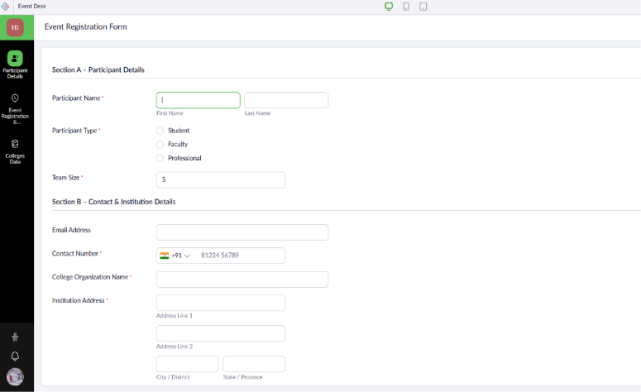
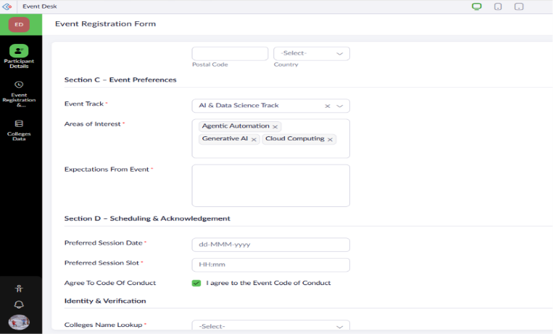
Event Registration Form
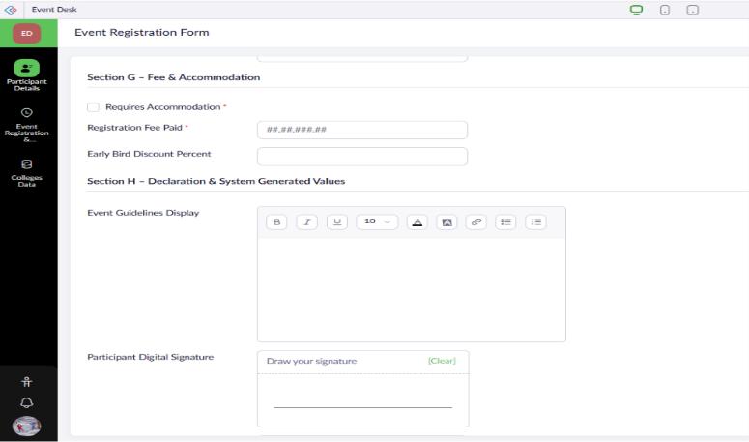
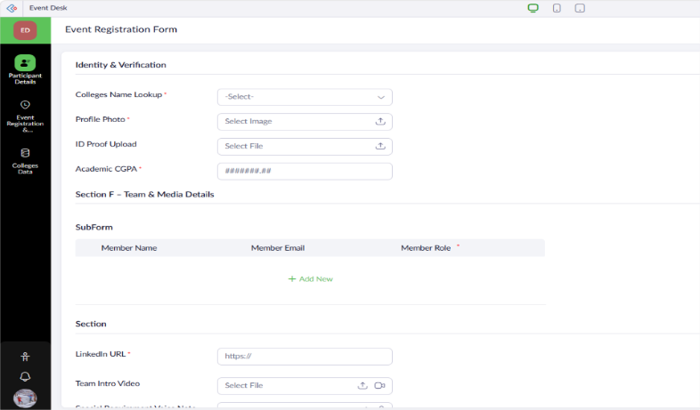

Event Registration Report
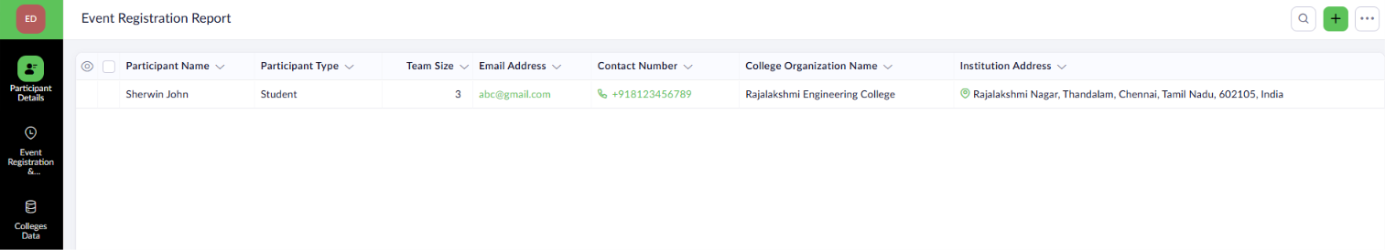

Result
The Event Registration Form was successfully created in Zoho Creator with a structured data model, appropriate validations, and organized sections. Participant records were successfully submitted and displayed in the Event_Registration_Report, enabling efficient participant verification and event management.

