Result

In the study, an investigation into Error-related Potentials (ErrP) was conducted using data from various sources. Firstly, healthy individuals were tasked with plotting ErrP graphs alongside corrected graphs, providing valuable insights into the typical response patterns of this neural phenomenon. Additionally, ErrP signals were obtained from a dataset comprising individuals diagnosed with schizophrenia, allowing for comparative analysis between healthy and clinically affected populations. Moreover, the research extended to include real-time ErrP signals from a cohort of 16 subjects with learning disabilities, aiming to broaden understanding of ErrP across diverse cognitive profiles. The results derived from these datasets are poised to offer significant contributions to the field, potentially shedding light on the underlying neural mechanisms of error processing in both healthy and clinical populations, thereby paving the way for more targeted interventions and treatments for conditions affecting cognitive processing and error monitoring.

Analyzing EEG Patterns in Healthy Patients: Insights into Task Performance and Error Perception

The four tasks described involve investigating error-related potentials (ErrPs) in various contexts: typing tasks, human-robot interaction (HRI), and brain-computer interface (BCI) speller tasks. By analyzing EEG signals, these tasks aim to understand neural responses associated with error perception, facilitating adaptive behavior and real-time feedback. The ErrP graph plots, depicting average brain activity waveforms for correct and error trials, highlight variations in neural responses. These tasks hold significance for improving human-robot interaction and developing more intuitive BCI systems.

ErrP pattern recognition is crucial for decoding neural signals and informing adaptive behavior in real-world applications. Importantly, these tasks can be applied to healthy patients to study cognitive processes, enhance human-computer interaction, and develop assistive technologies for individuals with motor disabilities or communication disorders, ultimately improving quality of life.

Fig1.Errp pattern Recognition by using Gaze based keyboard task.

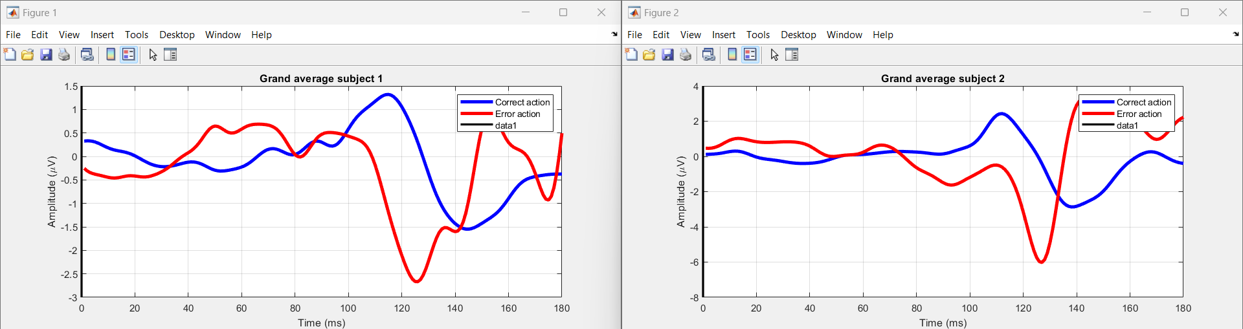

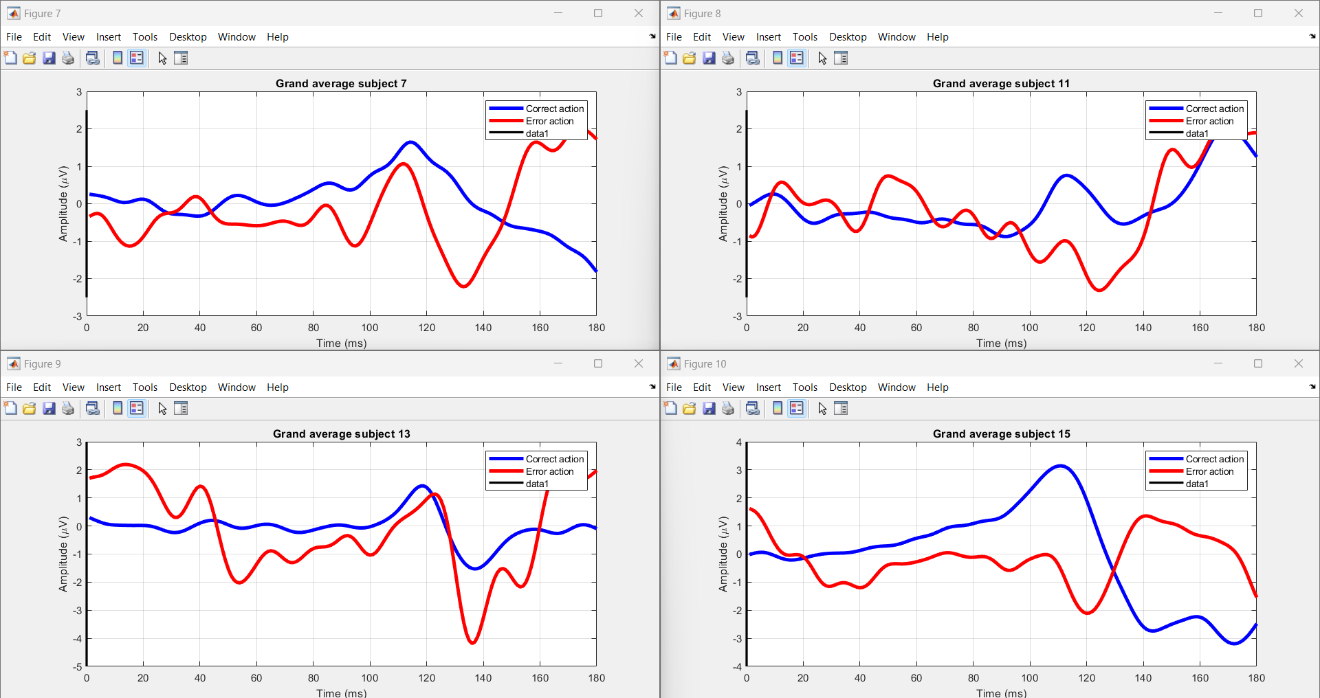

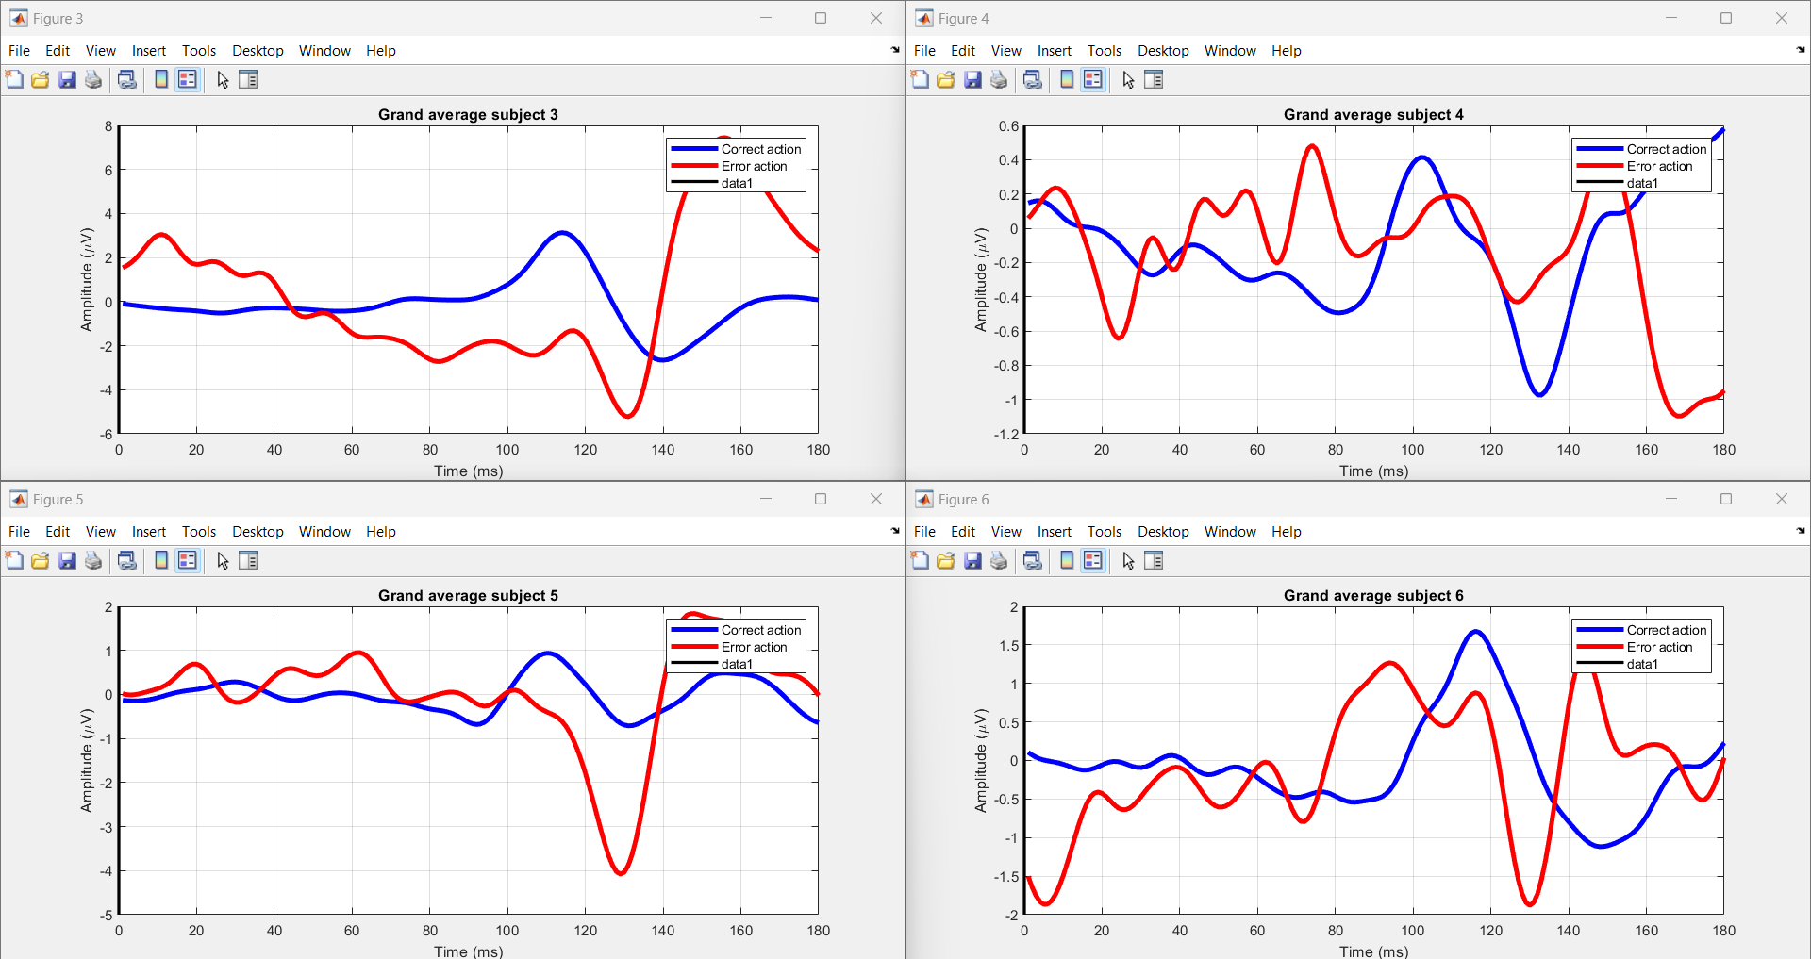

The task at hand involves investigating the physiological responses associated with error perception during typing tasks(The graph will superimpose the average brain activity waveforms for both correct and error trials, accentuating variations in neural responses between the two). Each session comprises typing a sentence followed by a brief pause. Data encompassing typing speed, accuracy, and error detection are collected. The EBNeuro EEG device records brain electrical activity using 64 wet electrodes, while the SMI myGaze eye-tracker captures gaze movements on the screen. The Lab Streaming Layer software synchronizes EEG and eye-tracking data streams for coherent analysis. Segmented into epochs, data epochs capture physiological responses around key presses. Support Vector Machine (SVM) models are employed for classifying correct and erroneous typesetting based on collected data. The process involves data loading, preprocessing, feature extraction, dataset splitting, and training SVM models. Code functionalities include loading EEG data, visualizing EEG activity for each subject, and saving processed data into MAT files for further analysis. The study involves 10 participants, aiming to understand the interplay between physiological responses and error perception during typing tasks.

Fig 2.Errp pattern Recognition by using Human-Robot Interaction.

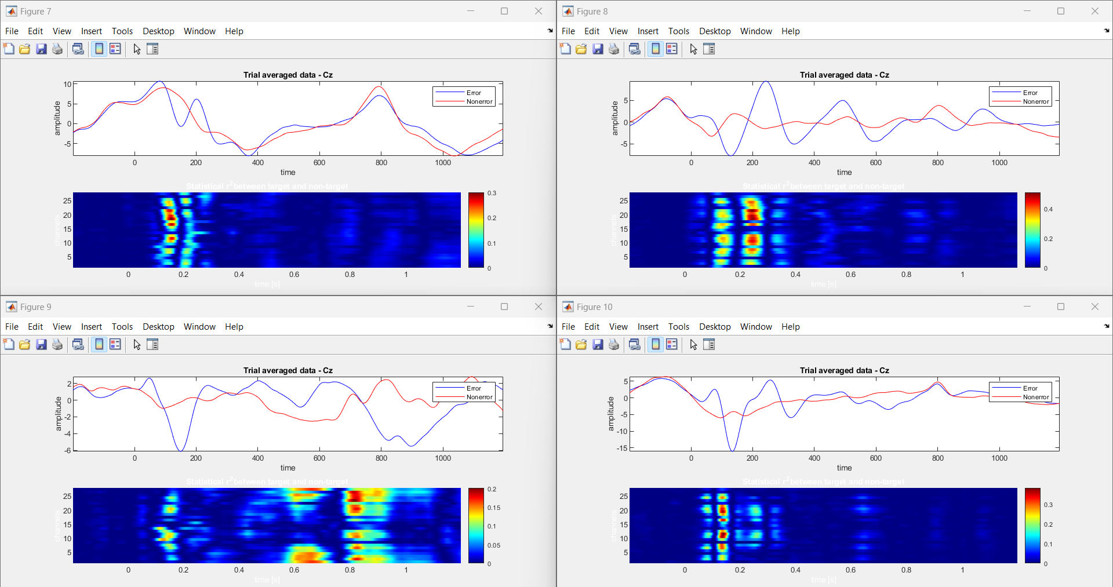

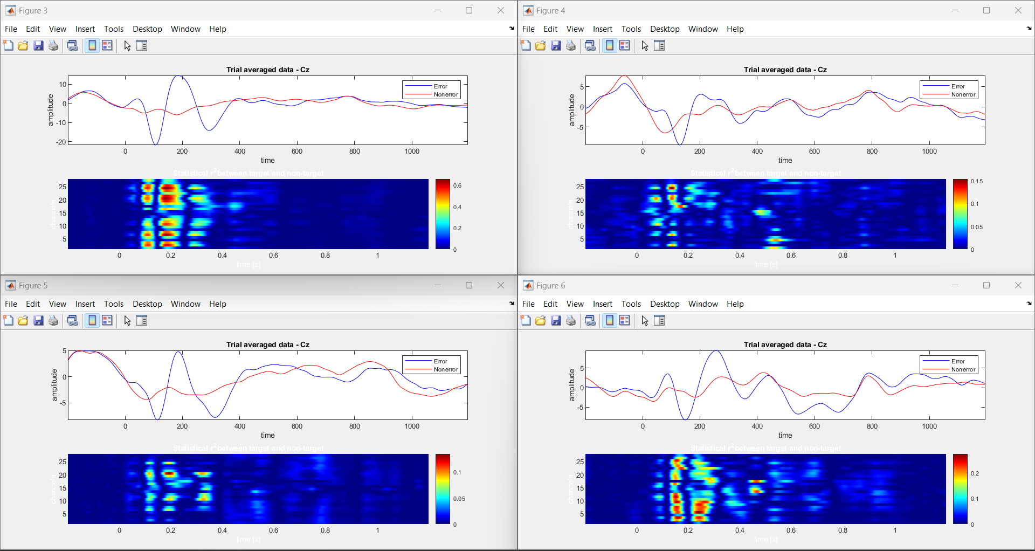 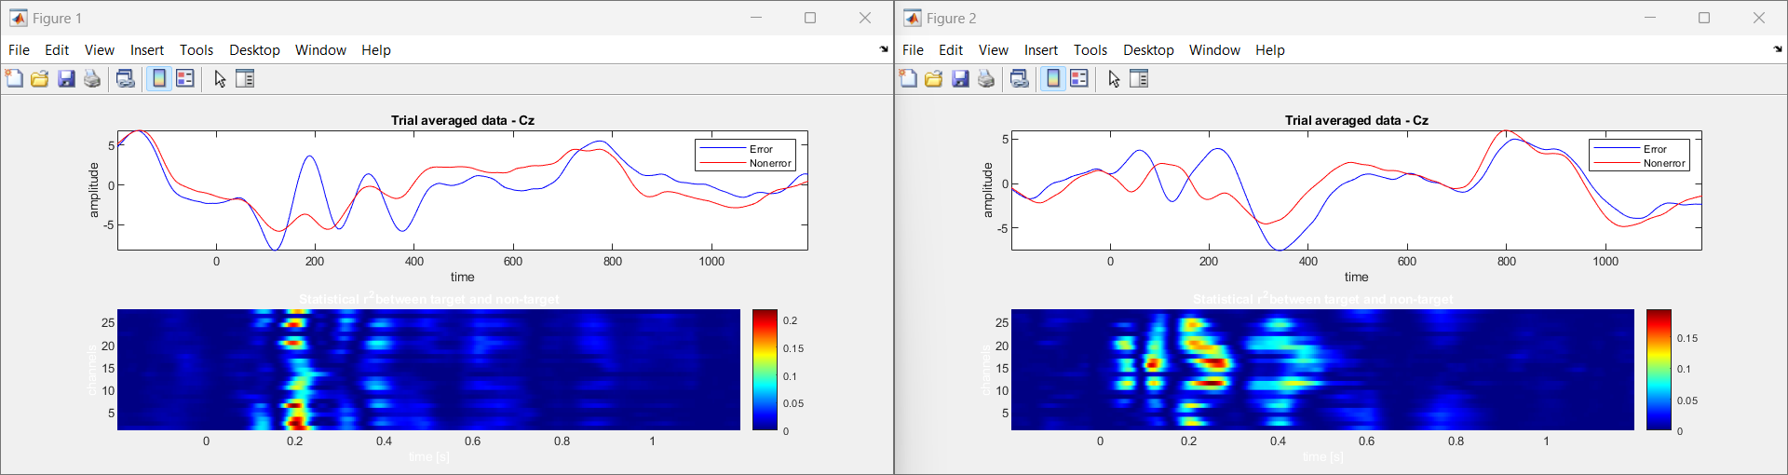

The Human-Robot Interaction (HRI) investigates EEG-based ErrPs (error-related potentials) during interactions with a humanoid robot in a simplified task. Using an ActiCHamp amplifier with electrodes, the study captures brain activity time-locked to robot actions. Advanced signal processing and high-quality signal acquisition ensure accurate data collection. MATLAB and EEGLAB are employed for preprocessing, including common average reference application and band-pass filtering. Epoching and event selection focus analysis on relevant feedback presentation instances. Support Vector Machine (SVM) classification is utilized for error detection. The project emphasizes visualizing average ErrP signals, highlighting differences between correct and error trials. This enables understanding of neural responses to robot-induced errors, facilitating adaptive behavior and real-time feedback. By decoding EEG signals, the study informs the robot's actions, enhancing its interaction capabilities. The study findings hold significance for improving human-robot interaction by enabling robots to adjust behaviors based on neural responses.

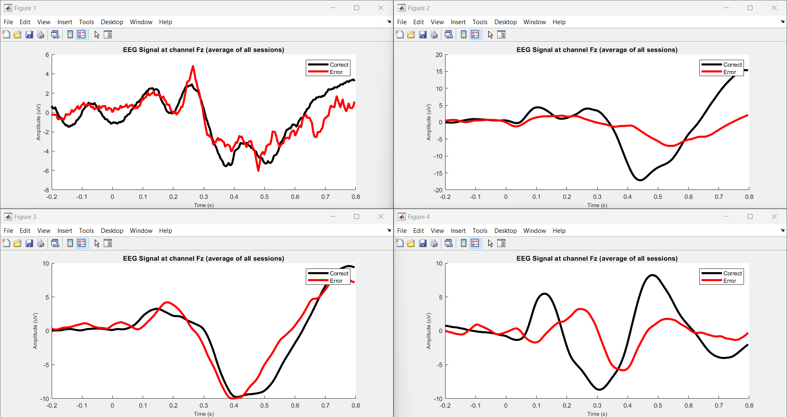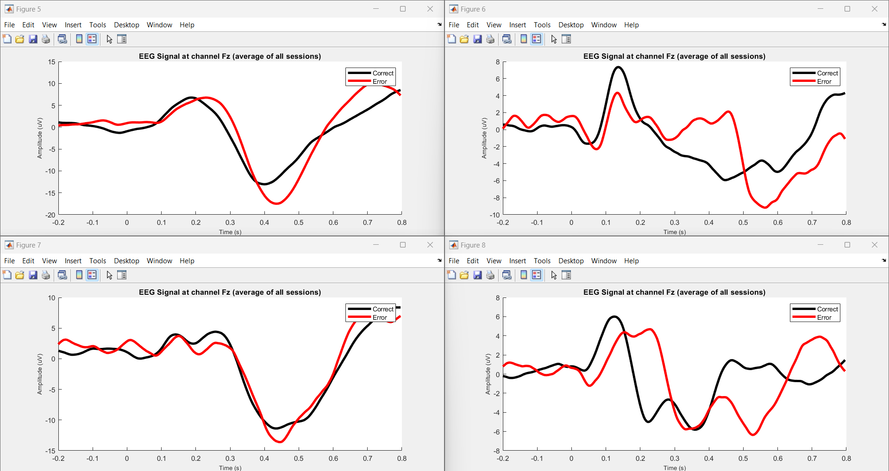

Fig 3.Errp pattern Recognition by using P300 based BCI speller.

The task investigates error-related potentials (ErrPs) and P300 event-related potentials (ERPs) in EEG data, particularly focusing on human-robot interaction (HRI). EEG signals are acquired using an ActiCHamp amplifier, capturing brain activity during interactions with a humanoid robot in a simplified task. Preprocessing involves filtering EEG data to extract relevant neural signals, followed by ErrP data extraction and labeling. The processed data, including participant IDs and session information, are stored for analysis. The project utilizes MATLAB for data processing and visualization, including plotting average EEG signals at channel Fz for correct and error conditions. This analysis aids in understanding neural responses to robot-induced errors, facilitating adaptive behavior and real-time feedback. The task aims to improve human-robot interaction by enabling robots to adjust behaviors based on neural responses, enhancing the efficiency and reliability of the interaction process.

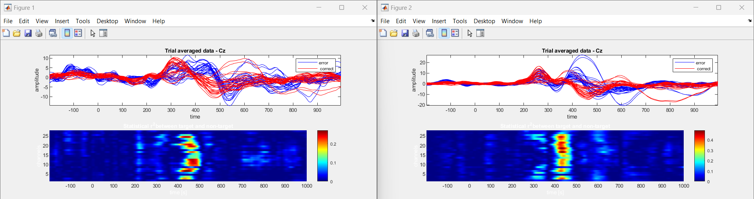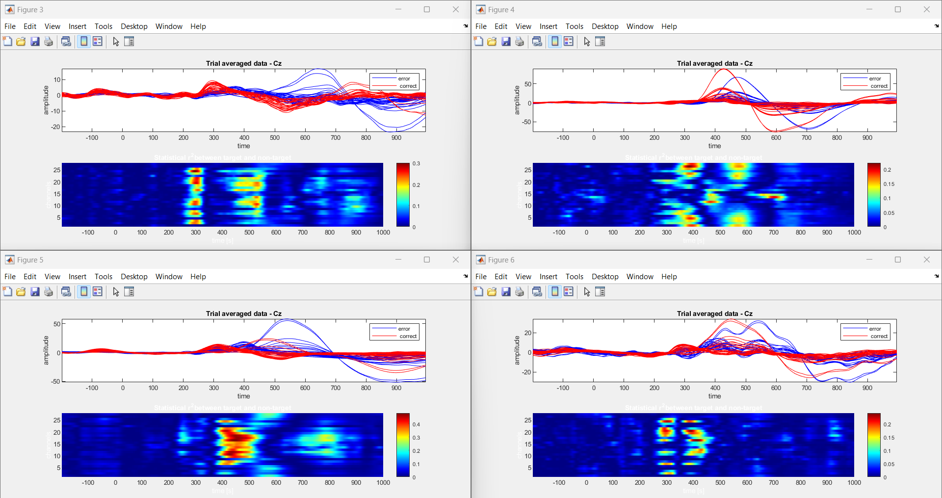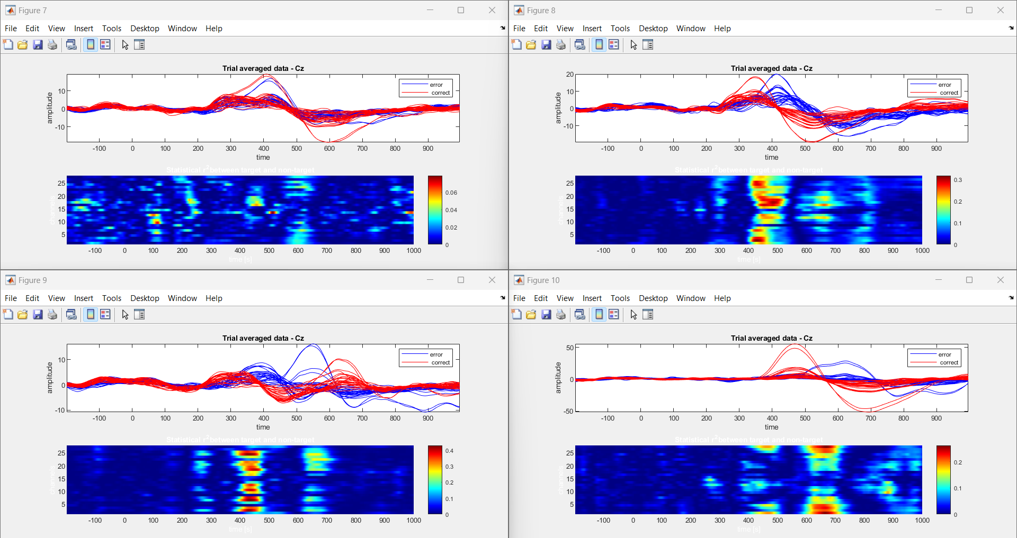

Fig 4. Errp pattern Recognition by using Human-Robot interaction task (Fostering Human-Agent Co-Adaptation Through Error-Related Potentials)

In "Human-agent Co-adaptation using Error-related Potentials", participants engaged in a guessing game with a robot partner. EEG data was acquired during two main phases: a calibration session and closed-loop co-adaptation sessions. The calibration session involved participants guessing the robot's chosen object, while closed-loop sessions continued this interaction. EEG signals were analyzed to decode error-related potentials (ErrPs), indicative of participant's error perception. The robot's behavior adapted based on these decoded ErrPs, fostering human-agent co-adaptation. Data analysis involved preprocessing EEG signals, extracting features, and decoding ErrPs for real-time feedback. Graphical analysis of ErrPs provided insights into participants' error perception dynamics, facilitating adaptive behavior in the robot. Overall, the task aimed to enhance human-agent collaboration through real-time neural signal processing, paving the way for more intuitive and efficient human-robot interaction paradigms.

EEG ErrP Dataset Comparison between Schizophrenia and Healthy Controls

In our study, we conducted analyses comparing EEG signals during a button-tone task between individuals diagnosed with schizophrenia and healthy controls. The preprocessing of EEG data ensured data quality by removing artifacts. Subsequently, we plotted the EEG signals recorded during the task for both groups using Python.Our analysis aimed to gain insights into the neural mechanisms underlying schizophrenia and potential differences in task performance between the two groups. Notably, individuals with schizophrenia may experience predictive coding failures, leading to inappropriate salience of sensations that should have been predicted but were not. These failures in predictive mechanisms can influence the suppression of neural responses, including the reduced suppression of the negative peak observed in individuals with schizophrenia.

Moreover, cognitive impairments such as deficits in attention, working memory, and executive functions may further impact the suppression of neural responses in individuals with schizophrenia. Dysfunctional cognitive processes may disrupt the regulation of neural activity, contributing to variations in suppression levels, including the reduced suppression of the negative peak in ERPs observed in schizophrenia compared to healthy controls. The interplay between cognitive impairments, neural processing abnormalities, and predictive coding failures collectively influences the suppression of neural responses, such as the negative peak observed in EEG ERPs. Differences in cognitive functioning and neural mechanisms between healthy controls and individuals with schizophrenia may underlie the observed differences in suppression levels, reflecting the complex interplay of cognitive and neural factors in the disorder.

Overall, our analysis of EEG ErrP datasets highlights the intricate relationship between cognitive impairments, neural processing abnormalities, and predictive coding failures in schizophrenia. These findings contribute to a deeper understanding of the disorder's neurobiology and may inform future research directions and treatment approaches aimed at addressing cognitive and neural dysfunctions in schizophrenia.

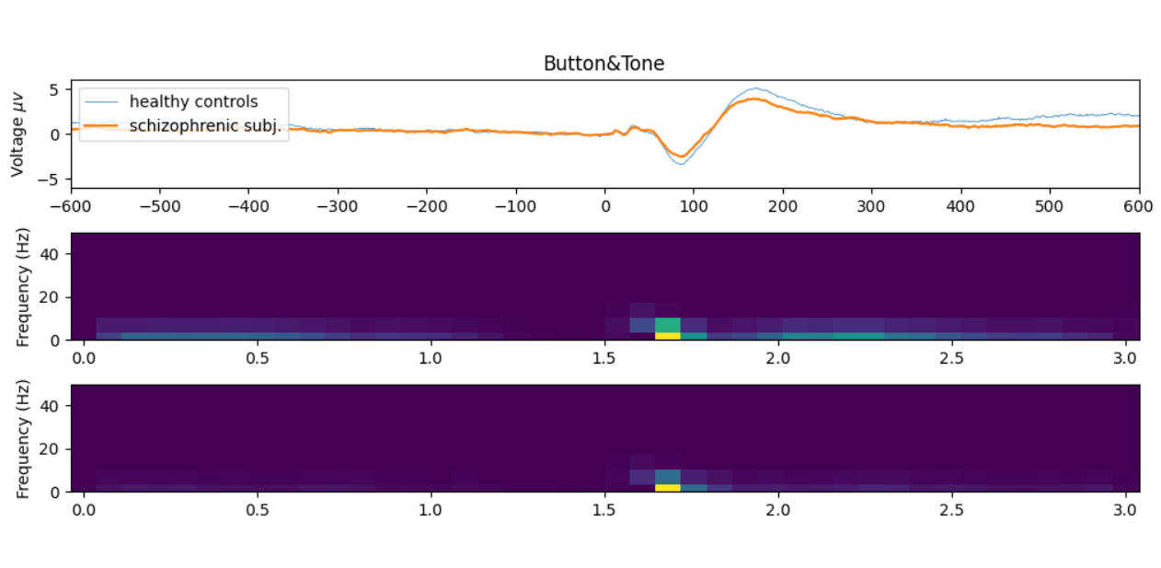

Furthermore, our analysis revealed that individuals with schizophrenia exhibited greater negative suppression compared to healthy controls, as depicted in the graph. This indicates abnormal neural response patterns in schizophrenia, particularly in error monitoring tasks. The heightened negative suppression observed suggests underlying neurobiological dysregulation contributing to cognitive deficits and altered error processing mechanisms in the disorder. These findings underscore the significance of understanding these mechanisms for improving diagnostic and therapeutic strategies for schizophrenia.

Error-related Potentials (ErrP) Acquisition in Subjects with Learning Disabilities

In this study, EEG techniques captured real-time neural activity associated with Error-related Potentials (ErrP). Three electrodes placed strategically on participants' frontal-central scalps recorded neural signals linked to error monitoring. Graphical representations and CSV files enabled detailed analysis, offering insights into cognitive processing in real-time. Differences in ErrP patterns between conditions and participant groups were observed, highlighting the interplay between cognitive processes and neural activity. This approach contributes to understanding error monitoring mechanisms and cognitive control, with implications for targeted interventions in various populations.

The research investigated how our brains handle errors using a technique called electroencephalography (EEG). Participants engaged in eye-gazing experiments with varying conditions. Researchers monitored their brain activity through EEG, specifically focusing on error-related potentials (ErrPs). These ErrPs are tiny voltage fluctuations that occur when the brain detects an error. By analyzing the timing and characteristics of these ErrPs across different conditions and participants, the researchers aimed to understand how attention, error processing, and brain activity interact. The findings provide valuable insights into the complex interplay between our thoughts and brain functions, furthering our understanding of cognitive neuroscience.

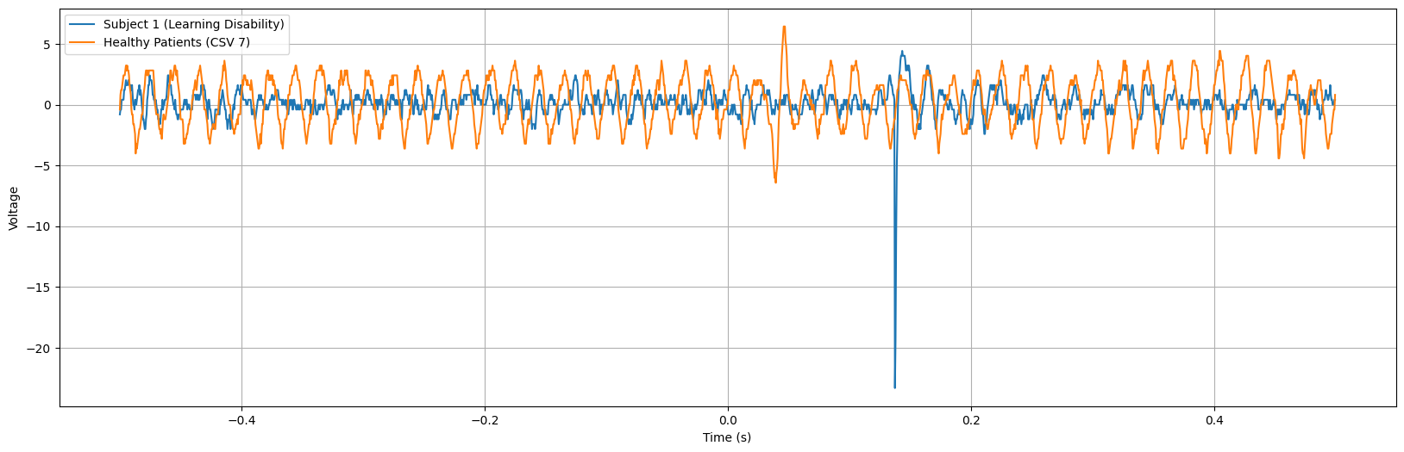

The graph depicts Error-related Potentials (ErrP) of subjects with learning disabilities, showcasing a notably higher negative peak occurring around 170 ms after error onset. This heightened negative peak suggests an amplified neural response associated with error detection processes in individuals with learning disabilities. The increased magnitude of the negative peak may reflect intensified neural activity involved in error monitoring and processing among this population.

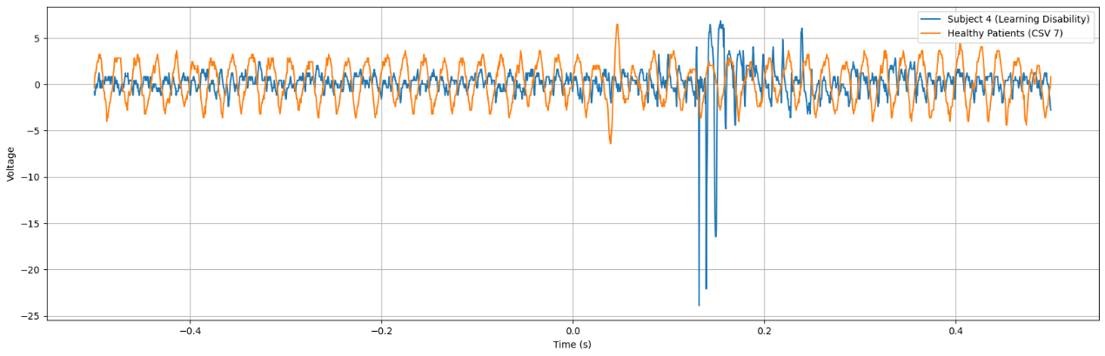

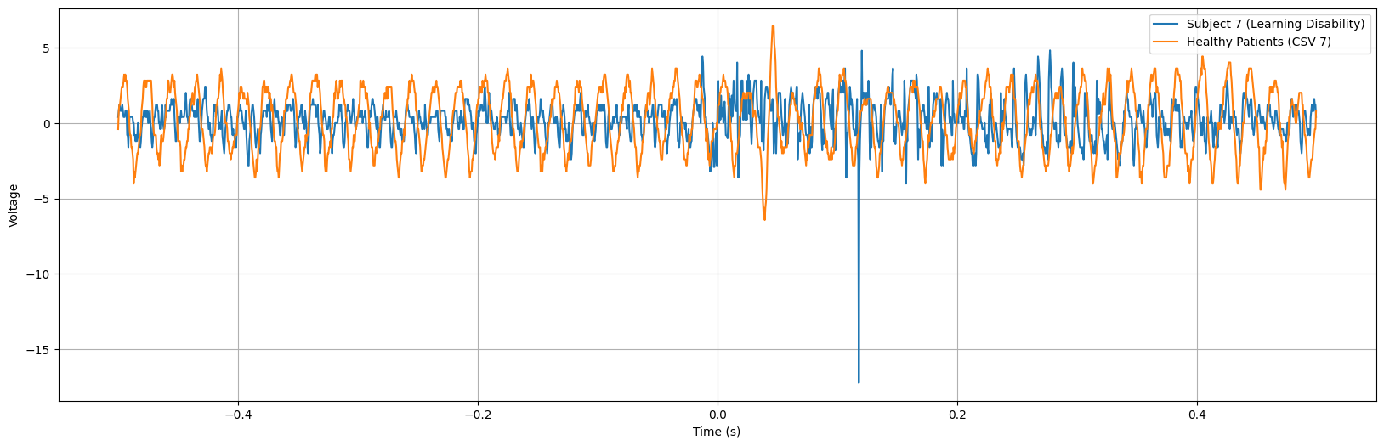

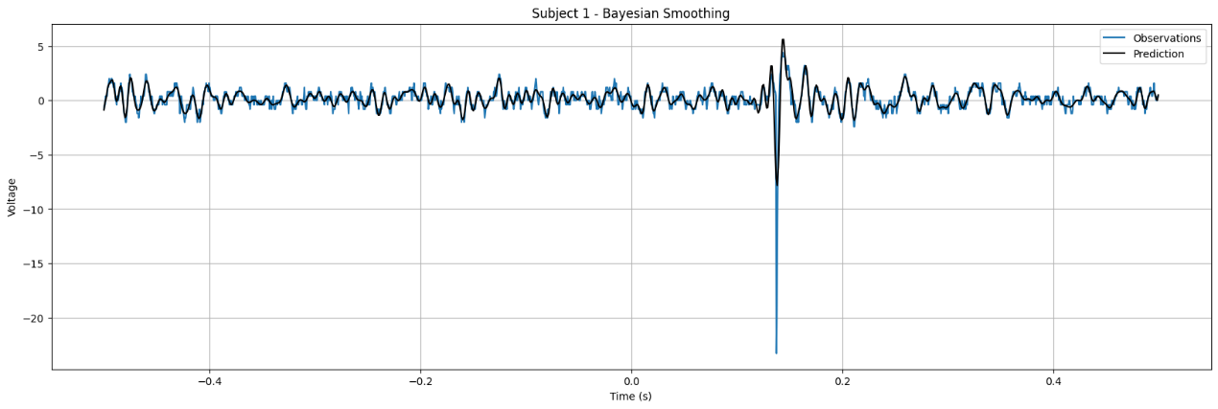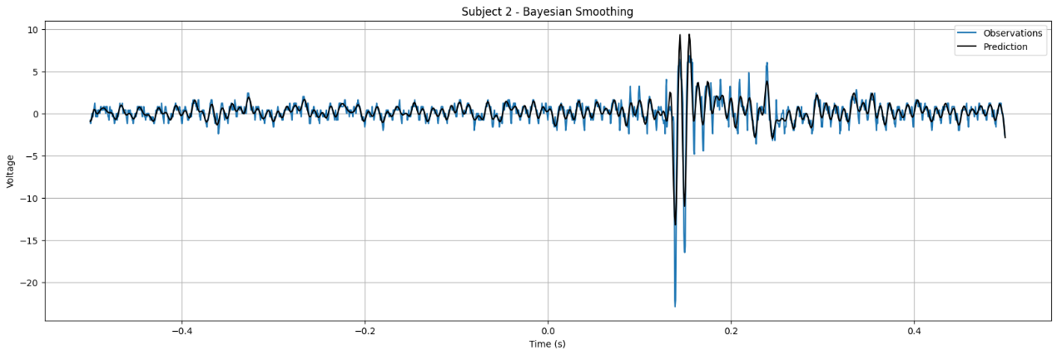

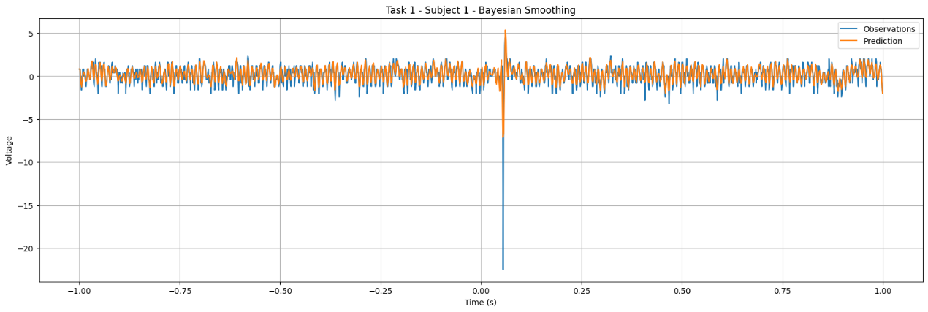

Discussion

The investigation into Error-related Potentials (ErrP) across various contexts and populations has provided valuable insights into the neural mechanisms underlying error processing and cognitive control. These findings have important implications for understanding cognitive impairments in conditions such as schizophrenia and learning disabilities, as well as for developing targeted interventions and treatments.

1. **Schizophrenia and Abnormal Neural Responses:** The comparison between individuals with schizophrenia and healthy controls revealed distinct neural response patterns during error monitoring tasks. Specifically, individuals with schizophrenia exhibited heightened negative suppression, indicating underlying neurobiological dysregulation. This abnormal neural response pattern may contribute to cognitive deficits observed in schizophrenia, such as deficits in attention, working memory, and executive functions. Understanding these neural mechanisms is crucial for developing targeted interventions to improve cognitive processing and error monitoring in individuals with schizophrenia.
2. **Learning Disabilities and Amplified Neural Responses:** The investigation into ErrP acquisition in subjects with learning disabilities uncovered amplified neural responses associated with error detection processes. This heightened negative peak suggests intensified neural activity involved in error monitoring and processing among individuals with learning disabilities. These findings highlight the importance of understanding cognitive processing mechanisms in diverse populations and developing tailored interventions to improve cognitive processing and error monitoring in individuals with learning disabilities.
3. **Implications for Intervention and Treatment:** The insights gained from ErrP research have significant implications for developing targeted interventions and treatments for conditions affecting cognitive processing and error monitoring. By understanding the neural mechanisms underlying error processing, researchers and clinicians can develop interventions aimed at improving cognitive control and error monitoring abilities in individuals with schizophrenia and learning disabilities. These interventions may include cognitive training programs, neurofeedback techniques, or pharmacological interventions targeting specific neural pathways implicated in error processing.
4. **Future Directions:** Future research in ErrP could focus on further elucidating the neural mechanisms underlying error processing across different populations and contexts. Additionally, longitudinal studies could investigate how neural response patterns change over time and in response to interventions. Furthermore, integrating neuroimaging techniques such as functional magnetic resonance imaging (fMRI) or magnetoencephalography (MEG) with EEG could provide a more comprehensive understanding of the neural circuits involved in error processing.

Conclusion

Based on the investigations into Error-related Potentials (ErrP) across various contexts and populations, significant insights into neural processing associated with error detection and cognitive control have been gleaned. From analyzing EEG patterns in healthy patients to comparing ErrP signals between individuals with schizophrenia and healthy controls, as well as examining ErrP acquisition in subjects with learning disabilities, a comprehensive understanding of the neural mechanisms underlying error processing has been achieved.The findings suggest that individuals with schizophrenia exhibit distinct neural responses during error monitoring tasks, characterized by heightened negative suppression compared to healthy controls. This abnormal neural response pattern highlights underlying neurobiological dysregulation in schizophrenia, potentially contributing to cognitive deficits and altered error processing mechanisms in the disorder. These insights underscore the importance of understanding the complex interplay between cognitive impairments, neural processing abnormalities, and predictive coding failures in schizophrenia for developing targeted interventions and treatments.

Furthermore, the investigation into ErrP acquisition in subjects with learning disabilities revealed amplified neural responses associated with error detection processes. This heightened negative peak suggests intensified neural activity involved in error monitoring and processing among individuals with learning disabilities. Understanding these neural response patterns offers valuable insights into cognitive processing mechanisms in diverse populations, facilitating the development of targeted interventions to improve cognitive processing and error monitoring in individuals with learning disabilities.

Motive of the Project

The primary motive of this project is to delve into the intricate neural processes underlying error detection and cognitive control through the investigation of Error-related Potentials (ErrP) across diverse populations. By analyzing ErrP patterns in healthy individuals, individuals with schizophrenia, and subjects with learning disabilities, we aim to uncover the neural mechanisms involved in error processing and cognitive impairments.

1.**Understanding Neural Responses in Schizophrenia:** One key objective is to elucidate the abnormal neural responses associated with error monitoring tasks in individuals diagnosed with schizophrenia. By comparing ErrP signals between healthy controls and individuals with schizophrenia, we seek to uncover underlying neurobiological dysregulation contributing to cognitive deficits observed in this population.

2.**Exploring ErrP Patterns in Learning Disabilities:** Another objective is to investigate ErrP acquisition in subjects with learning disabilities. By examining ErrP patterns in this population, we aim to gain insights into amplified neural responses associated with error detection processes, thereby enhancing our understanding of cognitive processing mechanisms in individuals with learning disabilities.

3.**Informing Targeted Interventions and Treatments:** Through this project, we aim to inform the development of targeted interventions and treatments for conditions affecting cognitive processing and error monitoring. By understanding the neural mechanisms underlying error processing, we can develop interventions aimed at improving cognitive control and error monitoring abilities in individuals with schizophrenia and learning disabilities.

4.**Contributing to Cognitive Neuroscience:** Ultimately, this project contributes to advancing our understanding of cognitive neuroscience by investigating the neural mechanisms underlying error processing across diverse populations. By uncovering the neural processes involved in error detection and cognitive control, we pave the way for future research aimed at developing more effective interventions and treatments for cognitive impairments.