INTRODUCTION:

In the constantly evolving landscape of neurodegenerative diseases, innovative diagnostic and monitoring tools are increasingly essential. Here we explores the development of a comprehensive system for detecting Error-Related Potentials (ErrP), specifically designed to diagnose and monitor neurodegenerative conditions . These disorders pose significant challenges for healthcare providers and patients alike, underscoring the urgent need for diagnostic advancements.

The project adopts a multifaceted approach, integrating precise data acquisition techniques, advanced signal processing algorithms, and rigorous testing/training methodologies. By focusing on ErrP, an electroencephalographic marker associated with cognitive processes, the framework aims to provide a detailed understanding of the neurophysiological mechanisms underlying neurodegenerative diseases. Beyond creating a reliable diagnostic tool, this effort contributes to the broader landscape of neurology research.

As the report navigates through stages like electrode placement, signal recording, noise reduction, and feature extraction, it unravels the complexities of the ErrP detection system. By elucidating each phase's nuances, the report highlights the potential impact of this project on diagnosis, monitoring, and the scientific understanding of neurodegenerative diseases.

Shifting focus, individuals with schizophrenia often grapple with distortions in sensory perception, potentially contributing to psychotic symptoms. Unlike healthy individuals who effectively predict and process sensations, those with schizophrenia may struggle with dysfunctional predictive mechanisms. This impaired ability to make accurate predictions can lead to misinterpretations of expected and unexpected stimuli, contributing to challenges in sensory processing observed in the disorder.

Schizophrenia is associated with difficulties in predictive coding, affecting the brain's ability to accurately anticipate incoming sensory information. This difficulty manifests across various experimental setups, including tasks assessing pattern recognition and investigations into internal mechanisms like efference copy and corollary discharge.

Furthermore, research indicates reduced suppression of Error-Related Negativity in individuals with schizophrenia, suggesting a malfunction in predicting and suppressing self-generated sensations. This malfunction may contribute to sensory processing abnormalities and misperceptions commonly observed in the disorder.

In a different context, high-stakes gaming environments demand swift decision-making skills and involve complex cognitive functions. Errors during decision-making stages serve as crucial indicators for distinguishing between patients and healthy individuals, providing insights into cognitive resilience and decision-making proficiency, particularly under stress.

The synthesis of high-stakes gaming and cognitive error analysis offers an effective method for discerning cognitive health in participants, shedding light on decision-making abilities and cognitive responses to stress. Overall, these insights contribute to a deeper understanding of neurological disorders and their impact on individuals' cognitive processes.

1. \*\*Introduction/Motive of the Project\*\*:

In the constantly evolving landscape of neurodegenerative diseases, there is a pressing need for innovative diagnostic and monitoring tools. These conditions, such as Alzheimer's and Parkinson's disease, present significant challenges for both healthcare providers and patients. As such, the development of effective diagnostic capabilities has become increasingly imperative.

2. \*\*Objective of the Project\*\*:

The primary objective of this project is to develop a comprehensive system for detecting Error-Related Potentials (ErrP) specifically tailored for diagnosing and monitoring neurodegenerative conditions. By focusing on ErrP, an electroencephalographic marker associated with cognitive processes, the project aims to gain a deeper understanding of the neurophysiological mechanisms underlying these diseases.

COMPONENT DESCRIPITION:

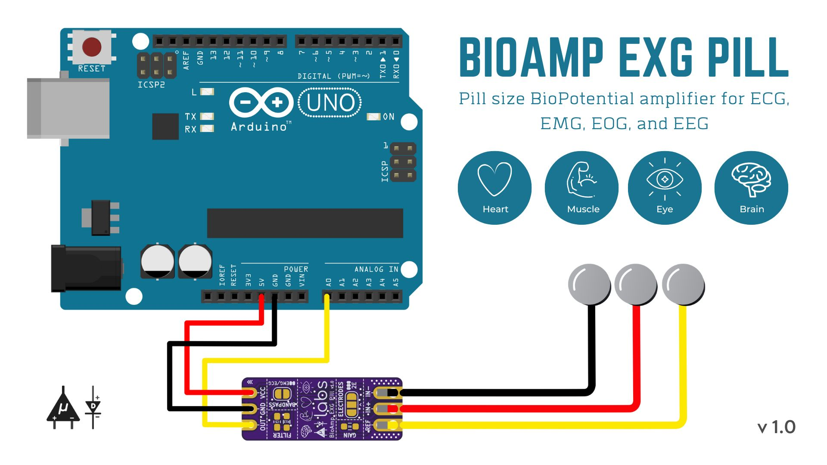

BioAmp EXG Pill is one of a kind pill-size chip that can record publication-grade biopotential signals from your body be it from the heart (ECG), brain (EEG), eyes (EOG), and muscles (EMG).It is used in projects of Human-Computer Interface (HCI) and Brain-Computer Interface (BCI) domains.

ELECTRODES:

Boxy Gel Electrodes, the compact solution for recording biopotential signals with ease. Measuring just 4.0 x 3.3 x 0.1 cm, these rectangular electrodes feature a conductive solid hydrogel and stainless steel snap connectors for efficient signal transmission. Crafted from polyethylene foam and acrylic medical-grade adhesive, they offer ultra-low impedance (<100 ohms) for rapid baseline stabilization. With lift tabs for convenient placement and removal, these electrodes ensure minimal cleanup thanks to the Ag/AgCl adhesive solid gel. Their special formulation guarantees optimal interface between the body and BioAmp cable, enabling seamless recording of signals from the heart (ECG), brain (EEG), muscles (EMG), or eyes (EOG).

ARDINO UNO:

The Arduino Uno is a popular microcontroller board based on the ATmega328P chip. It is a part of the Arduino open-source electronics platform, designed for easy prototyping and development of interactive projects. The Uno board features digital input/output pins (both PWM and standard), analog inputs, USB connectivity, a 16 MHz crystal oscillator, a power jack, and an ICSP header. It can be powered either via USB connection or an external power supply. The Uno is programmed using the Arduino Software (IDE), which is user-friendly and supports a simplified version of C++ programming language. With its versatility and wide range of compatible sensors and shields, the Arduino Uno is widely used in various applications such as robotics, home automation, IoT (Internet of Things), and educational projects.