API Document

|  |  |  |  |
| --- | --- | --- | --- |
| Method | POST | | |
| URL | /user/login | | |
| Request  Parameter | Field | Type | Description |
| uId | string | The id of a user |
| userName | string | The username of a user |
| pwd | string | The password of a user |
| Response | Filed | Type | Description |
| status | number |  |
| msg | string |  |

Demo:

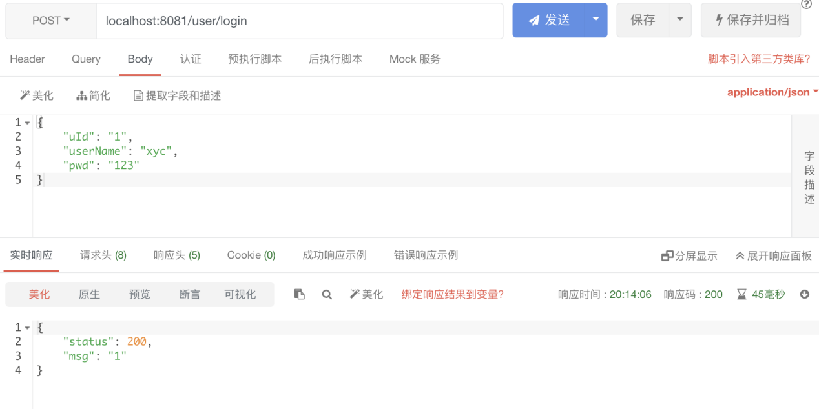

|  |  |  |  |
| --- | --- | --- | --- |
| Method | POST | | |
| URL | /user/register | | |
| Request  Parameter | Field | Type | Description |
| uId | string | The id of a user |
| userName | string | The username of a user |
| pwd | string | The password of a user |
| Response | Filed | Type | Description |
| status | number |  |
| msg | string |  |

Demo:

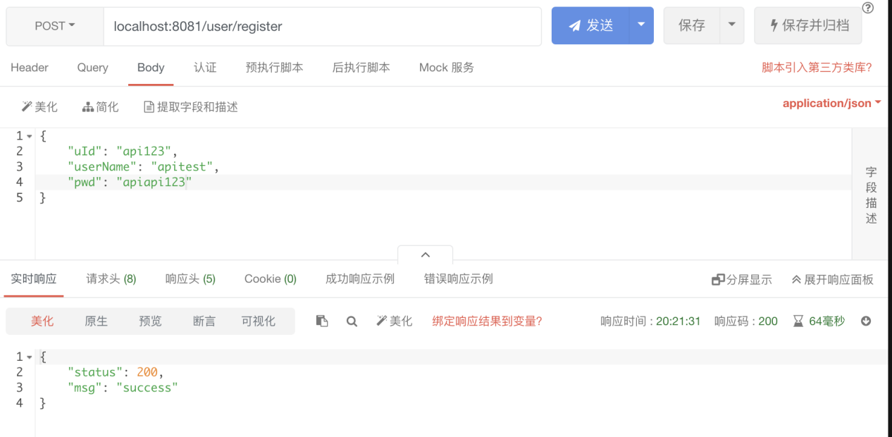

|  |  |  |  |
| --- | --- | --- | --- |
| Method | POST | | |
| URL | /picture/upload | | |
| Request  Parameter | Field | Type | Description |
| pic | file | A picture |
| uId | string | A path parameter |
| Response | Filed | Type | Description |
| status | number |  |
| msg | string |  |

Demo:

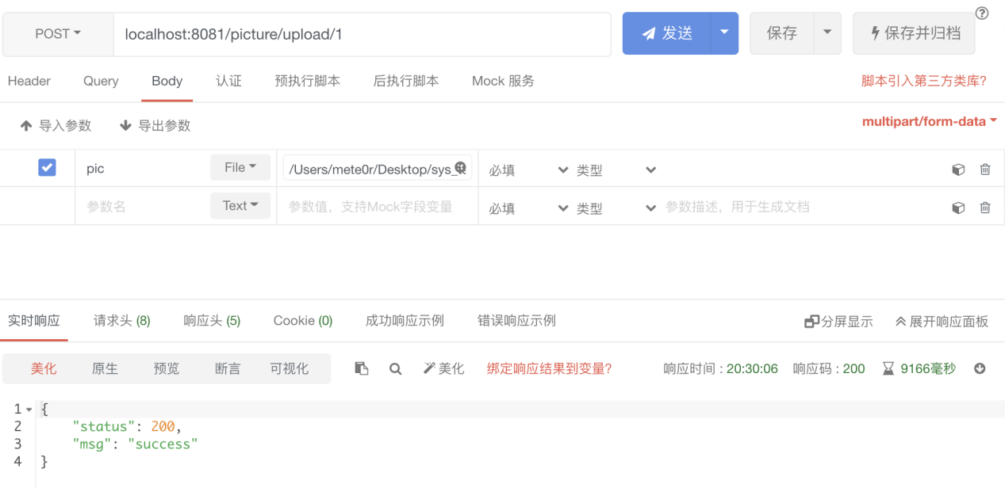

|  |  |  |  |
| --- | --- | --- | --- |
| Method | Get | | |
| URL | /picture/download | | |
| Request  Parameter | Field | Type | Description |
| hid | string | A path parameter |
| Response | Filed | Type | Description |
| file | file | A byte stream of the picture |

Demo:

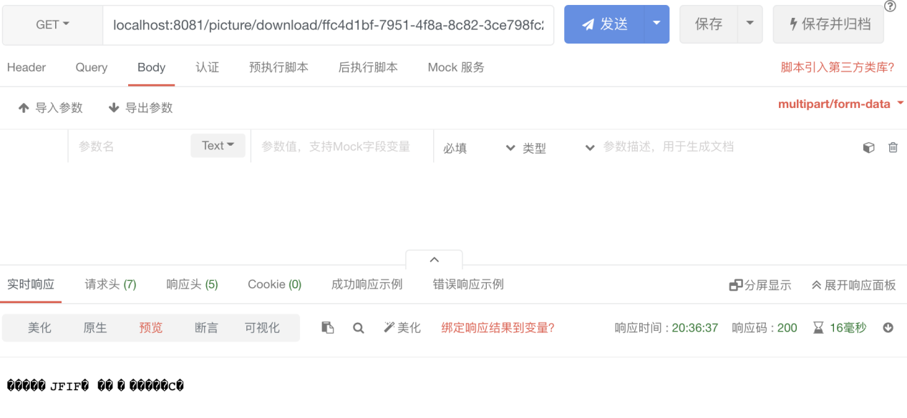

|  |  |  |  |
| --- | --- | --- | --- |
| Method | Get | | |
| URL | /picture/show | | |
| Request  Parameter | Field | Type | Description |
| uid | string | A path parameter |
| Response | Filed | Type | Description |
| string | string | A list about the history of the user |

Demo:

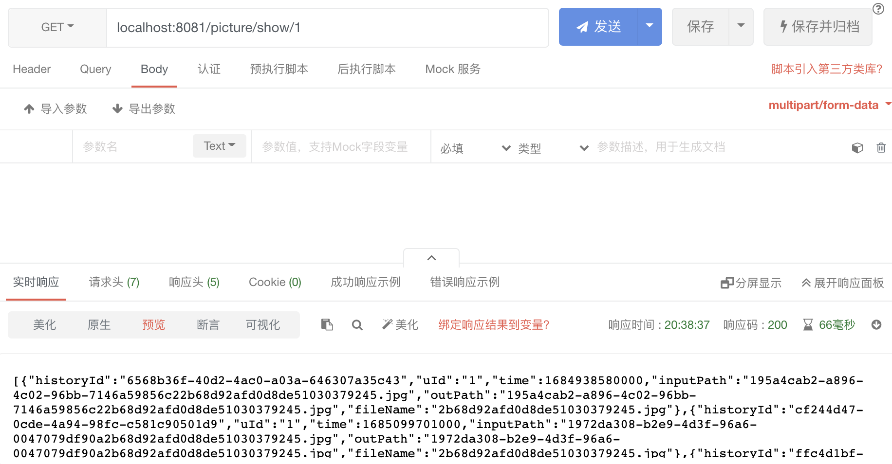

|  |  |  |  |
| --- | --- | --- | --- |
| Method | POST | | |
| URL | /picture/generate | | |
| Request  Parameter | Field | Type | Description |
| uid | string | A path parameter |
| historyId | string | The id of a user history |
| uId | string | The id of a user |
| time | date | The uploading time of the picture |
| inputPath | string | The input path |
| outPath | string | The output path |
| filename | string |  |
| Response | Filed | Type | Description |
| A file | file | A byte stream of the picture |

Demo:

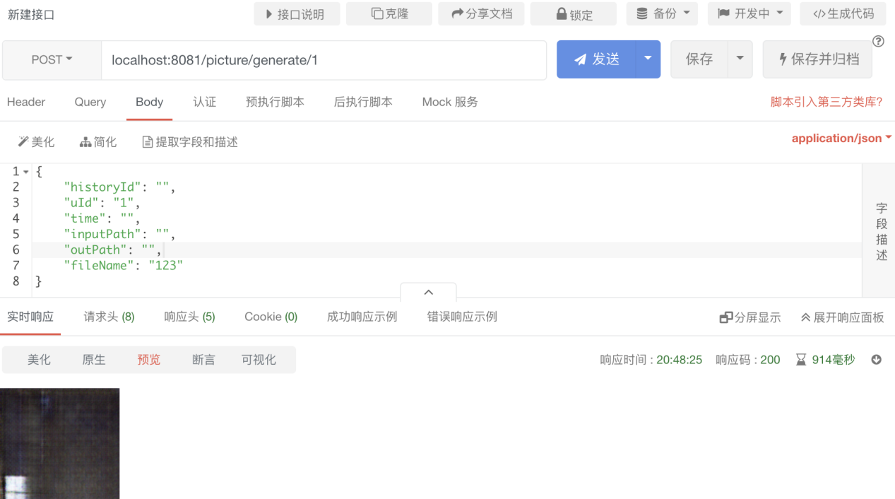

|  |  |  |  |
| --- | --- | --- | --- |
| Method | POST | | |
| URL | /picture/testdetect | | |
| Request  Parameter | Field | Type | Description |
| historyId | string | The id of a user history |
| uId | string | The id of a user |
| time | date | The uploading time of the picture |
| inputPath | string | The input path |
| outPath | string | The output path |
| filename | string |  |
| Response | Filed | Type | Description |
| A file | file | A byte stream of the picture |

Demo:

